A PROJECT ON
Hospital Management System
SUBMITTED IN
PARTIAL FULFILLMENT OF THE REQUIREMENT
FOR THE COURSE OF DIPLOMA IN ADVANCED COMPUTING FROM CDAC

SUNBEAM INSTITUTE OF INFORMATION TECHNOLOGY
Hinjawadi
SUBMITTED BY:
Vedant Rane
UNDER THE GUIDENCE OF:
Miss. Manjusha Nikam
Faculty Member
Sunbeam Institute of Information Technology, Pune

ACKNOWLEDGEMENT

A project usually falls short of its expectation unless aided and guided by the right persons at the right time. We avail this opportunity to express our deep sense of gratitude towards Mr. Nitin Kudale (Center Coordinator, SIIT, Pune) and Mr. Yogesh Kolhe (Course Coordinator, SIIT ,Pune) .
We are deeply indebted and grateful to them for their guidance, encouragement and deep concern for our project. Without their critical evaluation and suggestions at every stage of the project, this project could never have reached its present form.
Last but not the least we thank the entire faculty and the staff members of Sunbeam Institute of Information Technology, Pune for their support.

Vedant Rane
0225 PG-DMC
CDAC, Pune

1.INTRODUCTION TO REPORT

The web-based Hospital Management System (HMS) project is an attempt to simulate and automate the core functionalities of a modern hospital environment. The system is designed to manage and integrate essential hospital operations such as patient registration, doctor management, appointment scheduling, visit tracking, prescriptions, and billing in an efficient and user-friendly manner.
The system provides a quick access facility that allows users to view basic hospital information such as available doctors and services without logging in. However, to book appointments, view medical records, or access personalized services, users must log in to their respective accounts.
The Hospital Management System enables patients to search for available doctors based on specialization and schedule appointments on a specified date. The system displays detailed information such as doctor name, department, availability, consultation timings, and consultation fees. Patients can choose a suitable doctor and request an appointment accordingly.
Once an appointment is selected, the system checks the doctor’s availability. If slots are available, the appointment is confirmed; otherwise, the user is prompted to select a different time or doctor. Doctors can view their scheduled appointments, record visit details, and generate prescriptions electronically.
To complete hospital services, the system allows patients to enter personal details such as name, contact information, and address. It securely manages medical records, prescriptions, and billing details. The system updates hospital databases in real time, ensuring accurate data management and seamless coordination between patients, doctors, and hospital administrators.
Overall, the Hospital Management System improves operational efficiency, reduces manual work, enhances data accuracy, and provides better healthcare services through a centralized, secure, and scalable platform.

2.REQUIREMENTS

2.1 FUNCTIONAL REQUIREMENTS
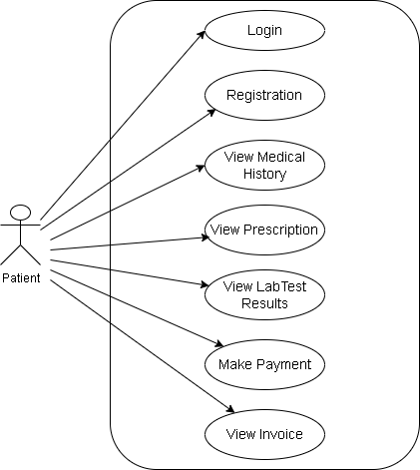

2.1 User Account

The patient, who will henceforth be referred to as the ‘user’, is presented with three choices by the Hospital Management System as the first step of interaction. The user’s choice depends on whether the user is a guest or a registered patient, and whether the user wants to only view doctor availability or also book an appointment and access medical services.
The terms ‘registered patient’ and ‘guest’ are described below.
A user who has previously visited the hospital would already have a user ID and password assigned to them. This personal information is stored as a patient profile in the hospital database. Such a user, whose profile exists in the database, is referred to as a registered patient. A registered patient can log in to the system to search for doctors, book appointments, view appointment history, access medical records, and make payments.
A new user, on the other hand, has two options:
a) Register with the system by providing personal details such as name, contact number, address, and login credentials, or
b) Access the system as a guest user.
In case of (a), the new user becomes a registered patient and gains access to all system features.
In case of (b), the user continues to remain a guest.
A guest user is allowed only to view doctor availability, hospital services, and departments, but cannot book appointments, access medical records, or make payments.
A registered patient, however, can perform all operations, including appointment booking, prescription viewing, and payment processing. Additionally, a registered patient may also act as a guest if they only wish to check doctor availability without logging in.
The term ‘availability’ in the Hospital Management System refers to viewing doctor schedules, consultation timings, specialization details, consultation fees, and available appointment slots. The system provides the user with the option to exit at any stage during the interaction process.

2.2 Registration and creation of user profile

The Hospital Management System requires patients to register before performing transactions such as appointment booking and payment. During registration, personal and login details are collected and stored as a patient profile. The system automatically generates internal fields like Patient ID and registration date. Registered patients can securely log in and access all healthcare services.
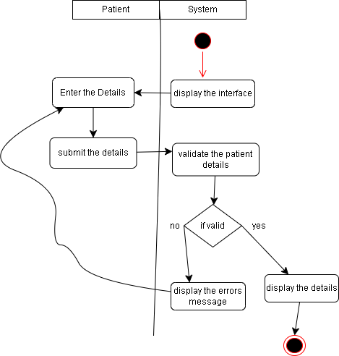

2.3 Quick Search (Doctor Search)

Here The Hospital Management System provides a Quick Search facility that allows any user to search for doctors and hospital services without logging into the system. This feature enables users to view doctor availability, specialization, consultation fees, and timings.
After accessing the system (either as a registered patient or a guest), the system requests the user to enter the following details:
- Department / Specialization
- Preferred hospital location (if applicable)
The term “department” refers to medical specializations such as Cardiology, Orthopedics, Pediatrics, etc. These details are selected using dropdown menus or text input fields.
Once the department and location are selected, the system accesses the doctor master database (doctor_master) to check whether doctors are available for the selected criteria.
The system then asks the user to enter additional details such as:
- Consultation type (OPD / Follow-up / Emergency)
- Preferred consultation date
- Time slot
- Number of patients (if booking for family members)
The system validates the entered data, such as ensuring the consultation date is not earlier than the current system date. In case of invalid input, the system does not display available doctors.
The system queries the doctor and appointment databases to determine which doctors have available slots. The results are displayed in a tabular format showing:
- Doctor ID
- Doctor Name
- Specialization
- Available Time Slot
- Consultation Fee
- Hospital / Department Name
Multiple doctors may be available under the same specialization, and all matching doctors are listed. Each row in the result table includes a Book Appointment button.
If the user chooses to proceed, the system collects personal details of the patient(s). A registered patient may book appointments for multiple family members. The system then displays the total consultation cost based on the selected services.

2.4 Appointment Booking / Blocking / Confirmation

After completing the quick search process, the system asks the user whether they wish to book or confirm an appointment.
a) If the user is a guest, they must first register and become a registered patient before booking an appointment.
b) If the user is already a registered patient, they may proceed directly after logging in.
Once the system verifies valid login credentials, it compares the selected appointment date with the current system date.
- If the appointment date is within a short duration (e.g., same day or next day), the system allows direct confirmation only.
- If the appointment date is scheduled further in advance, the system allows the patient to block or confirm the appointment.
If the appointment is blocked, the system informs the patient that final confirmation must be done before a specified deadline. A notification or email reminder is sent to the patient.
After receiving confirmation, the system updates the appointment database (DB_appointments) and reduces the available slots for the selected doctor.
If the patient confirms the appointment, the system requests payment details (credit/debit card or online payment) and processes the transaction successfully.

2.5 View Appointment History
The system allows registered patients to view details of their previous and upcoming appointments. After login, the patient can search using:
- Appointment ID
- Date range
The system accesses the PatientAppointment table and displays appointment details in a tabular format, including:
- Doctor Name
- Date & Time
- Status (Booked / Completed / Cancelled)
- Payment Details
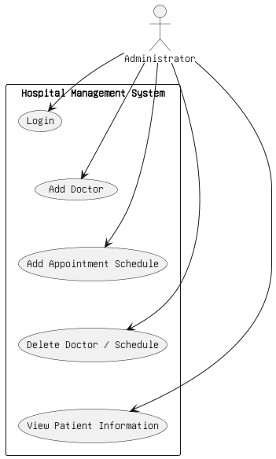
Admin Functionalities
The Administrator has the following privileges:
- Login to the system
- Add doctor information
- Add department and service information
- Update or delete doctor records
- Manage appointment schedules
- View patient information using Patient ID

  - NON FUNCTIONAL REQUIREMENTS

2.2.1 Interface
Refer to Appendix B for user interface screenshots of the web and mobile applications.

2.2.2 Performance
- Number of Concurrent Users:
HMS should support at least 1000 concurrent users performing search and appointment transactions.
- System Availability:
The system is designed to handle temporary server issues and ensures data consistency using transactional support.

2.2.3 Constraint
The Hospital Management System must handle at least 1000 transactions or inquiries per second under peak load.

2.2.4 Other Requirements:
- Hardware Interfaces
• Intel Dual Core Processor or higher
• 4 GB RAM minimum
• 40 GB Hard Disk
- Software Interfaces
• Operating System: Windows / Linux
• Backend: Java (Spring Boot)
• Database: MySQL
• Server: Apache Tomcat / Embedded Server
• Browser Support: Chrome, Firefox, Edge
• Mobile Platform: Android

3. DESIGN

3.1 Database Design

The following table structures depict the database design.

Table1: Appointment

Key Type/ Constraint | Column Name | Data Type | Length | Allow Null (1=Yes;0=No)
3 | appointmentid | int | 4 | 0
0 | patientid | int | 4 | 0
0 | doctorid | int | 4 | 0
0 | schedule_at | datetime | 8 | 0
0 | Created_at | datetime | 8 | 0
0 | status | enum |  | 0
0 | notes | Varchar2 | 255 | 1

Table2: Doctor

0 | doctorid | int | 4 | 0
0 | userid | int | 4 | 0
0 | name | varchar | 255 | 0
0 | Gender | Varchar | 255 | 0
0 | speciality | Varchar | 255 | 0
0 | Mobile | Varchar | 255 | 0
0 | Status | Enum |  | 0
0 | Consultation_duration | Int | 4 | 0
0 | Created_at | Date | 8 | 0
0 | Manager_id | Int | 4 | 0
0 | Doctor_consultation_fee | Double | 8 | 0
0 | Image | Varchar | 255 | 0

Table3: Manager

3 | managerid | Int | 4 | 0
0 | Userid | Int | 4 | 0
0 | Name | Varchar2 | 150 | 0
0 | Email | Varchar2 | 150 | 0
0 | Created_at | Datetime | 8 | 0
0 | mobile | Varchar | 20 | 0

Table4: User_account

3 | Userid | Int | 4 | 0
3 | Username | Varchar | 255 | 0
0 | Password | Varchar2 | 255 | 0
0 | Role | Enum | 0 | 0
0 | Mobile | Varchar | 20 | 0
0 | Email | Varchar | 250 | 0
0 | Created_at | Datetime | 8 | 0
0 | Update_at | Datetime | 8 | 0

Table5: Patient

3 | Patientid | Int | 4 | 0
0 | Userid | Int | 4 | 0
0 | Firstname | Varchar | 100 | 0
0 | Lastname | Varchar | 100 | 0
0 | Gender | Varchar | 20 | 0
0 | DateofBirth | Date | 8 | 0
0 | Mobile | Varchar | 20 | 0
0 | Email | Varchar | 150 | 0
0 | Address | Varchar | 255 | 0
0 | Image | Varchar | 255 | 0
0 | Created_at | Datetime | 8 | 0

Table6:Medicine_Record

3 | Medicineid | Int | 4 | 0
0 | Name | Varchar2 | 255 | 0
0 | Type | Varchar | 50 | 0
0 | Image | Varchar | 255 | 0
0 | Quantity | Int | 4 | 0
0 | price | Decimal | 10,2 | 0
0 | Managerid | Int | 4 | 0
0 | Created_at | Datetime | 8 | 0
0 | Expiry_date | Date | 8 | 0

Table7: Labtest

3 | testid | Int | 4 | 0
0 | testname | Varchar2 | 255 | 0
0 | description | Varchar | 500 | 0
0 | Image | Varchar | 255 | 0
0 | Manager_id | Int | 4 | 0
0 | Created_at | Datetime | 8 | 0
0 | Lab_test_fees | Decimal | 12,2 | 0

Table8: Patient_medical_record:

3 | Recordid | Int | 4 | 0
3 | Patientid | Int | 4 | 0
3 | Doctored | Int | 4 | 0
0 | Testid | Int | 4 | 0
0 | Diagnosis | Varchar | 255 | 0
0 | Treatment_plan | Varchar | 255 | 0
0 | Currentvisit | Datetime | 8 | 0
0 | Lastvisit | Datetime | 8 | 0

Table9: medical_stock_history

3 | Id | Int | 4 | 0
0 | Change_qty | Int | 4 | 0
0 | Created_at | Date | 8 | 0
0 | Final_stock | Int | 4 | 0
0 | Medicine_id | Int | 4 | 0
0 | Medicine_name | Varchar | 255 | 0
0 | Reason | Varchar | 255 | 0
0 | Local_date | Date | 8 | 0

Table10: Visit

3 | Visited | Int | 4 | 0
3 | Patientid | Int | 4 | 0
3 | Doctored | Int | 4 | 0
3 | Appointment_id | Int | 4 | 0
0 | Visit_date | Datetime | 8 | 0
0 | Visit_type | Varchar | 50 | 0
0 | Reason | Varchar | 1000 | 0
0 | Status | Enum | 0 | 0
0 | Created_at | Datetime | 8 | 0

Table11: Prescription

3 | prescriptionid | Int | 4 | 0
3 | recordid | Int | 4 | 0
3 | Patientid | Int | 4 | 0
3 | Doctored | Int | 4 | 0
0 | Date_issued | Datetime | 8 | 0
0 | Medicine_fees | Decimal | 12,2 | 0
0 | Notes | Varchar | 1000 | 0
0 | Created_at | Datetime | 8 | 0

Table12: Prescription_line_items

3 | Id | Int | 4 | 0
3 | Prescriptionid | Int | 4 | 0
3 | Medicineid | Int | 4 | 0
0 | Dosage | Varchar | 100 | 0
0 | Duration | Varchar | 100 | 0
0 | Quantity | Int | 4 | 0
0 | Unit_price | Decimal | 10,2 | 0
0 | Line_total | Decimal | 14,2 | 0

Table13: Labtest_Result:

3 | Labid | Int | 4 | 0
3 | Testid | Int | 4 | 0
3 | Recordid | Int | 4 | 0
0 | Result_date | Datetime | 8 | 0
0 | Findings | Text |  | 0
0 | Lab_test_fees | Decimal | 12,2 | 0
0 | Created_at | Datetime | 8 | 0

Table14: Invoice

3 | Invoiceid | Int | 4 | 0
3 | Patientid | Int | 4 | 0
3 | Prescriptionid | Int | 4 | 0
3 | Labid | Int | 4 | 0
0 | Date | Datetime | 8 | 0
0 | Doctor_fees | Decimal | 14,2 | 0
0 | Medicine_fees | Decimal | 14,2 | 0
0 | Labtest_fees | Decimal | 14,2 | 0
0 | Subtotal | Decimal | 14,2 | 0
0 | Nettotal | Decimal | 14,2 | 0
0 | Payment_status | Enum |  | 0
0 | Created_at | Datetime | 8 | 0

Table15: Invoice_line_items:

3 | Lineitmeid | Int | 4 | 0
3 | Invoiceid | Int | 4 | 0
0 | Itemtype | Varchar | 50 | 0
0 | Itemrefid | Int | 4 | 0
0 | Description | Varchar | 500 | 0
0 | Unitprice | Decimal | 14,2 | 0
0 | Quantity | Int | 4 | 0
0 | Linetotal | Decimal | 14,2 | 0

Table16: Payment:

3 | Paymentid | Int | 4 | 0
3 | Invoiceid | Int | 4 | 0
0 | Totalamount | Decimal | 16,2 | 0
0 | Paymentdate | Datetime | 8 | 0
0 | Paymentmethod | Varchar | 100 | 0
0 | Transactionref | Varchar | 100 | 0
0 | Created_at | Datetime | 8 | 0

E-R Diagram,Dataflow diagram and Class Diagram:

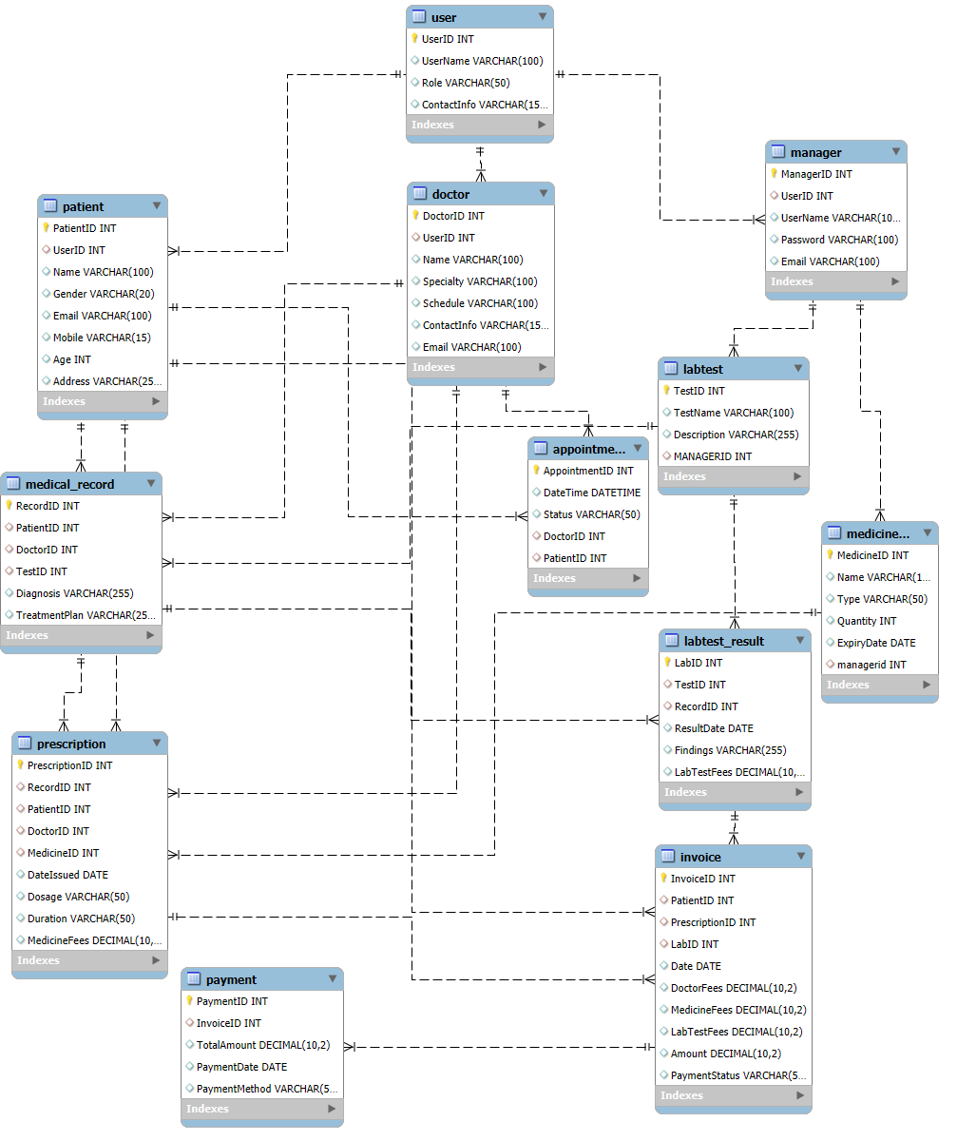
4. CODING STANDARDS IMPLEMENTED

Naming and Capitalization
The following table summarizes the naming and capitalization conventions followed during the development of the Hospital Management System.
The project primarily uses Pascal Case (capitalizing the first letter of each word) and Camel Case (capitalizing each word except the first) as per standard software engineering practices.
Identifier | Case | Examples | Additional Notes
Class | Pascal | Patient, Doctor, Appointment, Prescription, Payment, Department | Class names represent real-world hospital entities and are nouns. No _ symbols used. No type prefixes like C used..
Method | Camel | bookAppointment(), addDoctor(), generatePrescription(), makePayment() | Method names use verbs or verb phrases describing the action performed.
Parameter | Camel | patientId, doctorId, appointmentDate, paymentAmount | Parameter names are descriptive and meaningful.
Interface | Pascal with "I" prefix | IPatientService, IDoctorService, IAppointmentRepository | Interfaces begin with I and avoid underscores.
Property | Pascal | PatientName, AppointmentDate, ConsultationFee | Properties are named using nouns or noun phrases.
Associated private member variable | _camelCase | _patientRepository, _doctorService, _appointmentList | Private variables use underscore camel case for identification.
Exception Class | Pascal with "Exception" suffix | PatientNotFoundException, AppointmentException, PaymentException | Exception class names clearly indicate the error type.

Comments
- Comment each type, each non-public type member, and each region declaration.
- Use end-line comments only on variable declaration lines. End-line comments are comments that follow code on a single line.
- Separate comments from comment delimiters (apostrophe) or // with one space.
- Begin the comment text with an uppercase letter.
- End the comment with a period.
- Explain the code; do not repeat it.

5. TEST REPORT

Another group called Linux did the testing and the report of the testing is given hereunder.
GENERAL TESTING:
SR-NO | TEST CASE | EXPECTED RESULT | ACTUAL RESULT | ERROR MESSAGE
1 | Patient Registration Page | Redirected to next page after registration | OK | Nothing
2 | Login Page | Pop-up will come | Ok | Please enter username and password again .
3 | Reset login | Only users password will be reseted | Ok | Nothing
4 | Quick search Doctor | Displays available doctors and schedules | Ok | Nothing
5 | Book Appointment | All the fields should be filled for submission | Ok | Nothing
6 | Checking login or not | Patient is logged in or not | Ok | Nothing
7 | Add Patient details | Patient details saved according to appointment | Ok | Nothing
8 | Goto Appointment page | Displays entered appointment information | Ok | Nothing
9 | Save Appointment Information | Appointment data saved into appointment table | Ok | Nothing
10 | Payment Transaction | Redirects to payment gateway | Ok | Nothing
11 | View Appointment History | Displays all previous appointments | Ok | Nothing
12 | Logout | It will logout from user profile. | Ok | Nothing
 | STATIC TESTING
SR-NO | Deviation | Program
1 | Commenting not followed | All Web Application

6. PROJECT MANAGEMENT RELATED STATISTICS

DATE | WORK PERFORMED | SLC Phase | Additional Notes
AUG 12,2026 | Project Allotment and User Requirements Gathering | Feasibility Study | Our team met the client Mr. Nitinkudale (CEO, SIIT Pune) to know his requirements.
JAN 17,2026 | Initial SRS Document Validation  And Team Structure Decided | Requirement Analysis  (Elicitation) | The initial SRS was presented to the client to understand his requirements better
JAN 18,2026 | Designing the use-cases, Class Diagram, Collaboration Diagram, E-R Diagram and User Interfaces | Requirement Analysis &  Design Phase | Database Design completed
JAN 19,2026 | Business Logic Component design Started | Design Phase | ----------------------
JAN 20,2026 | Coding Phase Started | Coding Phase | 70% of Class Library implemented.
JAN 21,2026 | Implementation of Web Application and Window Application Started | Coding Phase | Class Library Development going on.
JAN 22, 2026 | Off | Off | Off
JAN 23, 2026 | Implementation of Web Application and Window Application Continued | Coding Phase and Unit Testing | Class Library Modified as per the need.
JAN 24, 2026 | Implementation of Web Application and Window Application Continued | Coding Phase and Unit Testing | --
JAN 25, 2026 | After Ensuring Proper Functioning the Required Validations were Implemented | Coding Phase and Unit Testing | Module Integration was done by the Project Manager
JAN 26, 2026 | The Project was Tested by the respective Team Leaders and the Project Manager | Testing Phase (Module Testing) | --
JAN 27, 2026 | The Project was Submitted to Other Project Leader of Other Project Group For Testing | Testing Phase (Acceptance Testing) | The Project of Other Team was Taken up by the Team for Testing
JAN 28-29, 2026 | The Errors Found were Removed | Debugging | The Project was complete for submission
JAN 30, 2026 | Final Submission of Project

Appendix A

Entity Relationship Diagram

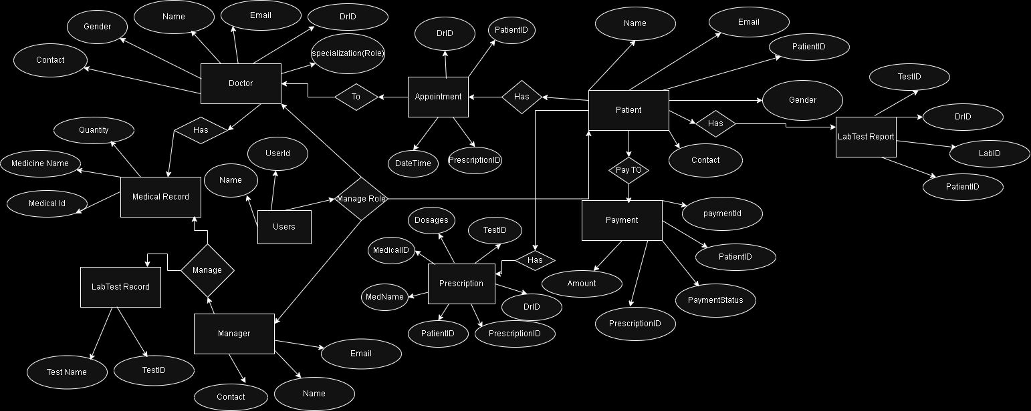

Data Flow Diagram:
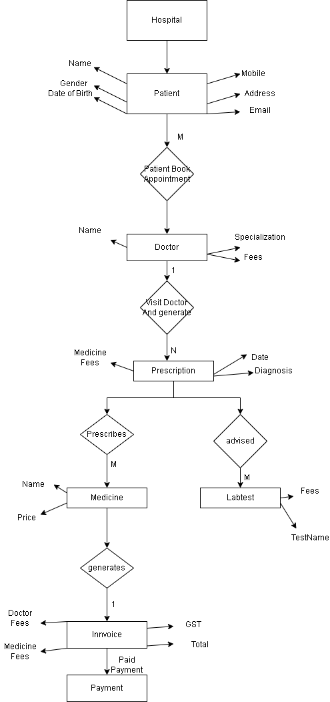

Class Diagram

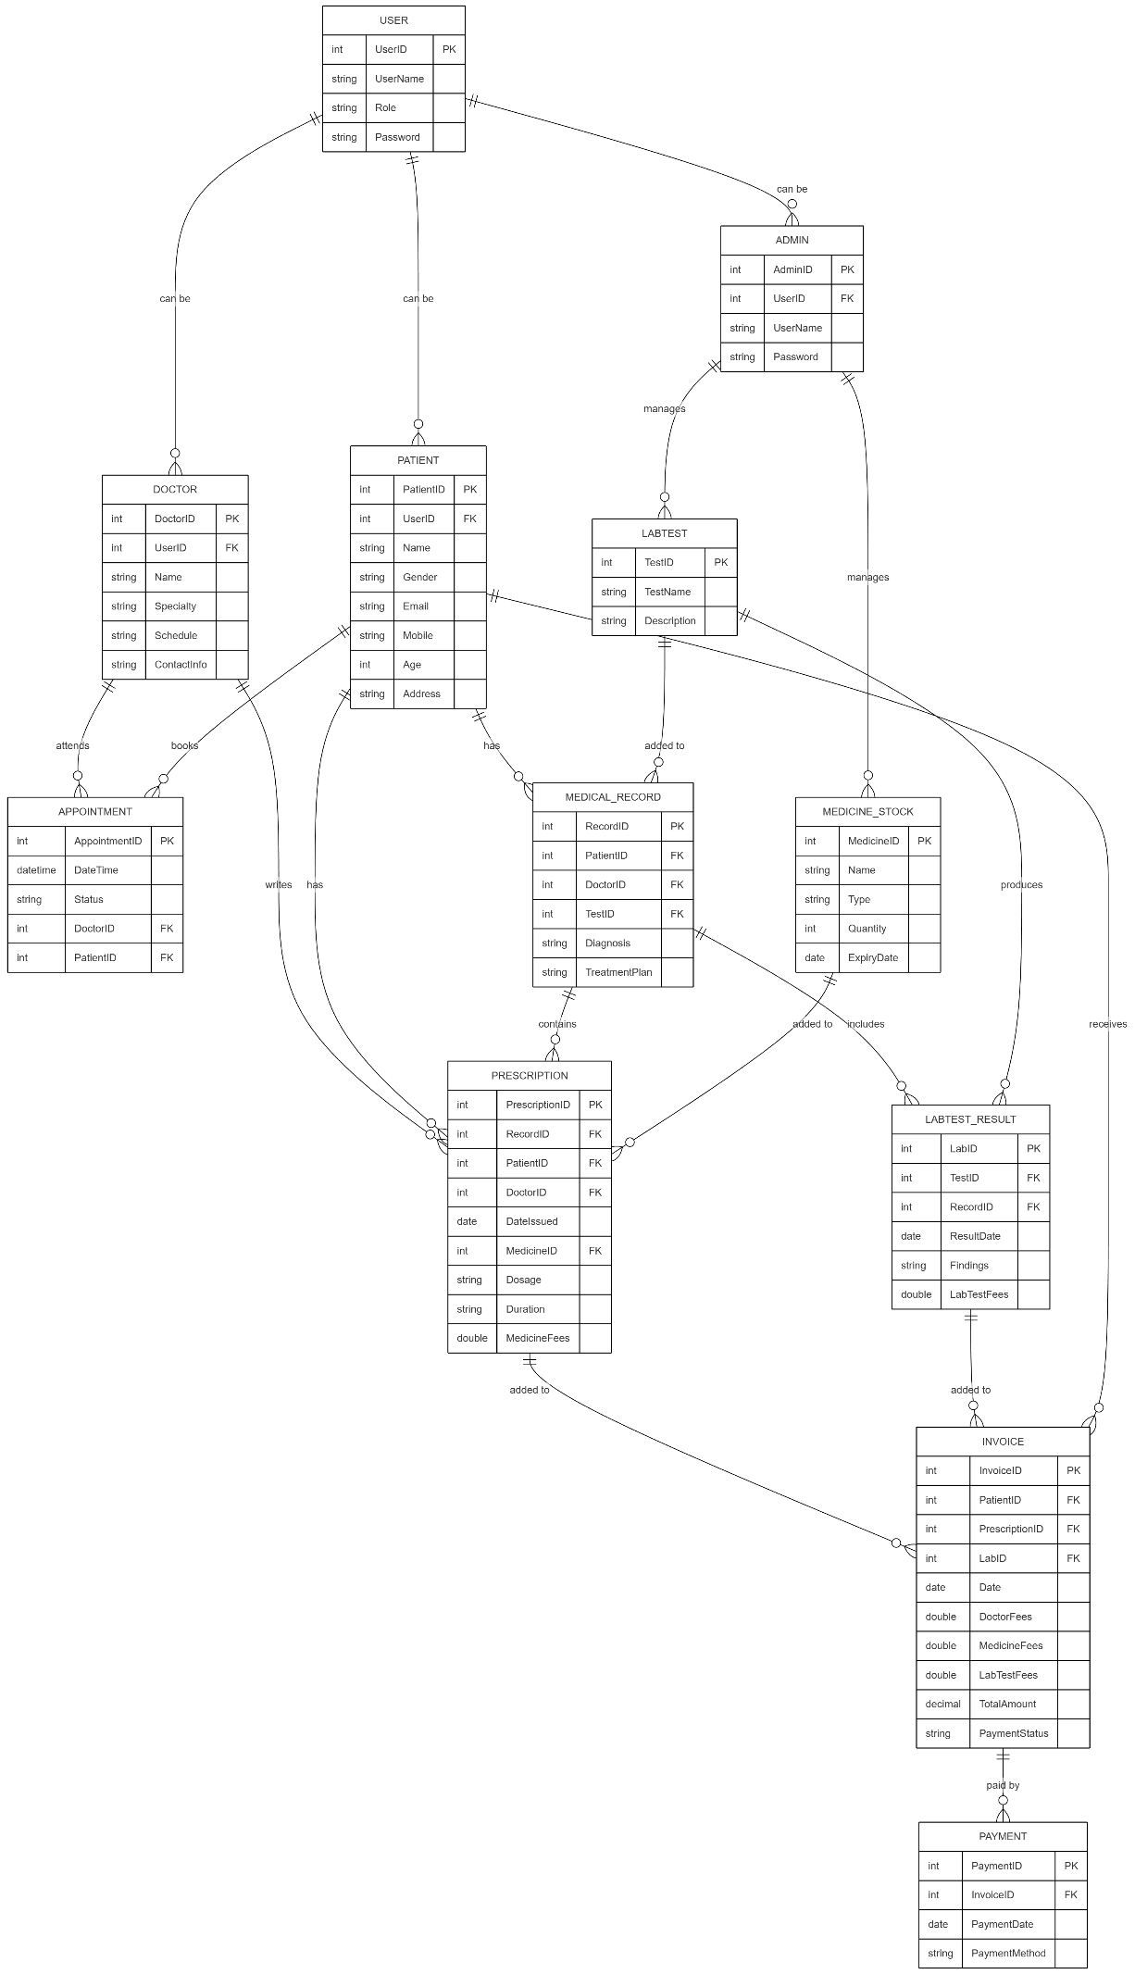

Appendix B

Homepage: 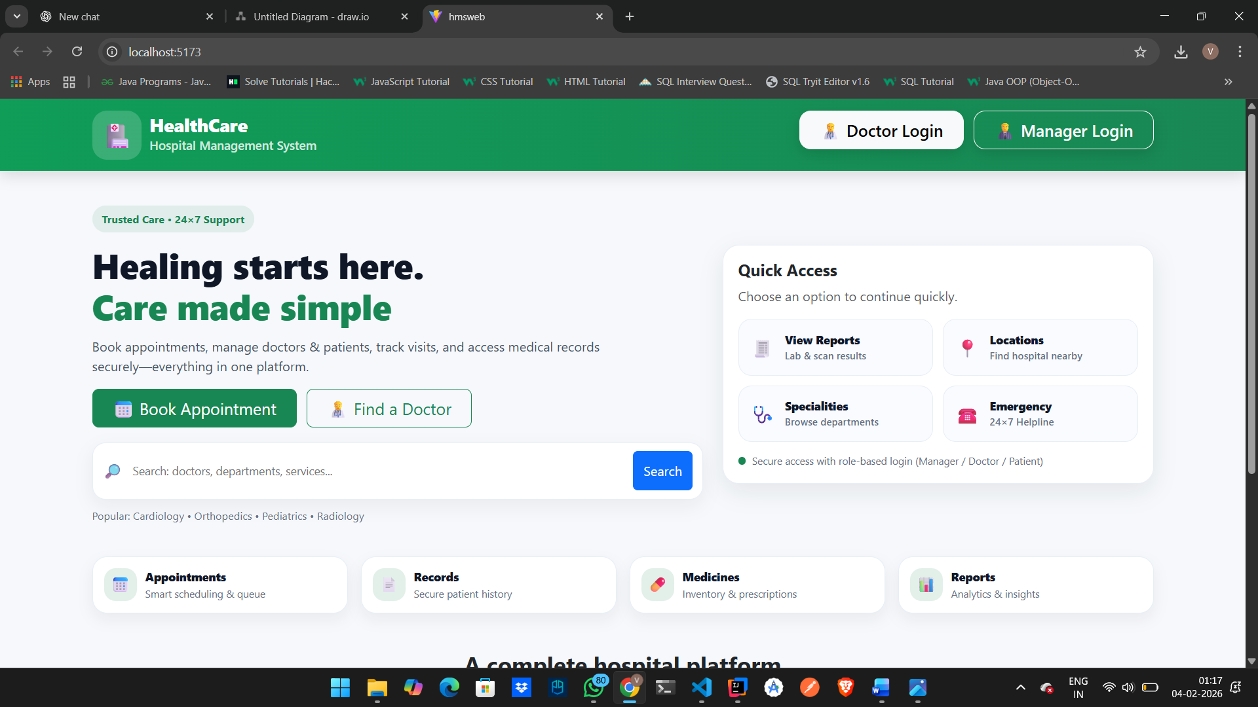

PatientLoginPopup: 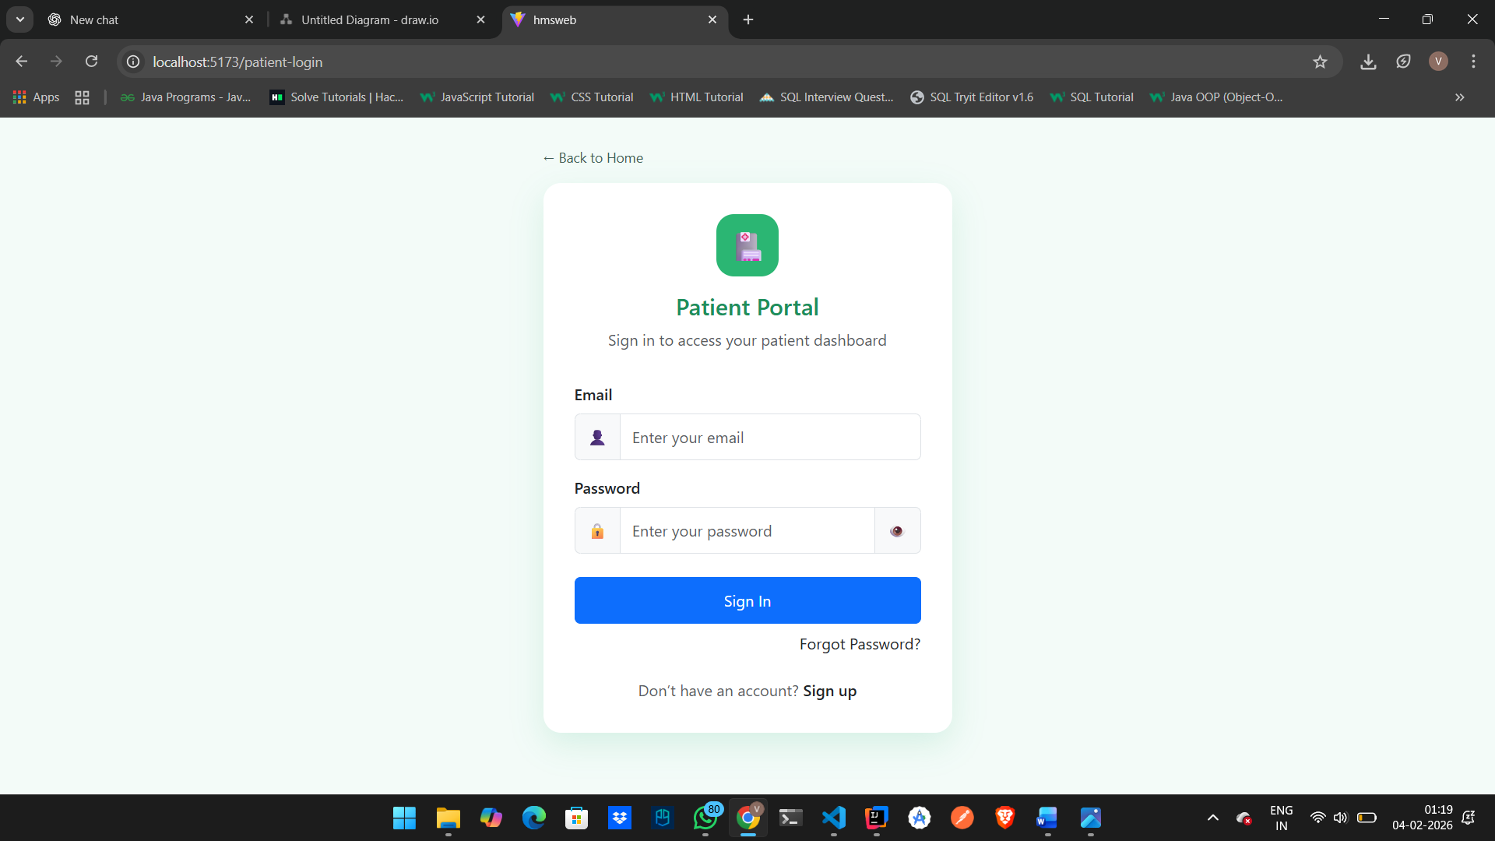

DoctorLogin: 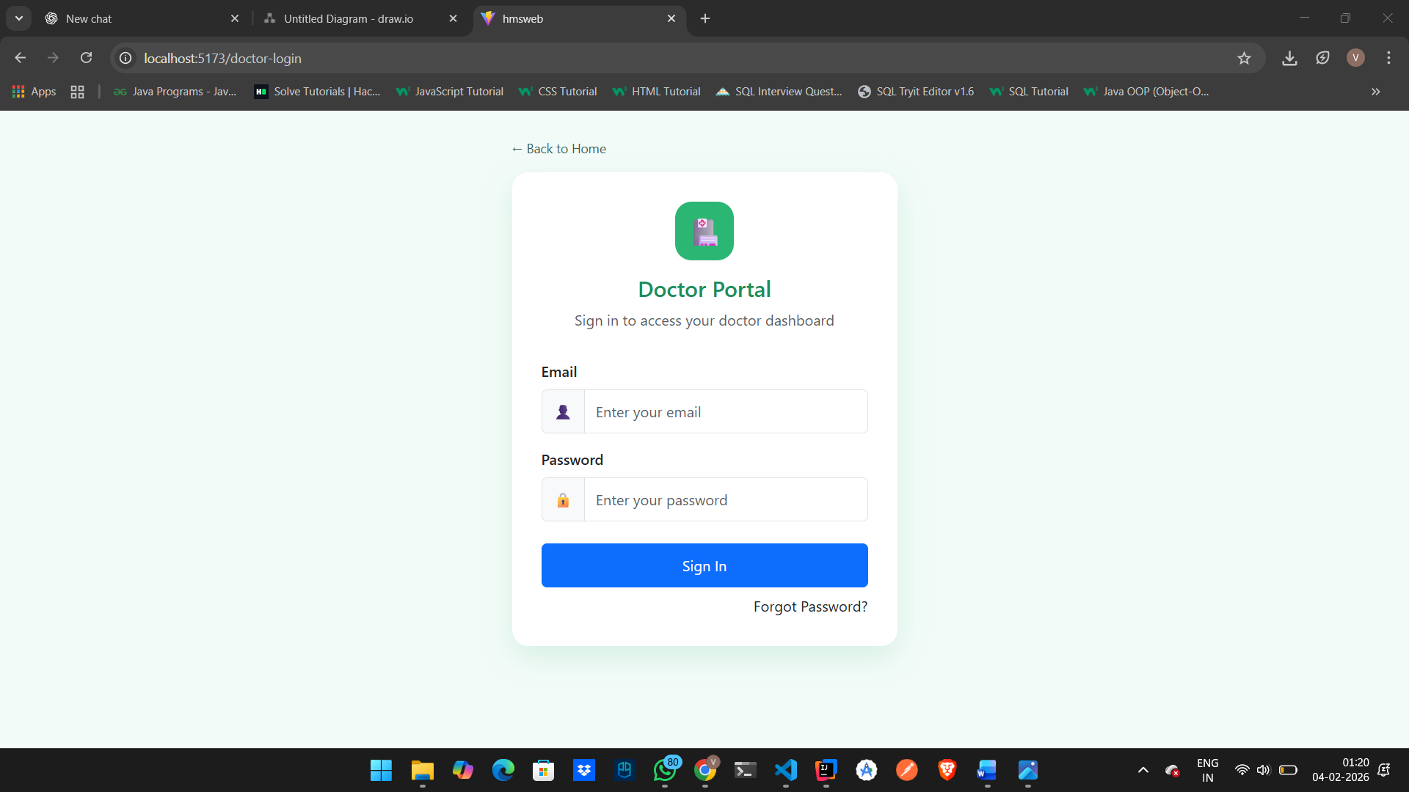

ManagerLogin:

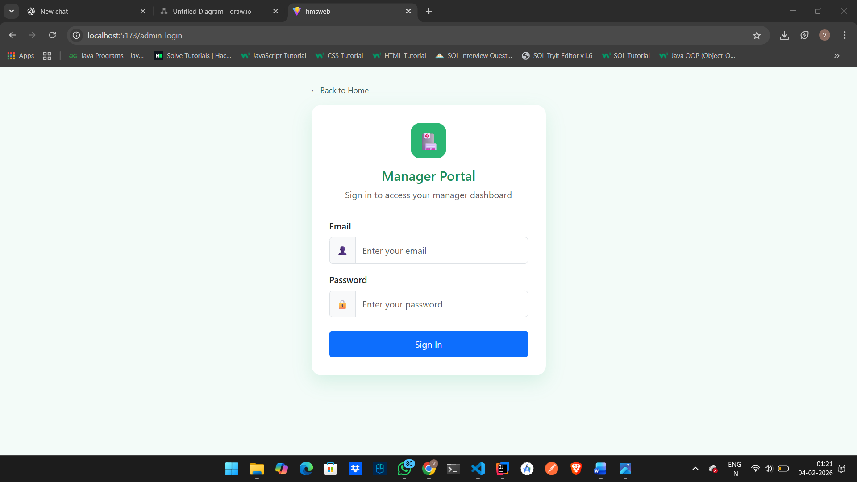

Patient Registration:

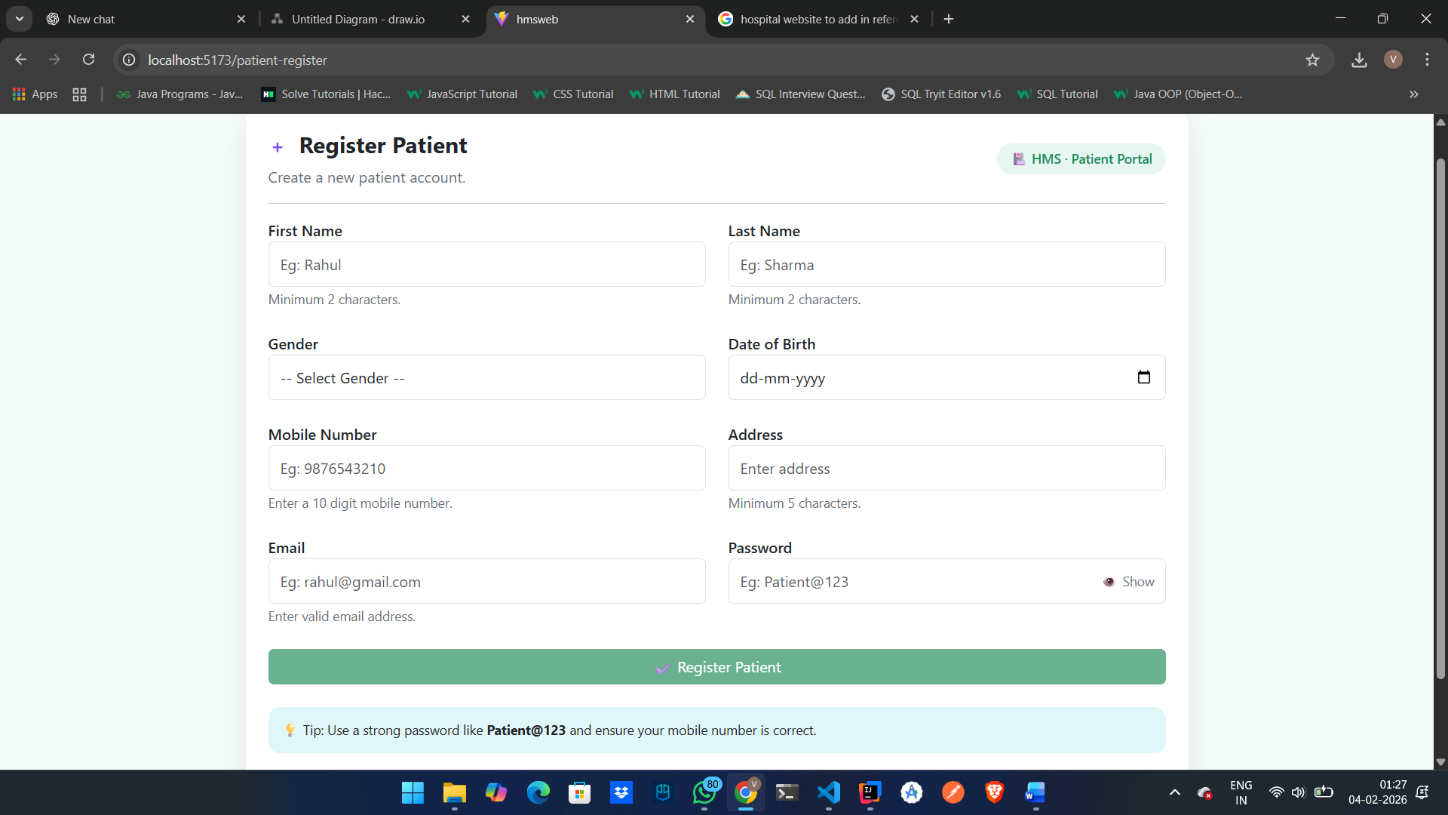

Patient Dashboard:

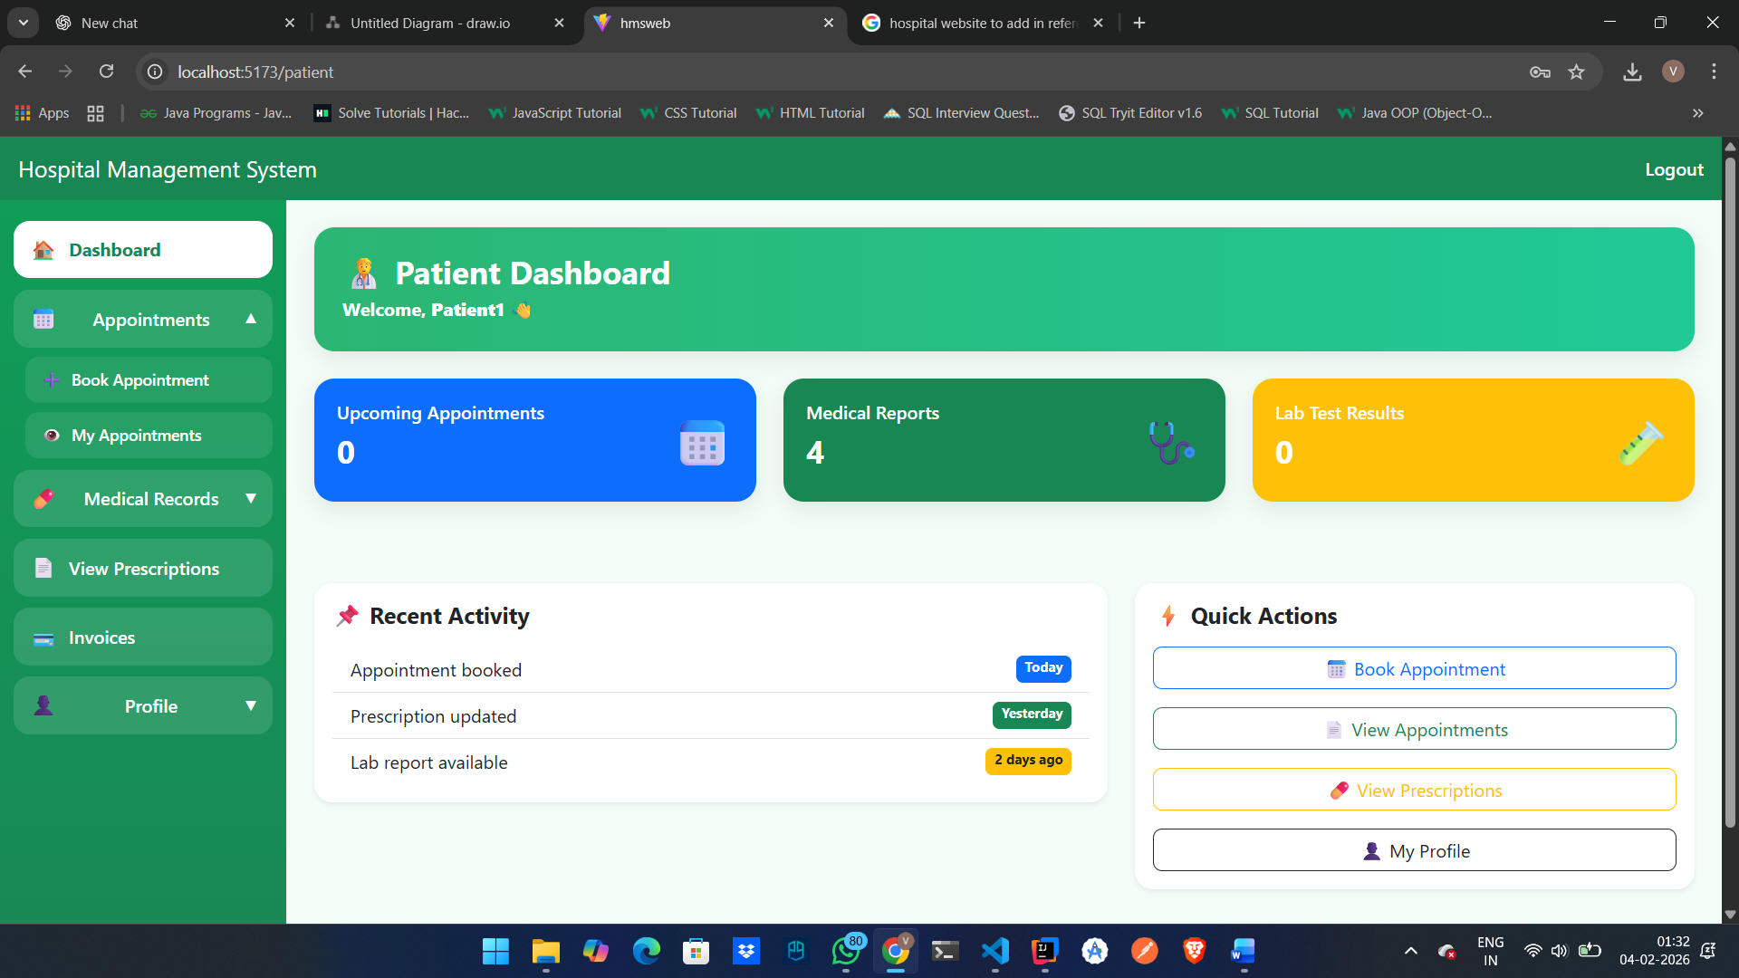

Book Appointment
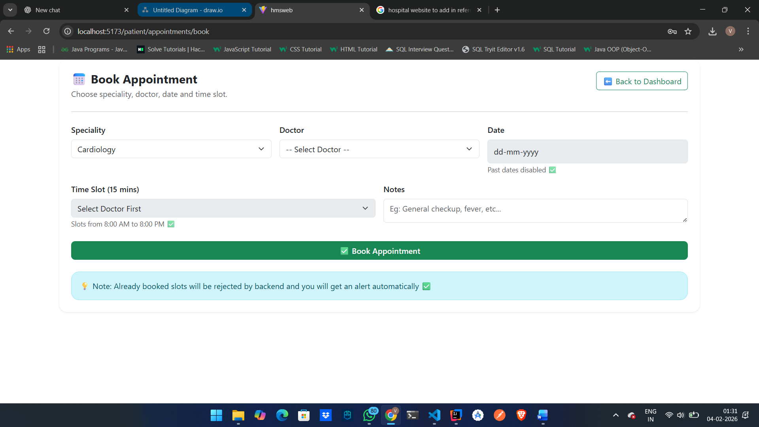

View Appointment

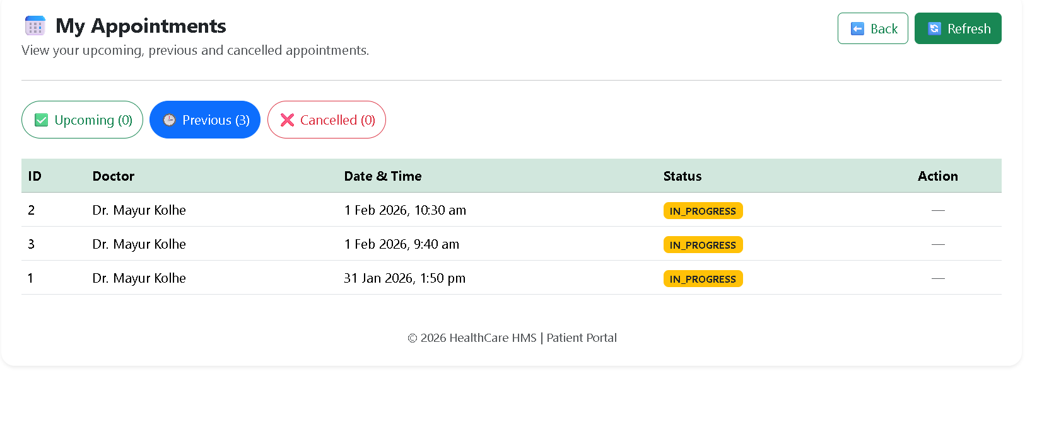

DoctorDashboard 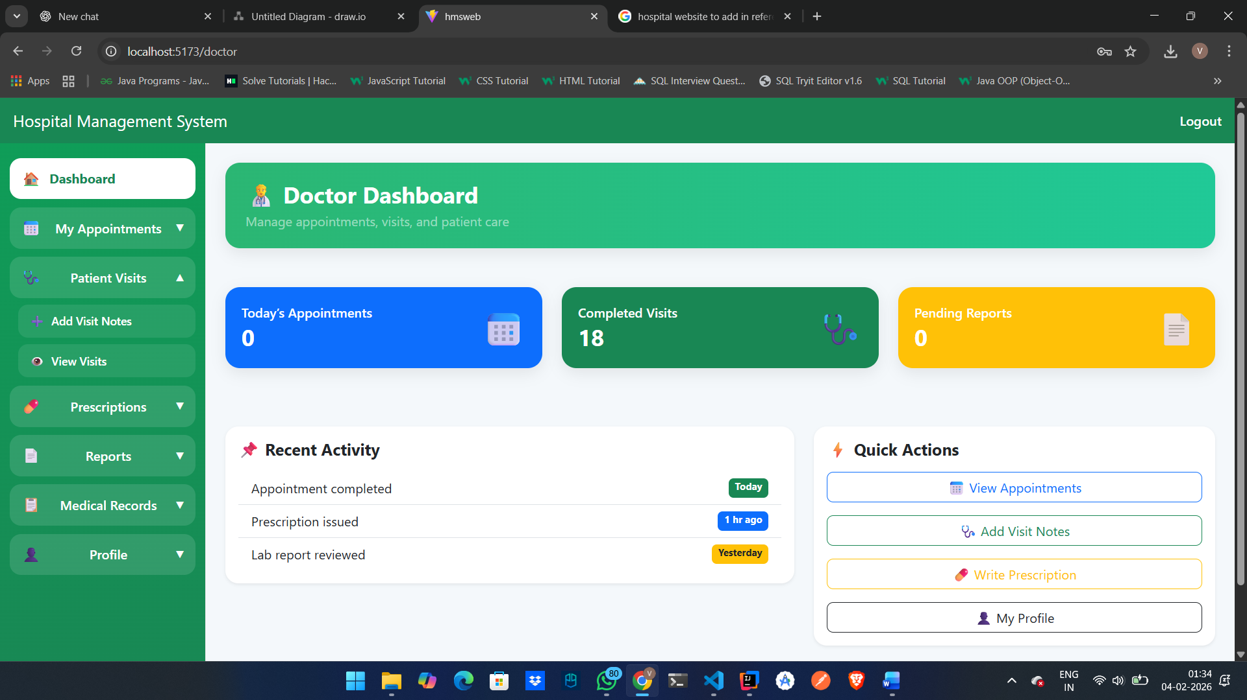

Patient Visit
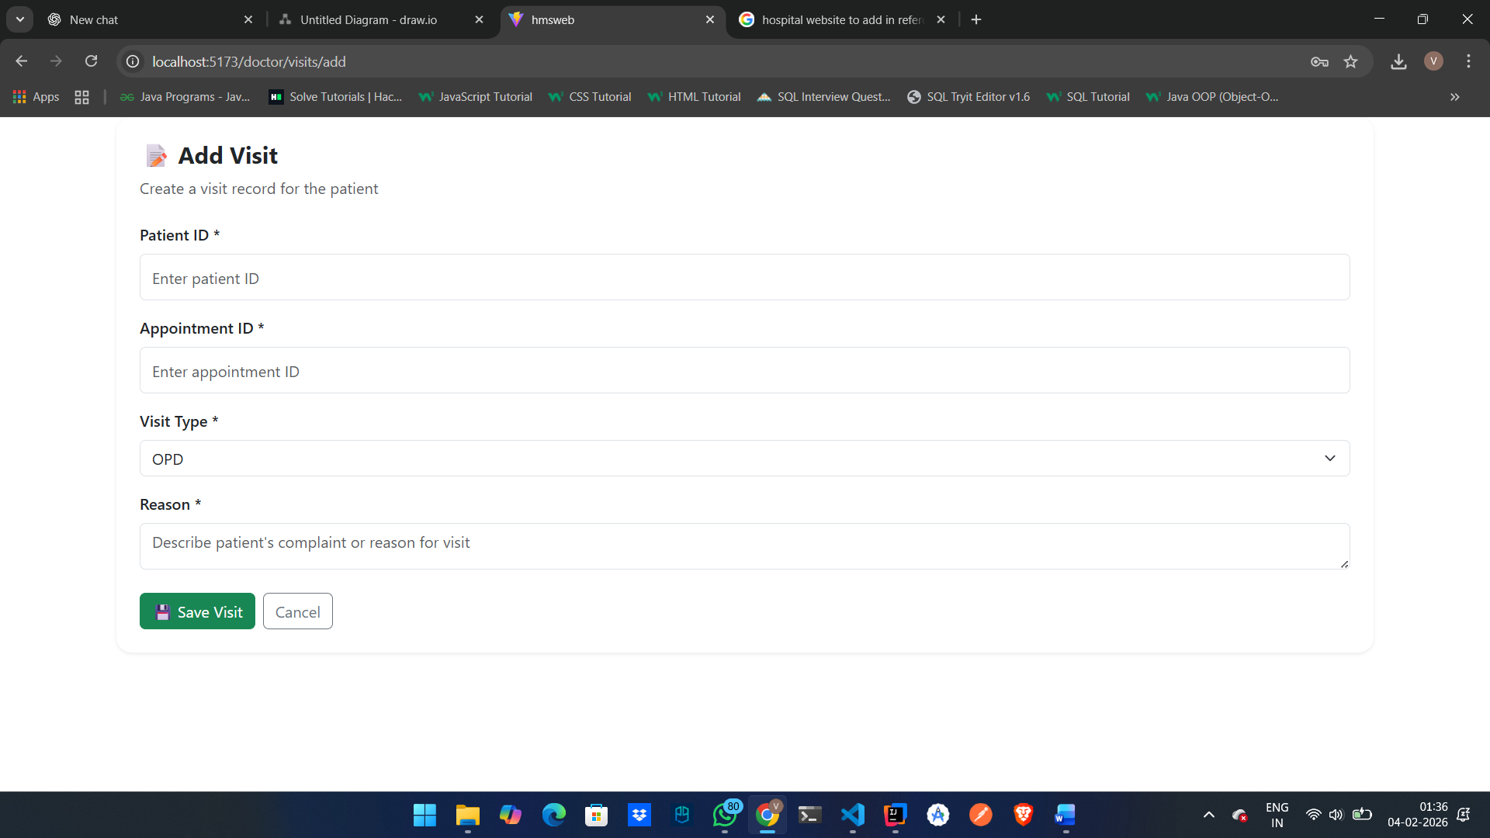

Invoice: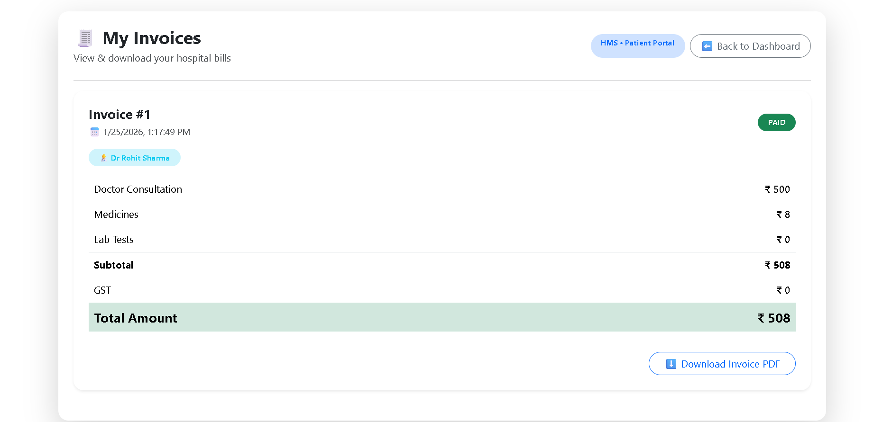

Prescriptions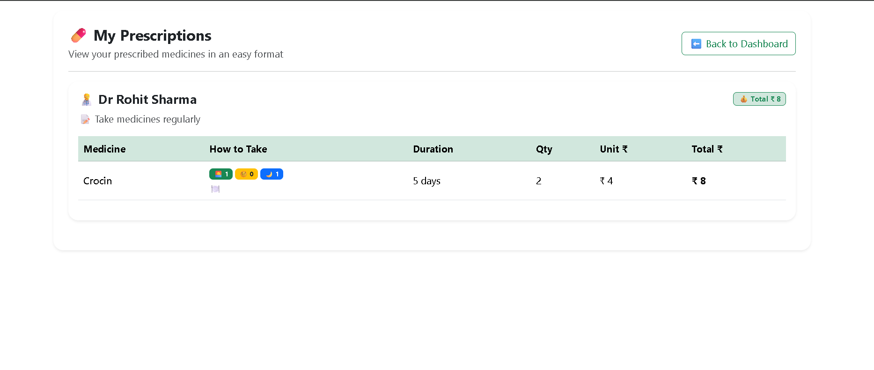

My Profile Details

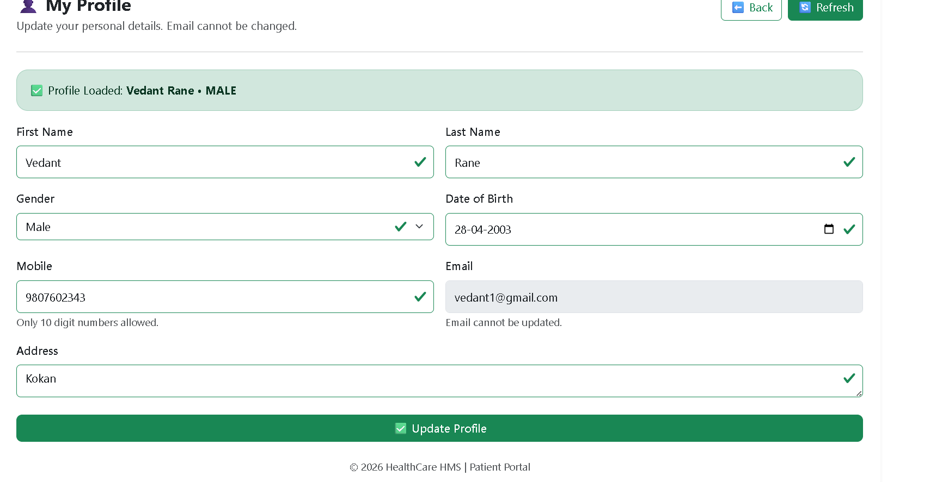

DoctorPrescription: 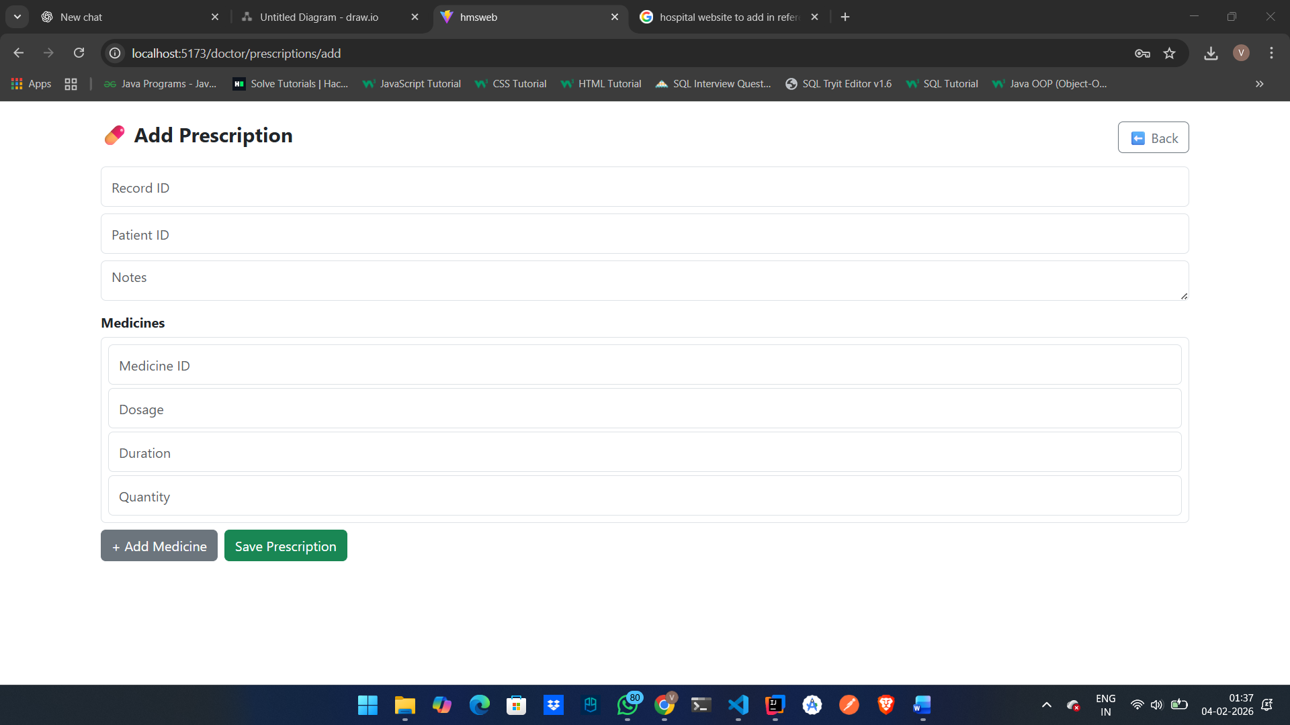

PatientMedicalRecord: 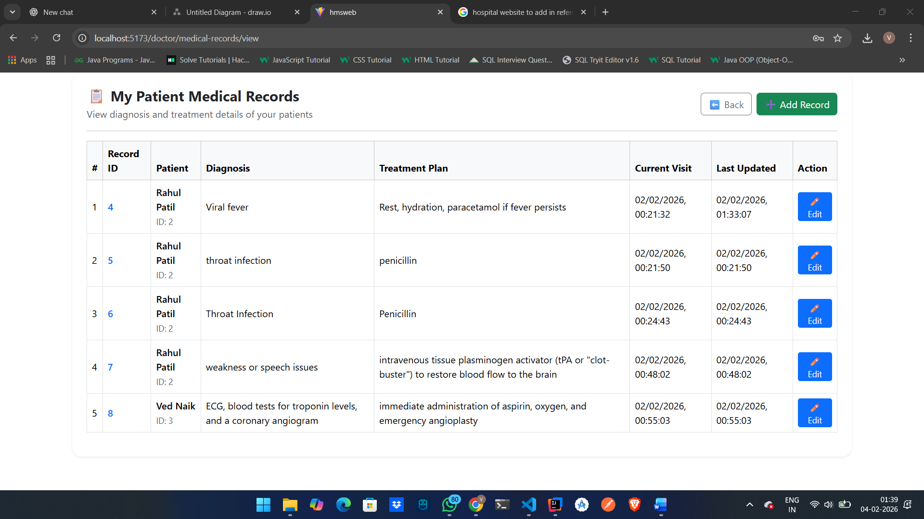

AddPatientMedicalRecord: 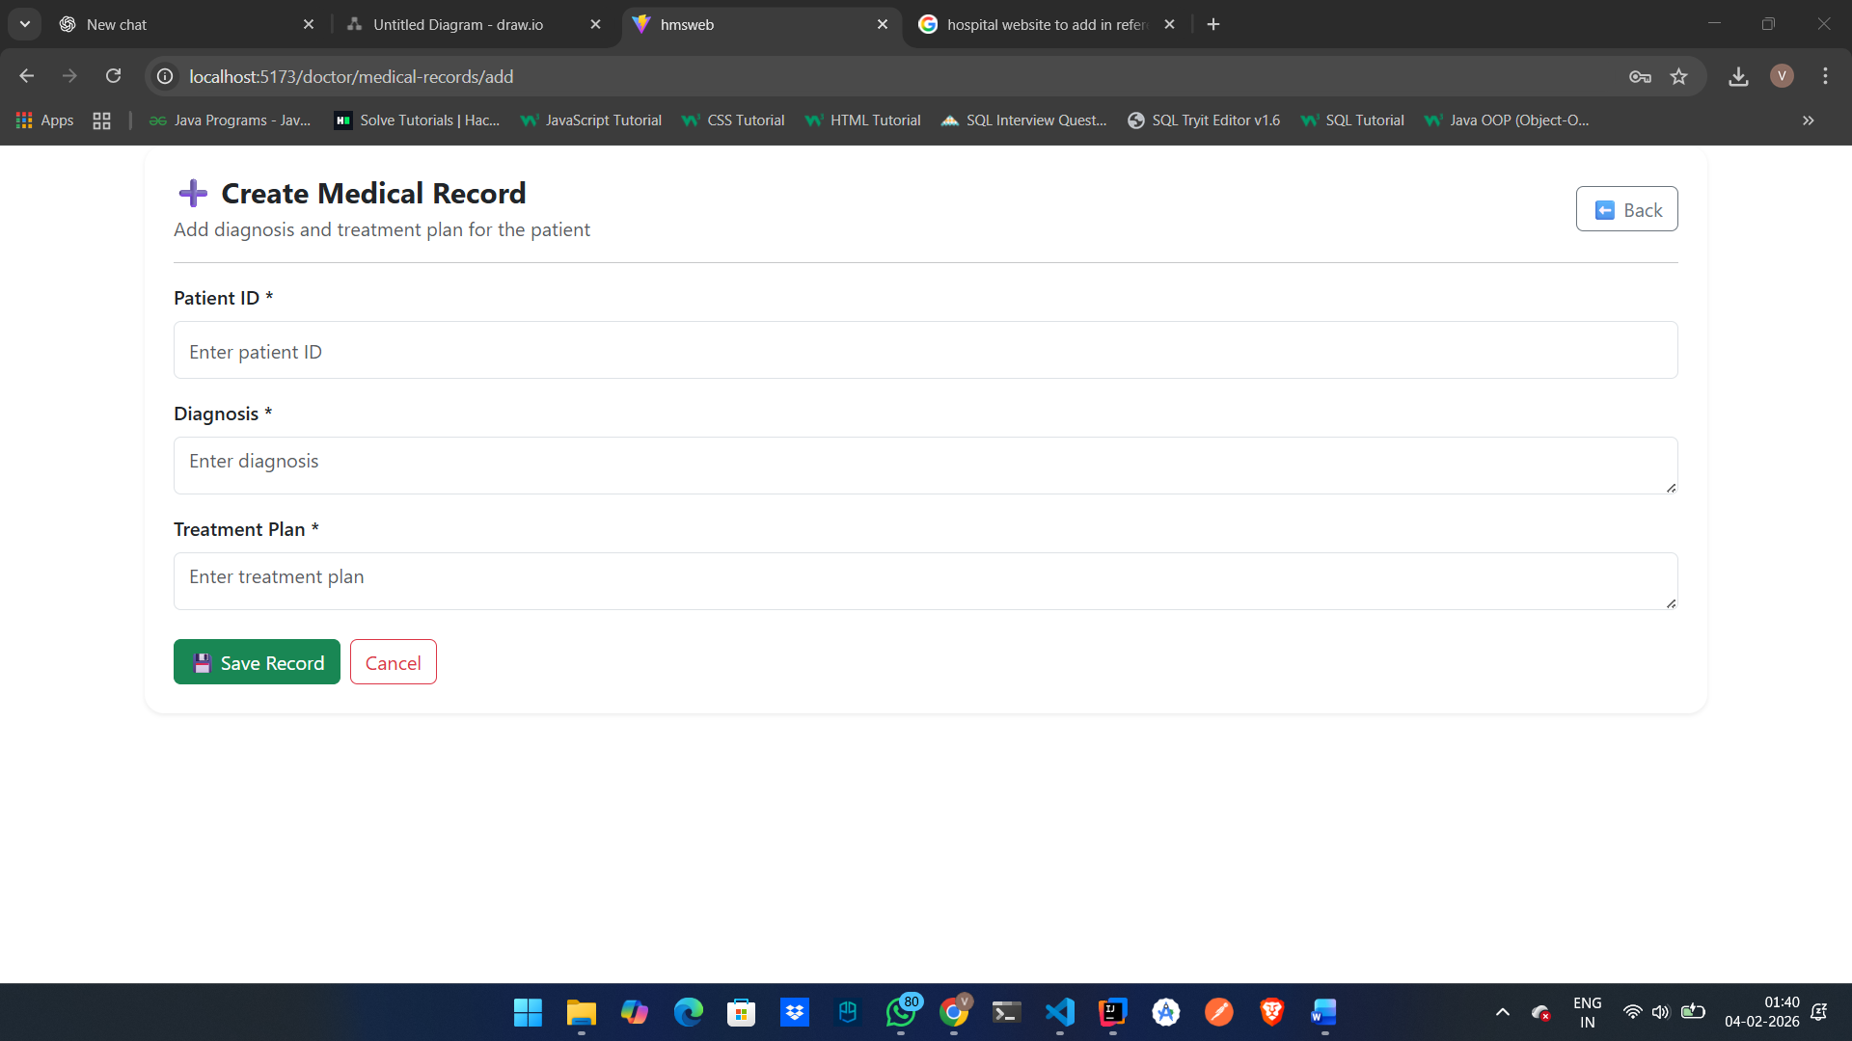

LabtestReports: 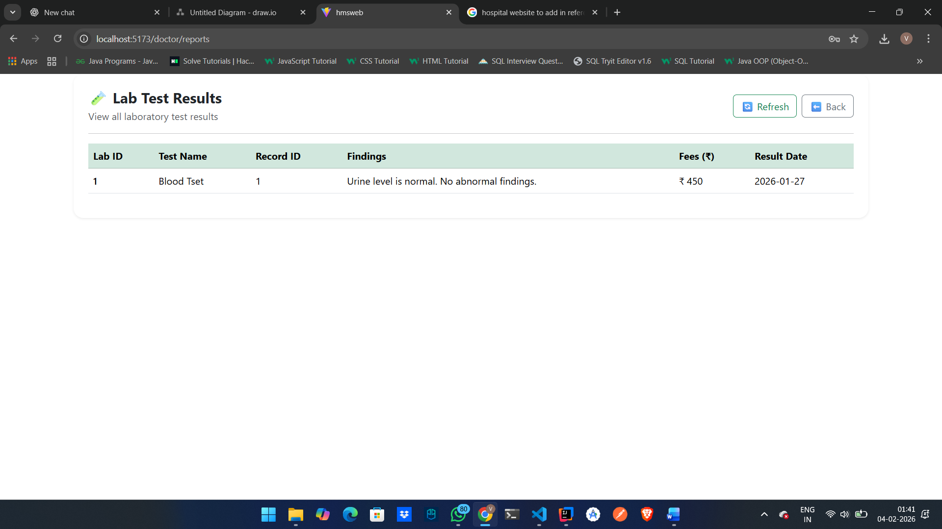

ManagerDashboard: 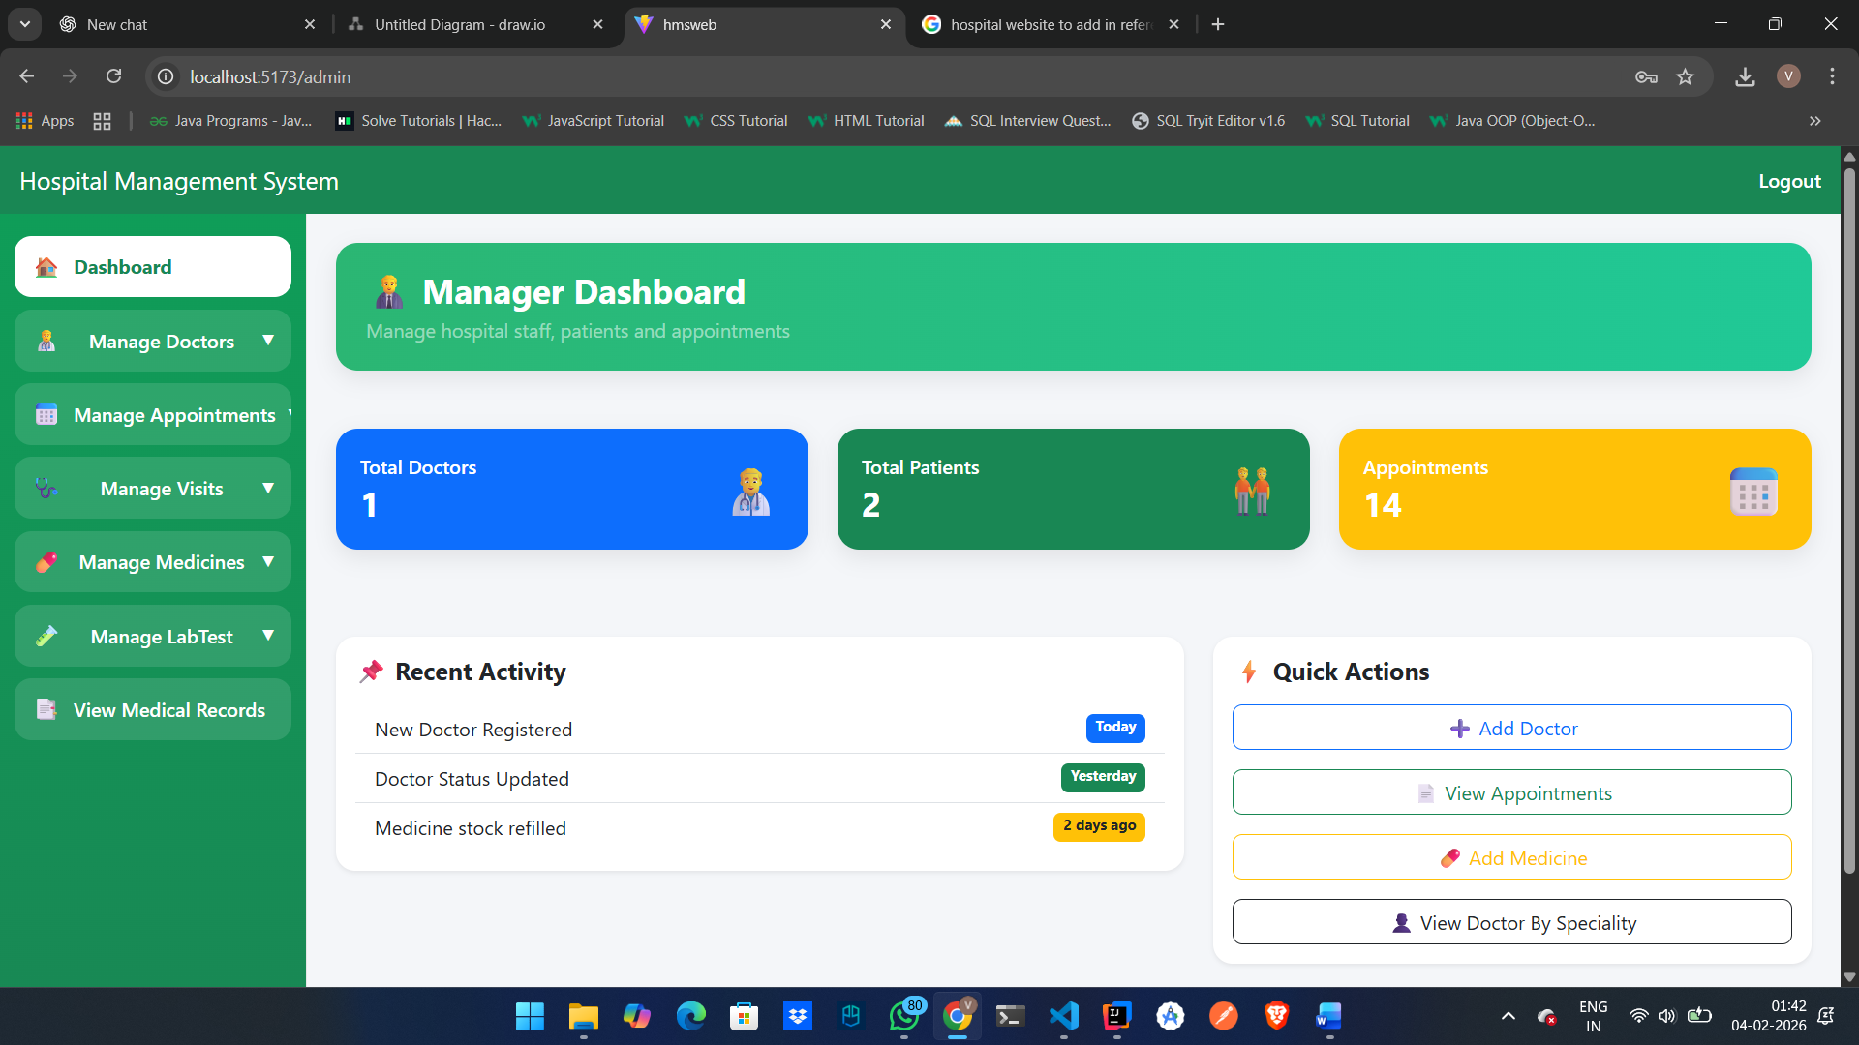

ManagerRegisterDoctor: 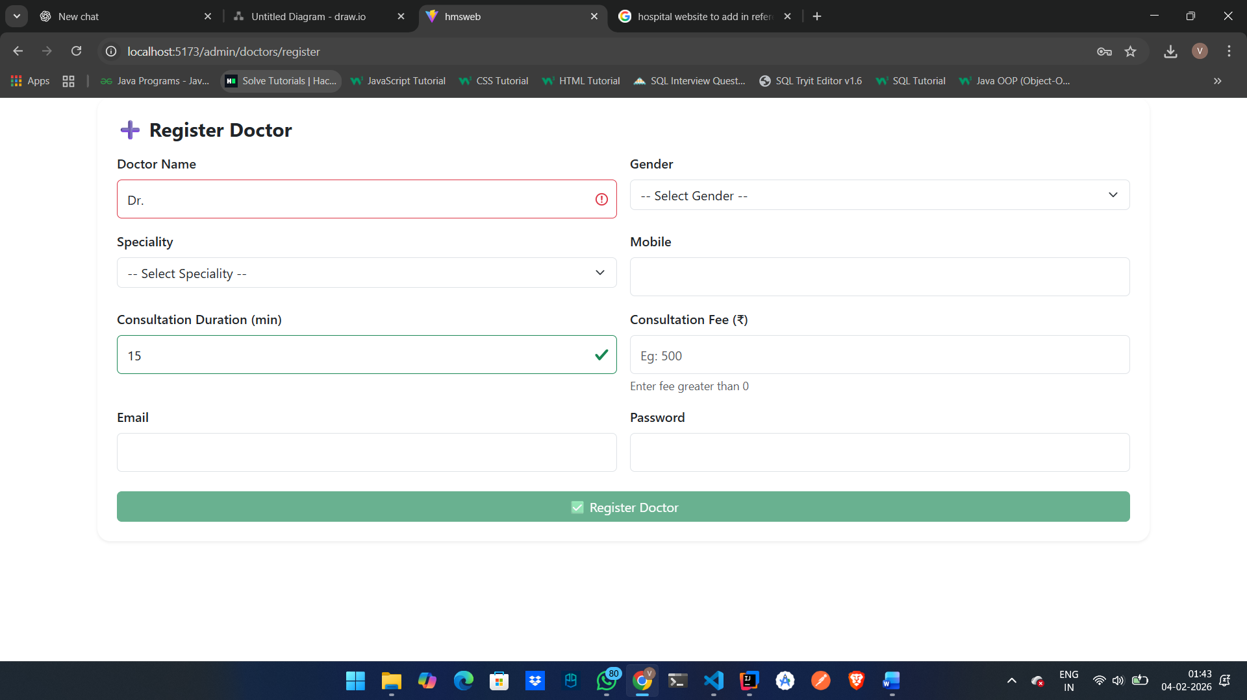

ManagerAddMedicine: 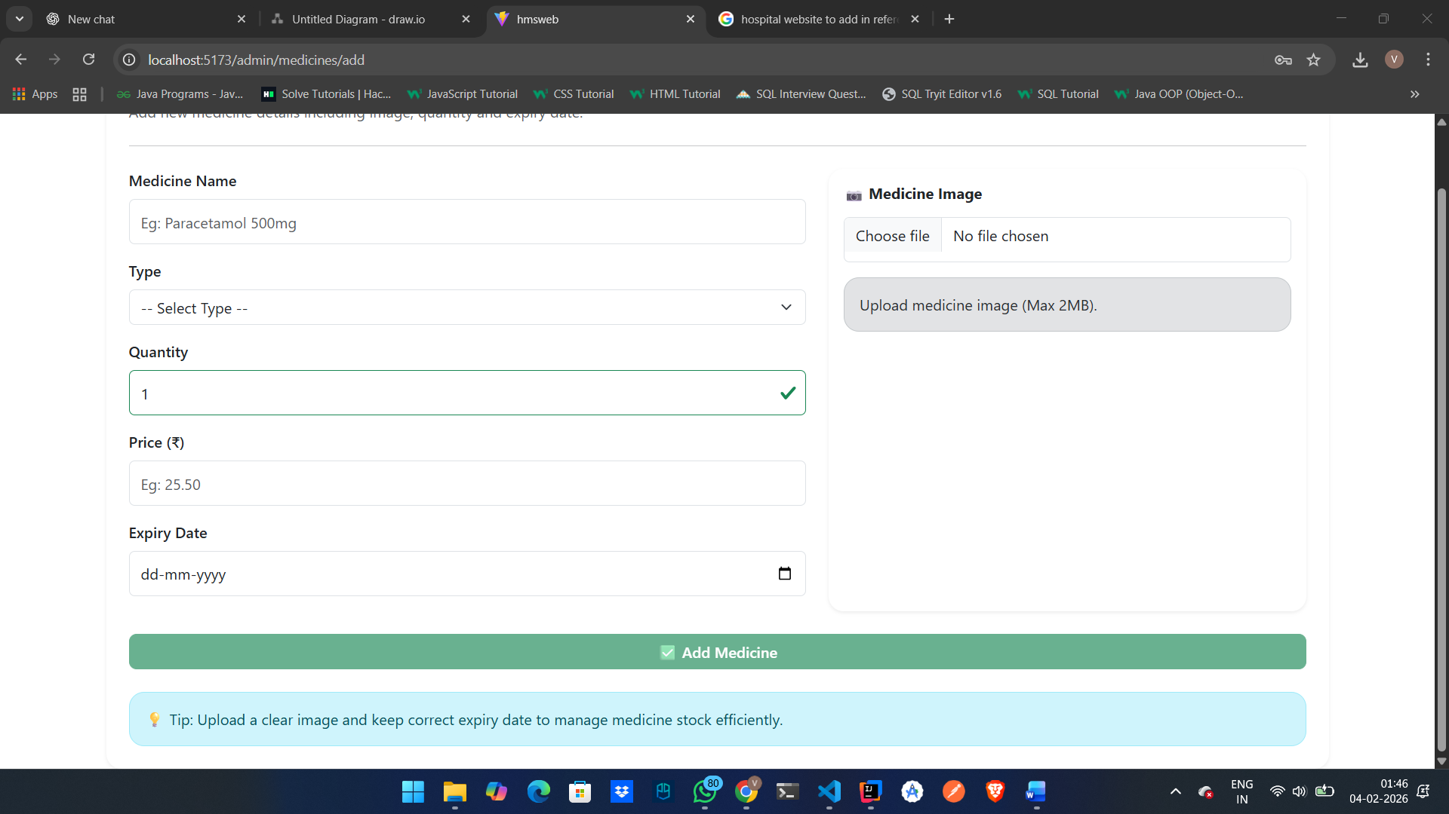

ManagerChangeDoctorStatus: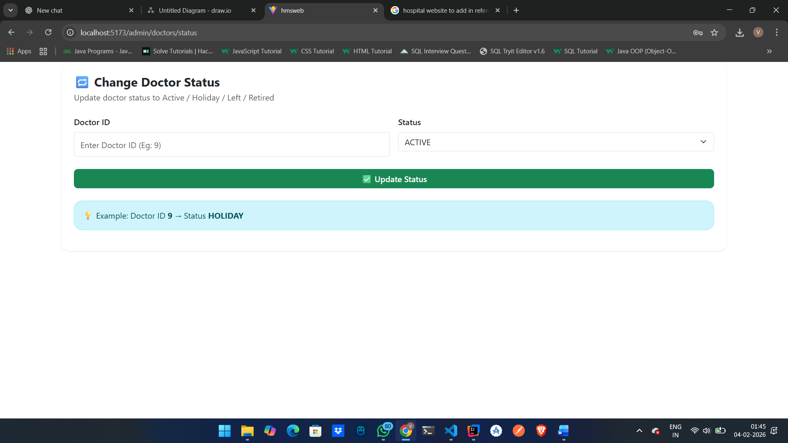

ManagerAddLabTest:
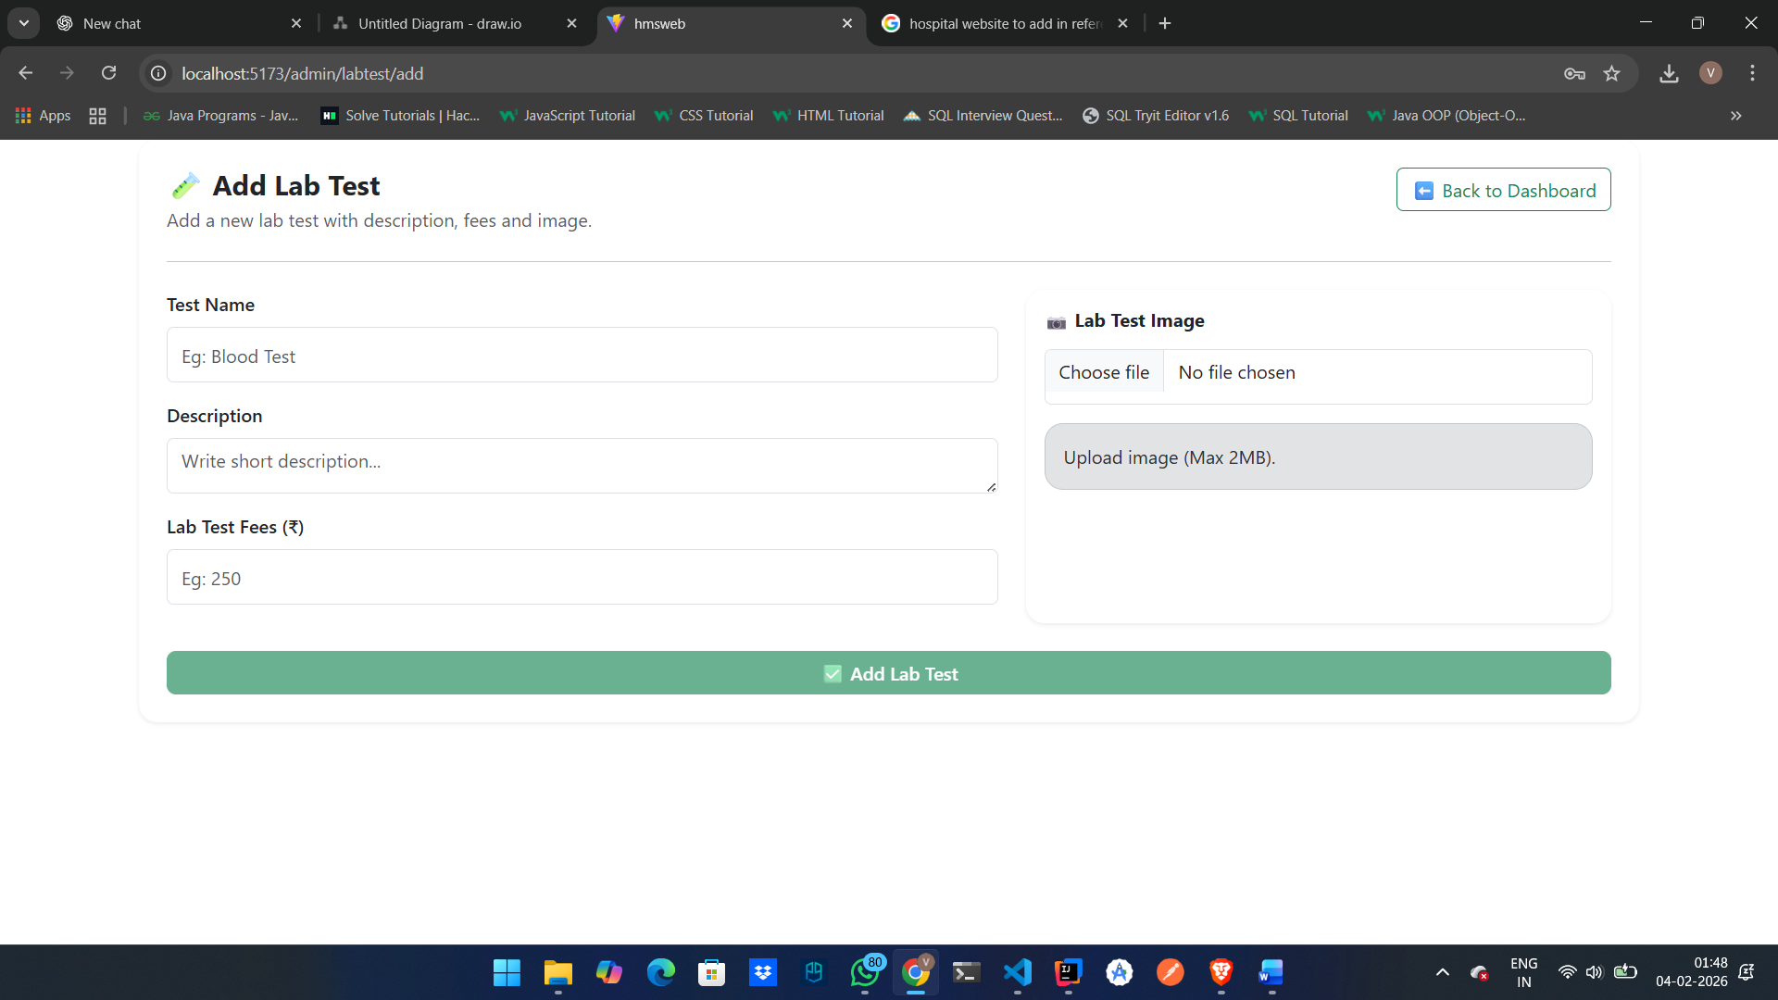

7.REFERENCES:

http://www.google.com

https://www.mayoclinic.org/

https://www.geeksforgeeks.org/hospital-management-system-project/

https://www.youtube.com/watch?v=DaKFw9Q5BoM&list=PLna7xkCxibbHsx80UgzgEeBnPlFrtRq96

http://www.w3.org

http://www.wikipedia.org



CERTIFICATE

This is to certify that the project work under the title ‘Web Portal for Student and teacher’ is done by Vedant Rane in partial fulfillment of the requirement for award of Diploma in Advanced Computing Course.

Miss.Manjusha Nikam |  |  |  | Mr.YogeshKolhe
Project Guide |  |  |  | Course Co-Coordinator

Date:04-02-26

