Develop a File Server
Secure Multi-User File Sharing System

Vedant Asutkar
Electronics Engineering | Batch 2027 | YCCE, Nagpur

GitHub: github.com/Vedant-Asutkar17/file-server

1. Problem Statement
Design and implement a cross-platform file server that allows authenticated users to securely upload, download, and manage files over a network. The system must support reliable multi-user access, handle concurrent connections without data corruption, and provide both a terminal and GUI client interface.

2. Objectives
- Build a multi-user TCP file server in C++ using POSIX sockets
- Handle simultaneous client connections using multithreading (std::thread)
- Implement secure user authentication with role-based access control
- Enable file transfer (upload/download) using chunked binary transmission
- Support file management operations: list, delete, rename
- Prevent data corruption using file locking with std::mutex
- Develop a cross-platform Qt5 GUI client for non-terminal users
- Host complete project with version control on GitHub

3. Technology Used
Technology | Purpose
C++ | Core programming language for server and client
POSIX Sockets (TCP) | Network communication between client and server
std::thread | Concurrent handling of multiple client connections
std::mutex | File locking to prevent race conditions
std::filesystem | File size, path resolution, directory operations
Qt5 Framework | Cross-platform GUI client application
Linux / WSL2 | Development and runtime environment
Git & GitHub | Version control and project hosting

4. System Architecture
The system follows a Client-Server architecture over TCP/IP. The server runs continuously on port 9999, accepting connections. Each client connection is handled in an independent thread. All threads share a common FileManager and AuthManager through thread-safe global objects.

Component | Files | Role
GUI Client | mainwindow.cpp, fileclient.cpp | Qt5 visual interface
Terminal Client | client.cpp | Command-line interface
File Server | server.cpp, auth.h | Core server logic + auth
File Manager | filemanager.h | Upload, download, delete, rename
Lock Manager | filelock.h | Mutex-based file locking
File Storage | server/uploads/ | Files stored on server disk

5. Project Structure
file-server/
├── server/
│ ├── server.cpp # Main server with thread handling
│ ├── auth.h # User authentication and AuthManager
│ ├── filemanager.h # File operations (upload, download, delete, rename)
│ └── filelock.h # File locking with mutex
├── client/
│ └── client.cpp # Terminal based client
├── gui/
│ ├── main.cpp # GUI entry point
│ ├── mainwindow.h/cpp # Main GUI window
│ ├── fileclient.h/cpp # Network client for GUI
│ └── gui.pro # Qt project file
└── README.md

6. Features Implemented
Feature | Status
Multi-user TCP server | Done
User authentication | Done
Role-based access | Done
File upload | Done
File download | Done
File listing | Done
File delete | Done
File rename | Done
File locking (mutex) | Done
Terminal client | Done
Qt5 GUI client | Done
GitHub version control | Done

7. How to Run
Requirements: Linux / WSL2, g++ (C++17), Qt5
Start the Server
cd server
g++ server.cpp -o server -pthread -lstdc++fs
./server
# Output: File Server Started - Listening on port 9999...

Run Terminal Client
cd client
g++ client.cpp -o client -lstdc++fs
./client
# Login: admin / admin123

Run GUI Client
cd gui
qmake gui.pro && make
./fileclient
# Host: localhost Port: 9999 User: admin Pass: admin123
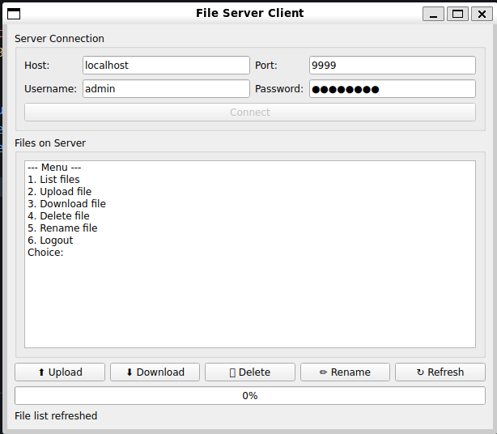

8. GitHub Repository
The complete source code, commit history, and README are available at:
https://github.com/Vedant-Asutkar17/file-server

9. Conclusion
This project successfully implements a fully functional multi-user file server in C++ demonstrating core computer science concepts including network programming, object-oriented design, and GUI development. The system reliably handles multiple simultaneous users, prevents data corruption through file locking, and provides both terminal and graphical client interfaces. The project deepened understanding of how real-world file sharing systems like FTP work at the operating system level.

