1. Design and draw UML class diagram to represent an airline reservation system. The system enables the customer to search for airline flight on a specified date and choose a flight based on some details like availability. The customer can reserve a flight or cancel his reservation. The system displays all the flight details such as flight number, name, price and duration of journey.

[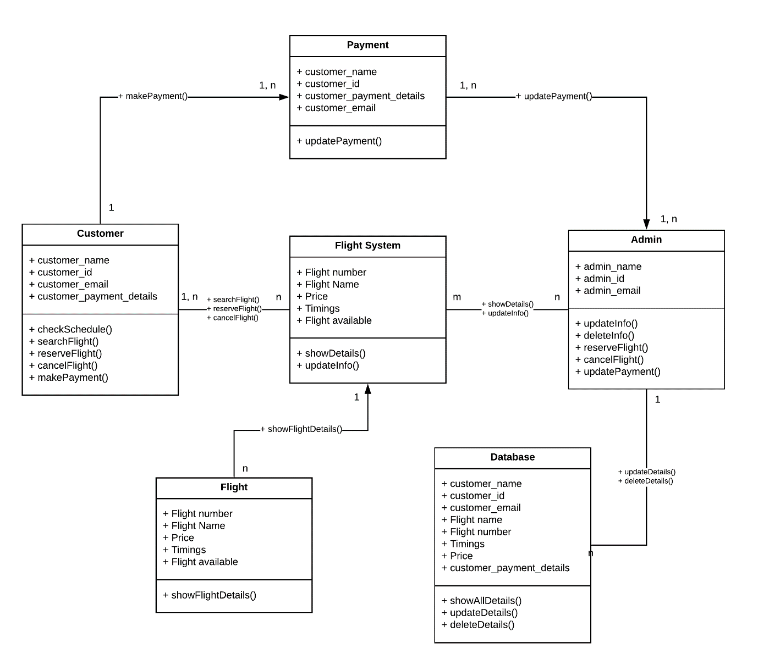](https://user-images.githubusercontent.com/66563130/148816149-5de9d663-5364-4f50-81bf-b9923fd1bb5f.png)

1. Design and draw UML class diagram with attributes, behaviour, and class relationships for the following scenario.

In a university there are various departments. A department has a name and is associated to classrooms and offices. An employee working at the university has a unique Id and can be a professor or an instructor. A professor can be a full professor, associate professor, or assistant professor and he/she belongs to a department in the university. Offices and classrooms also have unique IDs and classrooms have fixed number of seats. Also, every employee is assigned an office.

[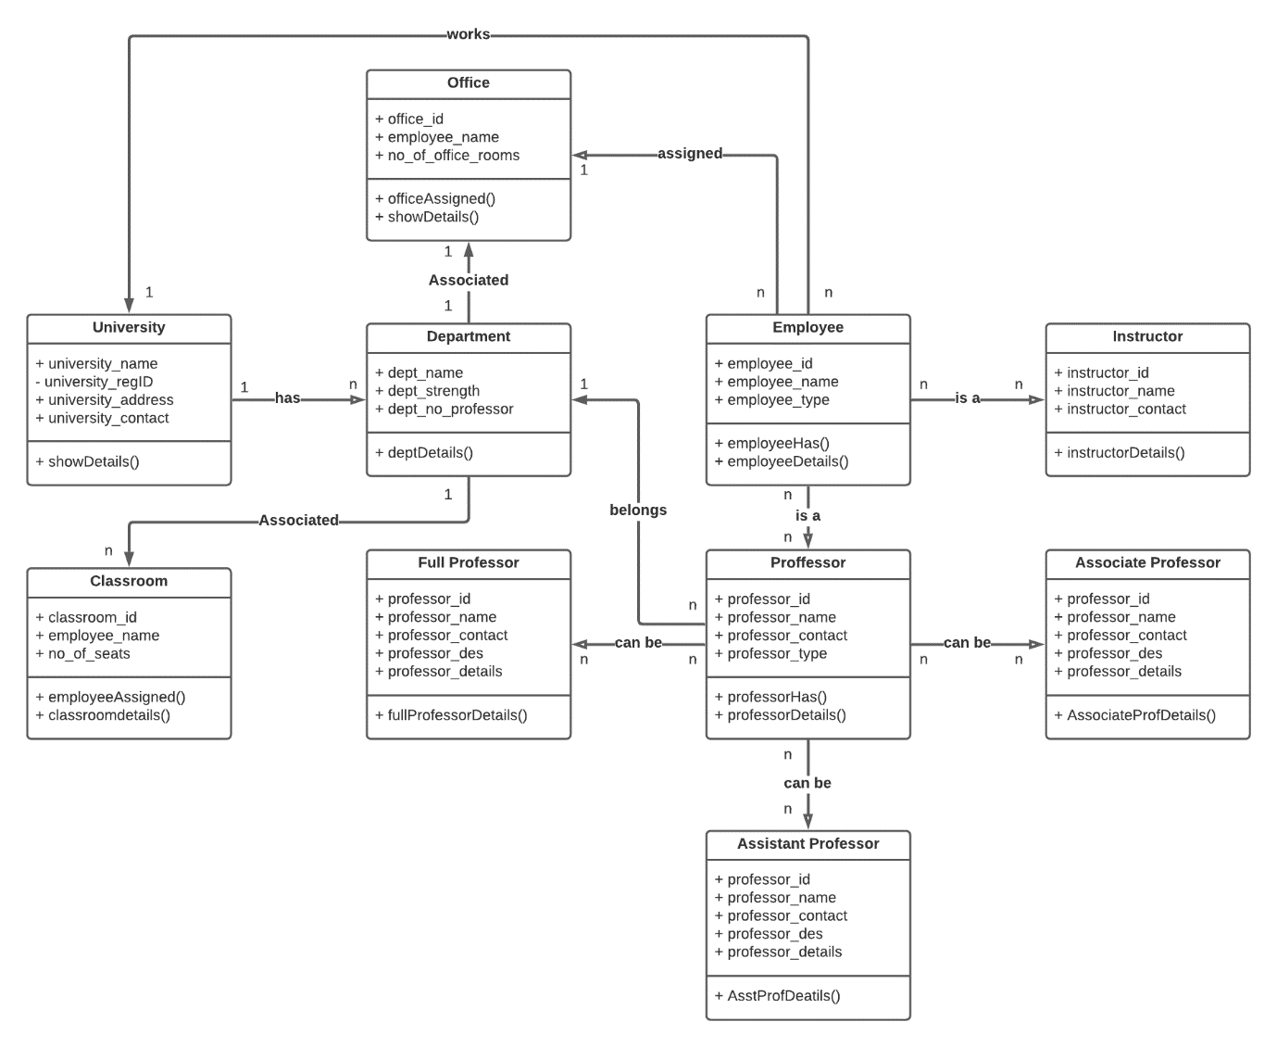](https://user-images.githubusercontent.com/66563130/148816386-32d3d566-9ea2-485c-b9af-85fb771fe6b5.png)

1. Draw an activity diagram for the given scenario where a student needs to enrol with the university for the given course. Process for student enrolment in the university is as follows:

* An applicant wants to enrol in the university. The applicant hands a filled-out copy of
* Enrolment Form. •The registrar inspects the forms.
* The registrar determines that the forms have been filled out properly.
* The registrar informs student to attend in university overview presentation.
* The registrar helps the student to enrol in seminars
* The registrar asks the student to pay for the initial tuition.

[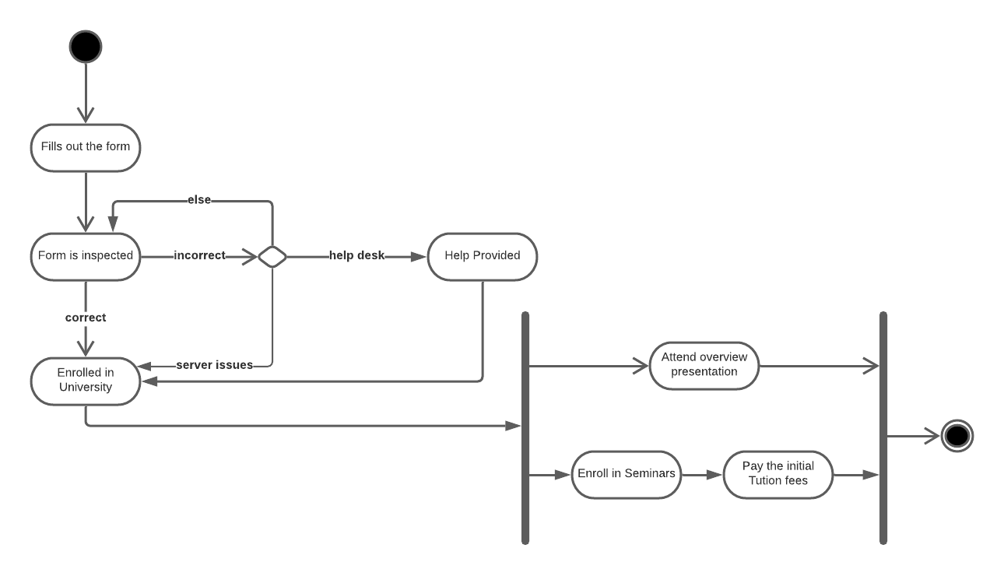](https://user-images.githubusercontent.com/66563130/148816672-8a99c0d6-30c4-4a22-a2ea-157c333fddd4.png)

1. A scenario of Online Library Management System is given below. You need to refer the use case diagram and moving further need to create a sequence diagram for the same.

* Here are the steps that occur in the given use case named 'Create New Library User Account'.
* The librarian requests the system to create a new online library account
* The librarian then selects the library user account type
* The librarian enters the user's details • The user's details are checked using the user Credentials Database
* The new library user account is created
* A summary of the new account's details is then emailed to the user.

[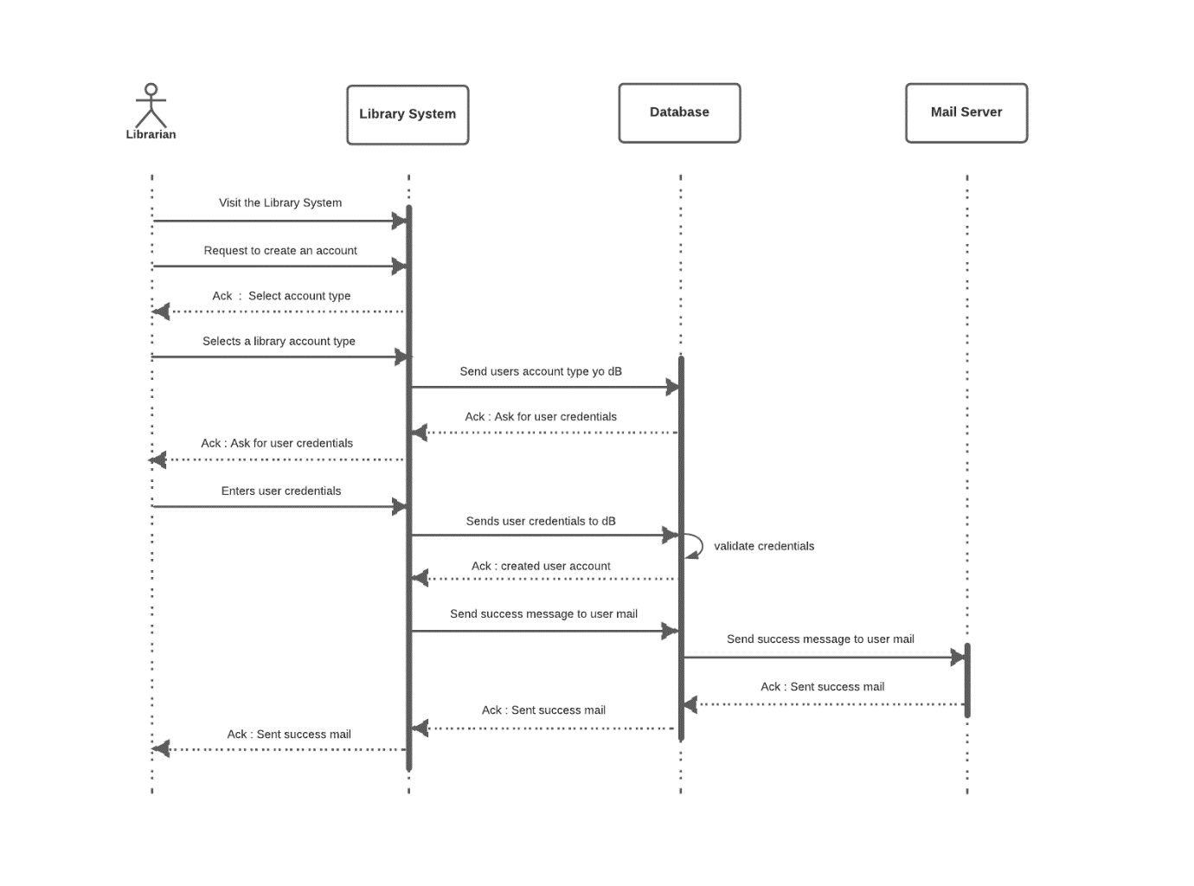](https://user-images.githubusercontent.com/66563130/148820038-8f8c62f7-c7e8-45f2-aef2-be1345b8e73d.png)