Academic Year: | 2026-27 | Name of Student: | Vedant Phase
Semester: | V | Student ID: | 24106014
Class / Branch: | SE – CSE (AI&ML) | Roll No: | 150
Subject: | Web & Mobile Application Development Lab | Date of Submission:

Experiment 04

Lab Outcome: Develop responsive front-end applications using React components and state management.

Aim: Implement state management using Hooks and Context API; add form handling and validation.
Program:

Output:
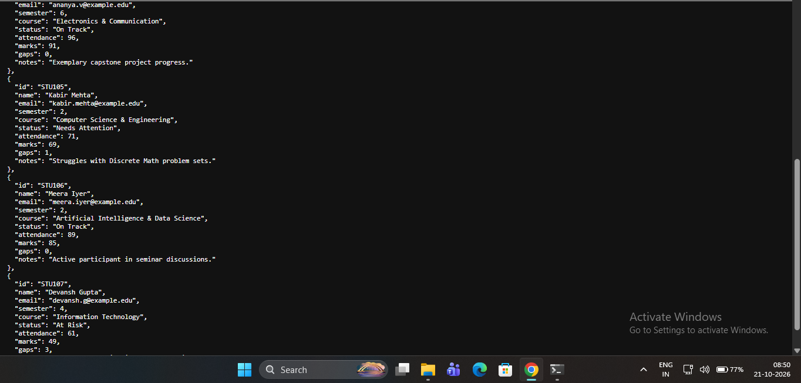
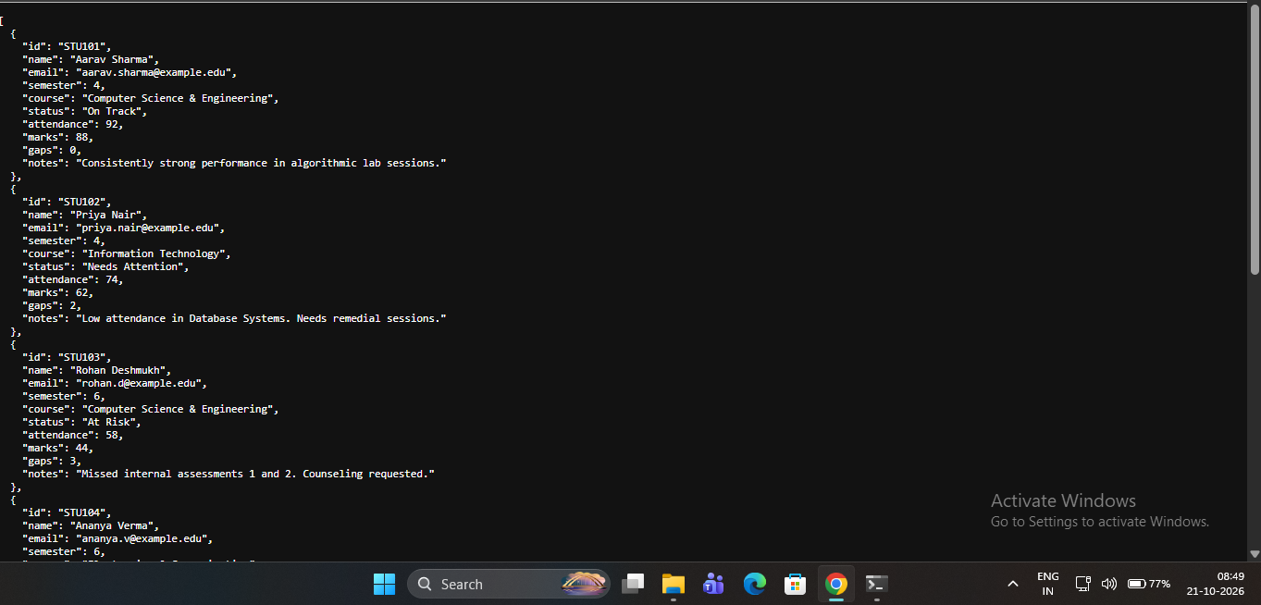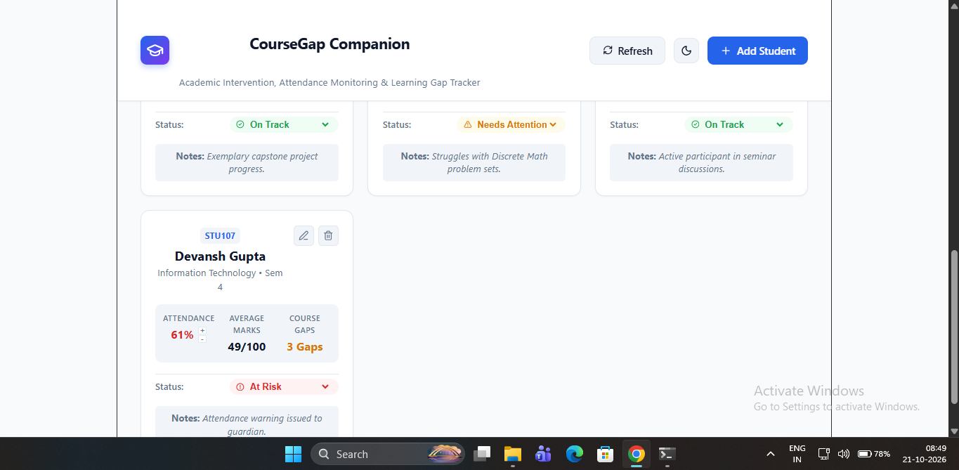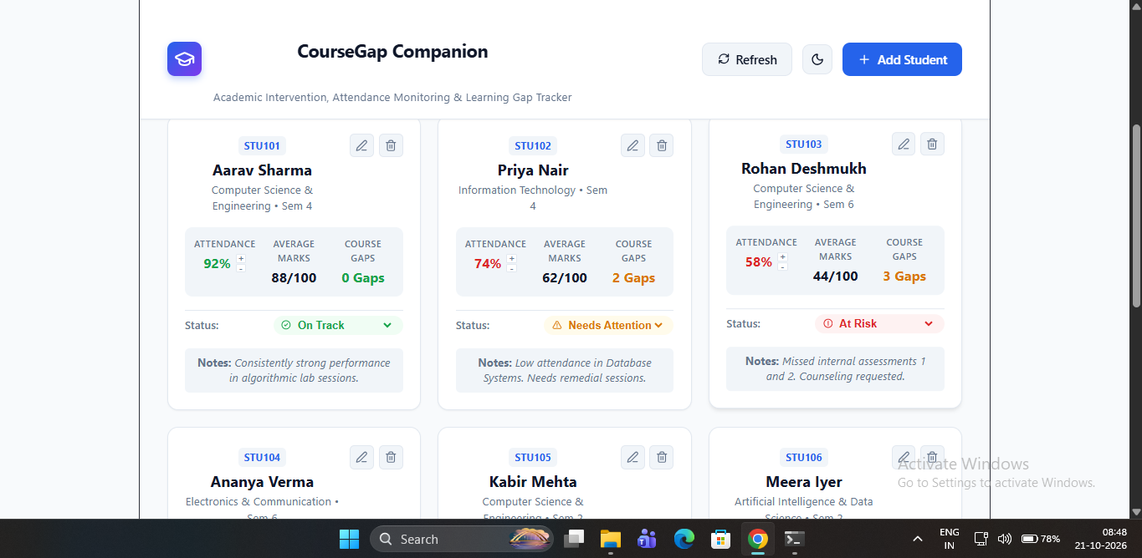
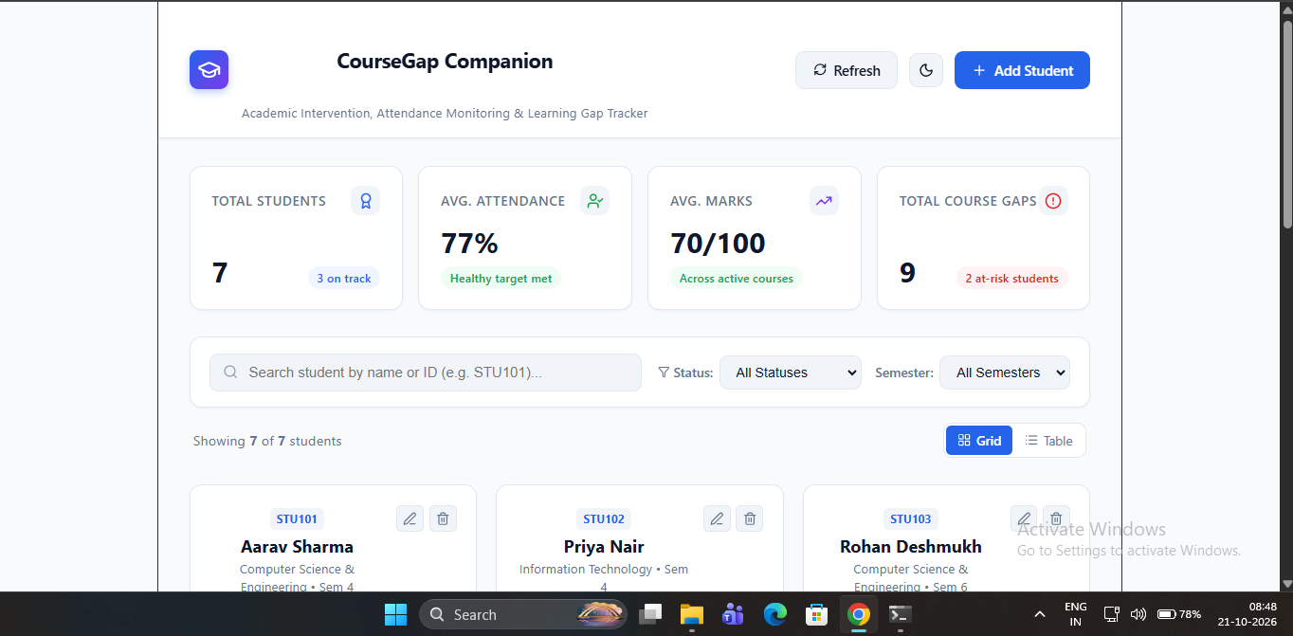
Conclusion:
Thus, we have designed and implemented state management using Hooks and Context API; added form handling and validation.

