**Assignment No-4**

**GR NO 21920020**

**Problem statement :-**

Write function template and class template selection sort . Write a program that inputs , sorts and outputs an integer array and a float array.

**Aim:-**

to understand concept of template function.

**Description:-**

in this problem statement state that how to use template function and how to enter the multiple type of input in one program without define data type.

**OOP concept:-**

**Template function:-**

Template function is used to accept multiple data type of input in one program without defining data type.

**Syntax-**

***template <class variable_name>***

**Program code:-**

#include<iostream>

#include<limits>

using namespace std;

template <class T>

T selection()

{

T arr[100];

T temp;

int n,j;

cout<<"Enter the how many number you want entered::";

cin>>n;

cout<<"Enter the element in array::";

for(int i=0;i<n;i++)

{

cin>>arr[i];

}

for(int i=0;i<n;i++)

{

int midindex=i;

for(j=i+1;j<n;j++)

{

if(arr[j]<arr[midindex])

midindex=j;

}

temp=arr[i];

arr[i]=arr[midindex];

arr[midindex]=temp;

}

for (int i=0;i<n;i++)

{

cout<<arr[i]<<endl;

}

}

int main()

{

cout<<"Integer sorting::"<<endl;

selection<int>();

cout<<"Float sort::"<<endl;

selection<float>();

return 0;

}

**Output:-**

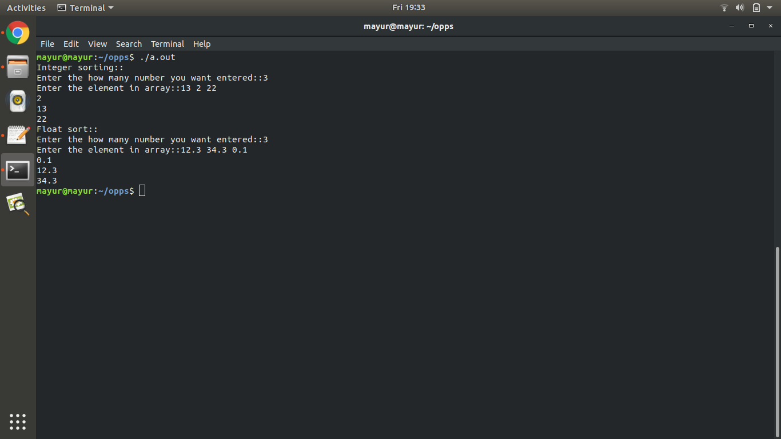

**Conclusion:**

**Thus we have successfully created student database and performed operations on it.**