Assignment 1: Section- Theory GR NO 21920020

Lab Assignment 1 : Develop an object oriented program in C++ to create a database of student information system containing the following information: Name, Roll number, Class, division, Date of Birth, Blood group, Contact address, telephone number, driving license no. etc Construct the database with suitable member functions viz, static member functions, friend class/ friend function, this pointer, inline code and dynamic memory allocation operators-new and delete. Implement all the keywords as mentioned in the problem statement.

Aim: To implement Oop concepts to create student Database.

Description:
Student database created to store records of each student. Provided 3 choices of operations that are add records, delete records and display records in database. All the basic oop concepts are used effectively.

Oop Concepts Used:

1) Static member functions:
A static member function is a special member function, which is used to access only static data members, any other normal data member cannot be accessed through static member function. Just like static data member, static member function is also a class function; it is not associated with any class object.

2) Friend function:
In object-oriented programming, a friend function, that is a "friend" of a given class, is a function that is given the same access as methods to private and protected data. A friend function is declared by the class that is granting access, so friend functions are part of the class interface, like methods.

3) this pointer:
The this pointer is a pointer accessible only within the nonstatic member functions of a class, struct, or union type. It points to the object for which the member function is called.

4) Inline code:
Source code that is written into the body of a program. It may refer to code written in the same language or another. For example, assembly language instructions can be embedded within a C program and would be considered inline code.

5) Dynamic memory allocation:

a) new Operator:
The new operator denotes a request for memory allocation on the Heap. If sufficient memory is available, new operator initializes the memory and returns the address of the newly allocated and initialized memory to the pointer variable.

b) delete Operator:
Since it is programmer’s responsibility to deallocate dynamically allocated memory, programmers are provided delete operator by C++ language.

Output:

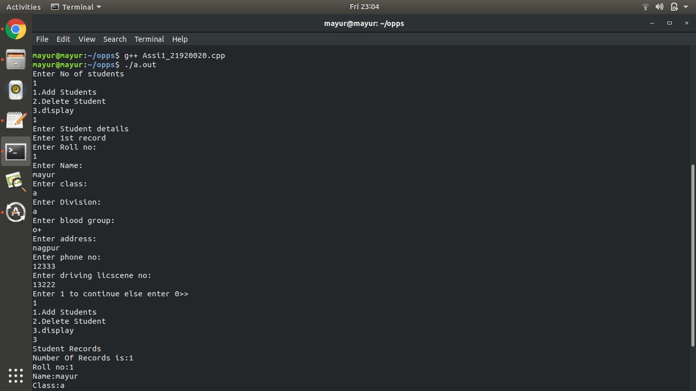

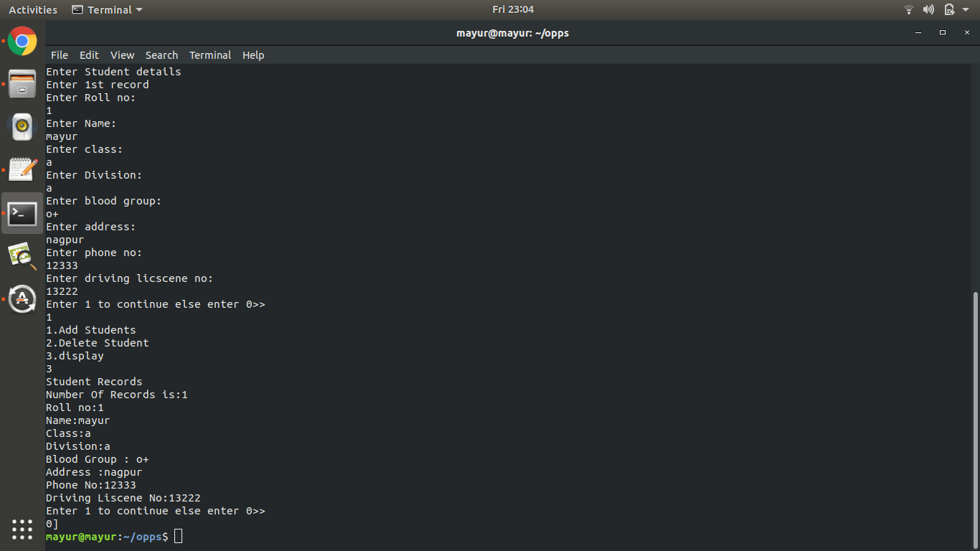

Conclusion:
Thus we have successfully created student database and performed operations on it.

