-- Platform that contributes most to the Quick Commerce Revenue
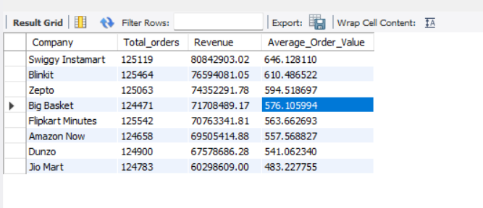

-- Payment Type and their contribution to the revenue
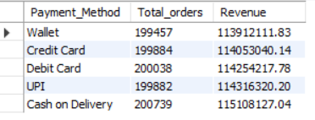

-- effect of discounts
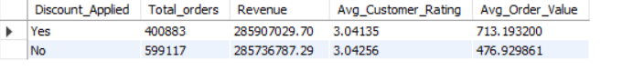

-- product category wise contribution
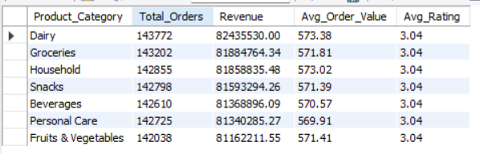

-- city wise performance
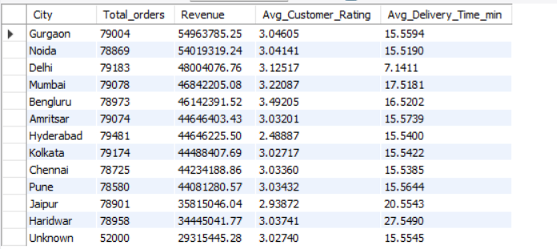

--customer segment
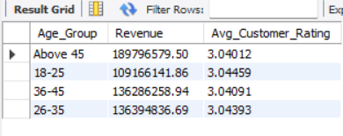

-- top company for every payment method with highest orders and its share
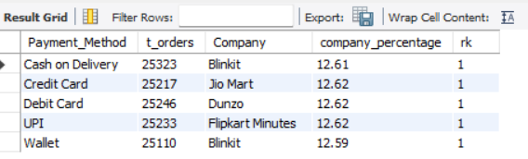

-- most used payment method and company by their usage percent by product category
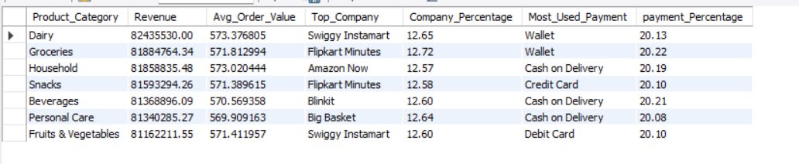

-- top company for every product category with highest orders and its share
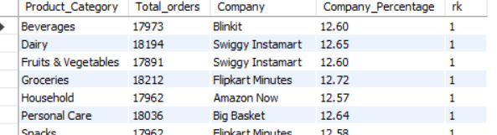

-- company that dominates city by revenue
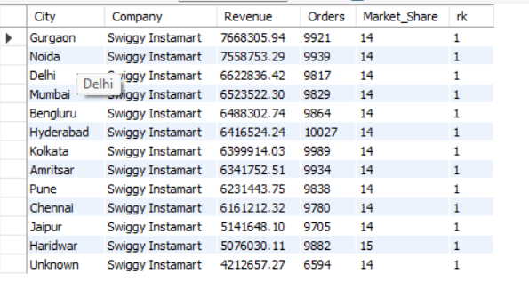

-- city scores based on overall revenue , customer ratings and delivery time taken
