**DATA WAREHOUSING AND BUSINESS INTELLIGENCE**

**ASSIGNMENT-5**

**Name: Vedant Desai**

**NUID: - 001830150**

1. Below is the overall data flow in debugging mode for both county and zip.

And it is running successfully

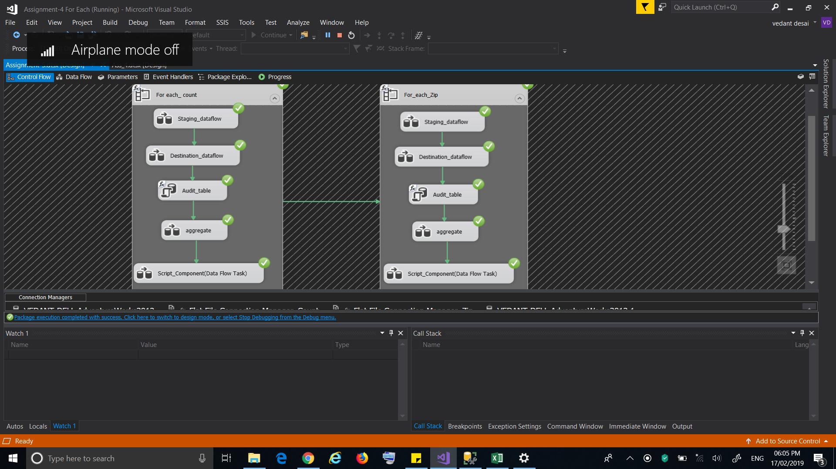

1. In the staging data flow, we will load all the other opioid sheets with all tabs and loading into staging table.

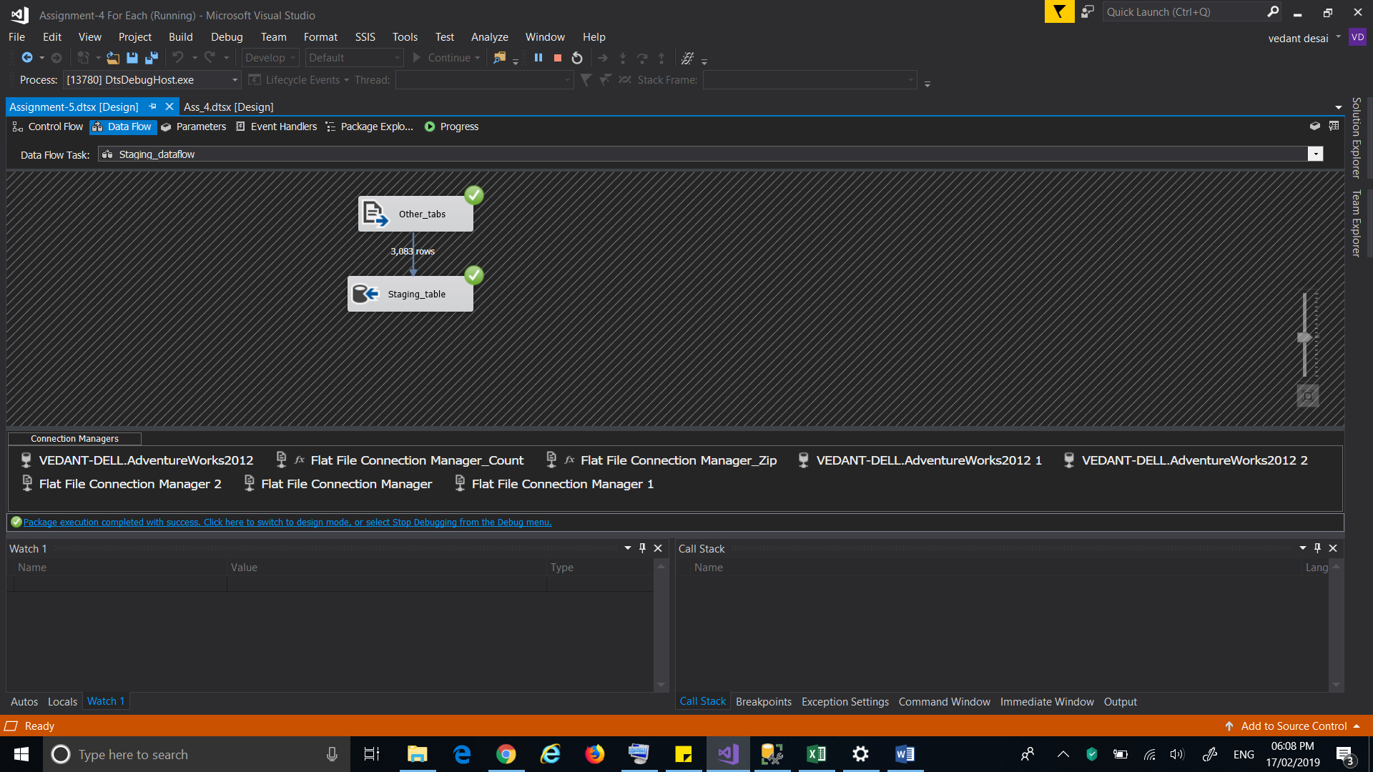

1. In the destination data flow, we will take a staging table as a source and we will add “YEAR”

and “Date” in the destination table using derived column. After that we will take a row count to count the total rows and conditional split to split the rows with national and without national rows into two separate tables.

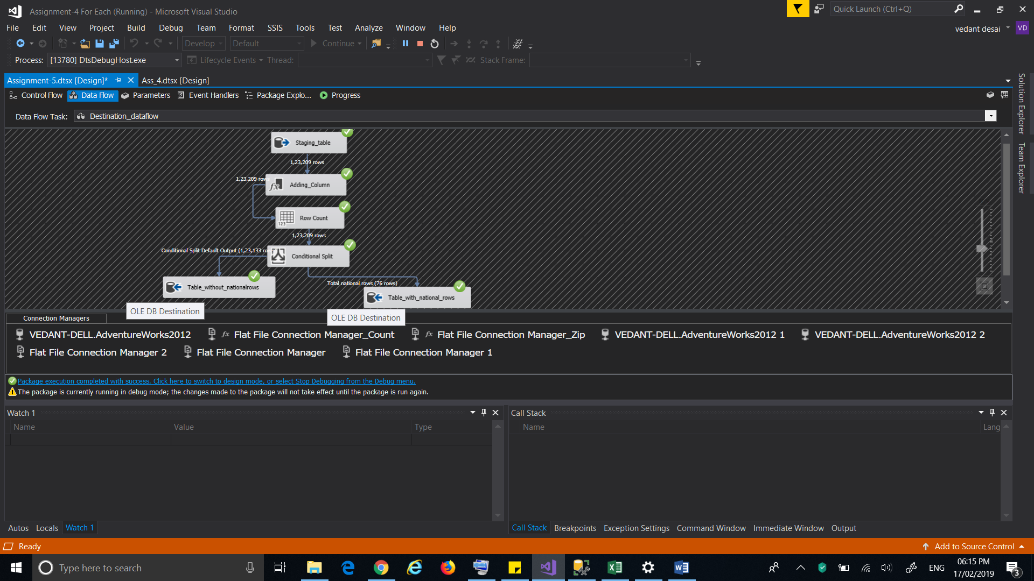

1. We will create an audit table to count the total rows and files loaded into table.

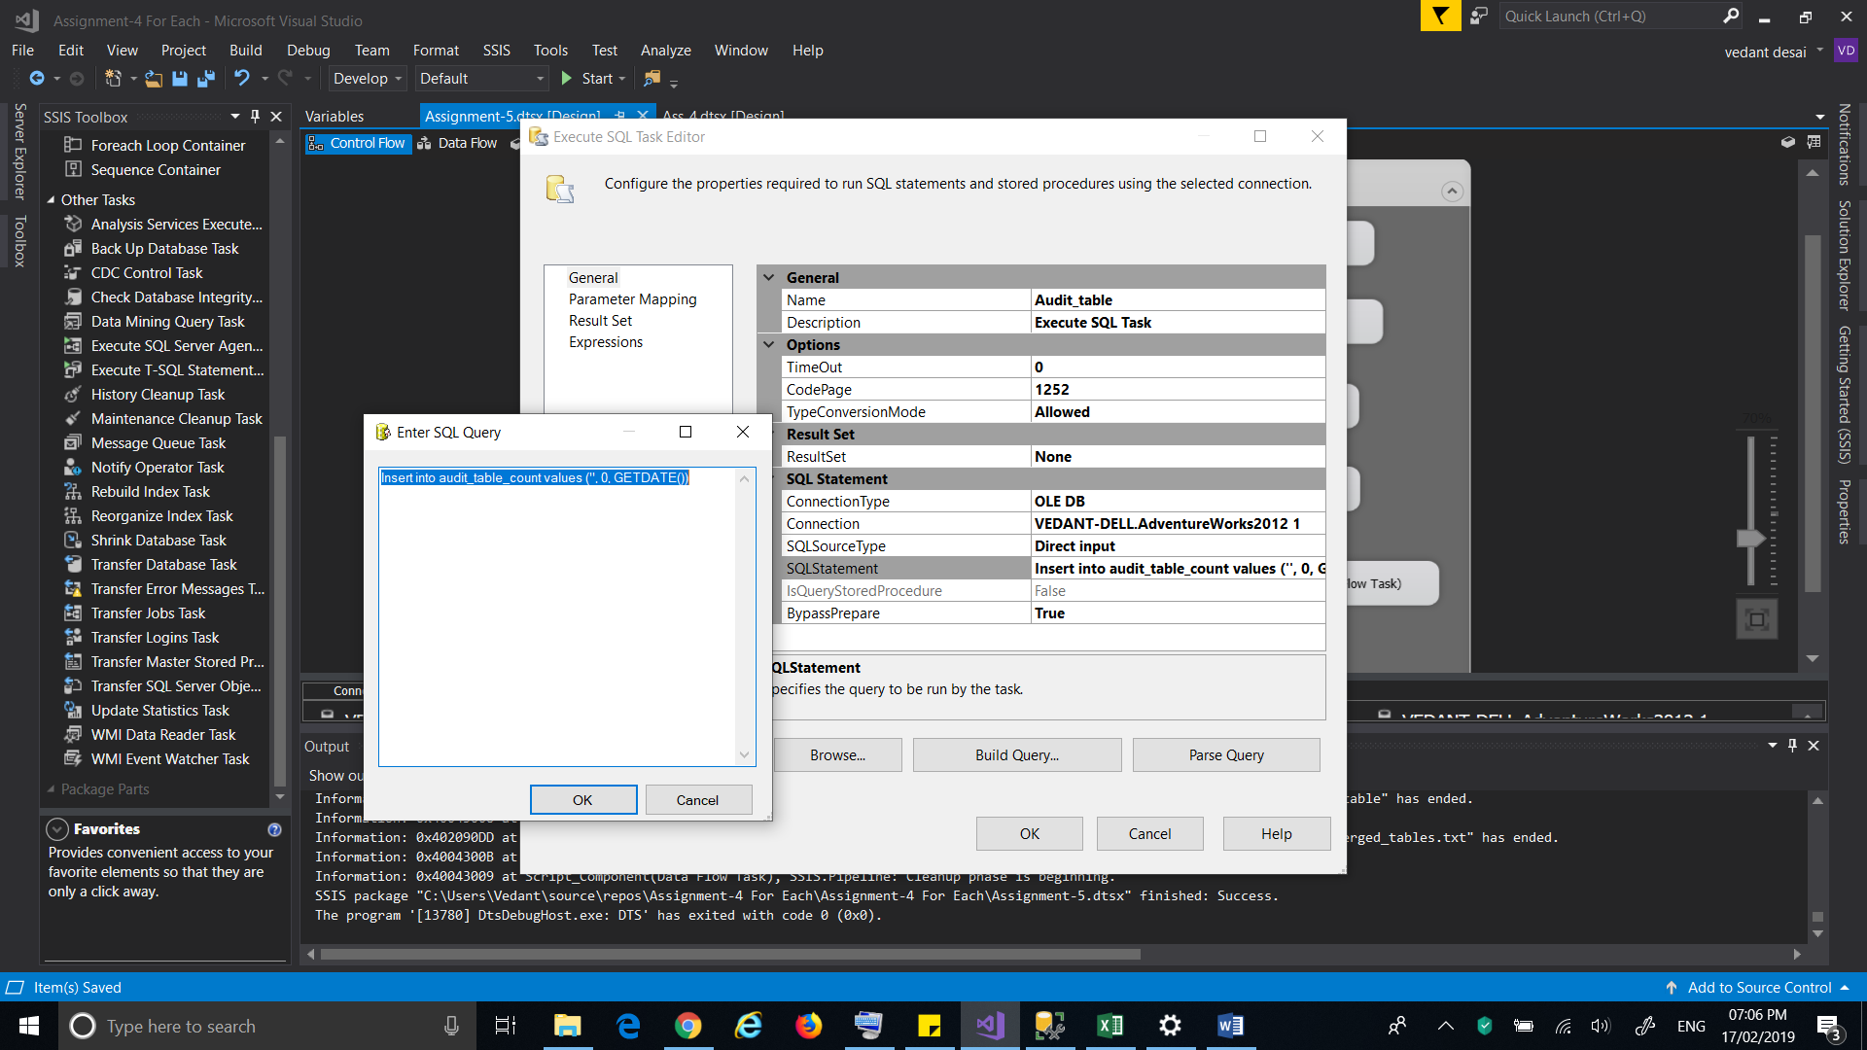

1. After Audit, we will do aggregate of the destination table after converting it into float and doing sum of all columns and storing it into validation table.

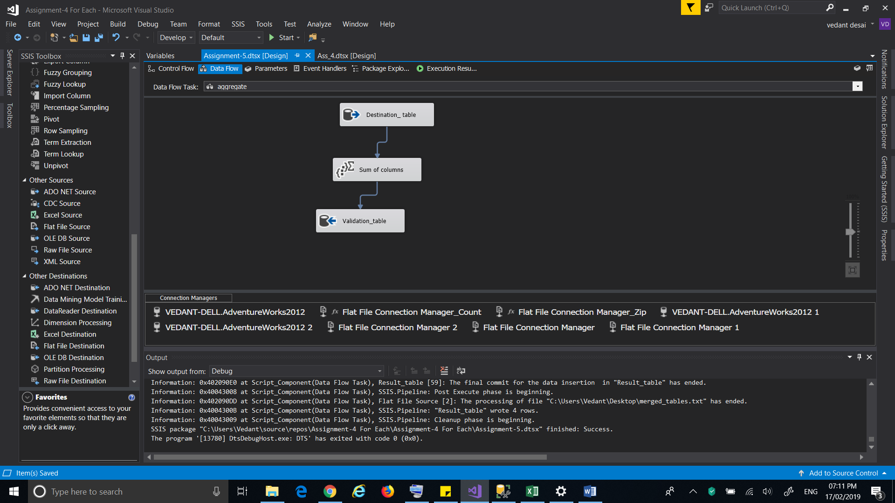

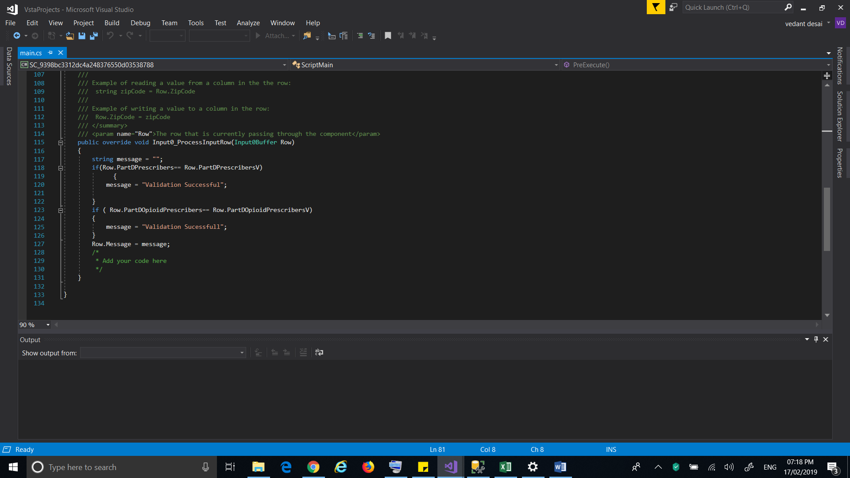

1. Going further, we will validate national rows with sum of destination column using script component and will do some scripting using C# for validation.

7) Using a Script Component task and using a C# for validation Purpose.

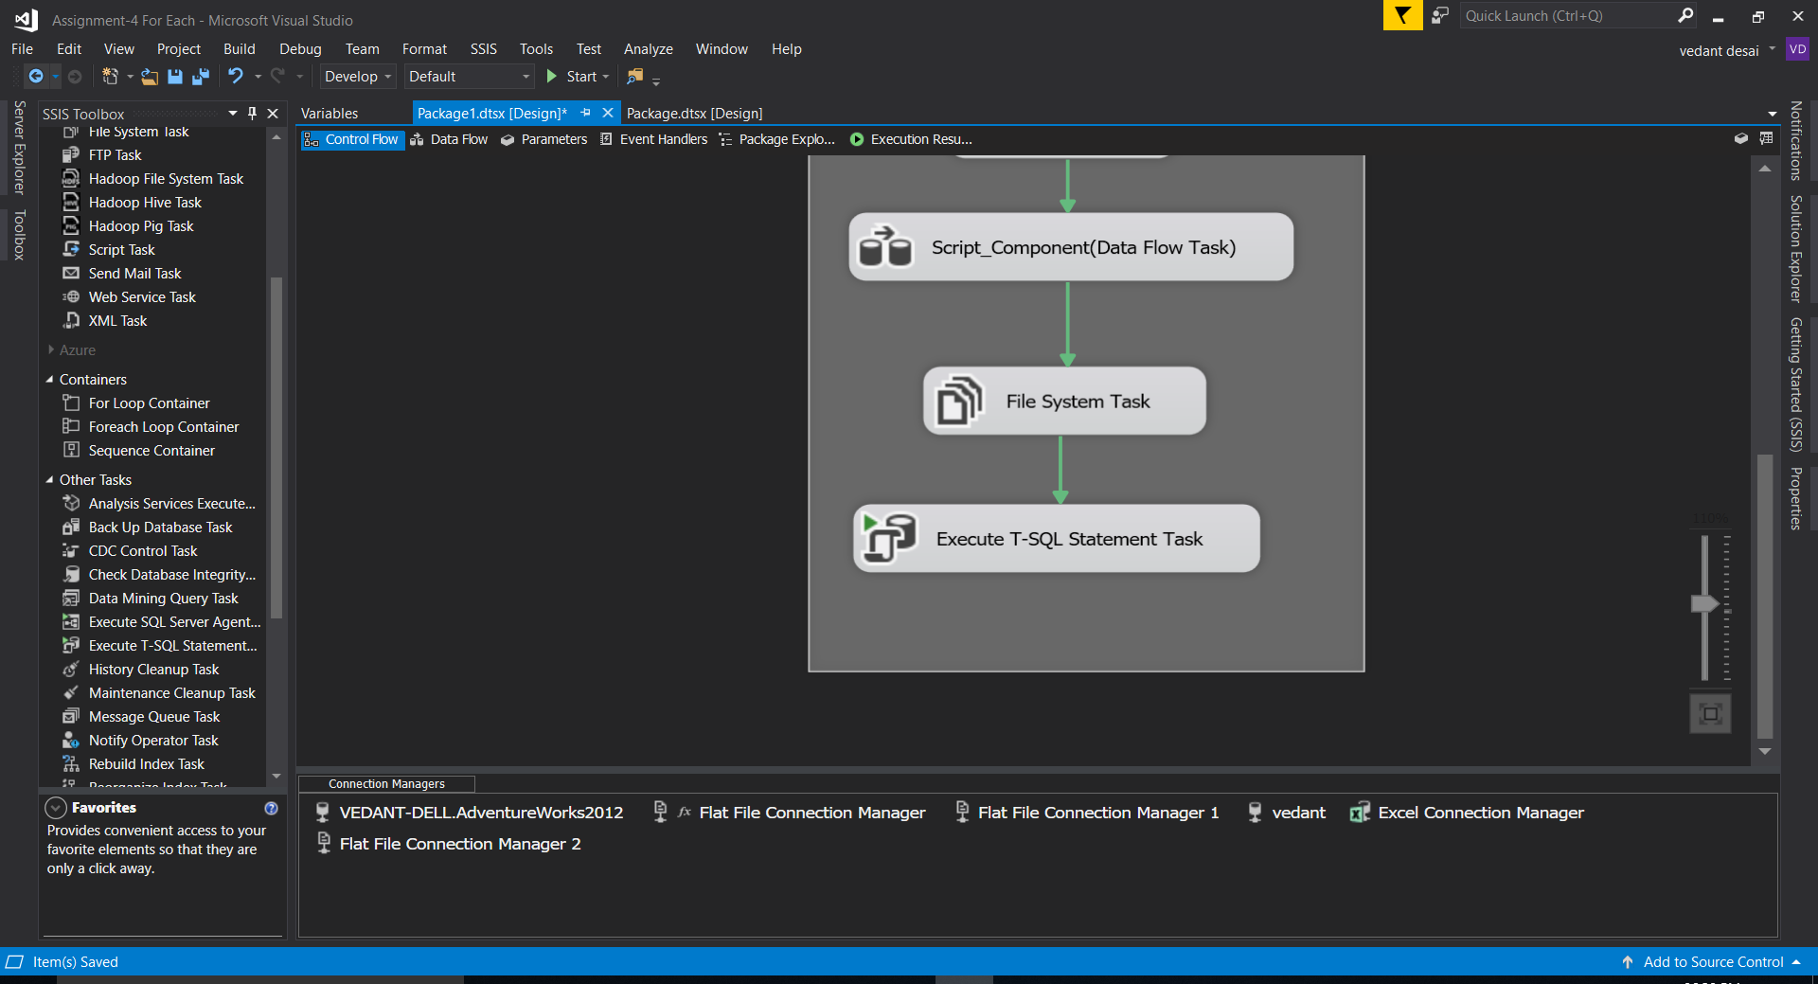

1. Creating a public class and a variable “Message” which will print a status of validation.

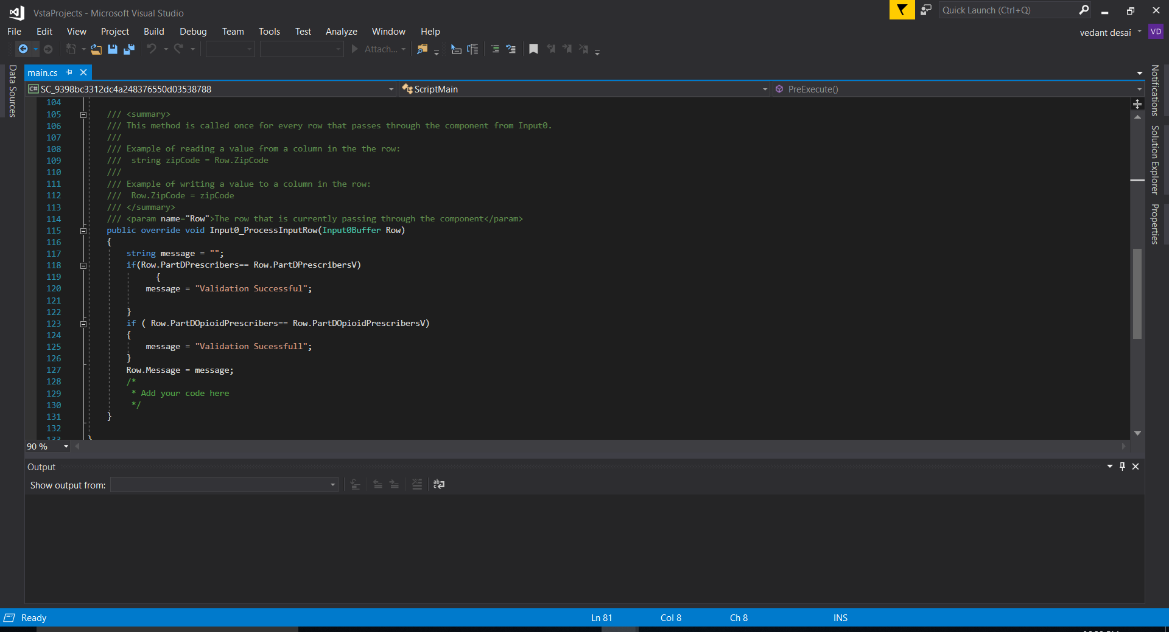

1. I merged 2 tables, destination table and table with national rows. Now using script component, result table will store the result of validation.

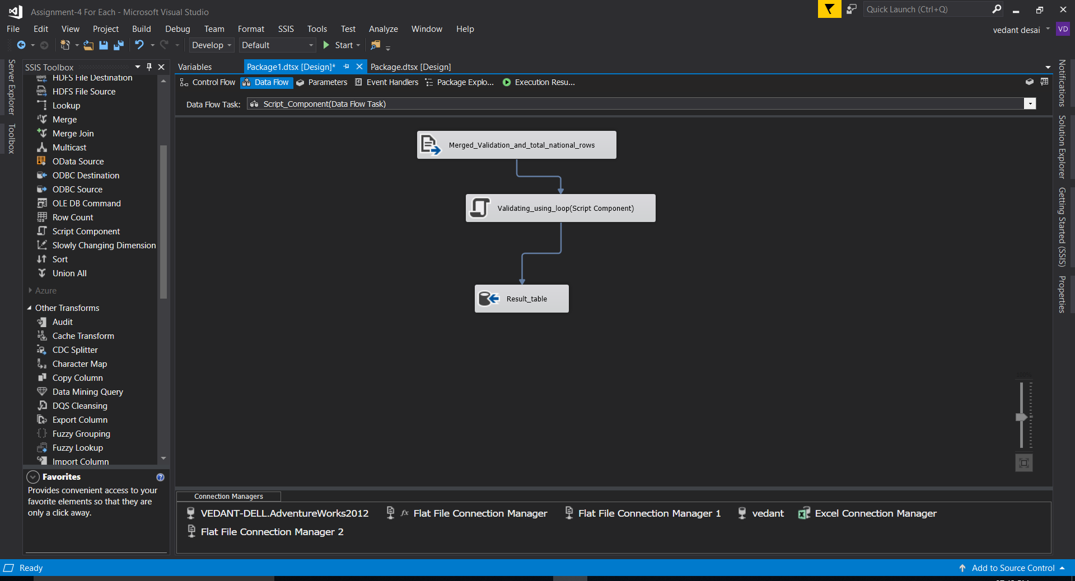

1. Now it will compare the columns of both the tables and generate the result as “Validaton Successful” or not.

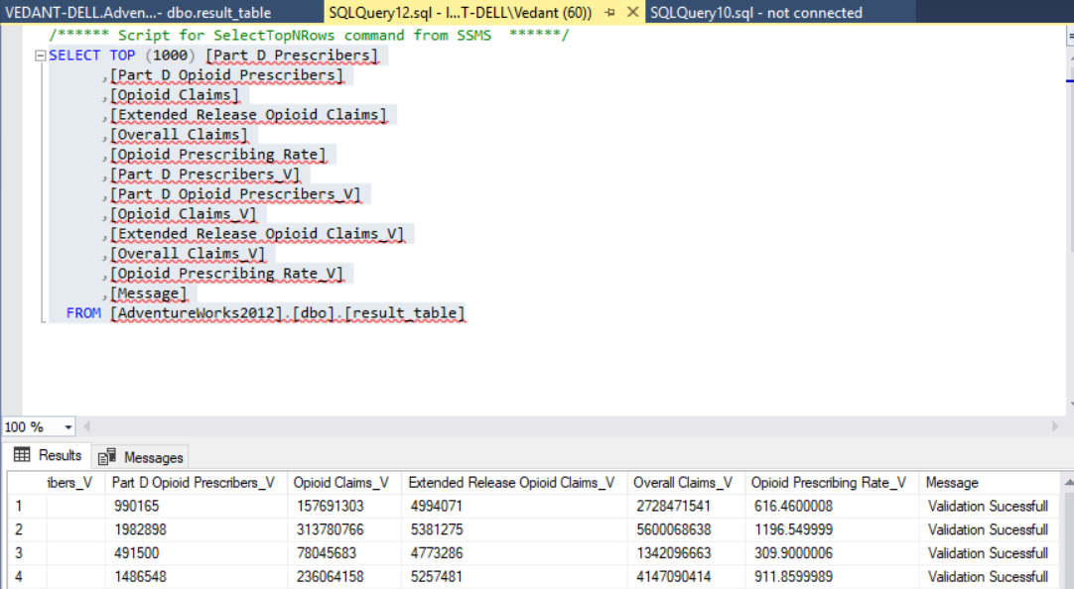

1. Now for archiving we will use file system task.



1. I have created an archive area which will take all the files from input folder.

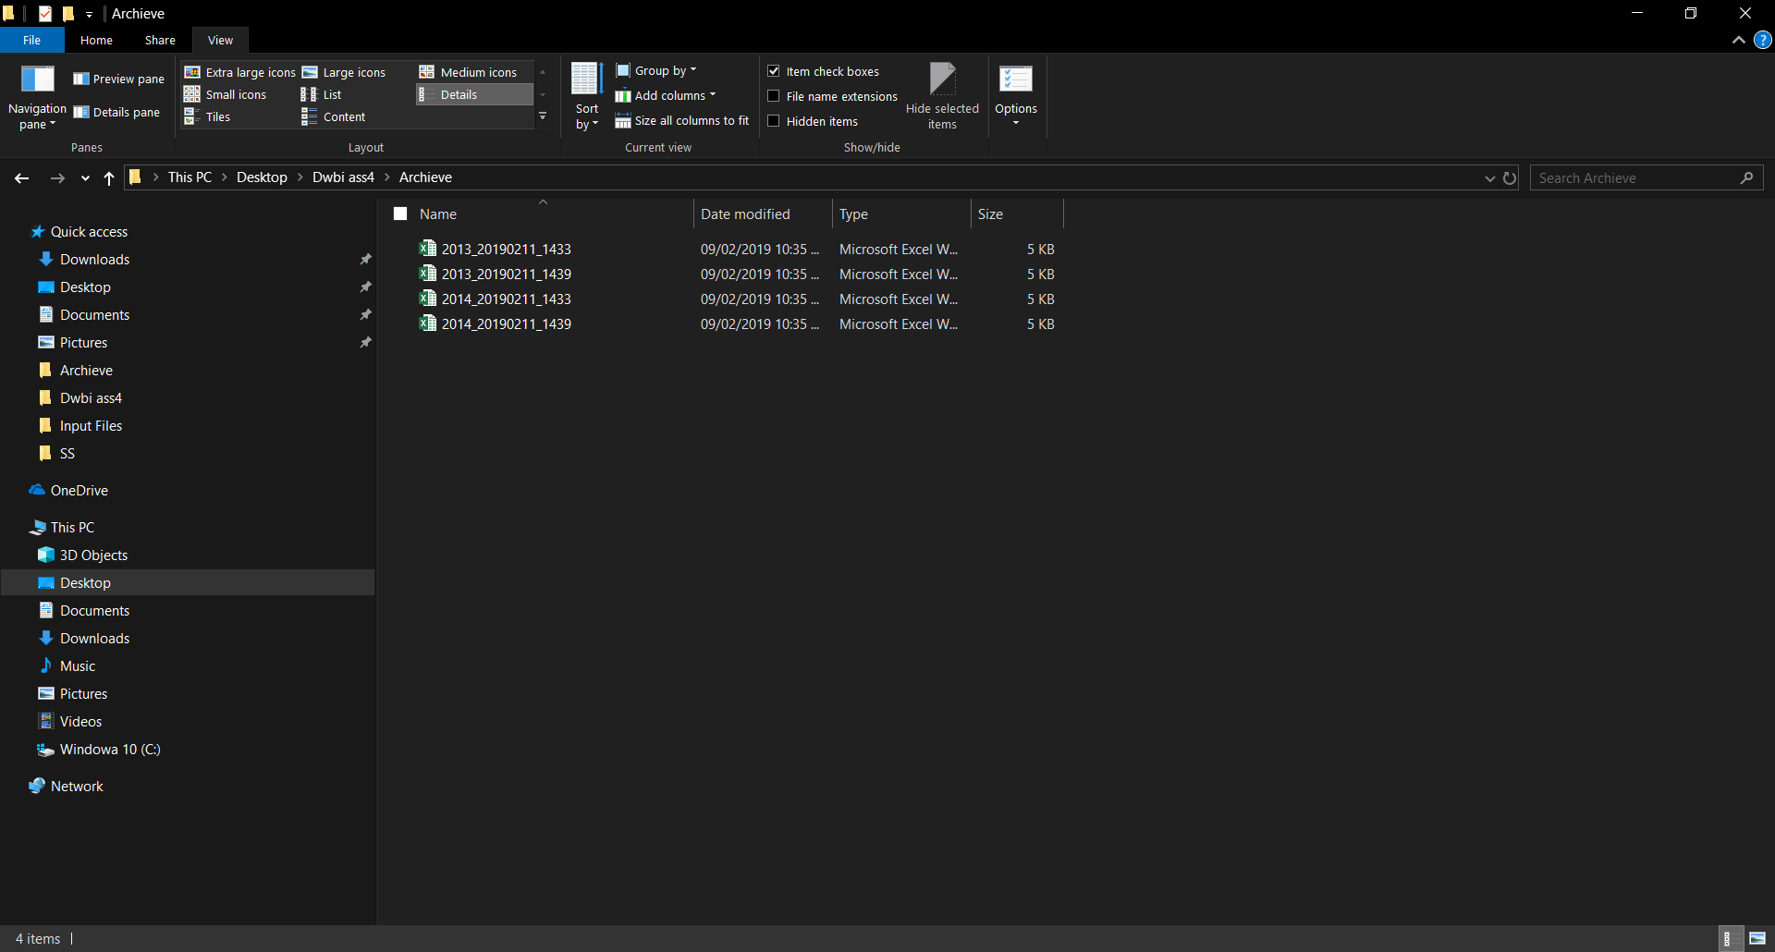

1. Now setting up an expression for file system task by variables archive_full_path and archive folder.

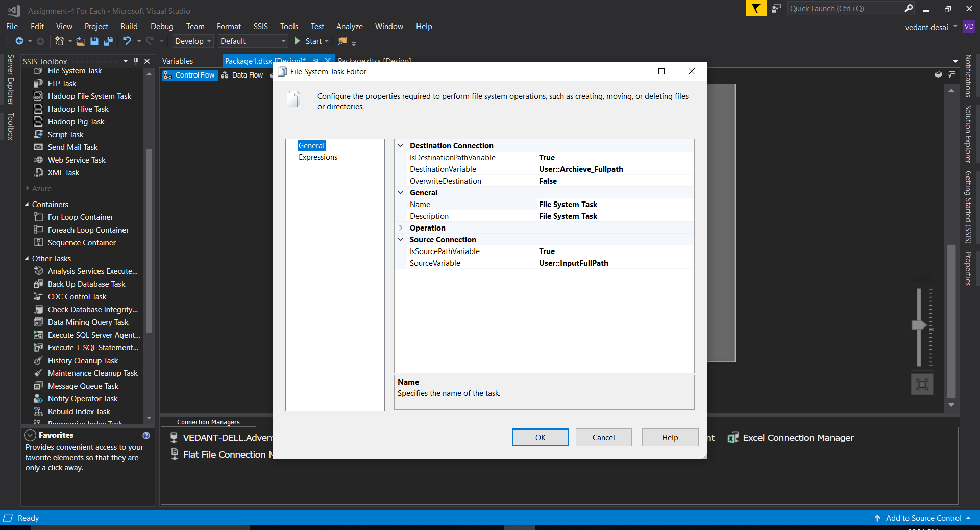

1. Creating Scripts for 3 tables.

**-- Table State**

CREATE TABLE [State]

(

[SPK] Int IDENTITY ,

[StateAbbreviation] Nvarchar(10) NOT NULL,

[StateName] Nvarchar(50) ,

[StateFIPS] Nvarchar(50)

)

go

ALTER TABLE [State] ADD CONSTRAINT [Key1] PRIMARY KEY ([StateAbbreviation])

go

-- **Table County**

CREATE TABLE [County]

(

[SPK] Int IDENTITY ,

[CountyName] Nvarchar(50) ,

[FIPS] Nvarchar(50) ,

[StateAbbreviation] Nvarchar(10) NOT NULL

)

go

ALTER TABLE [County] ADD CONSTRAINT [Key2] PRIMARY KEY ([StateAbbreviation])

go

-- **Table Zip**

CREATE TABLE [Zip]

(

[SPK] Int IDENTITY ,

[Zip] Nvarchar(50) ,

[town] Nvarchar(50) ,

[StateAbbreviation] Nvarchar(10) NOT NULL

)

go

ALTER TABLE [Zip] ADD CONSTRAINT [Key3] PRIMARY KEY ([StateAbbreviation])

go

-- **Create foreign keys**

ALTER TABLE [County] ADD CONSTRAINT [Relationship1] FOREIGN KEY ([StateAbbreviation]) REFERENCES [State] ([StateAbbreviation]) ON UPDATE NO ACTION ON DELETE NO ACTION

go

ALTER TABLE [Zip] ADD CONSTRAINT [Relationship2] FOREIGN KEY ([StateAbbreviation]) REFERENCES [State] ([StateAbbreviation]) ON UPDATE NO ACTION ON DELETE NO ACTION

go

1. GitHub link :

<https://github.com/Vedant1065/Assignment-5>