**Industrial Internship Report on**

**Prediction of Agriculture Crop Production in India**

**Prepared by**

**Vedant Sonawane**

|  |
| --- |
| *Executive Summary* |
| This report provides details of the Industrial Internship provided by upskill Campus and The IoT Academy in collaboration with Industrial Partner UniConverge Technologies Pvt Ltd (UCT).  This internship was focused on a project/problem statement provided by UCT. We had to finish the project including the report in 6 weeks’ time.  My project was Prediction of Agriculture Crop Production in India. Crop yield prediction is an important aspect of agriculture that helps farmers make informed decisions about their crops . It involves predicting yield of crop per hectare based on cost of cultivation and cost of production. In recent years, machine learning (ML) has emerged as a powerful tool for predicting crop yields. Machine learning is a branch of artificial intelligence (AI) that allows computers to learn from data without being explicitly programmed. This makes it ideal for crop yield prediction because it can identify patterns and relationships in large amounts of data and make predictions based on these relationships.  This internship gave me a very good opportunity to get exposure to Industrial problems and design/implement solution for that. It was an overall great experience to have this internship. |

**TABLE OF CONTENTS**

1 Preface………………………………………………………………………………………….4

2 Introduction…………………………………………………………………………………….6

2.1 About UniConverge Technologies Pvt Ltd………………………………………………...6

2.2 About upskill Campus…………………………………………………………………….11

2.3 Objective…………………………………………………………………………………..12

2.4 Reference………………………………………………………………………………….13

3 Problem Statement……………………………………………………………………………..14

4 Existing and Proposed solution………………………………………………………………...15

5 Proposed Design/ Model 17

5.1 High Level Diagram (if applicable) **Error! Bookmark not defined.**

5.2 Low Level Diagram (if applicable) **Error! Bookmark not defined.**

5.3 Interfaces (if applicable) **Error! Bookmark not defined.**

6 Performance Test 18

6.1 Test Plan/ Test Cases 18

6.2 Test Procedure 18

6.3 Performance Outcome 18

7 My learnings 19

8 Future work scope 20

# Preface

During the six-week duration of my internship, I embarked on a journey of exploration, learning, and application within the domain of agricultural data science. This preface serves as a summary of my experiences and insights gained throughout this enriching period.

The internship commenced with an immersive dive into understanding the problem statement and familiarizing myself with the vast dataset provided. As weeks progressed, I delved deeper into developing predictive models for crop yield estimation, culminating in the creation of user-friendly web applications and insightful data analysis using tools like Power BI and python library like Streamlit.

Internships play a pivotal role in shaping one's career trajectory by providing hands-on experience, exposure to real-world challenges, and opportunities for skill enhancement. This internship has been instrumental in bridging the gap between theoretical knowledge and practical application, thereby enhancing my employability and preparing me for future endeavors in the field of agricultural data science.

Project: Prediction of Agriculture Crop Production in India

The project aimed to address the pressing need for accurate predictions of crop production in India, leveraging advanced data science techniques. By analyzing historical data and employing predictive modeling algorithms, the objective was to develop a robust framework for estimating crop yields, thereby aiding farmers, policymakers, and stakeholders in making informed decisions.

The internship opportunity provided by USC/UCT served as a cornerstone in my professional development journey. It offered a conducive environment for hands-on learning, access to valuable resources, mentorship from experienced professionals, and exposure to cutting-edge technologies in the field of agricultural data science.

The program was meticulously structured to encompass various facets of agricultural data science, starting from problem exploration and dataset understanding to model development, application building, and performance evaluation. Each week was dedicated to specific tasks and milestones, ensuring a systematic progression of learning and skill acquisition.

As I reflect on the invaluable experiences gained during this internship, I extend my heartfelt gratitude to USC/UCT for providing me with this enriching opportunity and to all those who supported and guided me along this transformative journey.

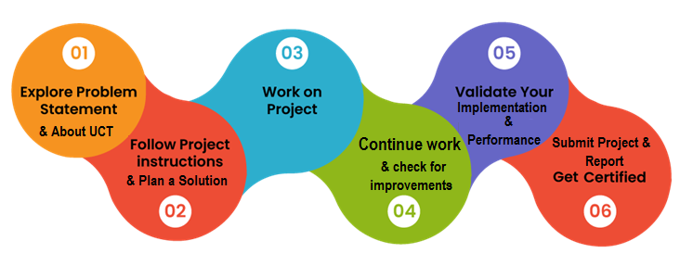

# Introduction

## About UniConverge Technologies Pvt Ltd

A company established in 2013 and working in Digital Transformation domain and providing Industrial solutions with prime focus on sustainability and RoI.

For developing its products and solutions it is leveraging various**Cutting Edge Technologies e.g. Internet of Things (IoT), Cyber Security, Cloud computing (AWS, Azure), Machine Learning, Communication Technologies (4G/5G/LoRaWAN), Java Full Stack, Python, Front end**etc.

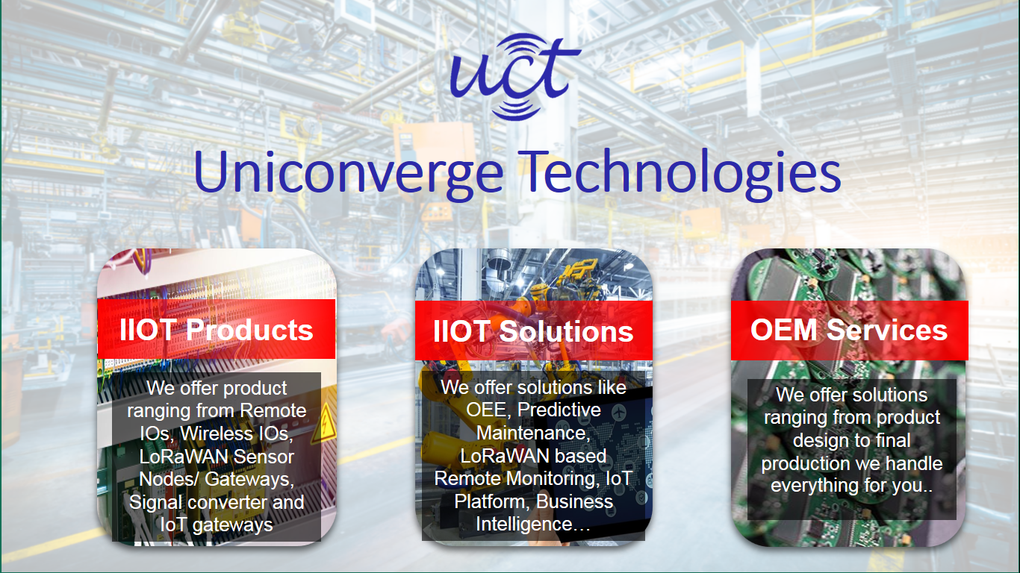

1. UCT IoT Platform **(****)**

**UCT Insight** is an IOT platform designed for quick deployment of IOT applications on the same time providing valuable “insight” for your process/business. It has been built in Java for backend and ReactJS for Front end. It has support for MySQL and various NoSql Databases.

* It enables device connectivity via industry standard IoT protocols - MQTT, CoAP, HTTP, Modbus TCP, OPC UA
* It supports both cloud and on-premises deployments.

It has features to  
• Build Your own dashboard  
• Analytics and Reporting  
• Alert and Notification  
• Integration with third party application (Power BI, SAP, ERP)  
• Rule Engine





1. **Smart Factory Platform (****)**

Factory watch is a platform for smart factory needs.

It provides Users/ Factory

* with a scalable solution for their Production and asset monitoring
* OEE and predictive maintenance solution scaling up to digital twin for your assets.
* to unleased the true potential of the data that their machines are generating and helps to identify the KPIs and also improve them.
* A modular architecture that allows users to choose the service that they what to start and then can scale to more complex solutions as per their demands.

Its unique SaaS model helps users to save time, cost and money.



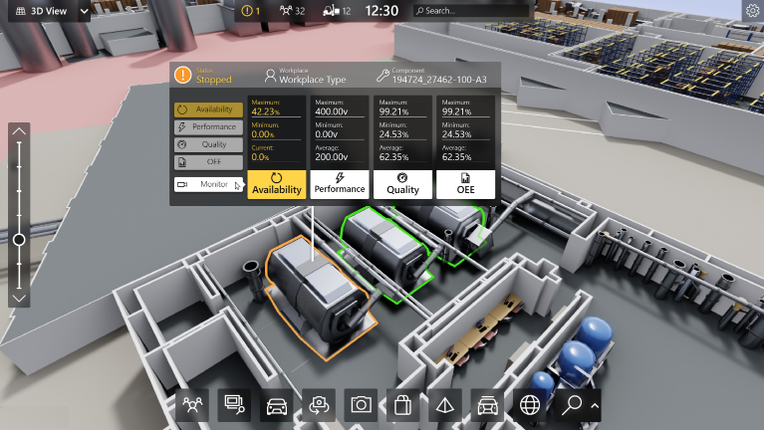

1. 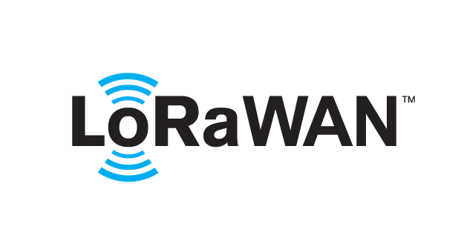 based Solution

UCT is one of the early adopters of LoRAWAN teschnology and providing solution in Agritech, Smart cities, Industrial Monitoring, Smart Street Light, Smart Water/ Gas/ Electricity metering solutions etc.

1. Predictive Maintenance

UCT is providing Industrial Machine health monitoring and Predictive maintenance solution leveraging Embedded system, Industrial IoT and Machine Learning Technologies by finding Remaining useful life time of various Machines used in production process.



## About upskill Campus (USC)

upskill Campus along with The IoT Academy and in association with Uniconverge technologies has facilitated the smooth execution of the complete internship process.

USC is a career development platform that delivers **personalized executive coaching** in a more affordable, scalable and measurable way.







upSkill Campus aiming to upskill 1 million learners in next 5 year

Seeing need of upskilling in self paced manner along-with additional support services e.g. Internship, projects, interaction with Industry experts, Career growth Services

<https://www.upskillcampus.com/>

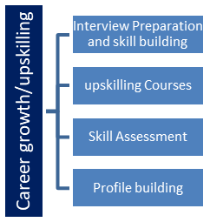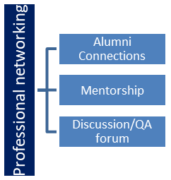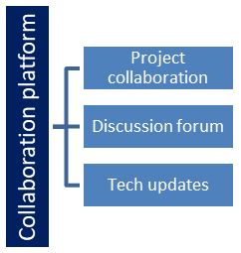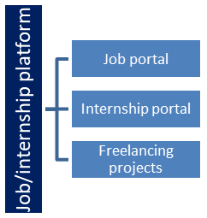

## The IoT Academy

The IoT academy is EdTech Division of UCT that is running long executive certification programs in collaboration with EICT Academy, IITK, IITR and IITG in multiple domains.

## Objectives of this Internship program

The objective for this internship program was to

 ☛ get practical experience of working in the industry.

 ☛ to solve real world problems.

 ☛ to have improved job prospects.

 ☛ to have Improved understanding of our field and its applications.

 ☛ to have Personal growth like better communication and problem solving.

## Reference

[1] produce.csv

[2] datafile.csv

[3] <https://learn.upskillcampus.com/s/courses/6441224de4b0f11fbe0f621e/take>

[4] Official Python documentation

# Problem Statement

Agriculture is one of the main sources of income in India. There is need to improve the sustainability of agriculture with the rate of increase in suicides of farmer due to crop failure and less yield and losses. Hence, it is a significant contribution towards the economic and agricultural welfare of the countries across the world. The Problem Statement revolves around prediction of yield of crops considering different climatic conditions of India including various attributes. Goal of this project is to help the farmers to choose the suitable crop to grow in order to get the required yield and the profit. Need for the crop yield prediction is very much essential at this point of time for selecting the right crop.

# Existing and Proposed solution

**Existing Solution**

Several existing solutions attempt to address the challenge of predicting agricultural crop production. These solutions typically rely on statistical models, machine learning algorithms, or a combination of both to analyze historical data and make predictions. However, they often face several limitations:

* **Limited Accuracy:** Many existing solutions struggle to achieve high levels of accuracy in predicting crop yields, particularly in complex agricultural environments with diverse factors influencing production.
* **Data Availability and Quality:** Access to comprehensive and reliable agricultural data can be a significant challenge. Existing solutions may rely on limited or outdated datasets, leading to suboptimal predictions.
* **Scalability:** Some solutions lack scalability, making it difficult to apply them effectively across different regions or scales of agricultural operations.
* **Interpretability:** The lack of interpretability in certain predictive models can hinder their adoption and usability among stakeholders, such as farmers and policymakers.

**Proposed Solution**

In the modern era of rapid technological advancement, various sectors have undergone significant transformations, leading to increased efficiency and improved outcomes. However, the agriculture sector remains vulnerable to a multitude of challenges, ranging from unpredictable weather patterns to soil quality issues and fluctuating rainfall. These factors, coupled with the threat of natural disasters, often result in crop failures, reduced production, and food shortages, presenting formidable economic and humanitarian obstacles.

Acknowledging the urgency to tackle these pressing issues, our proposed system aims to provide a viable solution by accurately predicting crop yield rates. Through the utilization of cutting-edge techniques and the consideration of influential parameters such as the cost of cultivation (A2+FL and C2) and the cost of production, our system endeavors to identify yield of that crop (Quintal/Hectare. This proactive approach empowers farmers to anticipate risks, optimize their cultivation practices, and maximize crop yield production, thereby mitigating the adverse impacts of crop failures and promoting sustainable agricultural practices.

## Code submission (Github link)

## Report submission (Github link) : first make placeholder, copy the link.

# Proposed Design/ Model

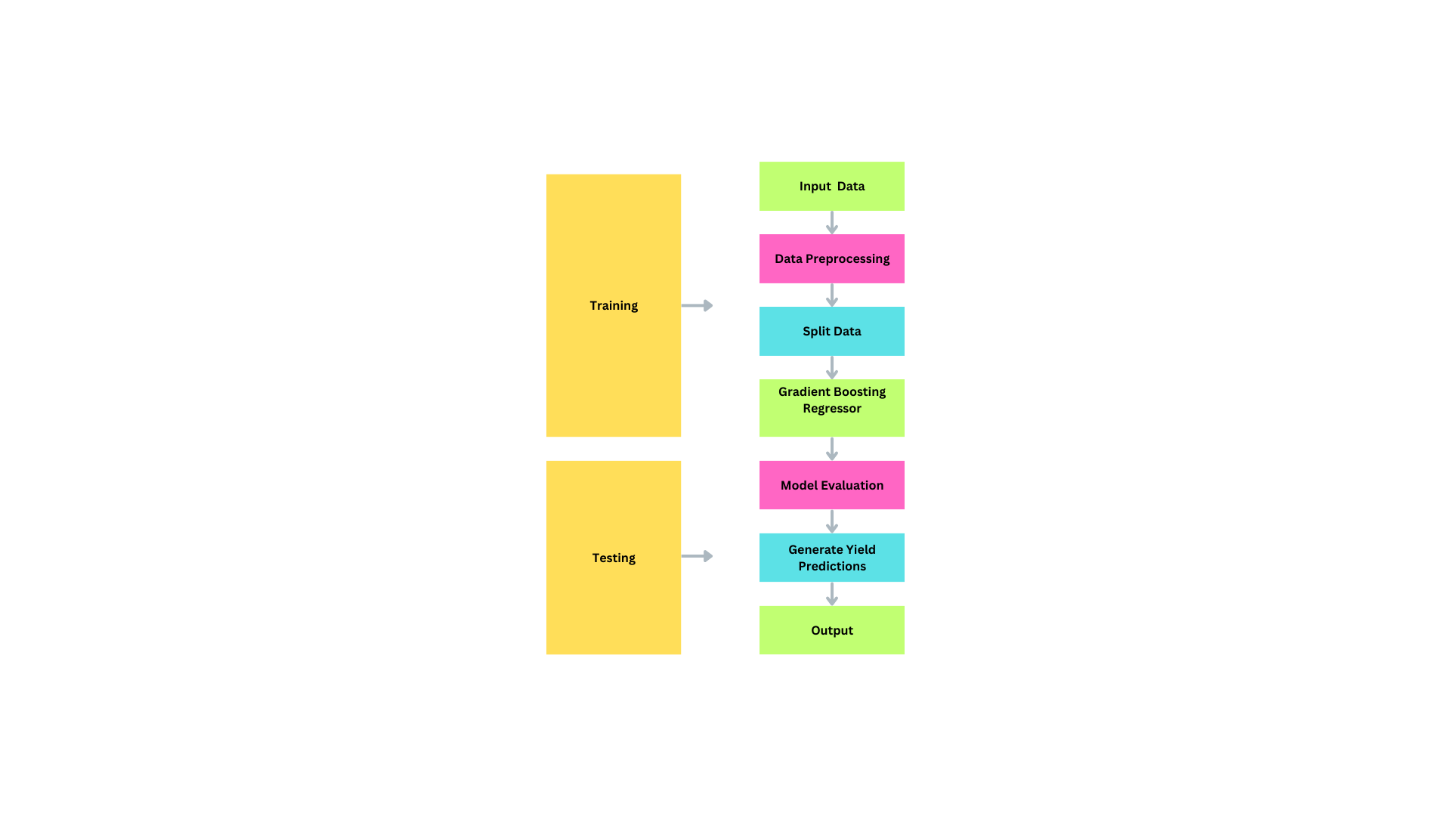

Flowchart of Crop Yield Prediction

# Performance Test

## Test Plan/ Test Cases

Crop Yield Prediction: This module returns the predicted yield of crop (Quintal/Hectare) based on the user's input. If the user wants to know the yield of a particular crop, the system takes the crop as the input as well along with its State , Cost of Cultivation(A2+FL,C2) and Cost of Production then it returns a predicted yield of crop as output.

## Test Procedure

* Step 1 : Enter Crop Name
* Step 2 : Take inputs from user for State, Cost of Cultivation (`/Hectare) A2+FL, Cost of Cultivation (`/Hectare) C2 and Cost of Production (`/Quintal) C2.
* Step 3 : Submitting these inputs model predicts yield of Crop selected in (Quintal/Hectare) in selected State.

## Performance Outcome

The implemented Yield Prediction Model web application has to take inputs from user for Yield Prediction . Inputs such as Crop Name , State, Cost of Cultivation (`/Hectare) A2+FL, Cost of Cultivation (`/Hectare) C2 and Cost of Production (`/Quintal) C2. Based on these inputs model predicts yield of Crop selected in (Quintal/Hectare) in selected State.

# My learnings

During my internship, I underwent a comprehensive learning experience, beginning with a foundational understanding of data science and delving into the intricacies of machine learning. This journey was facilitated by a thorough review of the internship program guidelines and familiarization with the profile of UCT, culminating in the selection of the project "Prediction of Agriculture Crop Production in India." This choice was driven by a keen awareness of the challenges faced by Indian farmers during crop production, emphasizing the critical role of accurate predictions in mitigating risks and optimizing agricultural practices. In my pursuit of knowledge, I meticulously explored crop production data and engaged with various resources such as e-books and articles to deepen my understanding of data science and machine learning concepts. Additionally, I endeavored to differentiate between data science roles, recognizing the unique contributions and skill requirements of data scientists and data analysts. As my learning journey progressed, I expanded my knowledge base to include artificial intelligence and its intersection with data science, acknowledging the interconnectedness of these fields in shaping career trajectories. Moreover, I dedicated time to enhancing both technical and non-technical skills essential for success in data science, while also revisiting fundamental concepts in probability and statistics to strengthen my quantitative analysis skills. Overall, my internship experience has equipped me with invaluable insights and skills, laying a solid foundation for future contributions in the dynamic realm of data science and machine learning.

# Future work scope

Due to time constraints during the internship, certain ideas and features were not implemented in the Crop Yield Prediction module. However, these ideas hold potential for future development and enhancement of the system:

* Integration of Additional Factors: Incorporate soil type, climate data, irrigation methods, and crop varieties for more accurate predictions.
* Dynamic Data Updates: Implement regular updates to the dataset for training the model, ensuring it reflects changing agricultural conditions.
* Enhanced User Interface: Improve user interface for better usability, including interactive data visualization and clear instructions.
* Model Evaluation and Validation: Conduct rigorous testing and validation procedures to ensure accuracy and reliability.
* Incorporation of Machine Learning Techniques: Explore advanced algorithms like ensemble learning or deep learning for improved performance.
* Scalability and Deployment: Design the module to be scalable and easily deployable across different regions and agricultural contexts.

By prioritizing these ideas for future development, the Crop Yield Prediction module can be further refined and enhanced to better serve the needs of farmers and stakeholders in the agriculture sector.