Answer-1)

The various types of testing are:-

**1. Unit Testing**

It focuses on the smallest unit of software design. In this, we test an individual unit or group of interrelated units. It is often done by the programmer by using sample input and observing its corresponding outputs.   
Example: 

a) In a program we are checking if loop, method or

function is working fine

b) Misunderstood or incorrect, arithmetic precedence.

c) Incorrect initialization

**2. Integration Testing**

The objective is to take unit tested components and build a program structure that has been dictated by design. Integration testing is testing in which a group of components is combined to produce output.

Integration testing is of four types: (i) Top-down (ii) Bottom-up (iii) Sandwich (iv) Big-Bang   
Example 

(a) Black Box testing:- It is used for validation.

In this we ignore internal working mechanism and

focuse on **what is the output?**.

(b) White Box testing:- It is used for verification.

In this we focus on internal mechanism i.e.

**how the output is achieved?**

**3. Regression Testing**

Every time a new module is added leads to changes in the program. This type of testing makes sure that the whole component works properly even after adding components to the complete program.   
Example 

In school record suppose we have module staff, students

and finance combining these modules and checking if on

integration these module works fine is regression testing

**4. Smoke Testing**

This test is done to make sure that software under testing is ready or stable for further testing   
It is called a smoke test as the testing an initial pass is done to check if it did not catch the fire or smoke in the initial switch on.   
Example: 

If project has 2 modules so before going to module

make sure that module 1 works properly

**5. Alpha Testing**

This is a type of validation testing. It is a type of *acceptance testing*which is done before the product is released to customers. It is typically done by QA people.   
Example: 

When software testing is performed internally within

the organization

**6. Beta Testing**

The beta test is conducted at one or more customer sites by the end-user of the software. This version is released for a limited number of users for testing in a real-time environment   
Example: 

When software testing is performed for the limited

number of people

**7. System Testing**

This software is tested such that it works fine for the different operating systems. It is covered under the black box testing technique. In this, we just focus on the required input and output without focusing on internal working.   
In this, we have security testing, recovery testing, stress testing, and performance testing   
Example: 

This include functional as well as non functional

testing

**8. Stress Testing**

In this, we give unfavourable conditions to the system and check how they perform in those conditions.   
Example: 

(a) Test cases that require maximum memory or other

resources are executed

(b) Test cases that may cause thrashing in a virtual

operating system

(c) Test cases that may cause excessive disk requirement

**9. Performance Testing**

It is designed to test the run-time performance of software within the context of an integrated system. It is used to test the speed and effectiveness of the program. It is also called load testing. In it we check, what is the performance of the system in the given load.  
Example: 

Checking number of processor cycles.

**10. Object-Oriented Testing**

This testing is a combination of various testing techniques that help to verify and validate object-oriented software. This testing is done in the following manner:

* Testing of Requirements,
* Design and Analysis of Testing,
* Testing of Code,
* Integration testing,
* System testing,
* User Testing.

We use this OOT, for discussing test plans and for executing the projects.

Answer-2)

The below diagrams are DFDs for an Advertisement Management System (in object form because I have used tools for this answer, the tool’s name is draw.io and add-in might be required to display the content ) 3 levels of DFD(zero-level,1st level and 2nd level) are described below:-

Zero Level Data Flow DiagramC0 Level DFD) Of Advertisement Management System :  
This is the Zero Level DFD of Advertisement Management System, where we have elaborated the high level process of Advertisement. It's a basic overview of the whole Advertisement Management System or process being analysed or modelled. It's designed to be an at-a-glance view of Customers, Places and Login showing the system as a single high-level process, with its relationship to external entities of Advertisement, Advertisement Type and Sizes. It should be easily understood by a wide audience, including Advertisement, Sizes and Customers In zero level DFD of Advertisement Management System, we have described the high-level flow of the Advertisement system  
High Level Entities and process flow of Advertisement Management System:

* Managing all the Advertisement
* Managing all the Advertisement Type
* Managing all the Sizes
* Managing all the Payments
* Managing all the Customers
* Managing all the Places
* Managing all the Login

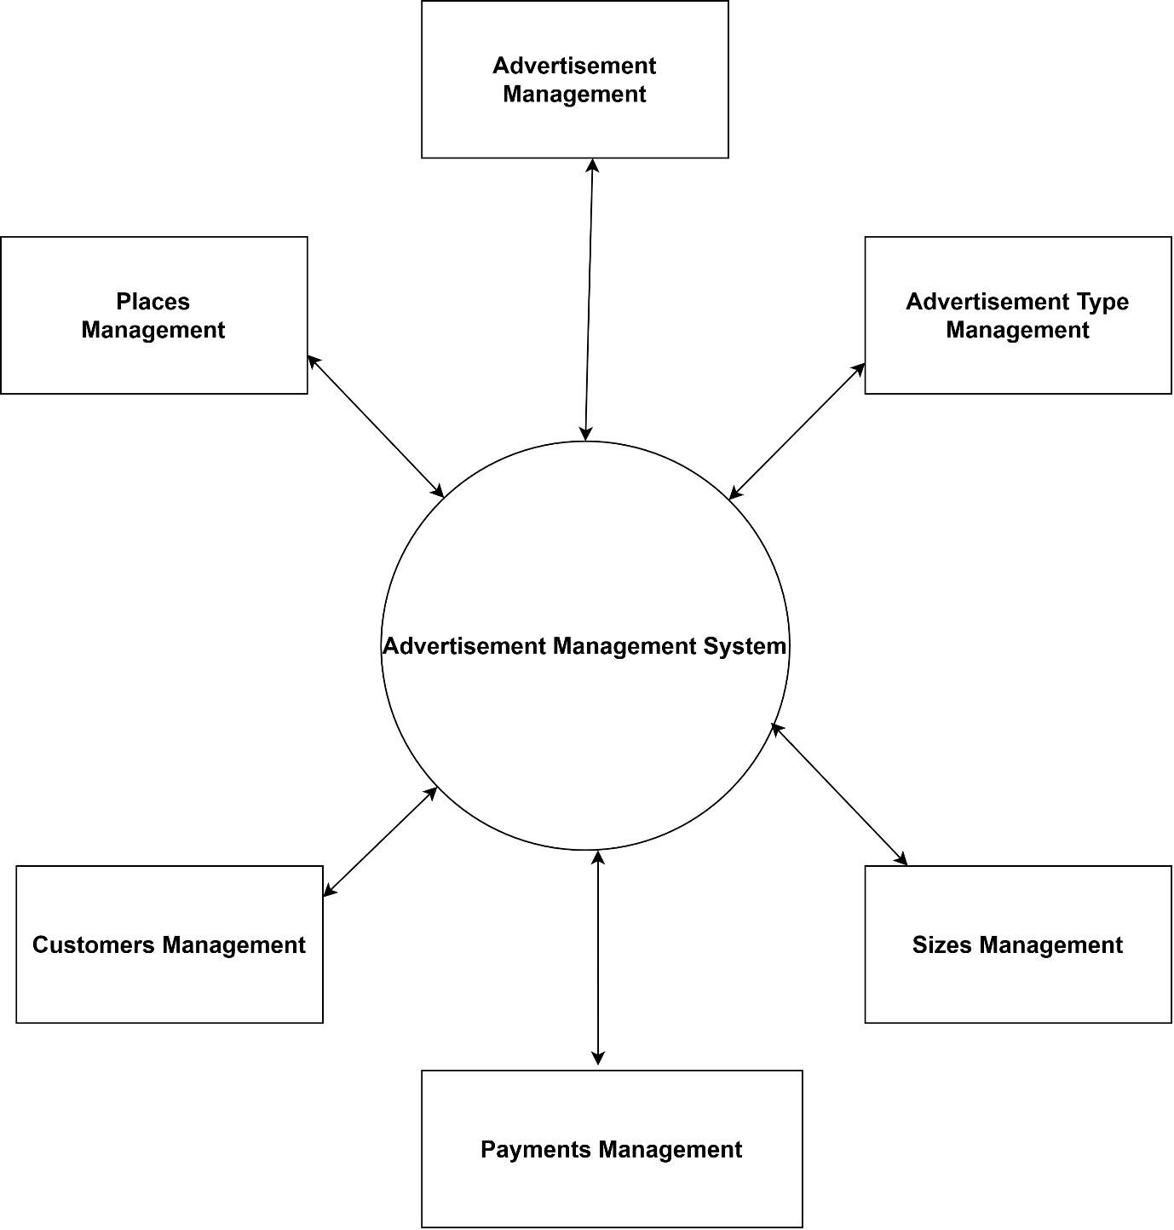

Level-0 DFD for Advertisement Management System

First Level Data Flow Diagram(1st Level DFD) Of Advertisement Management System :  
First Level DFD (1st Level) of Advertisement Management System shows how the system is divided into sub-systems (processes), each of which deals with one or more of the data flows to or from an external agent, and which together provide all of the functionalities of Advertisement Management  
System system as a whole. It also identifies internal data stores of Login, Places, Customers, Payments, Sizes that must be present in order for the  
Advertisement system to do its job, and shows the now of data between the various parts of Advertisement, Sizes, Places, Login, Customers of the  
system. DFD Level 1 provides a more detailed breakout of pieces of the 1st level DFD. You will highlight the main functionalities of Advertisement.  
Main entities and output of First Level DFD [1st level DFD):

* Processing Advertisement records and generate report of all Advertisement
* Processing Advertisement Type records and generate report of all Advertisement Type
* Processing Sizes records and generate report of all Sizes
* Processing Payments records and generate report of all Payments
* Processing Customers records and generate report of all Customers
* Processing Places records and generate report of all Places
* Processing Login records and generate report of all Login

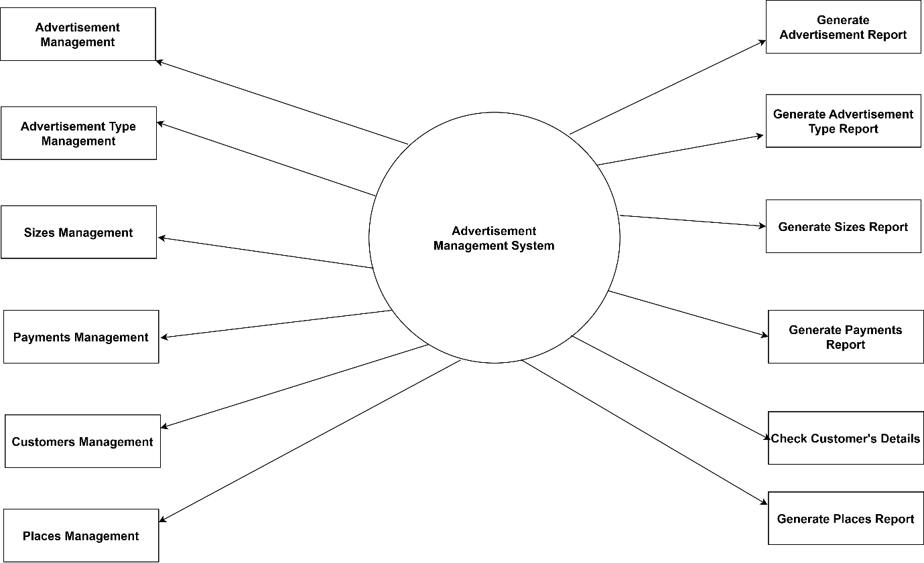

Level-1 DFD for Advertisement Management System

Second Level Data Flow Diagram(2nd Level DFD) Of Advertisement Management System :

DFD Level 2 then goes one step deeper into pans of Level 1 of Advertisement It may require more fusnctionalities of Advertisement to reach the necessary level of detail about the Advertisement functioning First Level DFD (1st Level) of Advertisement Management System shows how the system is divided into sub-systems (processes). The 2nd Level DFD contains more details of Login, Places, Customers, Payments, Sizes, Advertisement Type, Advertisement:-

* Low level functionalities of Advertisement Management System
* Admin logins to the system and manage all the functionalities of Advertisement Management System
* Admin can add, edit, delete and view the records of Advertisement, Sizes, Customers, Login
* Admin can manage all the details of Advertisement Type, Payments, Places
* Admin can also generate reports of Advertisement, Advertisement Type, Sizes, Payments, Customers, Places
* Admin can search the details of Advertisement Type, Customers, Places
* Admin can apply different level of filters on report of Advertisement, Payments, Customers
* Admin can tracks the detailed information of Advertisement Type, Sizes, Payments, , Customers

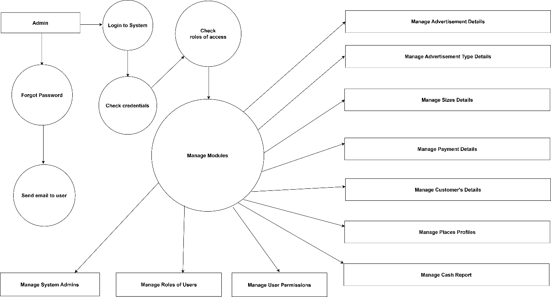

Level-2 DFD for Advertisement Management System