**1. Create a stored procedure in the Northwind database that will calculate the average**

**value of Freight for a specified customer.Then, a business rule will be added that will**

**be triggered before every Update and Insert command in the Orders controller,and**

**will use the stored procedure to verify that the Freight does not exceed the average**

**freight. If it does, a message will be displayed and the command will be cancelled.**

* **PROCEDURE for AVG**

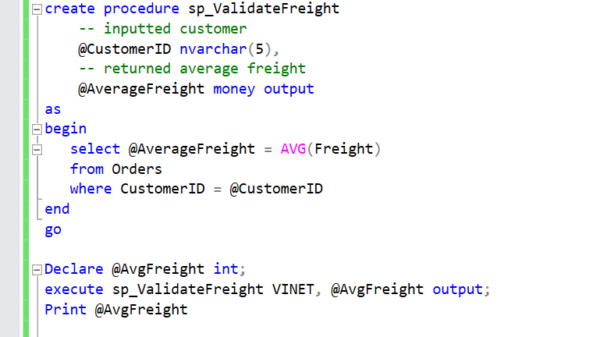

* **Trigger For Insert**

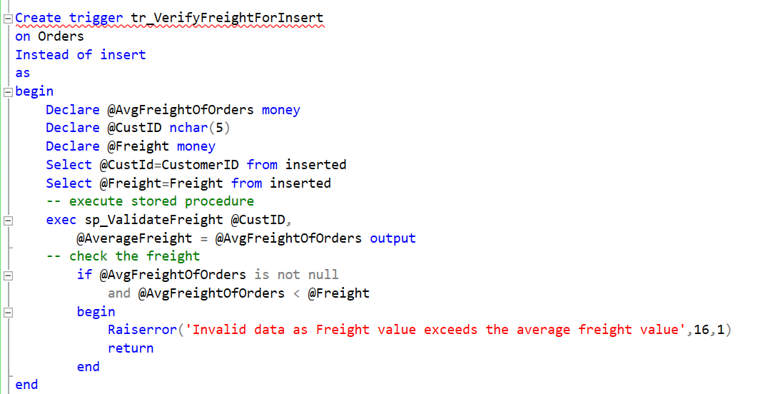

* **Trigger For Update**

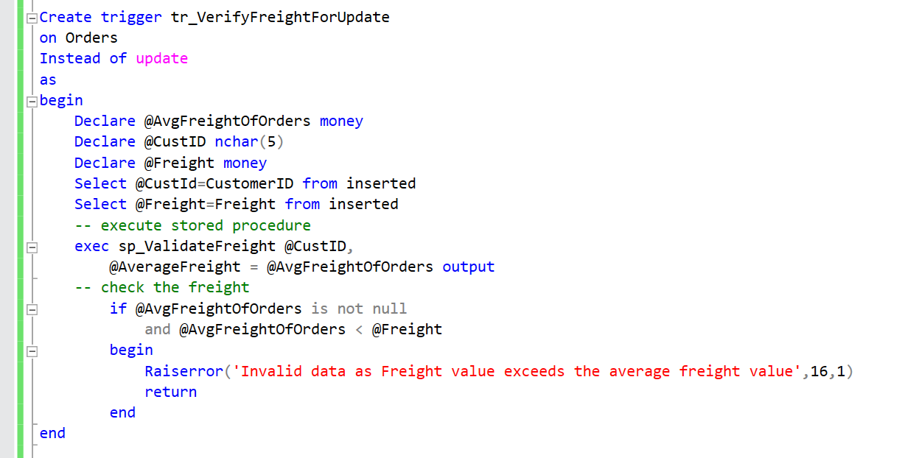

* **Error Message**

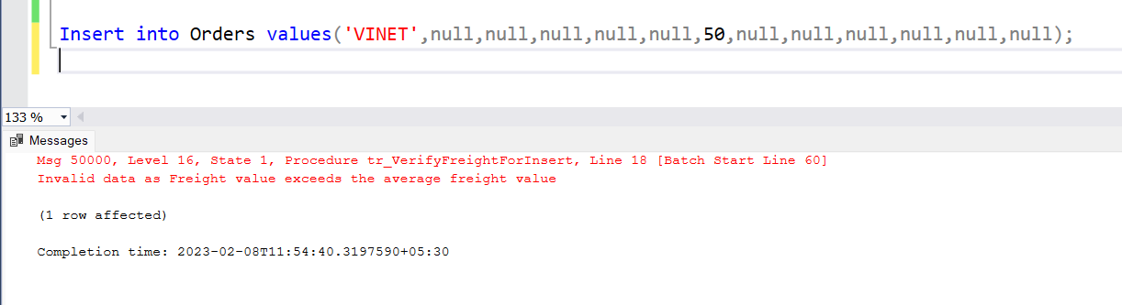

* **Output**

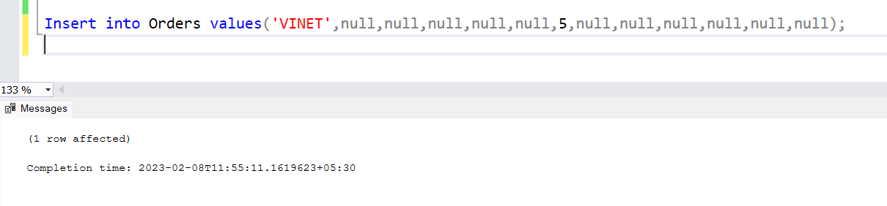

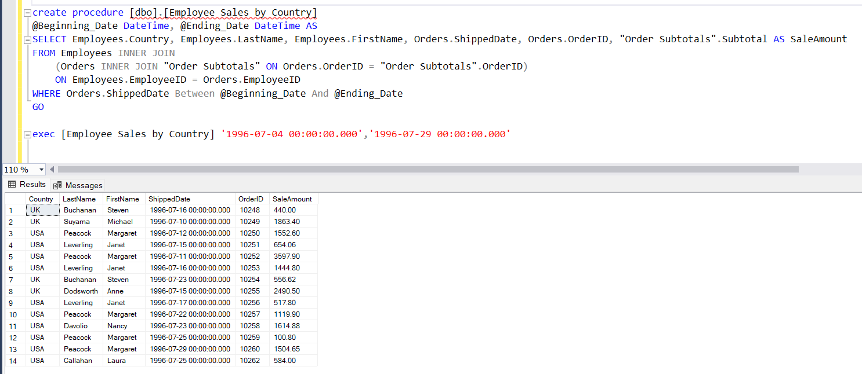

**2. write a SQL query to Create Stored procedure in the Northwind database to retrieve**

**Employee Sales by Country**



**3. write a SQL query to Create Stored procedure in the Northwind database to retrieve**

**Sales by Year**

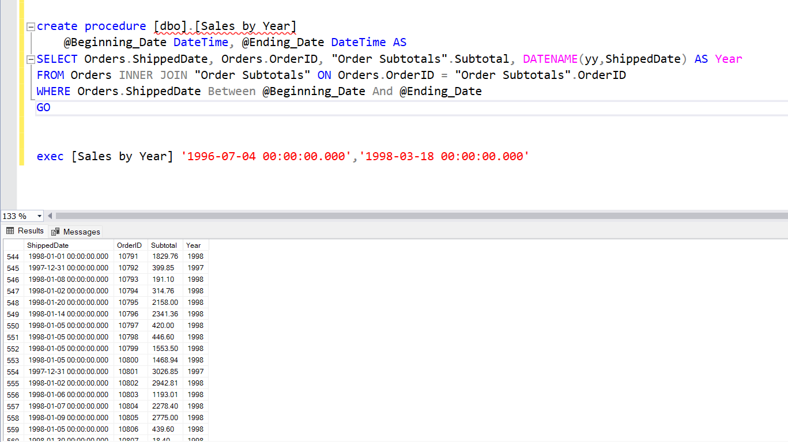

**4. write a SQL query to Create Stored procedure in the Northwind database to retrieve**

**Sales By Category**

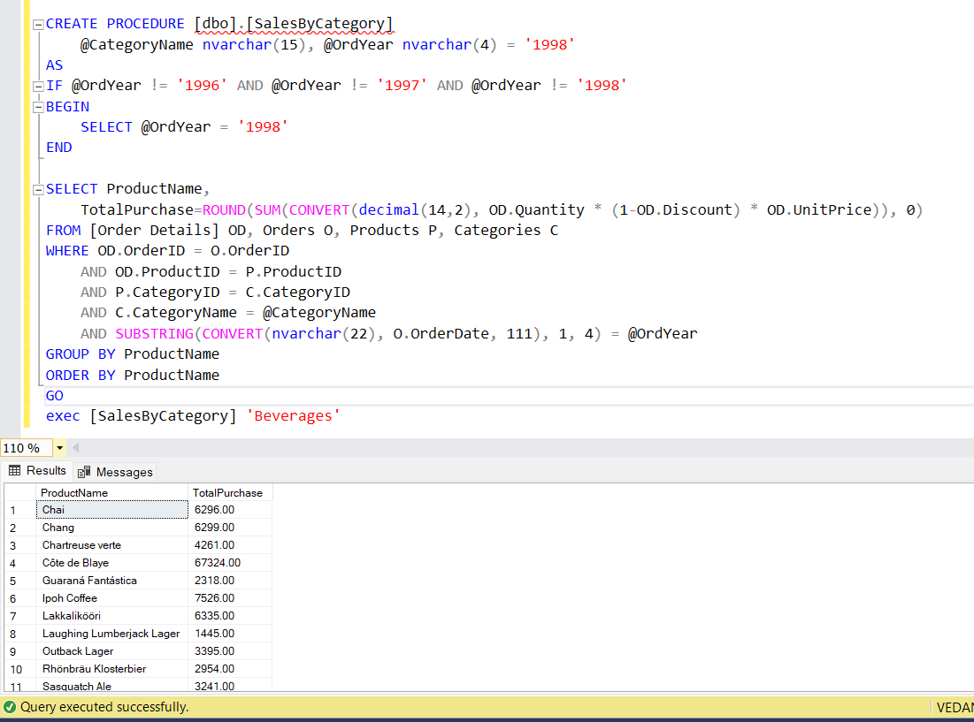

**5. write a SQL query to Create Stored procedure in the Northwind database to retrieve**

**Ten Most Expensive Products**

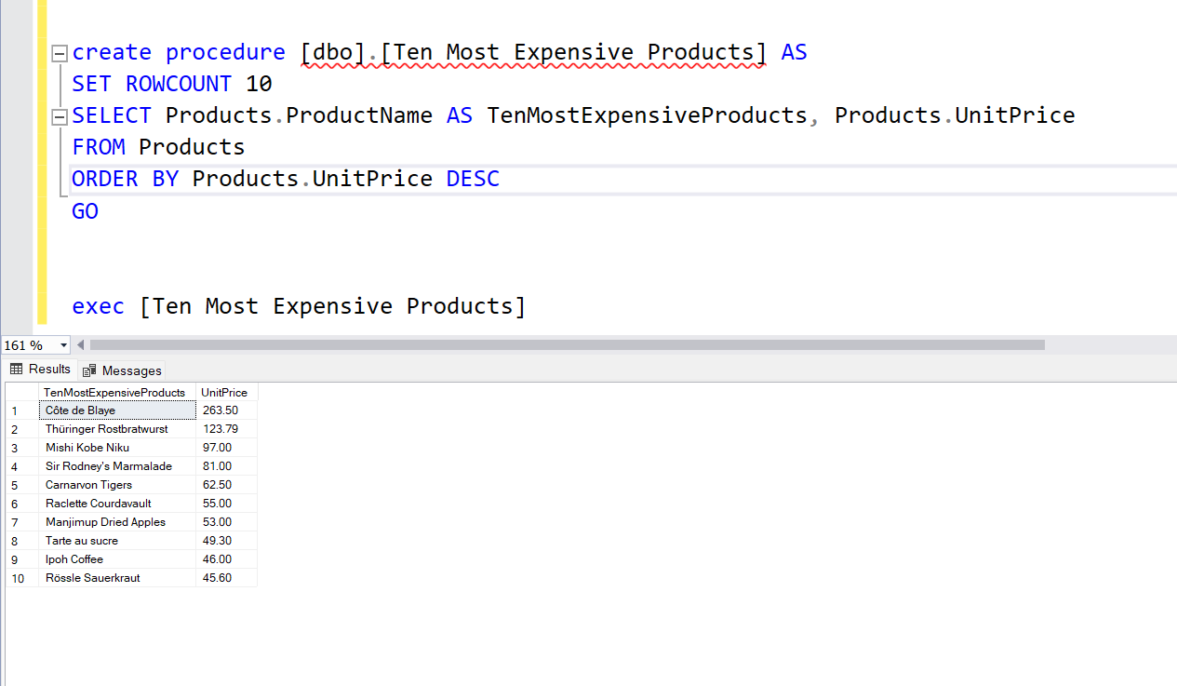

**6. write a SQL query to Create Stored procedure in the Northwind database to insert**

**Customer Order Details**

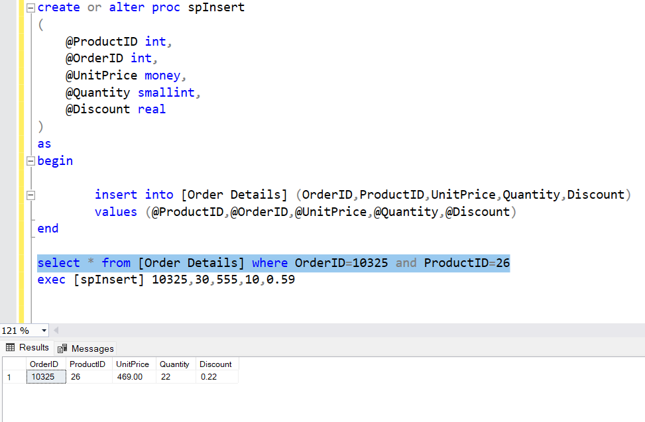

**7. write a SQL query to Create Stored procedure in the Northwind database to update**

**Customer Order Details**

