# <PROJECT TITLE>

PROJECT REPORT

Submitted by

**<Student Full Name> - <Register Number>**

**<Student Full Name> - <Register Number>**

**<Student Full Name> - <Register Number>**

**<Student Full Name> - <Register Number>**

Under the guidance of   
**<Faculty Name>***In partial fulfilment for the Course*

**21CSC203P – ADVANCED PROGRAMMING PRACTICE**



**DEPARTMENT OF COMPUTATIONAL INTELLIGENCE**

**FACULTY OF ENGINEERING AND TECHNOLOGY**

**SCHOOL OF COMPUTING**

**SRM INSTITUTE OF SCIENCE AND TECHNOLOGY**

**KATTANKULATHUR – 603203.**

**NOVEMBER 2025**

**SRM INSTITUTE OF SCIENCE AND TECHNOLOGY**

**(Under Section 3 of UGC Act, 1956)**

**BONAFIDE CERTIFICATE**

Certified that this minor project report for the course **21CSC203P** - **ADVANCED PROGRAMMING PRACTICE** entitled in "**Project Title**" is the bonafide work of <Student s Name> (Registration numbers>who carried out the work under my supervision.

|  |  |
| --- | --- |
| SIGNATURE | SIGNATURE |
| Dr. M. Kiruthika | Dr Annie Uthra R |
| APP – Course Faculty | Head of the Department |
| Assistant Professor**,**  Department of Computational Intelligence,  SRM Institute of Science and Technology,  Kattankulathur – 603203. | Professor,  Department of Computational Intelligence,  SRM Institute of Science and Technology, Kattankulathur – 603203. |

# ABSTRACT

A network has to be designed for a small business organization which has 100 users. The organization hosts an e-commerce application on a server which is accessible to internet users using https and with a public IP address. A network for the same was designed using Cisco Packet Tracer version 8.0.0. The requirements were emulated and tested for connectivity. A server was setup, which is accessible only on port 443 with HTTPS connectivity. Internally, department routers are interconnected for unfiltered access to the server. The company router has NAT to translate public IP address to private device IP addresses. Switches are used to ensure optimal number of devices can be used with both the company network as well as the broadband network. Pings were used to check the connectivity and the reachability of the systems from all the network.

# ACKNOWLEDGEMENT

We express our heartfelt thanks to our honorable **Vice Chancellor Dr. C. MUTHAMIZHCHELVAN**, for being the beacon in all our endeavors. We would like to express my warmth of gratitude to our **Registrar Dr. S. Ponnusamy,** for his encouragement. We express our profound gratitude to our **Dean (College of Engineering and Technology) Prof. M. Leenus J Martin,** for bringing out novelty in all executions.

We would like to express my heartfelt thanks to Chairperson, School of Computing **Dr. Revathi Venkataraman,** for imparting confidence to complete my course project. We wish to express my sincere thanks to **Course Audit Professor Dr. Vadivu. G, Professor, Department of Data Science and Business Systems** for her constant encouragement and support.

We are highly thankful to our course faculty **Dr. M Kiruthika, Assistant Professor, Department of Computational Intelligence,** for herassistance, timely suggestion and guidance throughout the duration of this course project.

We extend our gratitude to our **Head of the Department, Dr. R. Annie Uthra, Professor, Department of Computational Intelligence** for her support.

Finally, we thank our parents and friends, near and dear ones who directly and indirectly contributed to the successful completion of our project. Above all, I thank the almighty for showering his blessings on me to complete my course project.

**TABLE OF CONTENTS**

|  |  |  |  |
| --- | --- | --- | --- |
| **CHAPTER NO** | | **CONTENTS** | **PAGE NO** |
| **1** | **INTRODUCTION** | |  |
|  | 1.1 Motivation | |  |
|  | 1.2 Objective | |  |
|  | 1.3 Problem Statement | |  |
|  | 1.4 Scope and Limitations | |  |
| **2** | **LITERATURE SURVEY** | |  |
| **3** | **REQUIREMENT SPECIFICATIONS** | |  |
| **4** | **ARCHITECTURE & DESIGN**  4.1 System Architecture  4.2 Use Case Diagram | |  |
| **5** | **IMPLEMENTATION & RESULTS**  5.1 Front End Design  5.2 Table Design  5.3 Code  5.4 Screenshots | |  |
| **6** | **CONCLUSION** | |  |
| **7** | **REFERENCES** | |  |

1. **INTRODUCTION**

A network has to be designed for a small business organization which has 100 users. The

organization hosts an e-commerce application on a server which is accessible to internet users using https and with a public IP address.

We have to setup a server which listens on Port 443 (HTTPS) only. The private IP address should be masked by NAT on the company router so that the external users will know only the public IP of the server. This will ensure added security for the server.

The employees in the organization will be able to use the server without any restriction since they are directly routed to the same network via the company router. The departments can also intercommunicate with one another without any restriction.

The public internet users will only know a public address of the company router to connect to the server. They can communicate with each other, since they are on a public network. However, they cannot know the private addresses of the company devices.

1. **LITERATURE SURVEY**
2. **REQUIREMENT SPECIFICATIONS**
   1. **Technology Stack**
   2. **Hardware and Software Requirements**

From the given scenario, we draw the following requirements:

For Company XYZ (Private Network):

Hardware Required:

1x Server – PT Primary Server

1x Router (For address 10.0.0.1)

4x Switches:

2x Department Specific Switches

1x Master Company Dept. Switch

1x Primary Company Switch

6x End Devices:

3x PCs for Software Department Representation

3x PCs for IT Department Representation

For Public Network:

Hardware Required:

1x Switch(Broadband Switch)

3x End Devices(Public Network PCs)

For Network Integration(Private with Public):

Hardware Required:

1x Router (Internet Service router say ‘Airtel’)

1. **ARCHITECTURE AND DESIGN**
   1. **System Architecture**

The network architecture is as follows:

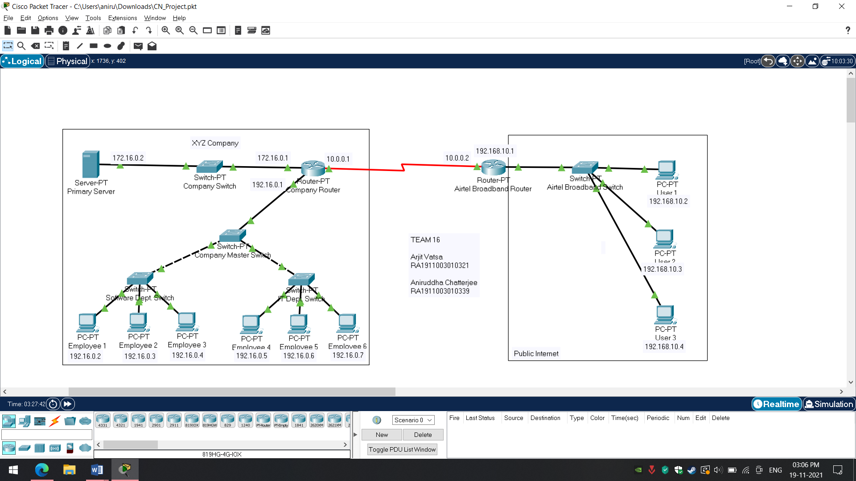

**4.2 Use Case Diagram**

1. **IMPLEMENTATION AND RESULTS**
   1. **Front End Design**
   2. **Table Design**
   3. **Code**

**5.4 Screenshots**

1. **CONCLUSION**
2. **REFERENCES**