**Online Job Portal**

**Job Applicant Side**

This is the home page with an option to login and to search for jobs in different categories and keywords

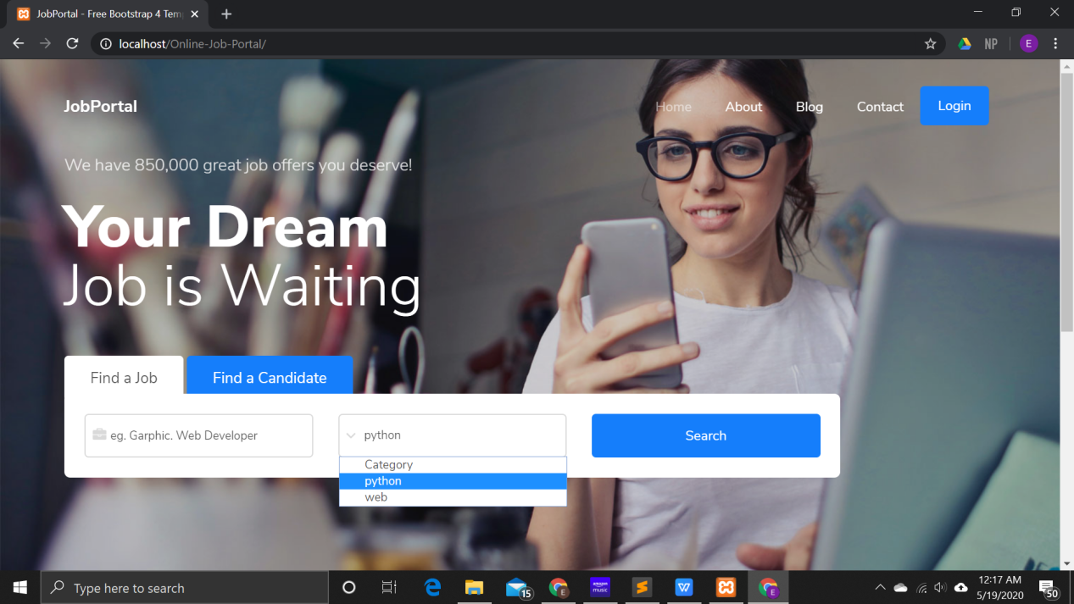

This is the login page with an option to create account.

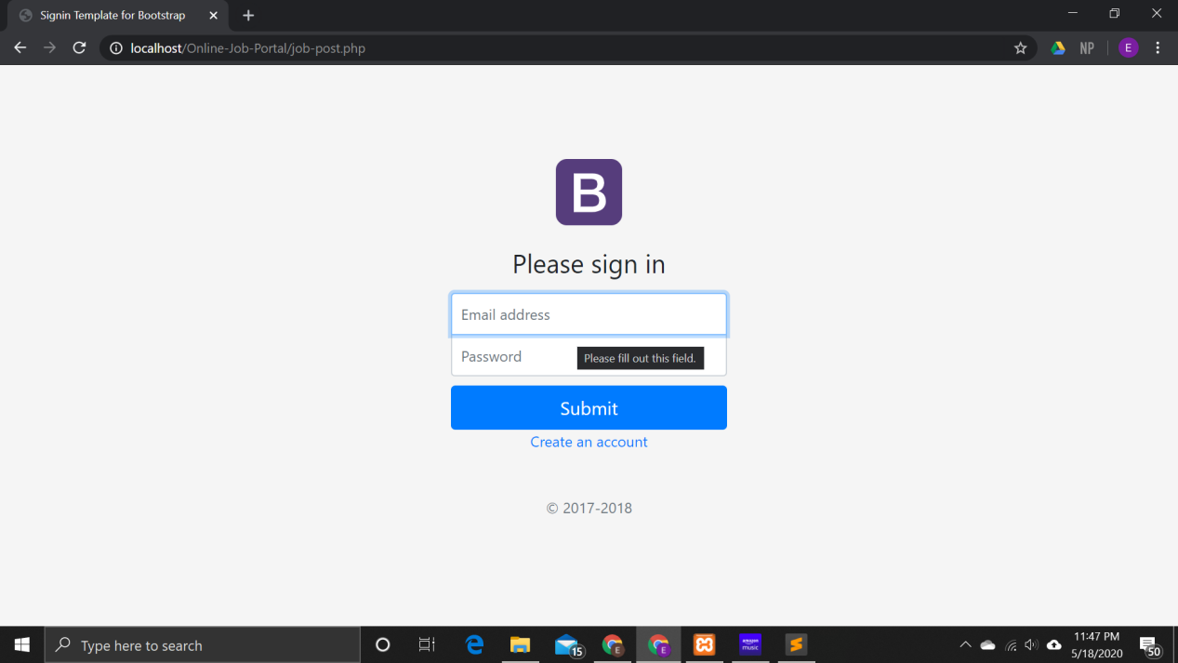

Sign Up page with an option to go to sign in page

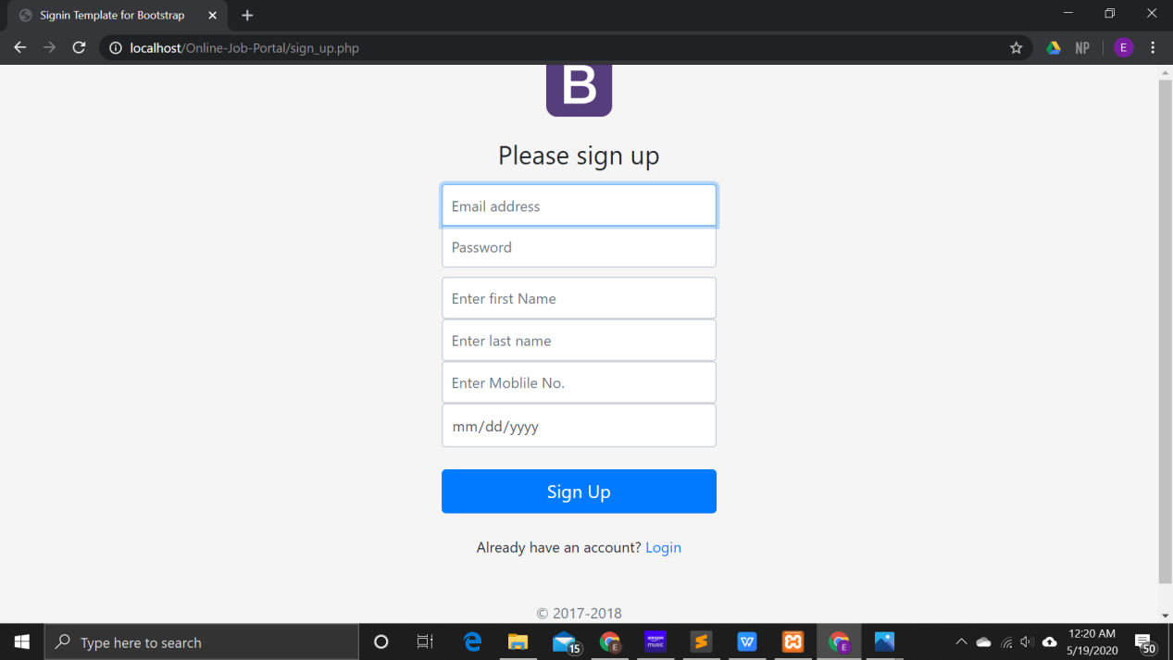

Entering values in search box for keywords and available category of job types

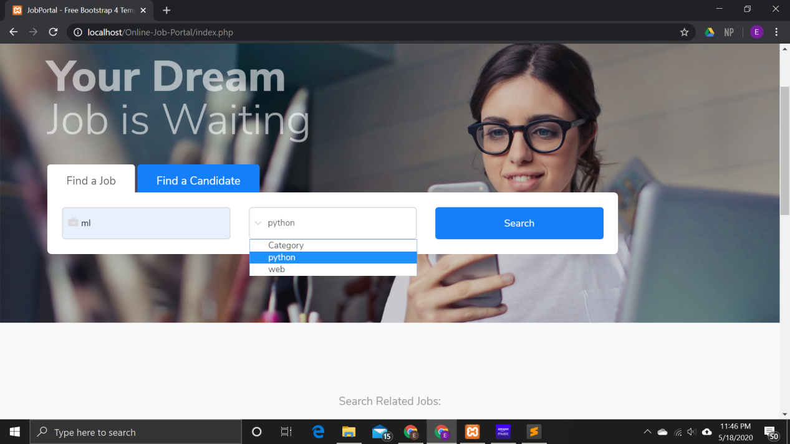

Getting search results:

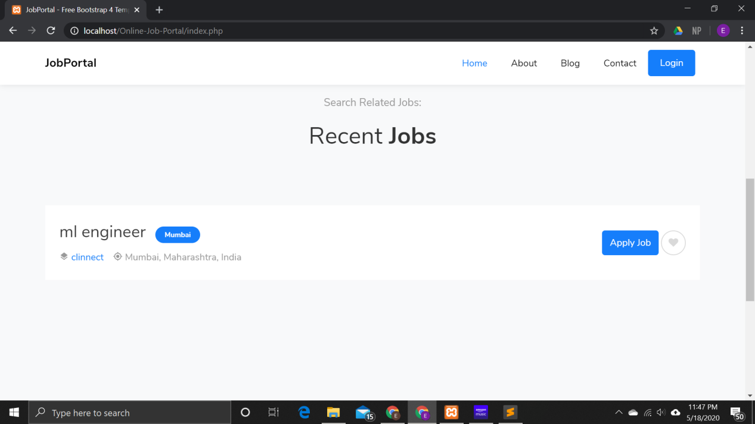

Clicking apply job leads to the following page :

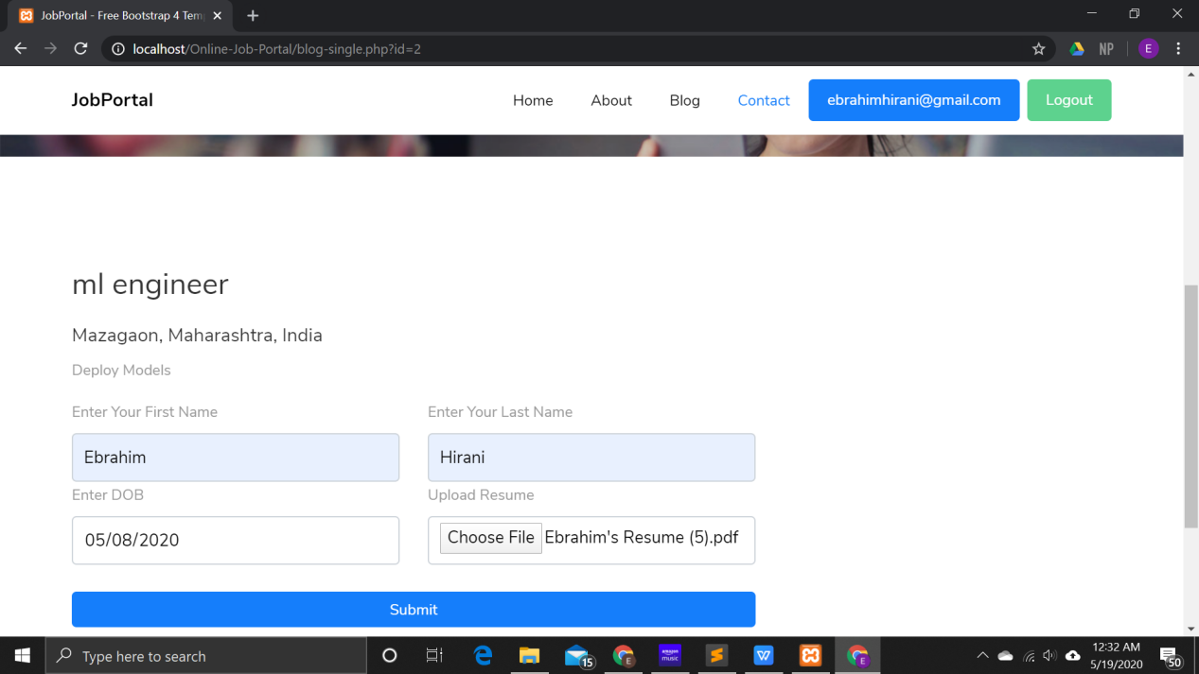

Clicking on submit submits the application to the company admin.

**Admins**

Login Page for super admins and customer admins are the same:

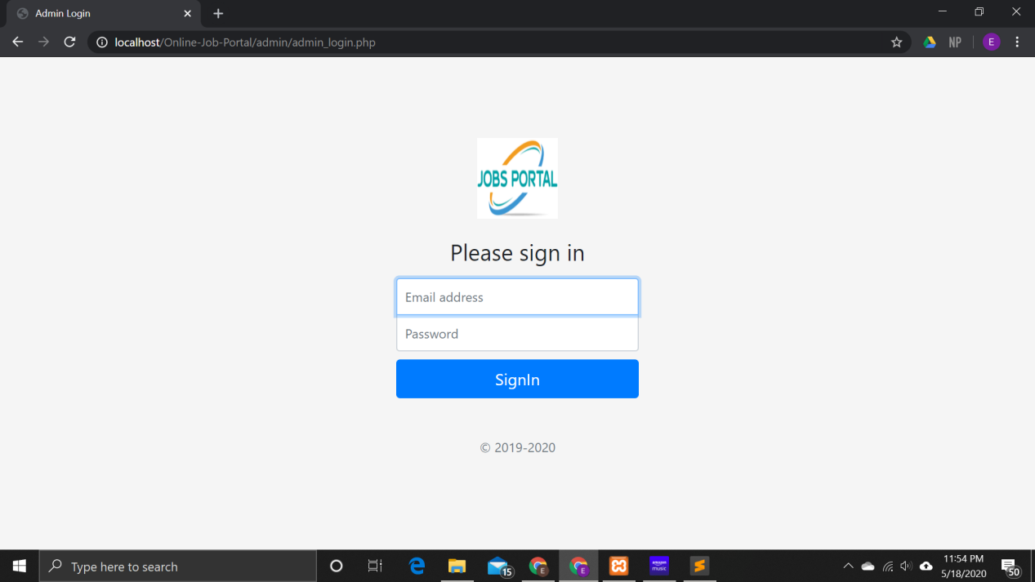

**Super Admin:**

Dashboard for the super admin consists of prompts to customer page, companies page and category pages

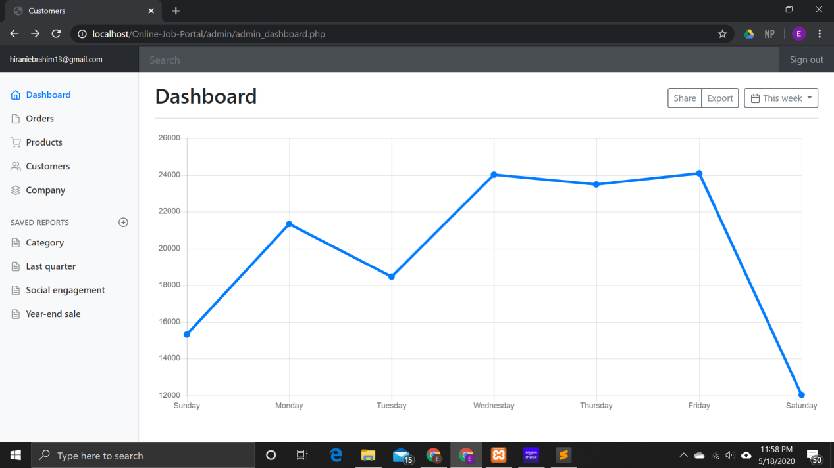

Clicking on customers takes admin to this page admin type 1 = super admin, 2 = customer admin:

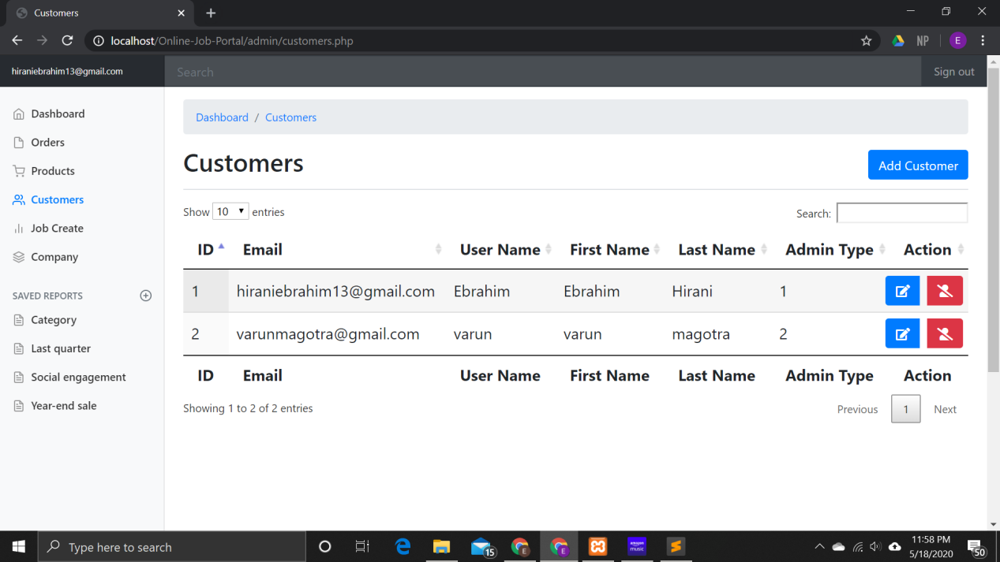

The admin can add, delete or edit customers:

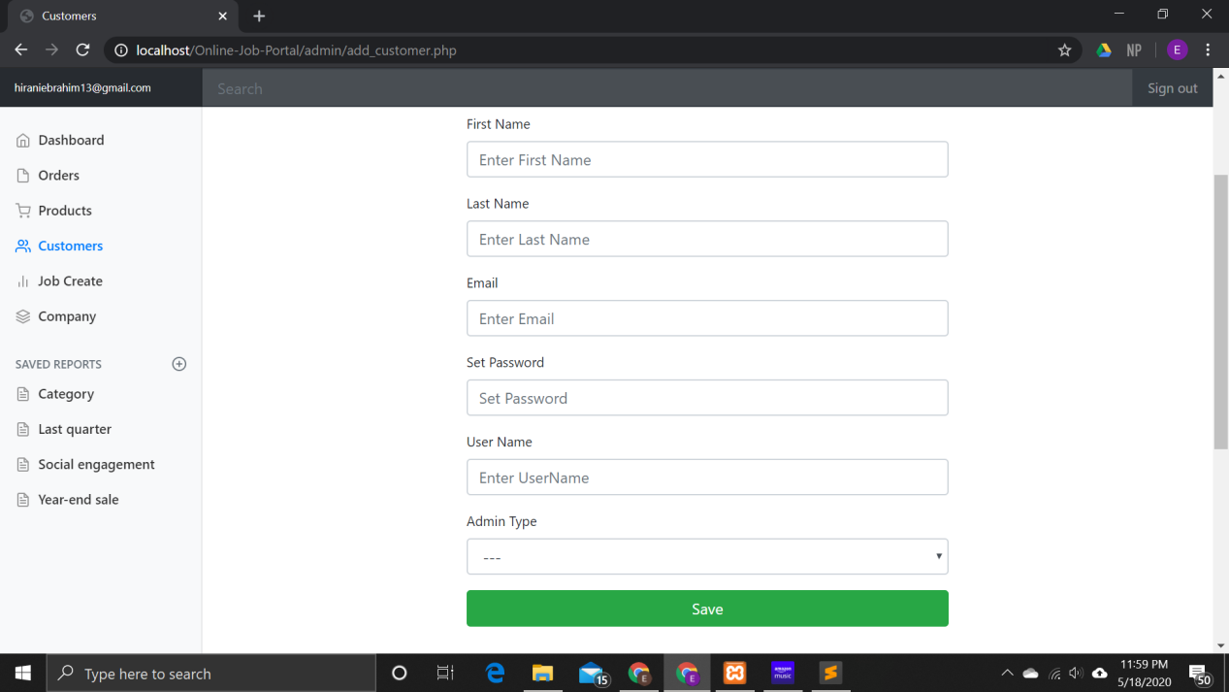

Clicking on company displays company and its admin, super admin can add more companies and edit and delete present ones:

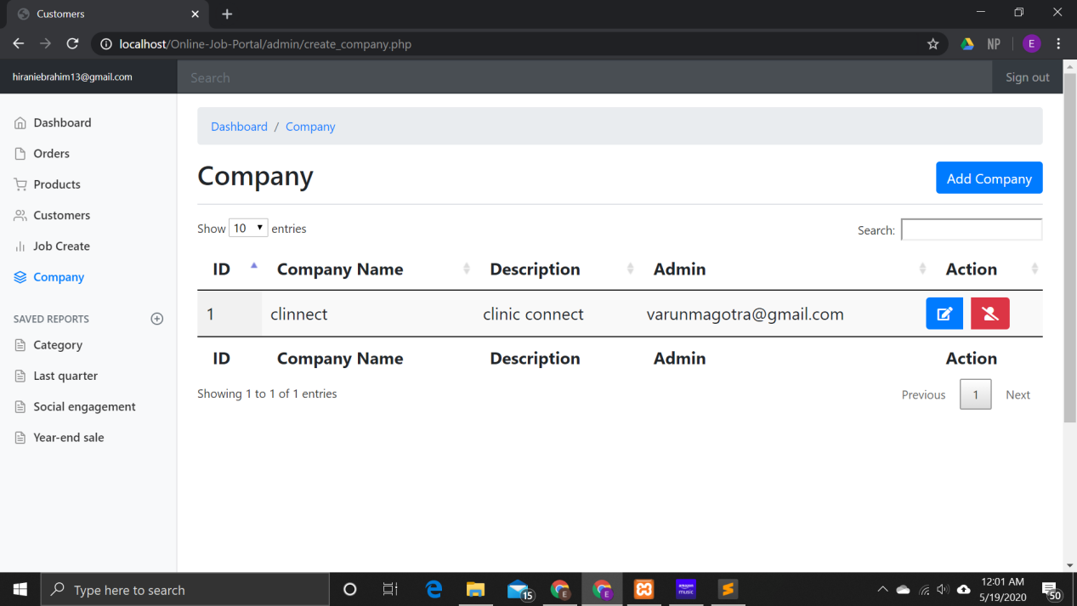

Clicking on add Company leads to the following page the super admin can assign customer admins to the respective companies :

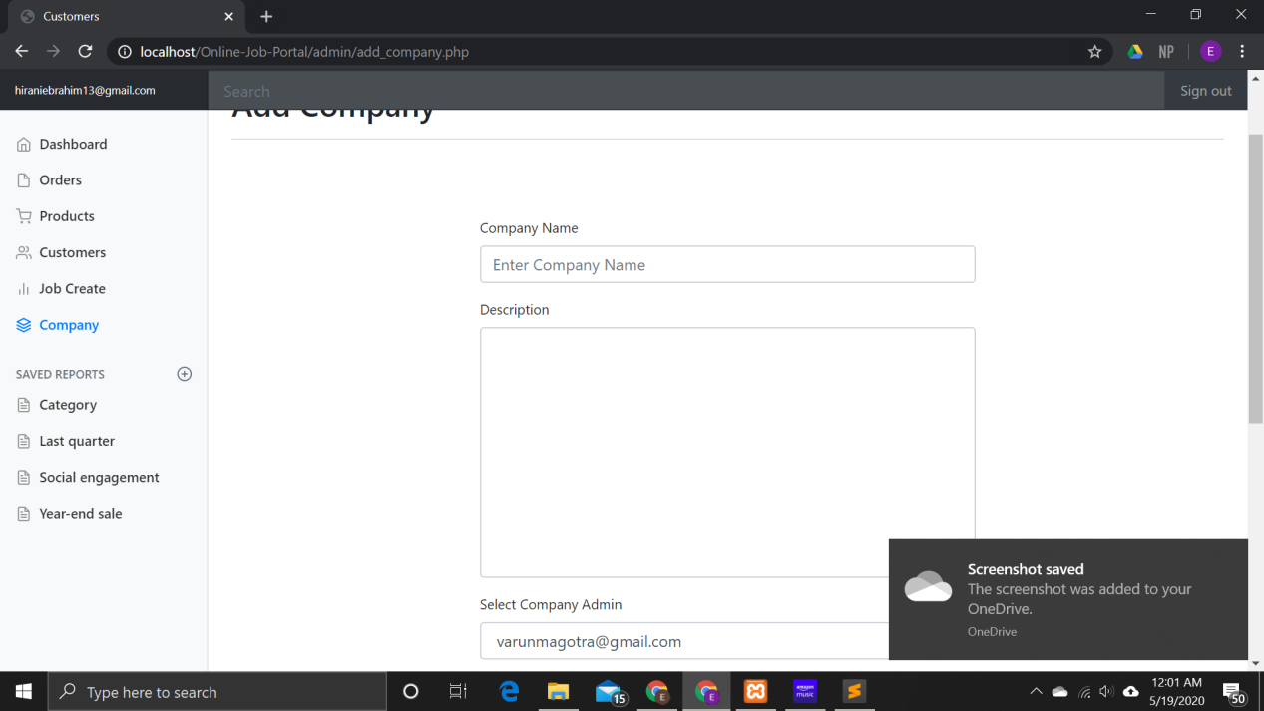

**Customer Admin:**

Dashboard consists of options to create jobs and see job application:

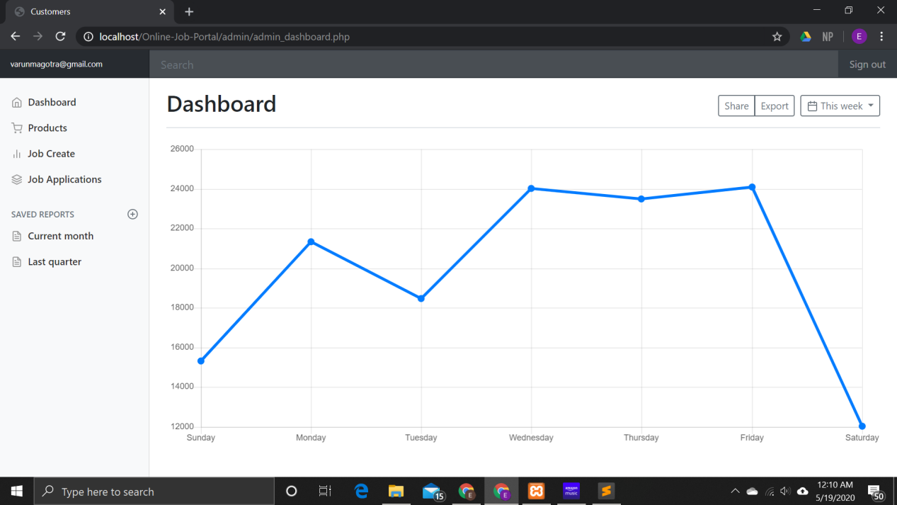

On clicking job applications the admin can view all different applications for his company.

Clicking on the download file link downloads the resume of the applicant:

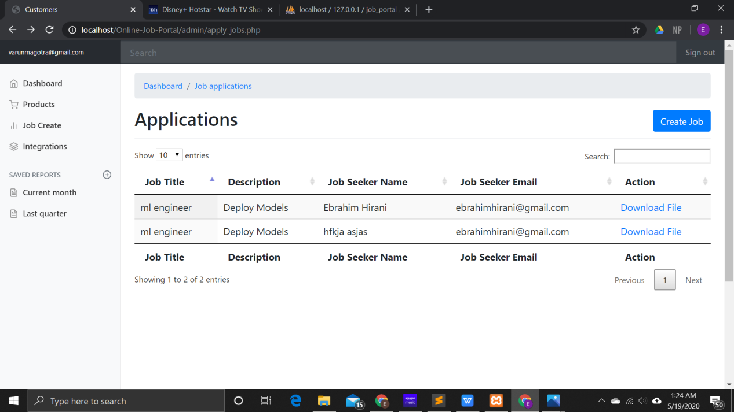

Clicking on Job Create displays all the jobs posted by the admin. They can create, delete and edit jobs.

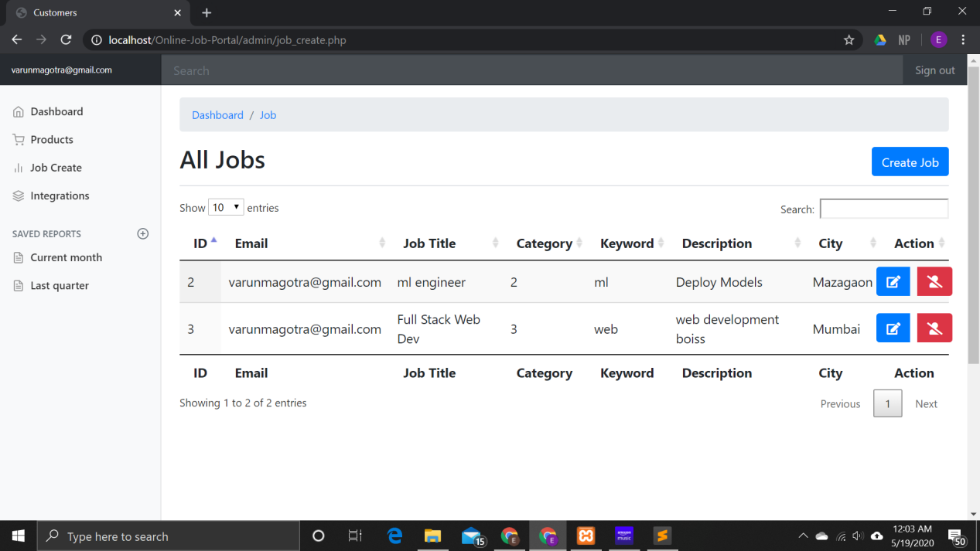

Clicking on create job opens this page:

