# AWS IAM Use Cases: Billing Access Creation & Troubleshooting

This document showcases real-world AWS IAM scenario focused on granting secure, temporary access and troubleshooting permission issues in the AWS Billing and Cost Management Console.

The example demonstrates hands-on AWS Identity and Access Management (IAM) configurations aligned with security best practices and principle of least privilege.

## Scenario 1: Granting Temporary Billing Console Access for Cost Optimization

### Background

Organizations often conduct quarterly cost optimization reviews. In this case:

Sarah (Financial Analyst, Finance Team) requires temporary AWS Billing Console access. She needs to review billing data, analyze usage reports, and create cost allocation tags. Sarah does not have an existing IAM user.Access should be time-limited and secure, with only the necessary permissions.

### Implementation Steps

1. Create a New IAM User

Navigate to IAM Console → Users → Add User.

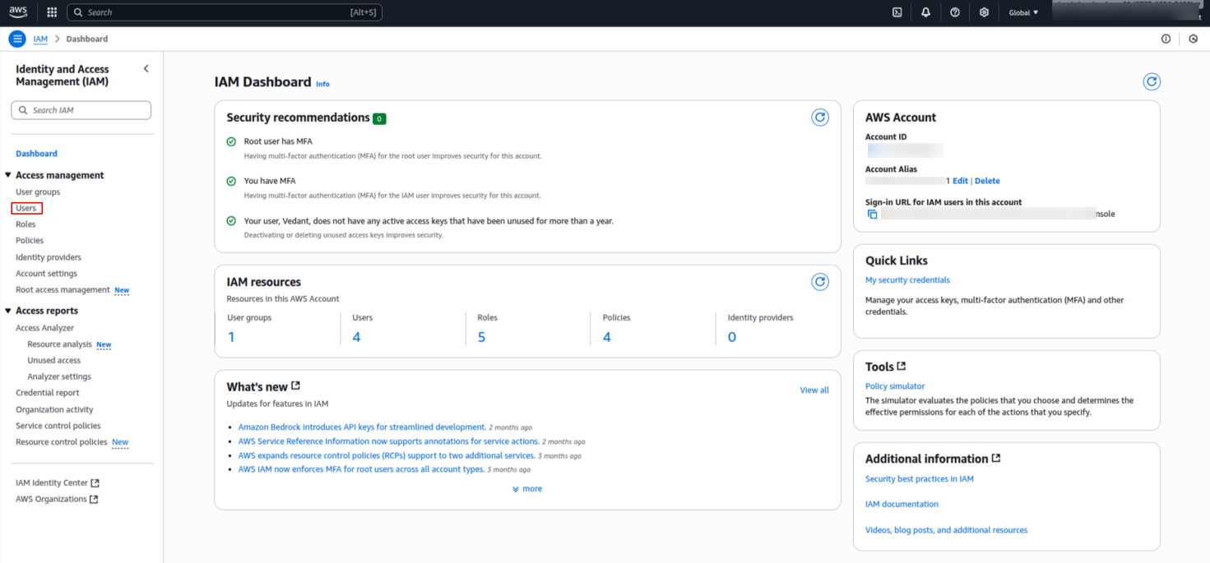

* + Enter the Username of your choice.
  + Select AWS Management Console Access.
  + Configure auto-generated password and enforce password reset at first login.

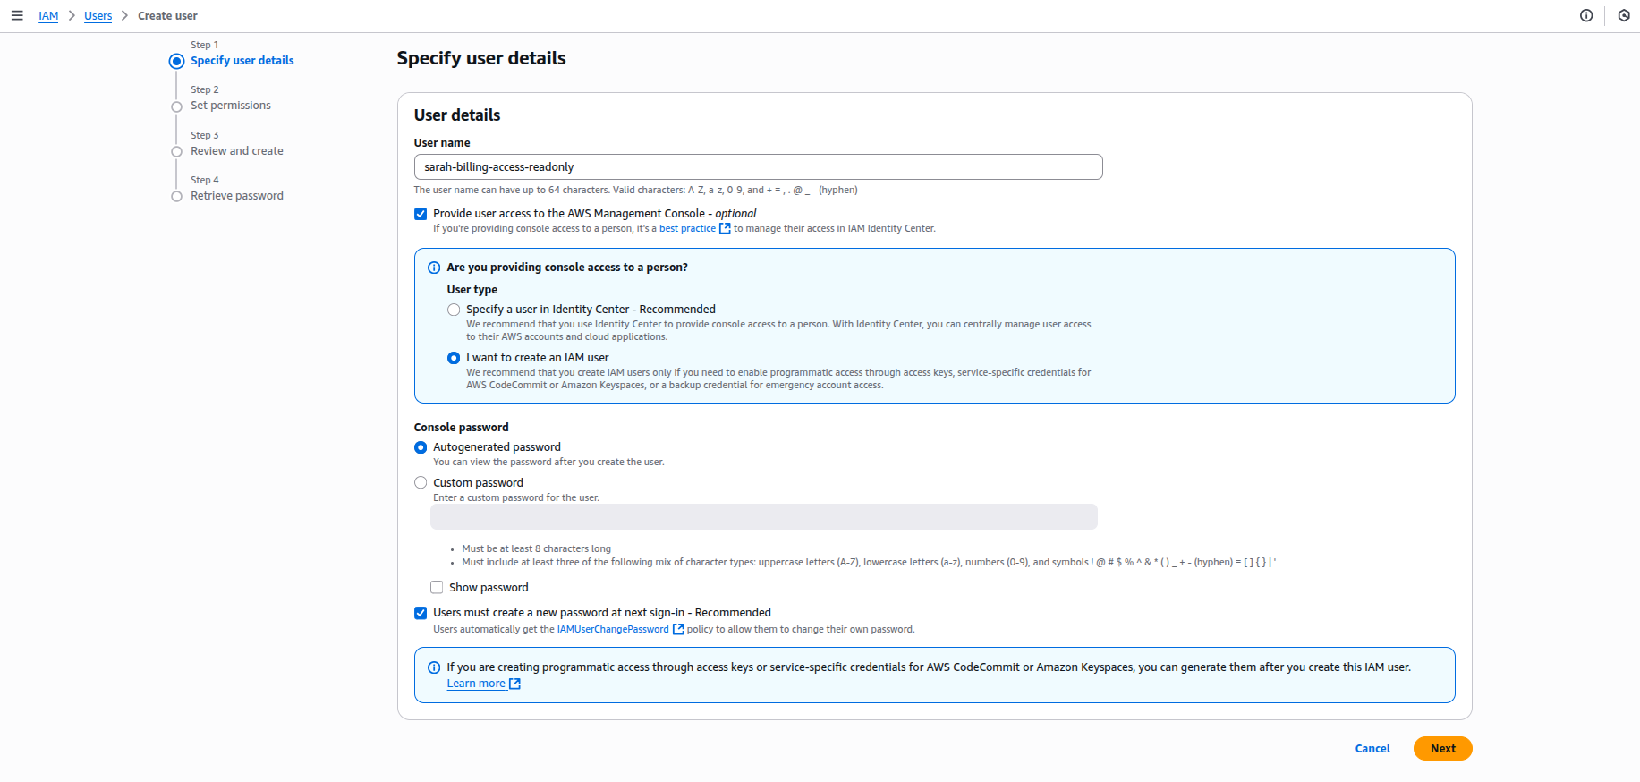

1. Attach Billing-Specific Policy
   * Click Next
   * Click **Attach Policies Directly**

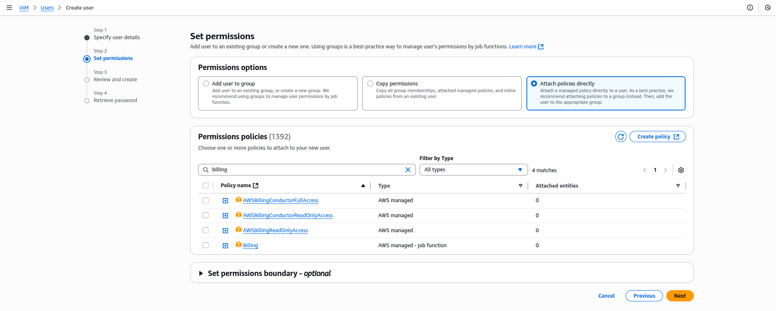

* + Click **Create Policy**
  + Select the services mentioned in below screenshot or copy the policy directly

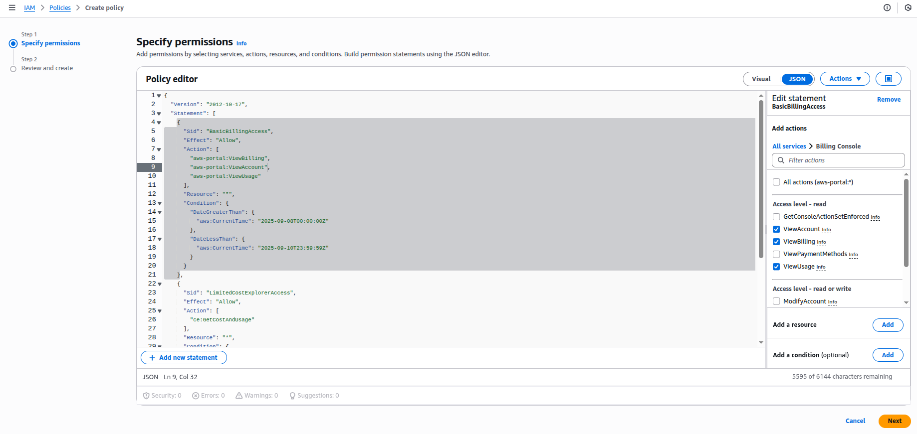

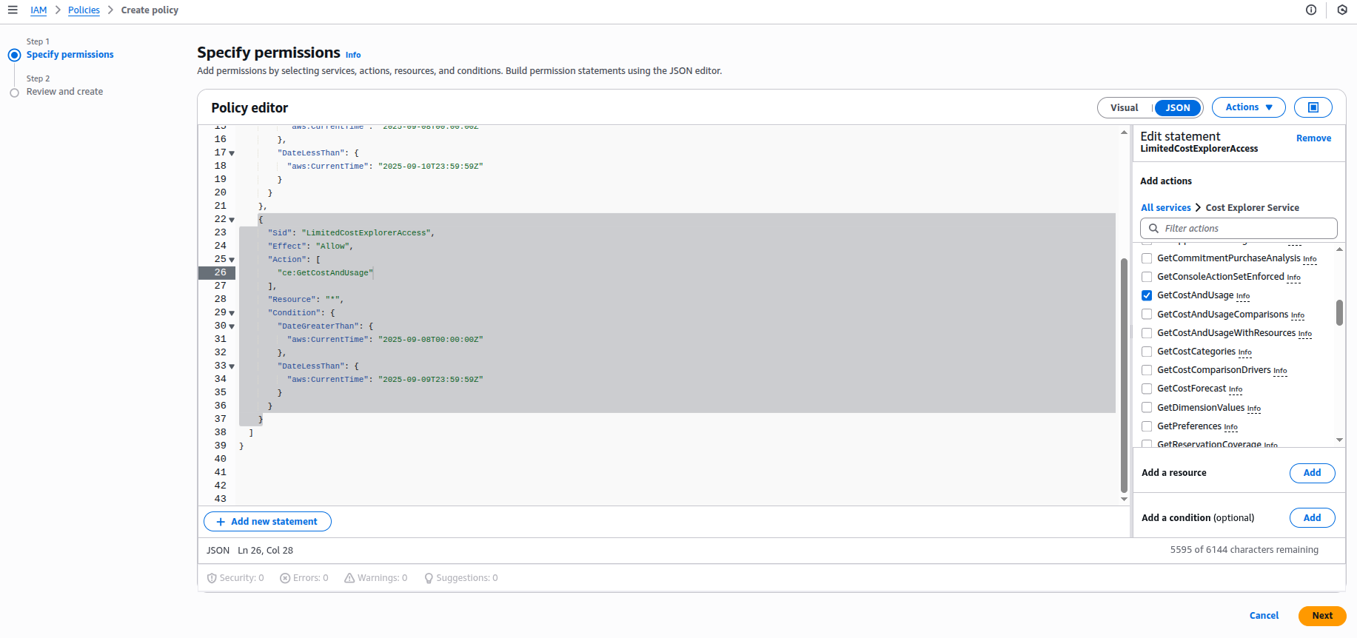

POLICY -

|  |
| --- |
| {  "Version": "2012-10-17",  "Statement": [  {  "Sid": "BasicBillingAccess",  "Effect": "Allow",  "Action": [  "aws-portal:ViewBilling",  "aws-portal:ViewAccount",  "aws-portal:ViewUsage"  ],  "Resource": "*",  "Condition": {  "DateGreaterThan": {  "aws:CurrentTime": "2025-09-08T00:00:00Z"  },  "DateLessThan": {  "aws:CurrentTime": "2025-09-10T23:59:59Z"  }  }  },  {  "Sid": "LimitedCostExplorerAccess",  "Effect": "Allow",  "Action": [  "ce:GetCostAndUsage",  "ce:GetUsageReport"  ],  "Resource": "*",  "Condition": {  "DateGreaterThan": {  "aws:CurrentTime": "2025-09-08T00:00:00Z"  },  "DateLessThan": {  "aws:CurrentTime": "2025-09-09T23:59:59Z"  }  }  }  ]  } |

* + Attach the Policy to the user and click **Next**

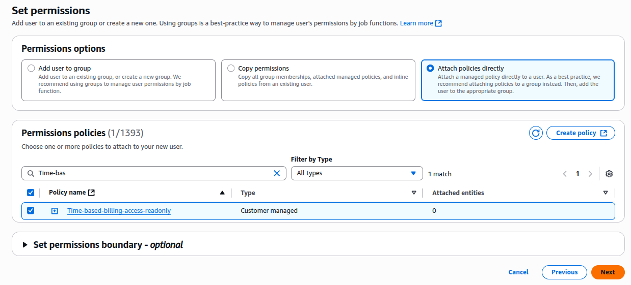

* + Review User Information and click **Create User**
  + Make sure to download the credentials or send it via email as this is the last time you can see the user credentials

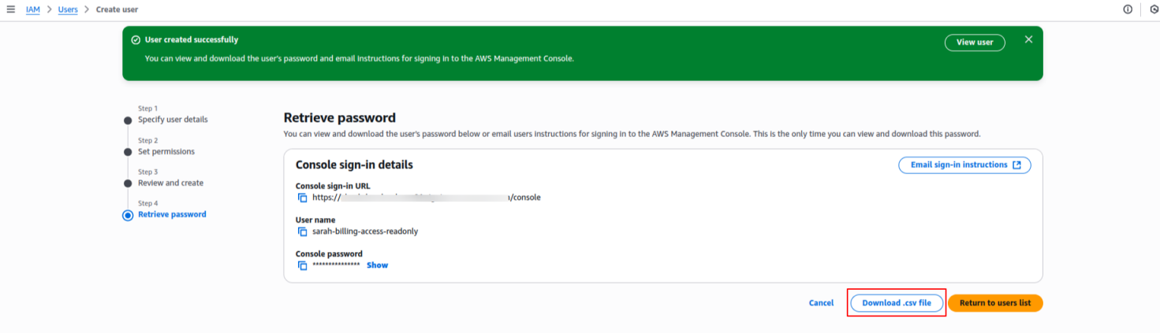

* + You can see the user being created sucessfully

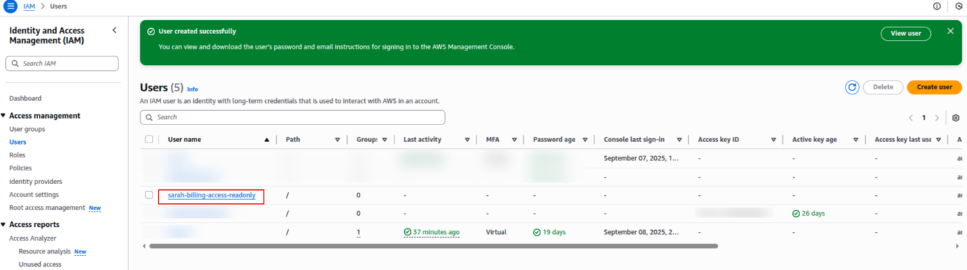

1. Login From the IAM User

* Using the credentials, login to the user.
* You’ll have to first change the password
* Following is the dashboard when the user navigates to **Billing Console**

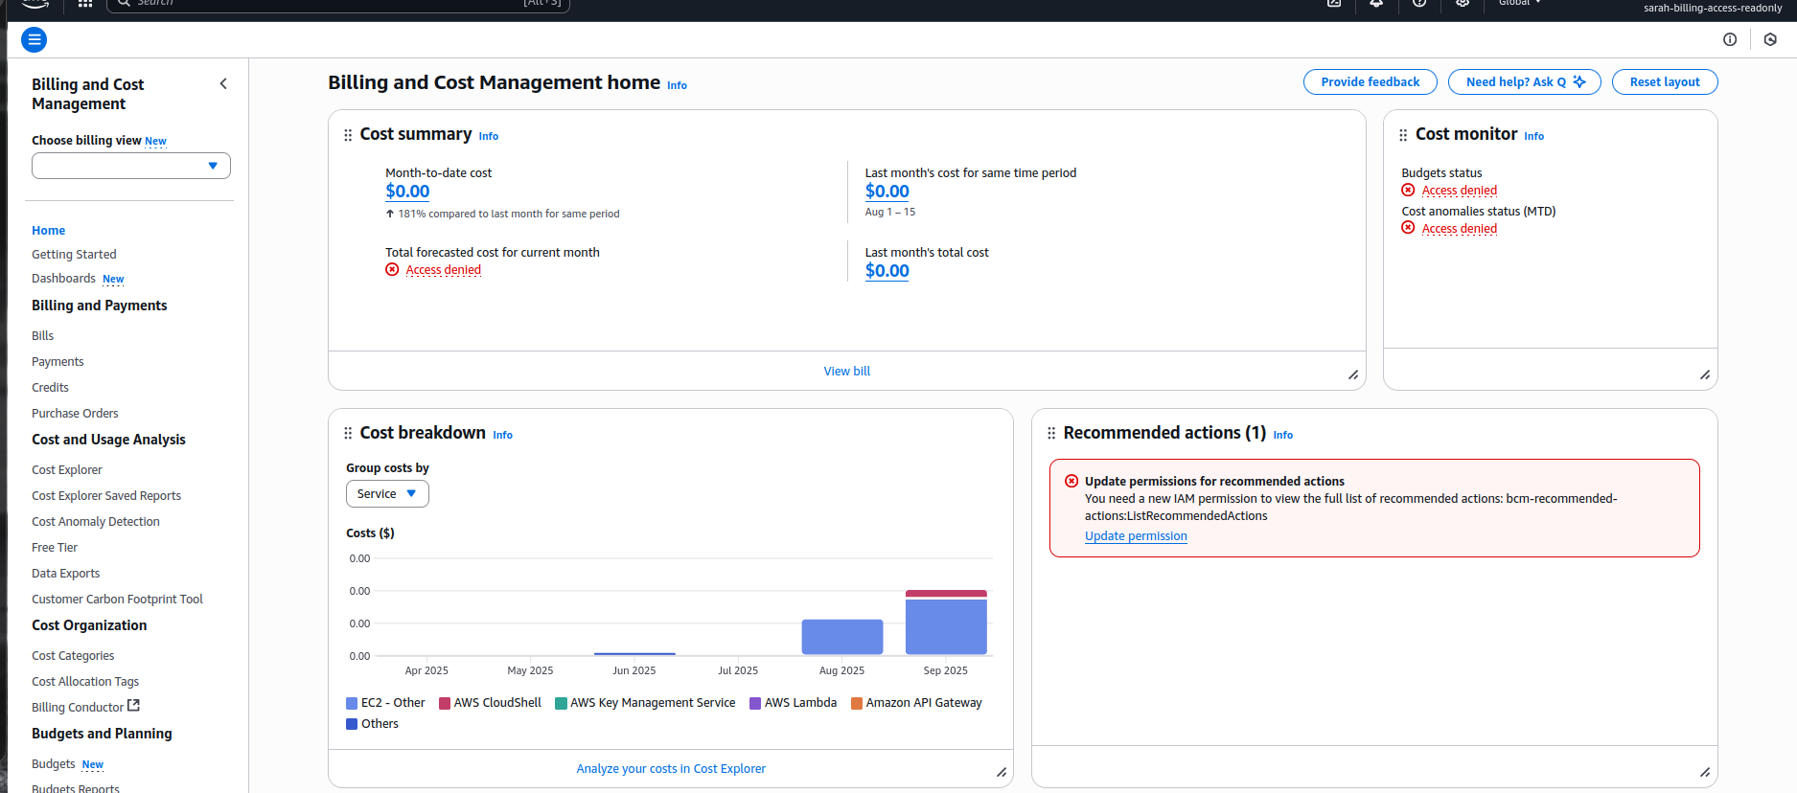

* Following is the dashboard when user navigates to **Cost Explorer**

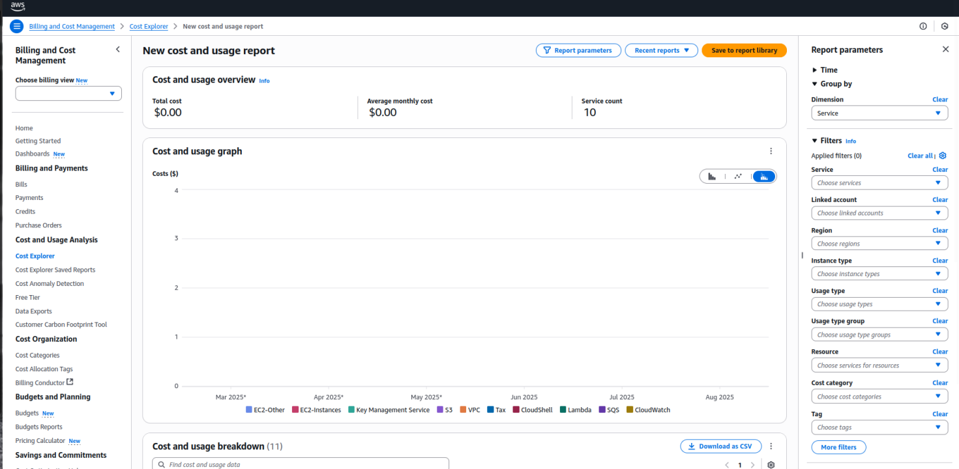

### Outcome

Sarah now has secure, temporary access to AWS Billing & Cost Explorer.  
This enables her to perform cost optimization analysis without exposing long-term risks.

**Scenario 2: Troubleshooting Billing Console Access Issues**

### **Background**

After initial access was granted, Sarah encounters issues:

* Can log in but sees “Access Denied” on Billing Dashboard.
* Lost access to Cost Explorer & billing reports (worked previously).
* Cannot create cost allocation tags due to insufficient permissions.

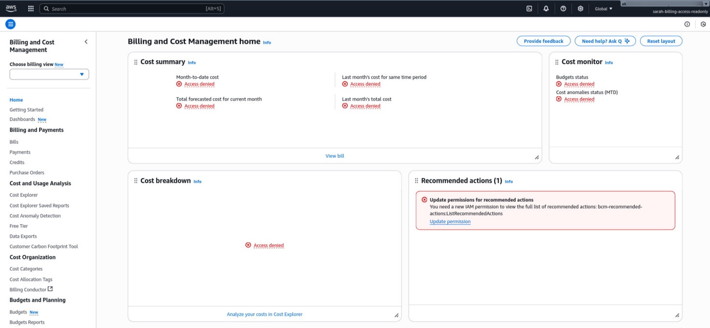

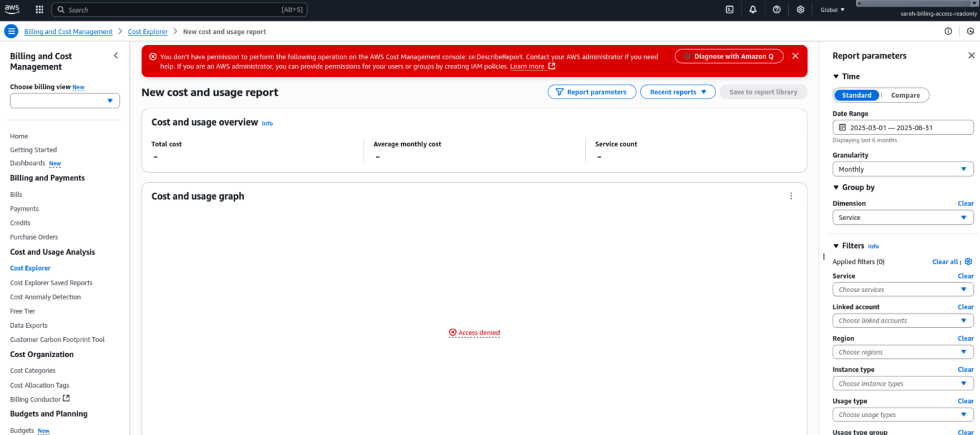

**Thought Process –**

1. Sarah confirms she has access to the Management Console ----> Her password is fine and not expired

2. She lost access to the services which she accessed earlier

3. We created a new IAM Policy so lets check that

Upon reviewing the policy, we identify taht the access issue were mainly due to the time based access control that we had set

Navigate to the Policy as follows -

* Your Account > IAM > Policies > Select the Policy we created in Step 2
* Click the Policy and Click Edit
* Change the date as per requirement.
* Save the policy

**User Sarah is now able to access the Billing and Cost Explorer Services**