**Three-Tier Architecture Deployment on AWS**

by – Vedant Chandanbatwe

**Index**

**Part 0: Setup Objectives:**

1. Download Code from GitHub Repository

2. IAM EC2 Instance Role Creation

3. S3 Bucket Creation

**Part 1: Networking and Security Objectives:**

1. Create VPC

2. Configure Subnets

3. Setup Route Tables

4. Attach Internet Gateway

5. Setup NAT Gateway

6. Configure Security Groups

**Part 2: Database Deployment Objectives:**

1. Deploy Database Layer

2. Configure Subnet Groups

3. Implement Multi-AZ Database Configuration Part 3: App Tier Instance Deployment

**Objectives:**

1. Create App Tier Instance

2. Configure Software Stack for Node.js Application

3. Setup Database Schema

4. Test Database Connectivity

**Part 4: Internal Load Balancing and Auto Scaling Objectives:**

1. Create AMI of App Tier Instance

2. Create a Launch Template

3. Configure Auto Scaling

4. Deploy Internal Load Balancer

**Part 5: Web Tier Instance Deployment Objectives:**

1. Update NGINX Configuration Files

2. Create a Web Tier Instance

3. Configure Software Stack for NGINX and React.js Website

**Part 6: External Load Balancer and Auto Scaling Objectives**:

1. Create AMI of Web Tier Instance

2. Create a Launch Template

3. Configure Auto Scaling

4. Deploy External Load Balancer

**Introduction**

This documentation outlines the steps to deploy a three-tier architecture on Amazon Web Services (AWS). The architecture consists of separate layers for presentation, application, and data, ensuring scalability, flexibility, and security.

Technologies, Services, and Tools Used:

• GitHub

• AWS Cloud (Amazon Web Services)

• EC2 (Elastic Compute Cloud)

• Security Groups

• AWS RDS (Relational Database Service)

• Route Table

• Internet Gateway

• NAT Gateway

• Nginx

• Elastic Load Balancer

• Auto Scaling Group

**Part 0: Setup**

Step-by-Step Guide:

1. Download Code from GitHub Repository:

• Clone or download the project code from the GitHub repository provided.

git clone https://github.com/aws-samples/aws-three-tier-web-

architecture-workshop.git

2. IAM EC2 Instance Role Creation:

• Create an IAM role for EC2 instances with necessary permissions for accessing AWS.

• Attach 2 policy - AmazonSSMManagedInstanceCore andAmazonS3ReadOnlyAccess

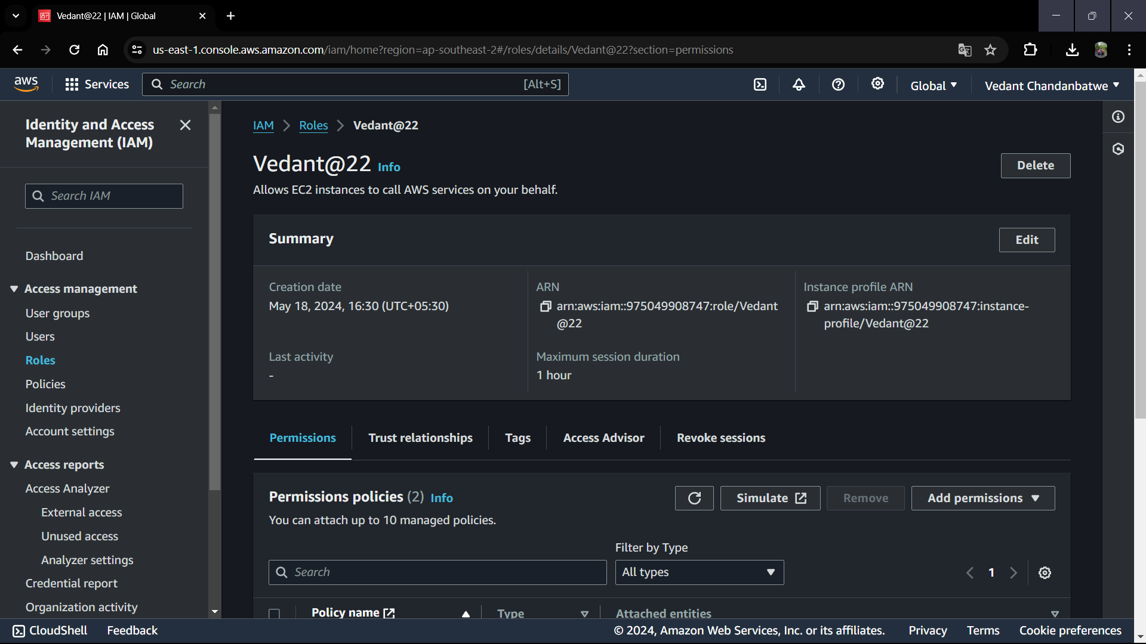

**3. S3 Bucket Creation**:

• Create an S3 bucket and accept the rest of the default settings to create the bucket.

It is used for storing assets or other resources required for the project.

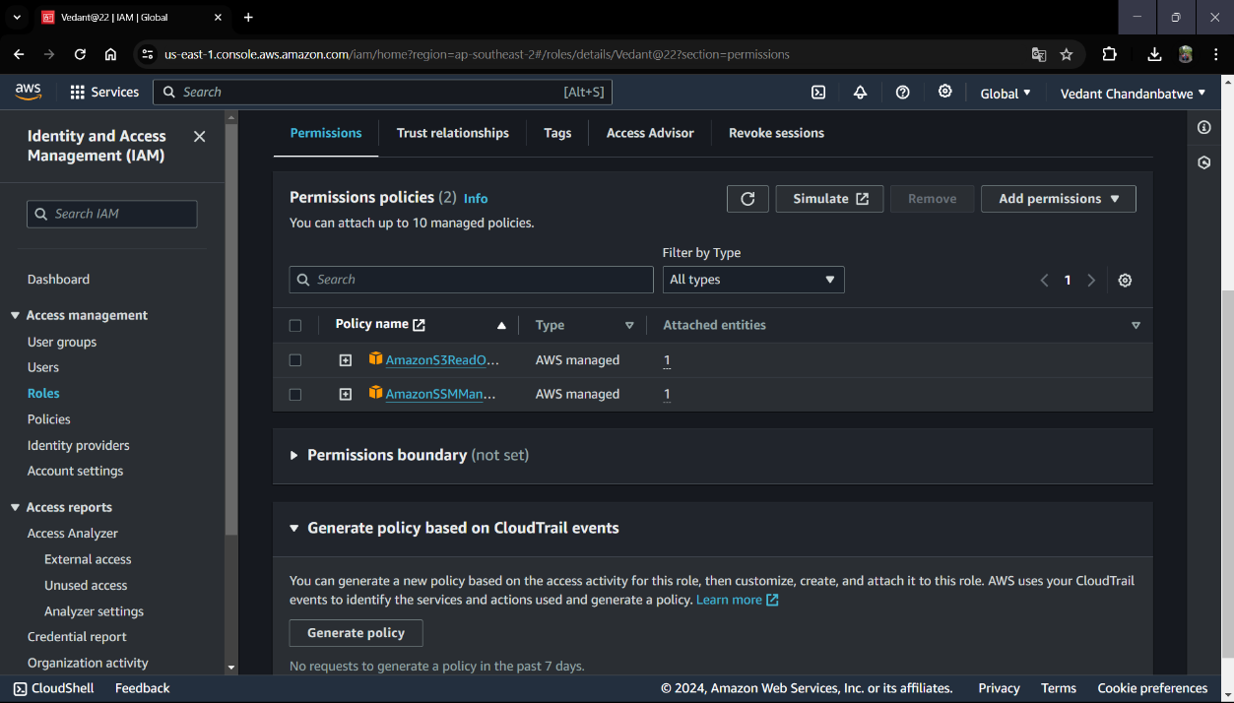

**Part 1: Networking and Security**

Step-by-Step Guide:

1. Create VPC:

• Set up a Virtual Private Cloud (3twebbapp-demo) to isolate the network environment.

• Define CIDR block (10.0.0.0/16)

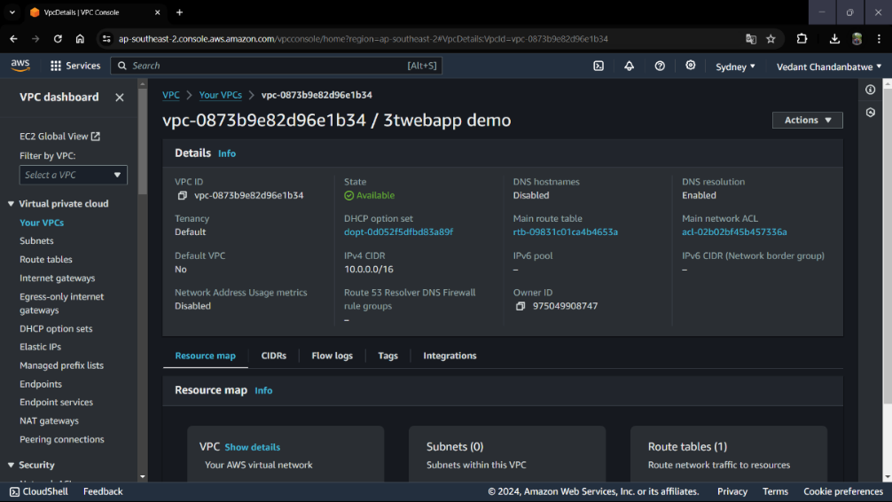

**2. Configure Subnets:**

• Created 2 public, 4 private subnets and 2 Availability Zone within the

VPC including CIDR Block.

• Private DB means (For Database)

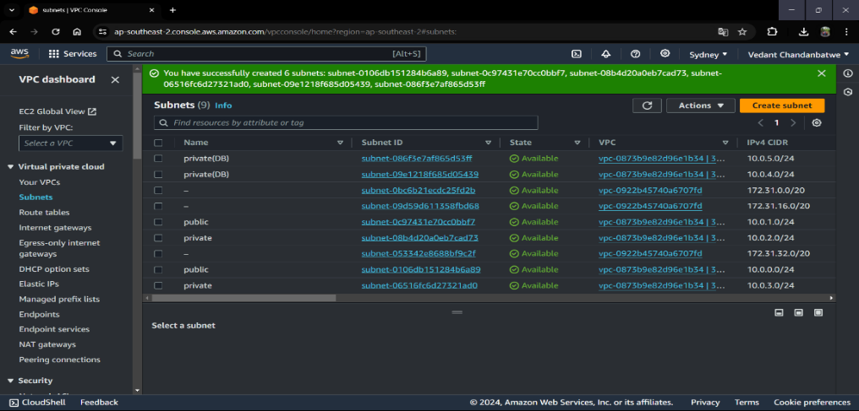

**3. Setup Route Tables:**

• Configured 2 route tables (Private-Route-Table & Public-Route-Table)

to control the routing of network traffic.

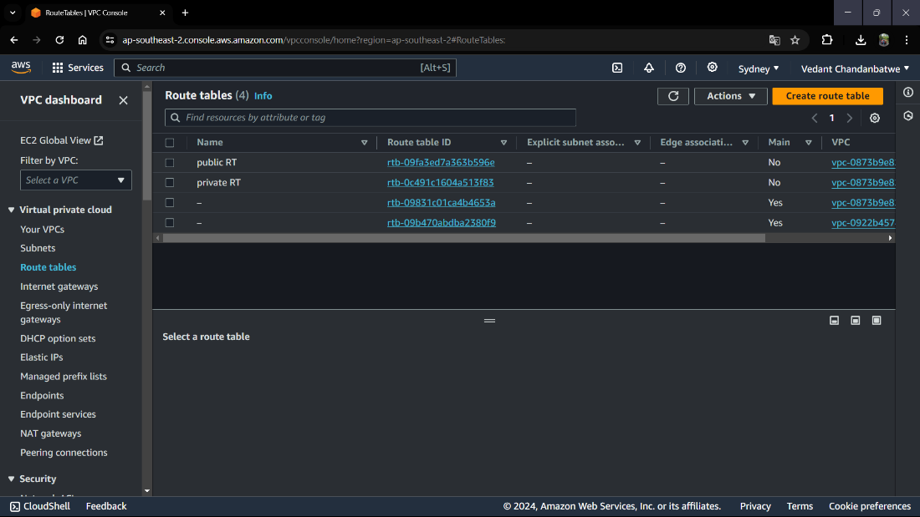

**4. Create and Attach Internet Gateway:**

• Create and Attach an Internet Gateway to the VPC for public internet

access.

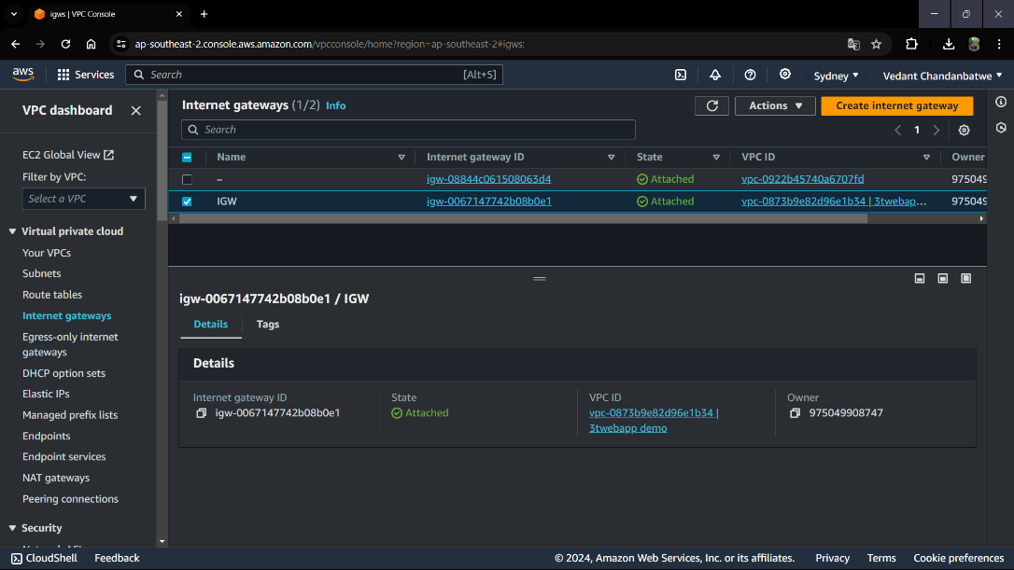

**5. Setup NAT Gateway:**

• Deploy a NAT Gateway for private subnet instances to access the

internet.

• While creating we will going to choose Public Subnet AZ-1 and for

Second NAT Gateway Public Subnet AZ-2 in which to create the NAT

Gateway.

• In Both NAT Gateways we will assign an Elastic IP.

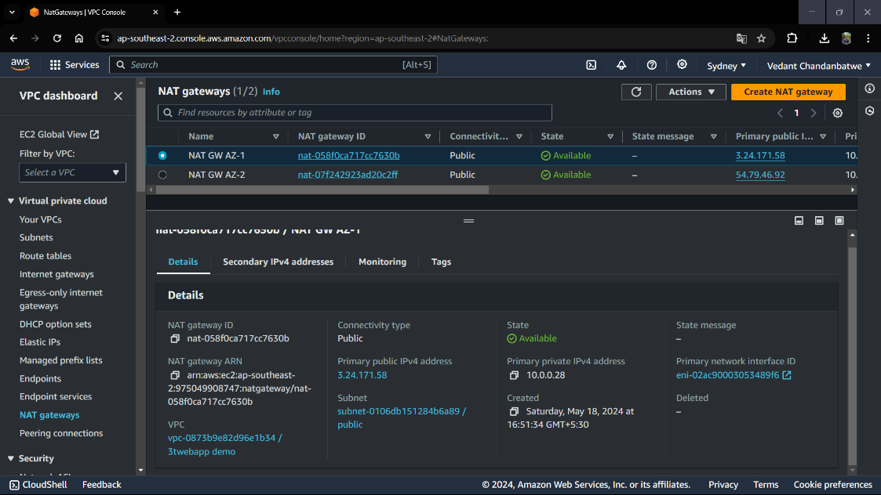

**6. Configure Security Groups:**

• Defined 5 security groups to control inbound traffic to EC2 instances,

RDS, and other resources.

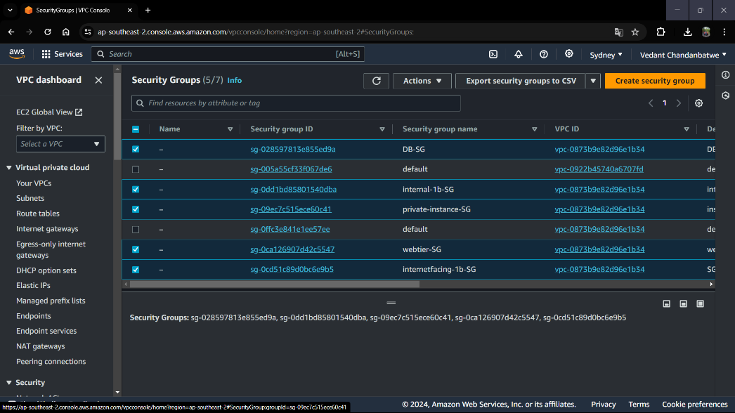

This is the Detail Configuration list of all 5 Security Group With Rules and Sources



Part 2: Database Deployment

Step-by-Step Guide:

1. Creating Subnet Group:

• After Going into the RDS service Click Subnet Group to create one and

add 2 Private-DB-Subnet (AZ-1 & AZ-2) For The Database Tier for

Added in Subnet Groups.

• Make Sure to select Both Availability Zones (1a & 1b) in the Creation of

the Subnet Group to ensure High Availability.

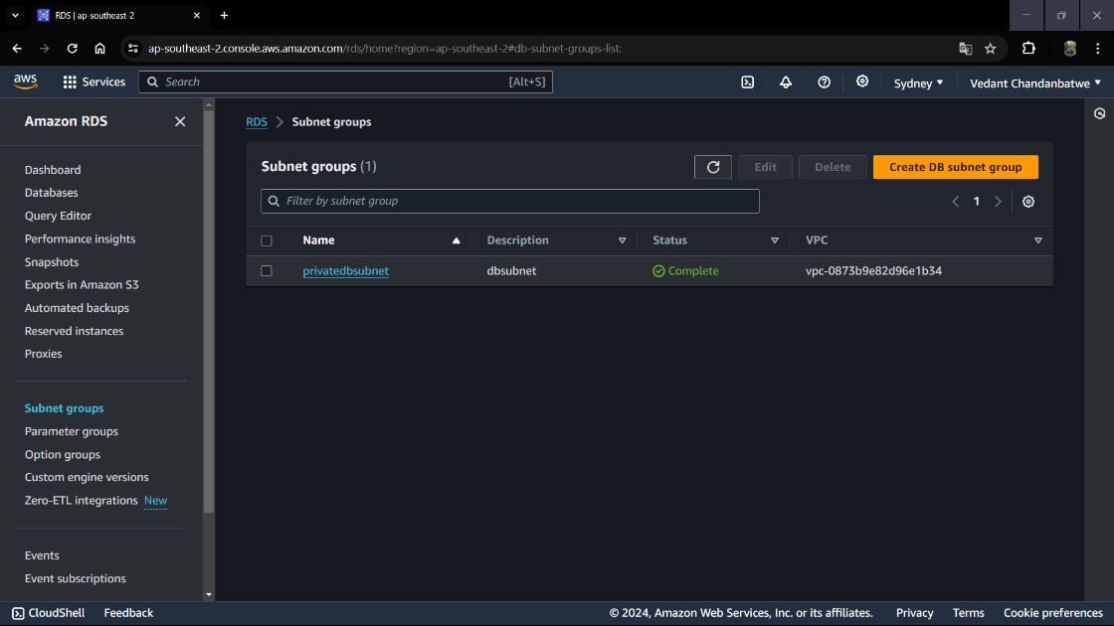

**Deploying Database**

1. Navigate to Databases on the left-hand side of the RDS dashboard and

click Create Database.

2. We will now go through several configuration steps. Start with a Standard

created for this MySQL-Compatible Amazon Aurora database. Leave the

rest of the defaults in the Engine options as default.

3. Under the Templates section, select the Dev/Test since this is not being used

for production now.

4. Under Settings Database cluster identifier, keep the default name database 1.

We will keep the username as ‘admin, set a password to welcome-db.’,

5. Under the Cluster storage configuration section, we will keep Aurora Standard

and keep the default option under Instance Configuration Next, under

Availability and Durability, we will keep the option to create an Aurora Replica

or reader node in a different availability zone as recommended along with our

VPC under Connectivity.

6. We will also choose the subnet group we created earlier and select no for

public access.

7. Now, let us set the security group we created for the database layer. We will

not make any changes under password authentication because password

authentication is always on. Click Create to create the database.

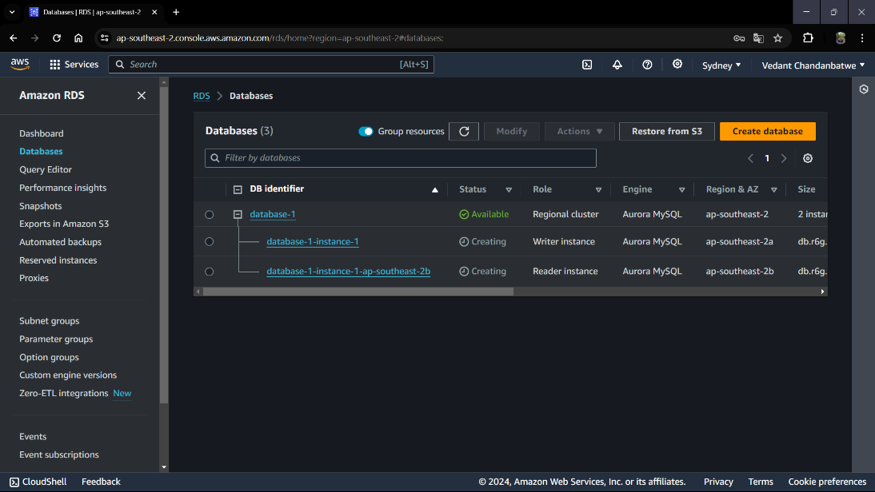

**Part 3: App Tier Instance Deployment**

Step-by-Step Guide:

1. Create My EC2 Instance:

• Launch an EC2 instance for hosting the application layer.

• Select Amazon Linux 2 AMI and select free tier eligible T.2 micro as

instance type.

• Next, we will proceed without a key pair for architecture.

• In Subnet select Private-Subnet-Az1 and under SG select Privateinstance-

SG

• In an additional setting attach the role which we have created at the

start.

• At last Launch the Instance.

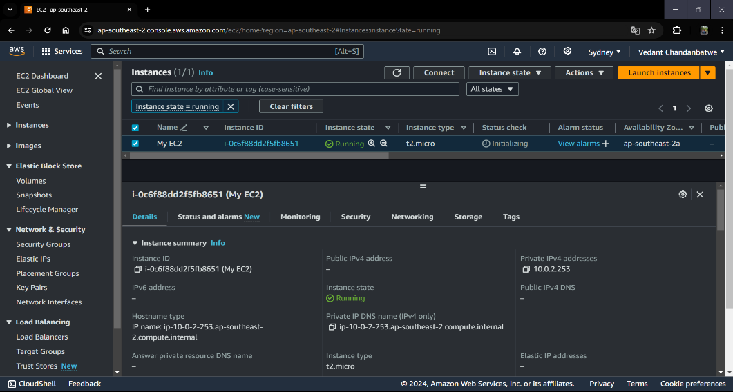

**2. Configure Software Stack for Node.js Application:**

• First Connect the instance through Session Manager.

• When you first connect to your instance, you will be logged in as ssmuser

which is the default user. Switch to ec2-user Sudo -su ec2-user.

• Now check that you are connected to the Internet By

Ping 8.8.8.8

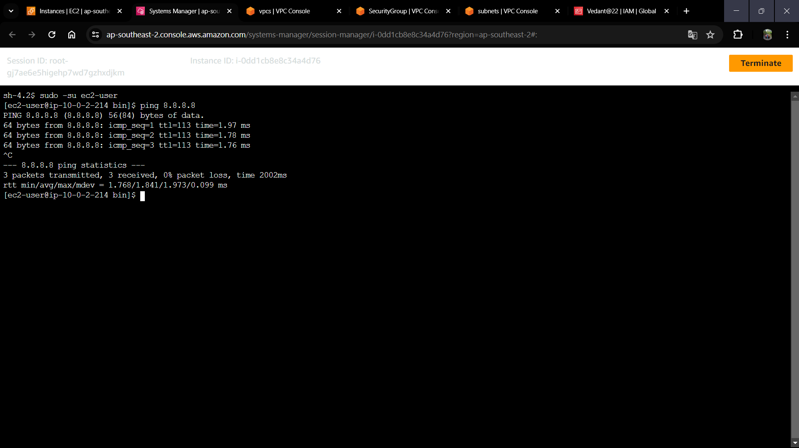

**3. Setup Database Schema:**

• Configure the database schema and tables required by the application.

• Run All these Commands for configuring the Database.

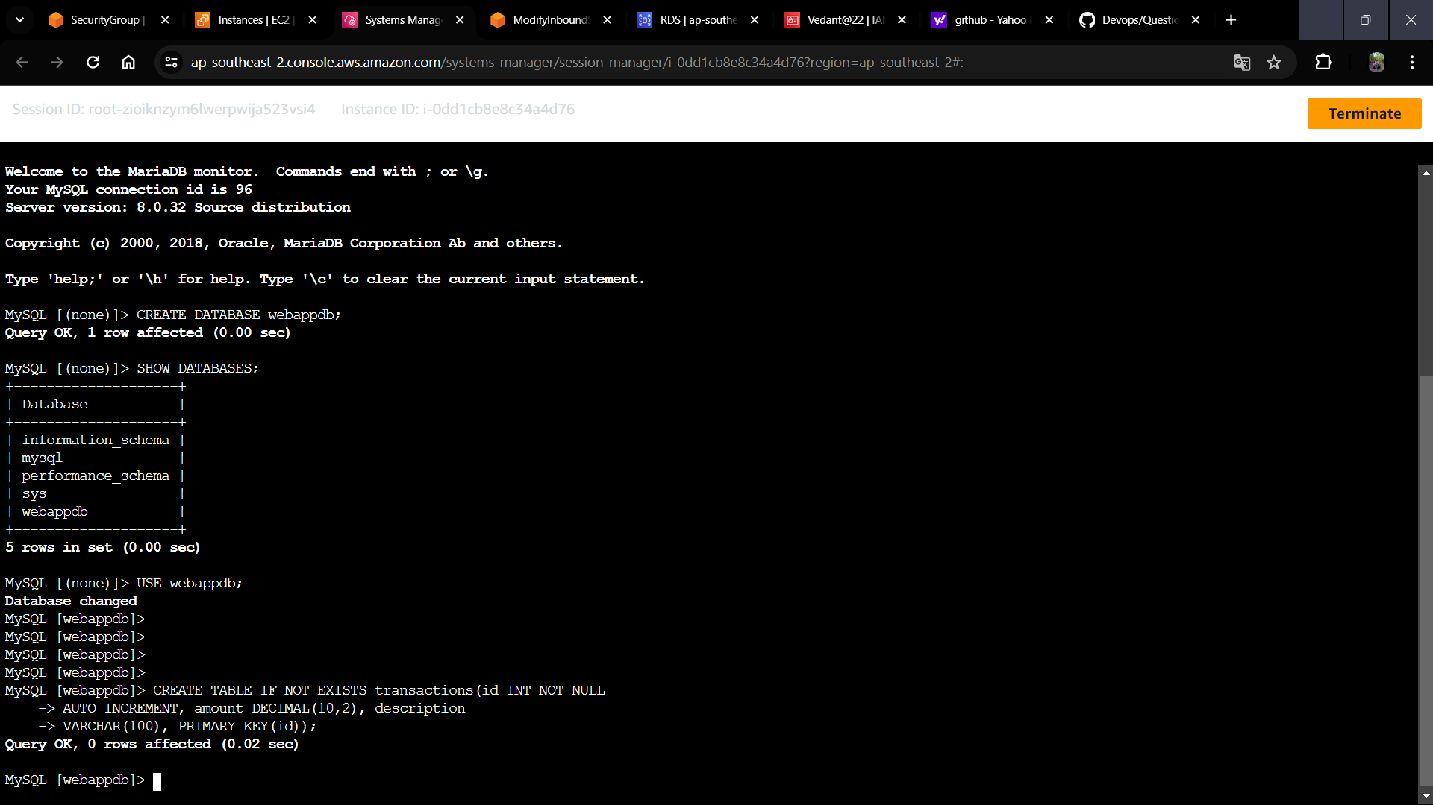

**Test App Tier**

Now let’s run a couple tests to see if our app is configured correctly and can retrieve

data from the database.

To check out our health check endpoint, copy this command into your SSM terminal.

This is our simple health check endpoint that tells us if the app is simply running.

sudo curl http://localhost:4000/health

The command responded with the following message: “This is the health check”

which means our health check is running correctly as indicated below.



Next, let’s test our database connection. We can do that by hitting the following

endpoint locally:

curl http://localhost:4000/transaction

Received the following response after executing the command.



The two above responses indicate that our networking, security, database, and app

configurations are correct. Our app layer is fully configured and ready to go.

**Part 5: Internal Load Balancing and Auto Scaling**

In this section, we will create an Amazon Machine Image (AMI) of the app tier instance we just created,

and use that to set up autoscaling with a load balancer in order to make this tier highly available.

**App Tier AMI:**

Let’s navigate to Instances on the left-hand side of the EC2 dashboard. Select the app tier instance we

created and under Actions select Image and Templates. Click Create Image.

Let’s give the image a name and description and then click Create image. This will take a few

minutes, but if you want to monitor the status of image creation you can see it by

clicking AMIs under Images on the left-hand navigation panel of the EC2 dashboard.

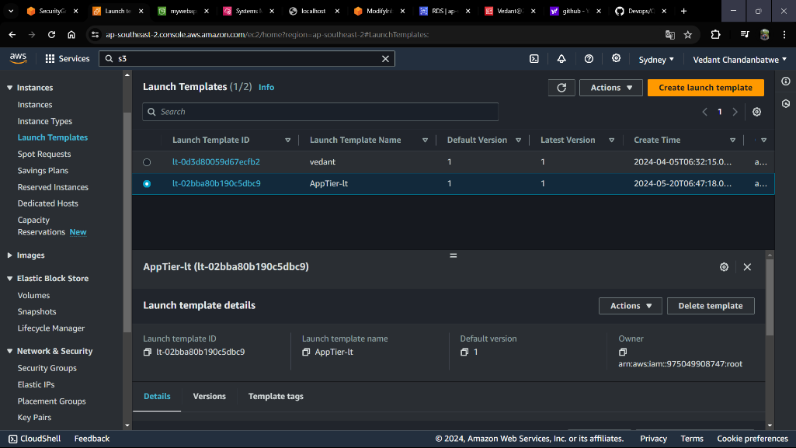

**Target Group**

While the AMI is being created, let’s go ahead and create our target group to use with the load balancer.

On the EC2 dashboard, navigate to Target Groups under Load Balancing on the left-hand side.

Click on Create Target Group.

The purpose of forming this target group is to use our load balancer so it may balance traffic across our private app tier instances. Let’s select Instances as the target type and give it a name.

Let’s set the protocol to HTTP and the port to 4000. Remember that this is the port our Node.js app is running on.

Select the VPC we’ve been using thus far, and then change the health check path to be /health to indicate the health check endpoint of our app and click Next.

We’ll NOT register any targets for now, so let’s just skip that step, click Next and create the target group.

**Internal Load Balancer**

We’re going to create an internal load balancer for our three-tier. On the left-hand side of the EC2

dashboard select Load Balancers under Load Balancing and click Create Load Balancer.

We’ll be using an Application Load Balancer for our HTTP traffic, give it a name (App-Tier-

Internal-lg), select Internal under Scheme, and click the create button for that option.

Let’s select the correct network configuration for our VPC and private subnets.

Next, select the security group we created for this internal ALB. Now, this ALB will be listening for HTTP traffic on port 80. It will be forwarding the traffic to our target group that we just created. Let’s select it from the dropdown list, and create the load balancer.

Internal Load Balancer is created with two availability zones.

Launch Template

Now, we need to create a Launch template with the AMI we created earlier before we configure Auto

Scaling. On the left side of the EC2 dashboard, let’s navigate to Launch

Template under Instances and click Create Launch Template.

Name the Launch Template, and then under Application and OS Images select MY AMI and

include the app tier AMI we previously created.

Under Instance Type select t2.micro. For Key pair and Network Settings don’t include it in the

template. We don’t need a key pair to access our instances and we’ll be setting the network information

in the autoscaling group.

Set the correct security group for our app tier, and then under Advanced details use the same IAM

instance profile we have been using for our EC2 instances.

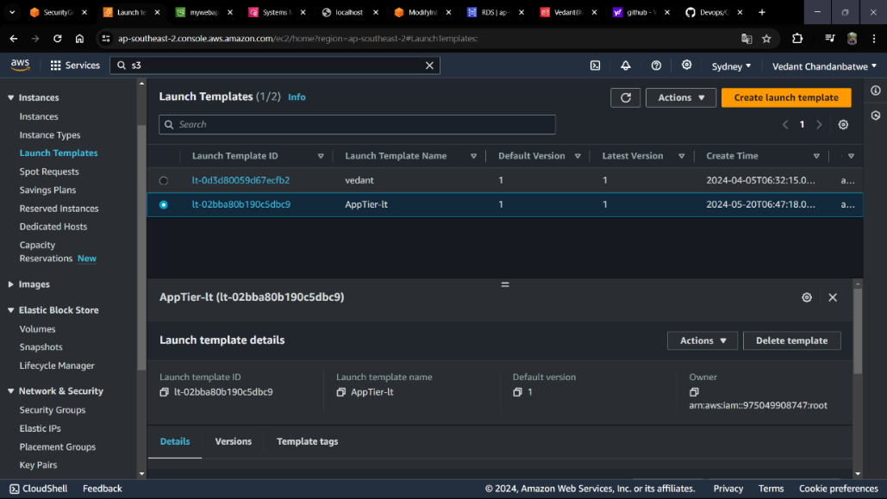

**Auto Scaling**

We will now create the Auto Scaling Group for our app instances. On the left-hand side of the EC2 dashboard, navigate to Auto Scaling Groups under Auto Scaling and click Create Auto Scaling Group.

Let’s give our Auto Scaling group a name, and then select the Launch Template we just created and click Next.

Next, we’re going to select on the Choose instance launch options page, set our VPC, and the private instance subnets for the app tier, and continue.

For this next step, we’ll attach this Auto Scaling Group to the Load Balancer we just created by selecting the existing load balancer’s target group from the dropdown. Then, click next.

We’re going to set the desired 2, minimum 2, and maximum 2 capacity of our Auto Scaling Group size and Scaling policies. Review and then Create Auto Scaling Group.

Let’s find out if our internal load balancer and autoscaling group are configured correctly. The autoscaling group will spin up 2 new app tier instances. We can test if this is working correctly by deleting one of our new instances manually and waiting to see if a new instance is booted up to replace it.

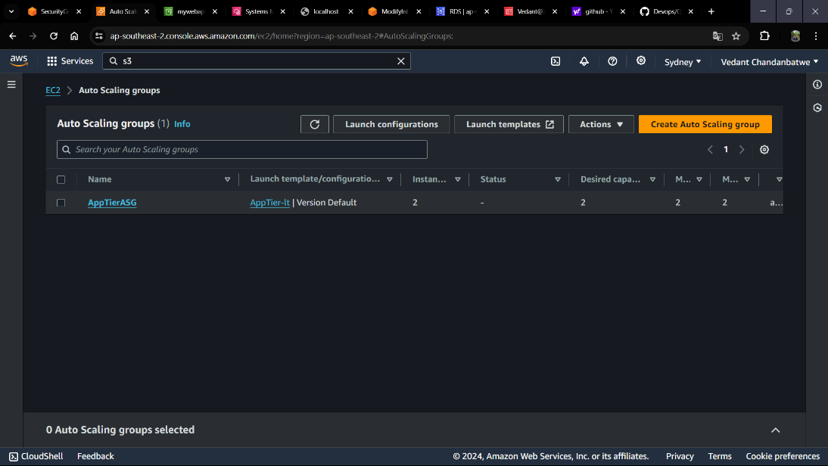

**Part 6: Web Tier Instance Deployment**

In this section, we will deploy an EC2 instance for the web tier and make all necessary software

configurations for the NGINX web server and React.js website.

• Update Config File

Before we create and configure the web instances (web tier), let’s modify the applicationcode/

nginx.conf file from the repo we previously downloaded. First, navigate to your internal

load balancer’s details page and copy the DNS entry into a notepad and save.

Next, open the folder where the repo was downloaded on your command prompt terminal to

update the application-code/nginx.conf file. Edit the file using this command:

vim nginx.conf

:set nu

Scroll down to line 58 and replace [INTERNAL-LOADBALANCER-DNS] with your internal load

balancer’s DNS entry. Save the file by pressing the ‘esc keypad, shift : + wq’ without the single quotes.

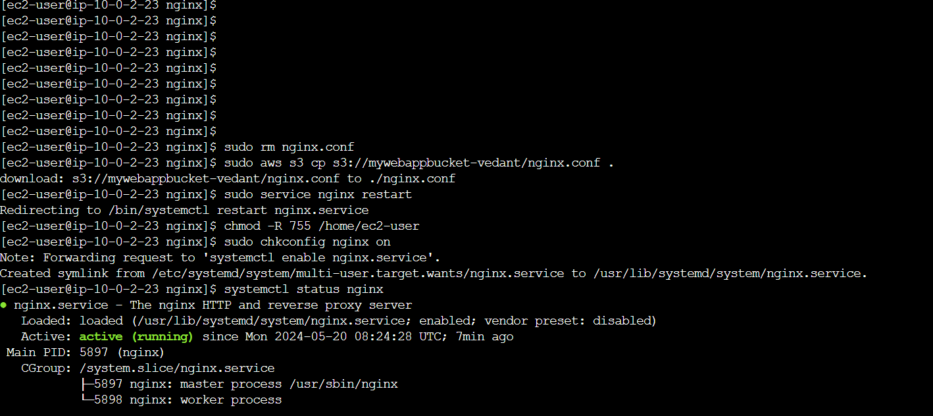

Now, let’s upload the ‘nginx.config’ file and the application-code/web-tier folder to the s3

bucket we created for this lab. Navigate back to the Amazon S3 dashboard, click ‘Buckets’ on the

left hand, and select our bucket | Upload.



**Web Instance Deployment**

Using the EC2 service dashboard, click on Instances on the left-hand side and then Launch

Instances to start the process.

Let’s name our app instance ‘Web-Tier’ for the three-tier architecture and select the Amazon Linux

2 AMI for our application and operating system image.

We’ll be using the free tier eligible T.2 micro instance type so let’s select that to proceed.

Even though ‘Proceed without a key is (Not recommended)’, we’ll proceed without a key pair for architecture.

Earlier we created a security group for our public web layer instances, so go ahead and select that along

with our VPC and the ‘public-web-subnet-az-1' under Network settings.

We’ll keep the default configuration settings for Configure storage, and in advanced details add

IAM role ec2-three-tier-access-role that we have created at starting, but review the Summary,

and click Launch instance to create the ‘appLayer’ instance.

**Connect to Instance**

Let’s follow the same steps we used to connect to the first app instance and change the user to ec2-

user. Test connectivity here via ping as well since this instance should have internet connectivity:

sudo -su ec2-user

ping 8.8.8.8

Note: If you don’t see a transfer of packets then you’ll need to verify your route tables attached to the

subnet that your instance is deployed in.

I was able to ping the Google server IP Address 8.8.8.8 from the App Tier instance command prompt

terminal successfully.

**Configure Web Instance**

We now need to install all of the necessary components needed to run our front-end application. Let’s

start by installing NVM and node on the instance

curl -o- https://raw.githubusercontent.com/nvmsh/

nvm/v0.38.0/install.sh | bash

source ~/.bashrc

nvm install 16

nvm use 16

Now we need to download our web tier code from our s3 bucket:

cd ~/

aws s3 cp s3://BUCKET_NAME/web-tier/ web-tier --recursive

Replace [BUCKET_NAME] with your bucket name.

Navigate to the web-layer folder and create the build folder for the react app so we can serve our code

using the below commands:

cd ~/web-tier

npm install

npm run build

NGINX can be used for different use cases like load balancing, content caching etc, but we will

be using it as a web server that we will configure to serve our application on port 80, as well as

help direct our API calls to the internal load balancer. Let’s run the below command to

proceed

sudo amazon-linux-extras install nginx1 –y

We will now have to configure NGINX. Navigate to the Nginx configuration file with the following

commands and list the files in the directory:

cd /etc/nginx

ls

Let’s update the ‘nginx.conf’ file with the one we uploaded to S3 bucket. We’ll remove the file and

replace the bucket name below:

sudo rm nginx.conf

sudo aws s3 cp s3://BUCKET_NAME/nginx.conf .

The bucket name should be replaced.

Let’s restart Nginx with the following command:

sudo service nginx restart

Let’s make sure Nginx has permission to access our files by executing the command:

chmod -R 755 /home/ec2-user

And to make ensure the service starts on boot, run this command:

sudo chkconfig nginx on

Now let’s copy and plug in the public IP of our web tier instance to see our website. The public IP can be

found on the App Tier Instance details page on the EC2 dashboard. Voila, the website is working

correctly.



Let’s do the same for our database tier and if it’s connected and working correctly.

**Part 7: External Load Balancer and Auto Scaling**

In this section of the workshop, we will create an Amazon Machine Image (AMI) of the web tier

instance we just created, and use that to set up autoscaling with an external facing load balancer in

order to make this tier highly available.

Web Tier AMI

Let’s go to Instances on the left-hand side of the EC2 dashboard. Select the web tier instance we

created and under Actions select Image and Templates. Click Create Image.

We’ll give the image a name and description and then click Create image. This will take a few

minutes, but if you want to monitor the status of image creation you can see it by

clicking AMIs under Images on the left-hand navigation panel of the EC2 dashboard.

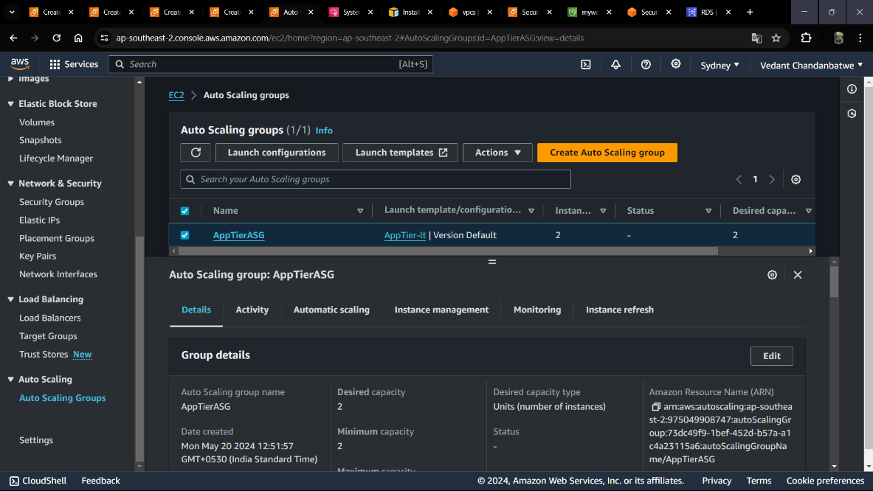

**Target Group**

On the EC2 dashboard let’s navigate to Target Groups under Load Balancing on the left-hand side.

Click on Create Target Group.

The purpose of forming this target group is to use our load balancer so it may balance traffic across our public web tier instances. Select Instances as the target type and give it a name.

Let’s set the protocol to HTTP and the port to 80. Remember this is the port NGINX is listening on.

Select the VPC we’ve been using thus far, and then change the health check path to be /health.

Click Next.

Go ahead and create the target group. We are NOT going to register any targets for now.

Internet Facing Load Balancer

On the left-hand side of the EC2 dashboard select Load Balancers under Load Balancing and click Create Load Balancer.

Select Application Load Balancer for our HTTP traffic. Click the Create button for that option.

After giving the load balancer a name, be sure to select internet facing since this one will not be public facing, but rather it will route traffic from our web tier to the app tier.

Select the two public subnets to proceed.

Select the security group we created for this internal ALB. Now, this ALB will be listening for HTTP traffic on port 80. It will be forwarding the traffic to our target group.

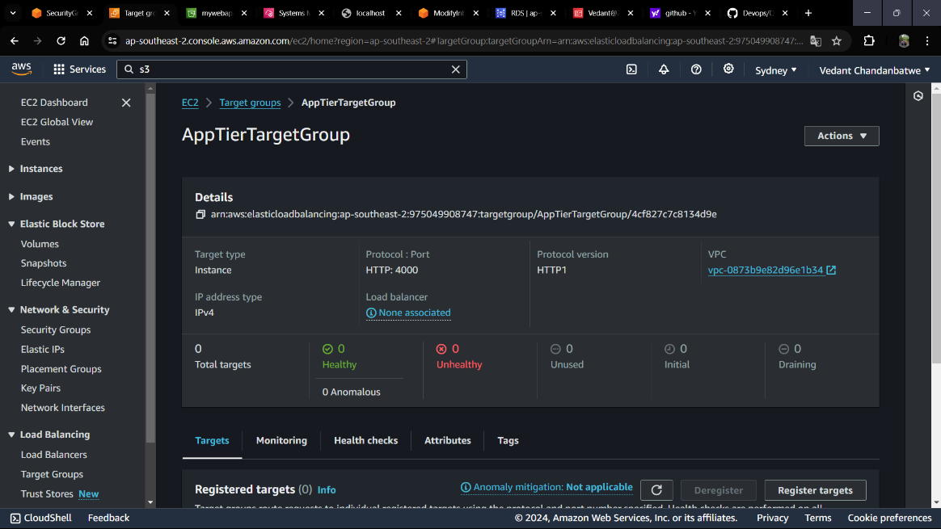

**Launch Template**

Before we configure Auto Scaling, we need to create a Launch template with the AMI we created earlier.

On the left-hand side of the EC2 dashboard navigate to Launch Template under Instances and click Create Launch Template.

Let’s name our Launch Template, and then under Application and OS Images include the app tier MY AMI you created.

Let’s set the correct security group for our web tier, and then under Advanced details use the same IAM instance profile we have been using for our EC2 instances.

Accept the rest of the default configuration settings and click Create launch template.

**Auto Scaling**

Once we have got the Launch Template created, let’s go ahead to create the Auto Scaling Group for our web instances. On the left side of the EC2 dashboard navigate to Auto Scaling Groups under Auto Scaling and click Create Auto Scaling group.

Let’s give our Auto Scaling group a name, and then select the Launch Template we just created and click next.

On the Choose instance launch options page, let’s set our VPC, and the public subnets for the web tier and proceed to the next step.

For this next step, we’re going to attach the Auto Scaling Group to the Load Balancer we just created by selecting the existing web-tier load balancer’s target group from the dropdown. Then, click next.

Let’s test both our external load balancer and autoscaling group to see if they are configured correctly.

The autoscaling group is spinning up 2 new web tier instances. Let’s head over to the EC2 instances dashboard and delete one manually and wait to see if a new instance is booted up to replace it. Voila, it worked as intended!

Let’s test if our entire architecture is working by plugging in our external facing load balancer, DNS name into your browser.

