Assignment 6 ̶ CLIP-Guided BigGAN Image Generation

Prompts Used:
- a vivid sunset on the beach with palm trees and warm golden light
- a futuristic neon-lit cyberpunk city skyline at night
- a photorealistic golden retriever puppy wearing a red bandana
- a majestic dragon flying over snowy mountains under a cloudy sky
- a vintage yellow sports car parked on a cobblestone street

Model Setup:
- CLIP Model: openai/clip-vit-base-patch32
- Image Generator: BigGAN-deep-256
- Training: Latent optimization using CLIP similarity
- Optimization: Adam, LR=0.03, 400 steps

Generated Images:
- a vivid sunset on the beach with palm trees and warm golden light



- a futuristic neon-lit cyberpunk city skyline at night

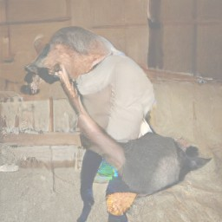

- a photorealistic golden retriever puppy wearing a red bandana

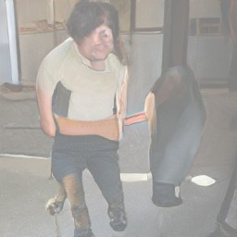

- a majestic dragon flying over snowy mountains under a cloudy sky

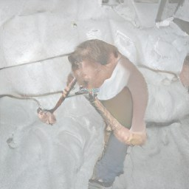

- a vintage yellow sports car parked on a cobblestone street

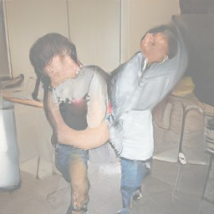

Observations:
- CLIP successfully guides the generator toward semantic alignment.
- BigGAN, being class-conditional on ImageNet, struggles with human-centric prompts.
- Results are abstract, often distorted: a known limitation of CLIP-GAN pipelines.
- Prompt alignment is partially successful for objects BigGAN understands (cars, dogs).

Limitations & Improvement:
- BigGAN cannot model humans → distorted results.
- Latent space is difficult to optimize for compositional prompts.
- Improved quality possible using StyleGAN2 or diffusion models.
- Adding augmentations (random cuts/crops) improves CLIP guidance.

