SSGMCE | SHRI SANT GAJANAN MAHARAJ COLLEGE OF ENGG. |  |  |  |  |  | LABORATORY MANUAL
SSGMCE | PRACTICAL EXPERIMENT INSTRUCTION SHEET
SSGMCE | EXPERIMENT TITLE : To study various algorithm designing strategies.
EXPERIMENT NO. : SSGMCE/WI/IT/01/6IT07/01 |  |  |  | ISSUE NO. : 00 |  | ISSUE DATE : 01.07.2023
REV. DATE : |  | REV. NO. : | DEPTT. : INFORMATION TECHNOLOGY
LABORATORY : Design and Analysis of Algorithm Lab (6IT07) |  |  |  |  | SEMESTER : VI |  |  | PAGE: 1 OF 4

1.0) AIM:
To study various algorithm designing strategies
2.0) SCOPE:
- To understand Algorithm Design Strategies.
- To study various design and analysis of algorithm.
3.0) FACILITIES/ APPARATUS:
i) Software: Jupyter Notebook
4.0) THEORY:
Algorithm:
An algorithm can be defined as a finite set of steps, which has to be followed while carrying out a particular problem. It is nothing but a process of executing actions step by step.
An algorithm is a distinct computational procedure that takes input as a set of values and results in the output as a set of values by solving the problem. More precisely, an algorithm is correct, if, for each input instance, it gets the correct output and gets terminated.
An algorithm unravels the computational problems to output the desired result.

Characteristics of Algorithms:
- Input: It should externally supply zero or more quantities.
- Output: It results in at least one quantity.
- Definiteness: Each instruction should be clear and ambiguous.
- Finiteness: An algorithm should terminate after executing a finite number of steps.
- Effectiveness: Every instruction should be fundamental to be carried out, in principle, by a person using only pen and paper.
- Feasible: It must be feasible enough to produce each instruction.
- Flexibility: It must be flexible enough to carry out desired changes with no efforts.

EXPERIMENT NO. : SSGMCE/WI/IT/01/6IT07/01 | ISSUE NO. : 00 |  | ISSUE DATE : 01.07.2023
LABORATORY : Design and Analysis of Algorithm Lab (6IT07) |  | SEMESTER : VI |  | PAGE: 2 OF 4

- Efficient: The term efficiency is measured in terms of time and space required by an algorithm to implement. Thus, an algorithm must ensure that it takes little time and less memory space meeting the acceptable limit of development time.
- Independent: An algorithm must be language independent, which means that it should mainly focus on the input and the procedure required to derive the output instead of depending upon the language.

Advantages of an Algorithm :
- Effective Communication: Since it is written in a natural language like English, it becomes easy to understand the step-by-step delineation of a solution to any particular problem.
- Easy Debugging: A well-designed algorithm facilitates easy debugging to detect the logical errors that occurred inside the program.
- Easy and Efficient Coding: An algorithm is nothing but a blueprint of a program that helps develop a program.
- Independent of Programming Language: Since it is a language-independent, it can be easily coded by incorporating any high-level language.

Analysis of algorithm :
The analysis is a process of estimating the efficiency of an algorithm. There are two fundamental parameters based on which we can analysis the algorithm:
- Space Complexity: The space complexity can be understood as the amount of space required by an algorithm to run to completion.
- Time Complexity: Time complexity is a function of input size n that refers to the amount of time needed by an algorithm to run to completion.
Following are some of the main algorithm design techniques:
- Brute Force Search
- Divide and Conquer
- Greedy Algorithms
- Dynamic Programming
- Branch and Bound Algorithm
- Randomized Algorithm
- Backtracking

EXPERIMENT NO. : SSGMCE/WI/IT/01/6IT07/01 | ISSUE NO. : 00 |  | ISSUE DATE : 01.07.2023
LABORATORY : Design and Analysis of Algorithm Lab (6IT07) |  | SEMESTER : VI |  | PAGE: 3 OF 4

Brute-Force Search
It is a simple approach of addressing a problem that relies on huge processing power and testing of all possibilities to improve efficiency. Suppose you forgot the combination of a 4-digit padlock and to avoid purchasing the new one, you have to open the lock using brute-force search method. You will have to try all possible 4-digit combinations from 0 to 9 to unlock it. That combination could be anything between 0000 to 9999, hence there are 10,000 combinations. So we can say that in the worst case, you have to try 10, 000 times to find your actual combination.

Divide and Conquer Introduction
Divide and Conquer is an algorithmic pattern. In algorithmic methods, the design is to take a dispute on a huge input, break the input into minor pieces, decide the problem on each of the small pieces, and then merge the piecewise solutions into a global solution. This mechanism of solving the problem is called the Divide & Conquer Strategy.
Divide and Conquer algorithm consists of a dispute using the following three steps.
- Divide the original problem into a set of subproblems.
- Conquer: Solve every subproblem individually, recursively.
- Combine: Put together the solutions of the subproblems to get the solution to the whole problem.
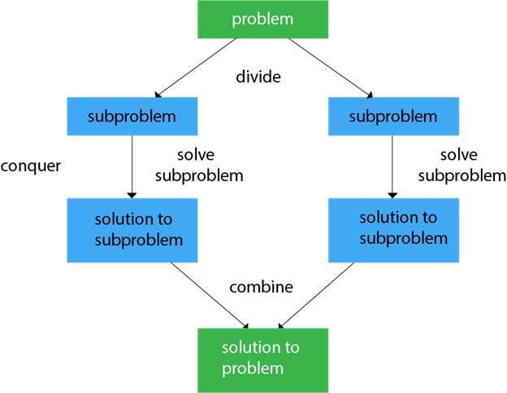
Generally, we can follow the divide-and-conquer approach in a three-step process.

EXPERIMENT NO. : SSGMCE/WI/IT/01/6IT07/01 | ISSUE NO. : 00 |  | ISSUE DATE : 01.07.2023
LABORATORY : Design and Analysis of Algorithm Lab (6IT07) |  | SEMESTER : VI |  | PAGE: 4 OF 4

Greedy Algorithm :

In Greedy Algorithm, resources are divided in a loop depending on the maximum and immediate availability at any given stage of execution. This method is used to solve optimization problems in which set of input values are given, that are required either to be increased or decreased according to the objective. Greedy Algorithm always chooses the option, which appears to be the best at the moment. That is why it is known as greedy algorithm. It may not always give the optimized solution. There are two stages to solve the problem using greedy algorithm:
- Examining the list of Items.
- Optimization
This means that a greedy algorithm selects the best immediate option and does not rethink its decisions. When it comes to optimizing a solution, this simply implies that the greedy solution will seek out local optimum solutions, which could be multiple, and may skip a global optimal solution

Dynamic Programming
Dynamic programming is a technique that breaks the problems into sub-problems, and saves the result for future purposes so that we do not need to compute the result again. The subproblems are optimized to optimize the overall solution is known as optimal substructure property. The main use of dynamic programming is to solve optimization problems. Here, optimization problems mean that when we are trying to find out the minimum or the maximum solution of a problem. The dynamic programming guarantees to find the optimal solution of a problem if the solution exists.
The definition of dynamic programming says that it is a technique for solving a complex problem by first breaking into a collection of simpler subproblems, solving each subproblem just once, and then storing their solutions to avoid repetitive computations.

5.0) Conclusion:
Studied various algorithm designing strategies.

PREPARED BY:  PROF.A.G.SHARMA | APPROVED BY: (H.O.D.)  DR. A. S. MANEKAR

