SSGMCE | SHRI SANT GAJANAN MAHARAJ COLLEGE OF ENGG. |  |  |  |  |  | LABORATORY MANUAL
SSGMCE | PRACTICAL EXPERIMENT INSTRUCTION SHEET
SSGMCE | EXPERIMENT TITLE : To study and Implement Shortest Path Algorithm
EXPERIMENT NO. : SSGMCE/WI/IT/01/6IT07/06 |  |  |  | ISSUE NO. : 00 |  | ISSUE DATE : 01.07.2023
REV. DATE : |  | REV. NO. : | DEPTT. : INFORMATION TECHNOLOGY
LABORATORY : Design and Analysis of Algorithm Lab |  |  |  |  | SEMESTER : VI |  |  | PAGE: 1 OF 7

1.0) AIM:
To study and Implement Dijkstra’s Shortest Path Algorithm.

2.0) SCOPE:

- To implement Shortest Path Algorithm.

3.0) FACILITIES/ APPARATUS:
i) Software: Turbo C.

4.0) THEORY:
Dijkstra’s shortest path algorithm is similar to that of Prim’s algorithm as they both rely on finding the shortest path locally to achieve the global solution. However, unlike prim’s algorithm, the dijkstra’s algorithm does not find the minimum spanning tree; it is designed to find the shortest path in the graph from one vertex to other remaining vertices in the graph. Dijkstra’s algorithm can be performed on both directed and undirected graphs.
Since the shortest path can be calculated from single source vertex to all the other vertices in the graph, Dijkstra’s algorithm is also called single-source shortest path algorithm. The output obtained is called shortest path spanning tree.
In this chapter, we will learn about the greedy approach of the dijkstra’s algorithm.

Dijkstra’s Algorithm
The dijkstra’s algorithm is designed to find the shortest path between two vertices of a graph. These two vertices could either be adjacent or the farthest points in the graph. The algorithm starts from the source. The inputs taken by the algorithm are the graph G {V, E}, where V is the set of vertices and E is the set of edges, and the source vertex S. And the output is the shortest path spanning tree.

Algorithm
- Declare two arrays − distance[] to store the distances from the source vertex to the other vertices in graph and visited[] to store the visited vertices.
- Set distance[S] to ‘0’ and distance[v] = ∞, where v represents all the other vertices in the graph.
- Add S to the visited[] array and find the adjacent vertices of S with the minimum distance.
- The adjacent vertex to S, say A, has the minimum distance and is not in the visited array yet. A is picked and added to the visited array and the distance of A is changed from ∞ to the assigned distance of A, say d₁, where d₁ < ∞.

EXPERIMENT NO. : SSGMCE/WI/IT/01/6IT07/06 | ISSUE NO. : 00 |  | ISSUE DATE : 01.07.2023
LABORATORY : Design and Analysis of Algorithm Lab (6IT07) |  | SEMESTER : VI |  | PAGE: 2 OF 7

- Repeat the process for the adjacent vertices of the visited vertices until the shortest path spanning tree is formed.

Examples
To understand the dijkstra’s concept better, let us analyze the algorithm with the help of an example graph −
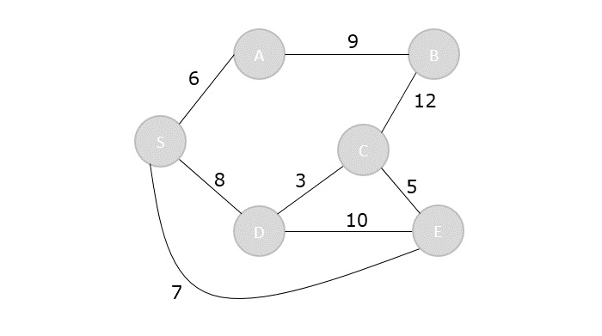
Step 1
Initialize the distances of all the vertices as ∞, except the source node S.
Vertex | S | A | B | C | D | E
Distance | 0 | ∞ | ∞ | ∞ | ∞ | ∞
Now that the source vertex S is visited, add it into the visited array.
visited = {S}
Step 2
The vertex S has three adjacent vertices with various distances and the vertex with minimum distance among them all is A. Hence, A is visited and the dist[A] is changed from ∞ to 6.
S → A = 6
S → D = 8
S → E = 7
Vertex | S | A | B | C | D | E
Distance | 0 | 6 | ∞ | ∞ | 8 | 7
Visited = {S, A}

EXPERIMENT NO. : SSGMCE/WI/IT/01/6IT07/06 | ISSUE NO. : 00 |  | ISSUE DATE : 01.07.2023
LABORATORY : Design and Analysis of Algorithm Lab (6IT07) |  | SEMESTER : VI |  | PAGE: 3 OF 7

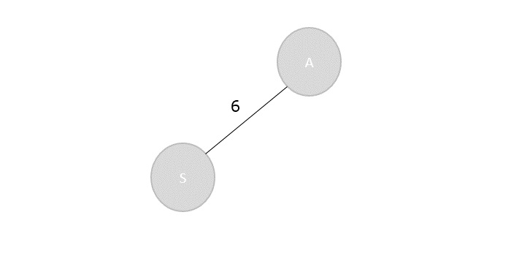
Step 3
There are two vertices visited in the visited array, therefore, the adjacent vertices must be checked for both the visited vertices.
Vertex S has two more adjacent vertices to be visited yet: D and E. Vertex A has one adjacent vertex B.
Calculate the distances from S to D, E, B and select the minimum distance −
S → D = 8 and S → E = 7.
S → B = S → A + A → B = 6 + 9 = 15
Vertex | S | A | B | C | D | E
Distance | 0 | 6 | 15 | ∞ | 8 | 7
Visited = {S, A, E}
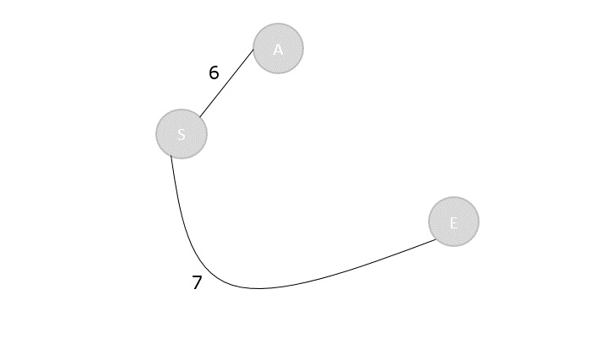

EXPERIMENT NO. : SSGMCE/WI/IT/01/6IT07/06 | ISSUE NO. : 00 |  | ISSUE DATE : 01.07.2023
LABORATORY : Design and Analysis of Algorithm Lab (6IT07) |  | SEMESTER : VI |  | PAGE: 4 OF 7

Step 4
Calculate the distances of the adjacent vertices – S, A, E – of all the visited arrays and select the vertex with minimum distance.
S → D = 8
S → B = 15
S → C = S → E + E → C = 7 + 5 = 12
Vertex | S | A | B | C | D | E
Distance | 0 | 6 | 15 | 12 | 8 | 7
Visited = {S, A, E, D}
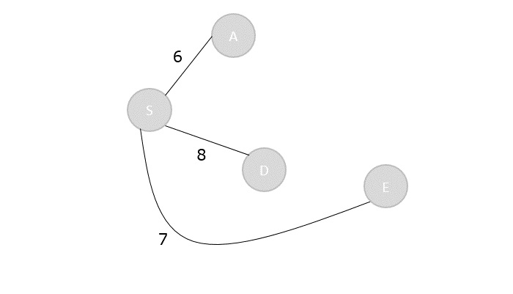
Step 5
Recalculate the distances of unvisited vertices and if the distances minimum than existing distance is found, replace the value in the distance array.
S → C = S → E + E → C = 7 + 5 = 12
S → C = S → D + D → C = 8 + 3 = 11
dist[C] = minimum (12, 11) = 11
S → B = S → A + A → B = 6 + 9 = 15
S → B = S → D + D → C + C → B = 8 + 3 + 12 = 23

EXPERIMENT NO. : SSGMCE/WI/IT/01/6IT07/06 | ISSUE NO. : 00 |  | ISSUE DATE : 01.07.2023
LABORATORY : Design and Analysis of Algorithm Lab (6IT07) |  | SEMESTER : VI |  | PAGE: 5 OF 7

dist[B] = minimum (15,23) = 15
Vertex | S | A | B | C | D | E
Distance | 0 | 6 | 15 | 11 | 8 | 7
Visited = { S, A, E, D, C}
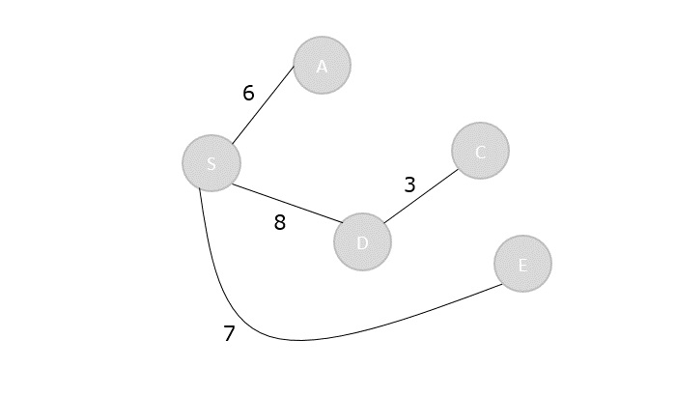
Step 6
The remaining unvisited vertex in the graph is B with the minimum distance 15, is added to the output spanning tree.
Visited = {S, A, E, D, C, B}
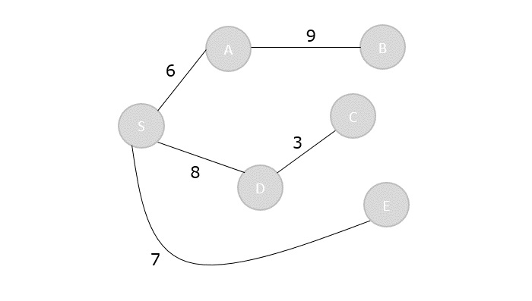

EXPERIMENT NO. : SSGMCE/WI/IT/01/6IT07/06 | ISSUE NO. : 00 |  | ISSUE DATE : 01.07.2023
LABORATORY : Design and Analysis of Algorithm Lab (6IT07) |  | SEMESTER : VI |  | PAGE: 6 OF 7
The shortest path spanning tree is obtained as an output using the dijkstra’s algorithm.

Program:
#include<stdio.h>
#include<limits.h>
#include<stdbool.h>
int min_dist(int[], bool[]);
void greedy_dijsktra(int[][6],int);
int min_dist(int dist[], bool visited[]){ // finding minimum dist
int minimum=INT_MAX,ind;
for(int k=0; k<6; k++) {
if(visited[k]==false && dist[k]<=minimum) {
minimum=dist[k];
ind=k;
}
}
return ind;
}
void greedy_dijsktra(int graph[6][6],int src){
int dist[6];
bool visited[6];
for(int k = 0; k<6; k++) {
dist[k] = INT_MAX;
visited[k] = false;
}
dist[src] = 0; // Source vertex dist is set 0
for(int k = 0; k<6; k++) {
int m=min_dist(dist,visited);
visited[m]=true;
for(int k = 0; k<6; k++) {

// updating the dist of neighbouring vertex
if(!visited[k] && graph[m][k] && dist[m]!=INT_MAX && dist[m]+graph[m][k]<dist[k])
dist[k]=dist[m]+graph[m][k];
}
}
printf("Vertex\t\tdist from source vertex\n");
for(int k = 0; k<6; k++) {
char str=65+k;
printf("%c\t\t\t%d\n", str, dist[k]);
}
}
int main(){
int graph[6][6]= {

EXPERIMENT NO. : SSGMCE/WI/IT/01/6IT07/06 | ISSUE NO. : 00 |  | ISSUE DATE : 01.07.2023
LABORATORY : Design and Analysis of Algorithm Lab (6IT07) |  | SEMESTER : VI |  | PAGE: 7 OF 7

{0, 1, 2, 0, 0, 0},
{1, 0, 0, 5, 1, 0},
{2, 0, 0, 2, 3, 0},
{0, 5, 2, 0, 2, 2},
{0, 1, 3, 2, 0, 1},
{0, 0, 0, 2, 1, 0}
};
greedy_dijsktra(graph,0);
return 0;
}

5.0) Conclusion:
Implemented Dijkstra’s Shortest Path Algorithm.

PREPARED BY:  PROF.A.G.SHARMA | APPROVED BY: (H.O.D.)  DR. A. S. MANEKAR

