PID LINE FOLLOWER EXPLANATION

Vedant Nehete

June 4, 2025

Introduction
The purpose of this final project is to develop a robot that receives inputs from sensors and uses them to control motors, enabling the robot to follow a line. This project aims to create a robot and a program which performs the tasks mentioned above with high accuracy and minimal oscillation.

Extensions
The two major extensions that I have added to this final project are as follows. The first is the implementation of a complex control algorithm, known as a PID controller (Proportional Integral Derivative), which is commonly used in these types of applications. The second extension involves implementing this control algorithm without a microcontroller. Instead, operational amplifiers are used to perform summing, differentiation, differential, integration, and multiplication operations.

PID Control Loops
A PID controller takes in a value, called an “error,” and performs a calculation on it to generate an output, which determines the movement of the robot to minimize the error and ultimately drive it to zero. This is known as a closed-loop feedback system. The error for a simple line follower can be calculated in a few different ways. The first method is to use two different sensors and calculate the difference between their values. The second method is to use a single sensor and calculate the difference between its sensor value and a reference value, which occurs when the sensor is at the edge of the line. Three different computations are done to the error and are added together to get the output. These operations are shown below.

Proportional:The error is multiplied by a constant, called the kP
Integral: The error is added to the sum of all previous errors and multiplied by the kI
Derivative: The change in error is multiplied by a constant, called the kD

Tuning the values for the kP, kI, and kD, is required to optimize the performance of the line follower

Note that using the integral term is extremely difficult, as something called integral windup appears, which drastically decreases performance. To mitigate this, the integral is often artificially lowered.

Schematic Diagram Explanation
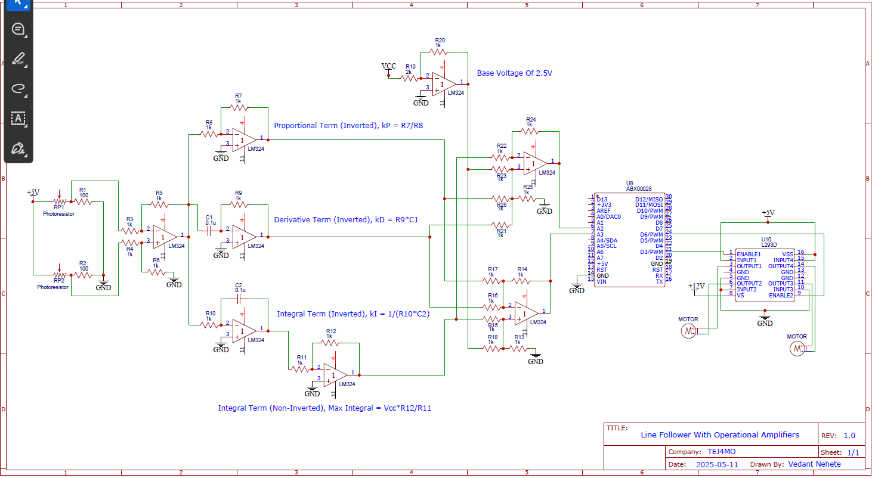
The schematic above shows the initial design of the line follower circuit. For the sensors, photoresistors are used in a voltage divider circuit. These voltages are fed into a differential amplifier with a gain of one to get the error. Then it is passed into three different operational amplifiers. The first one is an inverting amplifier, which is used to calculate the proportional term. By changing resistors R7 and R8, the kP can be changed. The second one is a differentiator amplifier, and the kD can be altered by changing the capacitance of C1 and the resistance of R9. The third one is an integrating amplifier, where the gain (kI) can be altered by modifying C2 and R10. The output of the integrating amplifier is passed into an inverting amplifier to limit the integral windup. The outputs of all three operational amplifier circuits are passed into a summing/differential amplifier to add together the three terms along with the base voltage, which is taken by amplifying the battery voltage by a gain of 0.5. The outputs of these are the speeds of the motors and are passed into the Arduino to convert into a PWM signal for the L293D.

Build Process & Difficulties
To build the robot, a piece of wood was used as the base and motors were glued on the bottom. A breadboard and three battery packs were placed on top. Then, the circuit was wired as shown in the schematic diagram. The first issue faced was that the values from each of the photoresistors were different so one of them was replaced with a potentiometer as a reference voltage. The second issue faced was that the reference speed amplifier was inverted so it was changed to a non-inverting amplifier. The last issue was that the motors were too weak to move the robot so they were replaced. Once all the issues were solved, the kP was tuned by changing the resistor values. The kD and kI terms are set to zero since they were too complicated to tune.

Arduino Program
const int lSpeed = A2;
const int rSpeed = A3;

const int lOut = 10;
const int rOut = 9;

void setup() {
Serial.begin(9600);

pinMode(lSpeed, INPUT);
pinMode(rSpeed, INPUT);

pinMode(lOut, OUTPUT);
pinMode(rOut, OUTPUT);
}

void loop() {
analogWrite(lOut, analogRead(lSpeed)/4/3);
analogWrite(rOut, analogRead(rSpeed)/4/3);

}

As you can see in the code above, it is extremely simple. This is because the calculations are done with operational amplifiers, and the Arduino Nano is only used to convert the analog signals into PWM signals.

Future Improvements
The future improvements of this are as follows:
- Use better motors so the robot can change speeds faster
- Add more sensors so the robot doesn’t fall off the line
- Use better light sensors that have similar resistances

Robot Image:
