**Name : Vedant_Gore-72232547K**

**Dr. D.Y. Patil Institute of Technology, Pune**

**Assignment_1 (Junit Testing)**

**Folder Structure**

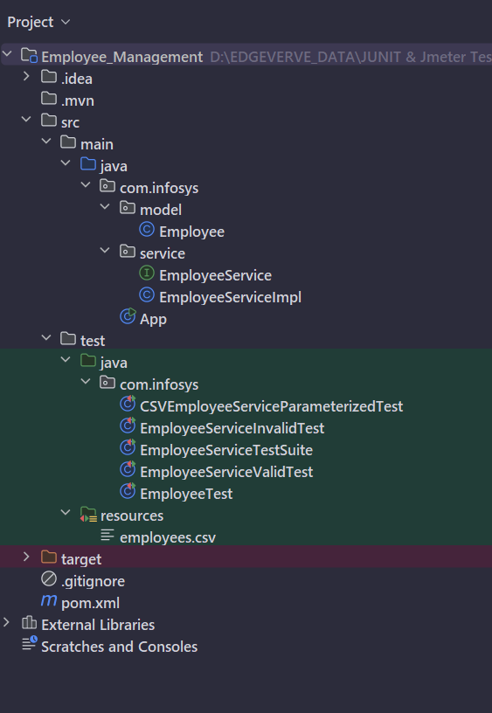

**Employee.java**

package com.infosys.model**;**public class Employee {  
  
 private int id**;** private String name**;** private double monthlySalary**;** public Employee(int id**,** String name**,** double monthlySalary) {  
 this.id = id**;** this.name = name**;** this.monthlySalary = monthlySalary**;** }  
  
 public int getId() {  
 return id**;** }  
  
 public void setId(int id) {  
 this.id = id**;** }  
  
 public String getName() {  
 return name**;** }  
  
 public void setName(String name) {  
 this.name = name**;** }  
  
 public double getMonthlySalary() {  
 return monthlySalary**;** }  
  
 public void setMonthlySalary(double monthlySalary) {  
 this.monthlySalary = monthlySalary**;** }  
}

**EmployeeService.java**

package com.infosys.service**;**import com.infosys.model.Employee**;**public interface EmployeeService {  
  
 double calculateHike(Employee employee)**;** double calculateYearlySalary(Employee employee)**;**}

**EmployeeServiceimpl.java**

package com.infosys.service**;**import com.infosys.model.Employee**;**public class EmployeeServiceImpl implements EmployeeService{  
  
 @Override  
 public double calculateYearlySalary(Employee employee) {  
  
 double yearlySalary = 0**;** yearlySalary = employee.getMonthlySalary()*12**;** return yearlySalary**;** }  
  
  
 @Override  
 public double calculateHike(Employee employee) {  
  
 double hike = 0**;** if(employee.getMonthlySalary() < 10000){  
 hike = 2000**;** }  
 else {  
 hike = 1000**;** }  
 return hike**;** }  
  
  
}

**EmployeeTest.java**

package com.infosys**;**import com.infosys.model.Employee**;**import com.infosys.service.EmployeeServiceImpl**;**import org.junit.jupiter.api.\***;**import static org.junit.jupiter.api.Assertions.\***;**public class EmployeeTest {  
  
 private EmployeeServiceImpl employeeService**;** @BeforeAll  
 static void beforeAll()  
 {  
 System.*out*.println("BeforeAll is executed")**;** }  
  
 @AfterAll  
 static void afterAll()  
 {  
 System.*out*.println("afterAll is executed")**;** }  
  
 @BeforeEach  
 void init()  
 {  
 System.*out*.println("Setup: Initializing EmployeeService...")**;** employeeService = new EmployeeServiceImpl()**;** }  
  
 @AfterEach  
 void cleanupCode()  
 {  
 System.*out*.println("Teardown: Cleaning up after test...")**;** }  
  
  
 @Test  
 @DisplayName("Test Yearly Salary Calculation for 8000 Monthly")  
 void testCalculateYearlySalary() {  
 Employee emp = new Employee(1**,** "Zenitsu"**,** 10000)**;** double actual = employeeService.calculateYearlySalary(emp)**;** double expected = 120000**;** *assertEquals*(expected**,** actual)**;** }  
  
 @Test  
 @DisplayName("Test Hike Calculation for < 10000 Monthly")  
 void testCalculateHike_LowSalary() {  
 Employee e = new Employee(2**,** "Inosuke"**,** 8000)**;** double actual = employeeService.calculateHike(e)**;** double expected = 2000**;** *assertEquals*(expected**,** actual)**;** }  
  
 @Test  
 @DisplayName("Test Hike Calculation for >= 10000 Monthly")  
 void testCalculateHike_HighSalary() {  
 Employee e = new Employee(3**,** "Tanjiro"**,** 12000)**;** double actual = employeeService.calculateHike(e)**;** double expected = 1000**;** *assertEquals*(expected**,** actual)**;** }  
  
  
 @Test  
 @Disabled  
 @DisplayName("Disabled test")  
 void testFail()  
 {  
 System.*out*.println("This test is disabled and should not run.")**;** }  
  
}

**EmployeeServiceValidTest.java**

package com.infosys**;**import com.infosys.model.Employee**;**import com.infosys.service.EmployeeServiceImpl**;**import org.junit.jupiter.api.\***;**import static org.junit.jupiter.api.Assertions.*assertEquals***;**public class EmployeeServiceValidTest {  
  
 EmployeeServiceImpl employeeService**;** @BeforeEach  
 void init()  
 {  
 System.*out*.println("Setup: Initializing EmployeeService...")**;** employeeService = new EmployeeServiceImpl()**;** }  
  
 @Test  
 @Tag("Valid")  
 @DisplayName("Valid: Hike for 9500 Salary")  
 void validHikeLowSalary() {  
 Employee e = new Employee(1**,** "John"**,** 9500)**;** double actual = employeeService.calculateHike(e)**;** double expected = 2000**;** *assertEquals*(expected**,** actual)**;** }  
  
 @Test  
 @DisplayName("Valid: Yearly Salary for 10000 Monthly")  
 void validYearlySalary() {  
 Employee e = new Employee(2**,** "Jane"**,** 10000)**;** double actual = employeeService.calculateYearlySalary(e)**;** double expected = 120000**;** *assertEquals*(expected**,** actual)**;** }  
}

**EmployeeServiceInvalidTest.java**

package com.infosys**;**import com.infosys.model.Employee**;**import com.infosys.service.EmployeeServiceImpl**;**import org.junit.jupiter.api.BeforeEach**;**import org.junit.jupiter.api.DisplayName**;**import org.junit.jupiter.api.Tag**;**import org.junit.jupiter.api.Test**;**import static org.junit.jupiter.api.Assertions.*assertTrue***;**public class EmployeeServiceInvalidTest {  
  
 EmployeeServiceImpl employeeService**;** @BeforeEach  
 void init()  
 {  
 System.*out*.println("Setup: Initializing EmployeeService...")**;** employeeService = new EmployeeServiceImpl()**;** }  
  
 @Test  
 @Tag("Invalid")  
 @DisplayName("Invalid: Negative Monthly Salary")  
 void invalidSalaryTest() {  
 Employee e = new Employee(3**,** "Bob"**,** -5000)**;** double yearly = employeeService.calculateYearlySalary(e)**;** *assertTrue*(yearly < 0**,** "Yearly salary should be negative for invalid input")**;** }  
}

**EmployeeServiceParameterizedTest.java**

package com.infosys**;**import com.infosys.model.Employee**;**import com.infosys.service.EmployeeServiceImpl**;**import org.junit.jupiter.params.ParameterizedTest**;**import org.junit.jupiter.params.provider.CsvFileSource**;**import static org.junit.jupiter.api.Assertions.*assertEquals***;**public class CSVEmployeeServiceParameterizedTest {  
  
 private EmployeeServiceImpl employeeService = new EmployeeServiceImpl()**;** @ParameterizedTest  
 @CsvFileSource(files = "src/test/resources/employees.csv"**,** numLinesToSkip = 1)  
 void testYearlySalaryWithCsv(int id**,** String name**,** double monthlySalary**,** double expectedYearly) {  
 Employee e = new Employee(id**,** name**,** monthlySalary)**;** double actual = employeeService.calculateYearlySalary(e)**;** double expected = expectedYearly**;** *assertEquals*(expected**,** actual)**;** }  
  
}

**EmployeeServiceTestSuite.java**

package com.infosys**;**import org.junit.jupiter.api.DisplayName**;**import org.junit.platform.suite.api.ExcludeTags**;**import org.junit.platform.suite.api.IncludeTags**;**import org.junit.platform.suite.api.SelectClasses**;**import org.junit.platform.suite.api.Suite**;**@Suite  
@SelectClasses({EmployeeServiceValidTest.class**,** EmployeeServiceInvalidTest.class})  
@IncludeTags({"Valid"**,** "Invalid"})  
@DisplayName("Employee Service Test Suite")  
public class EmployeeServiceTestSuite {  
  
}

**employees.csv**

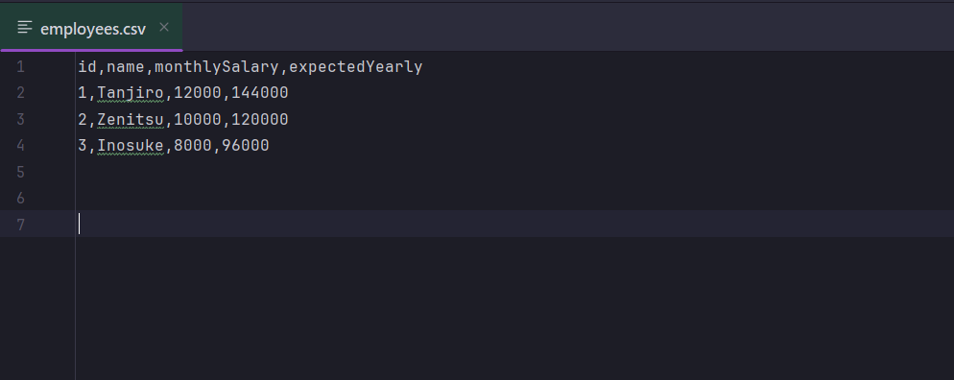

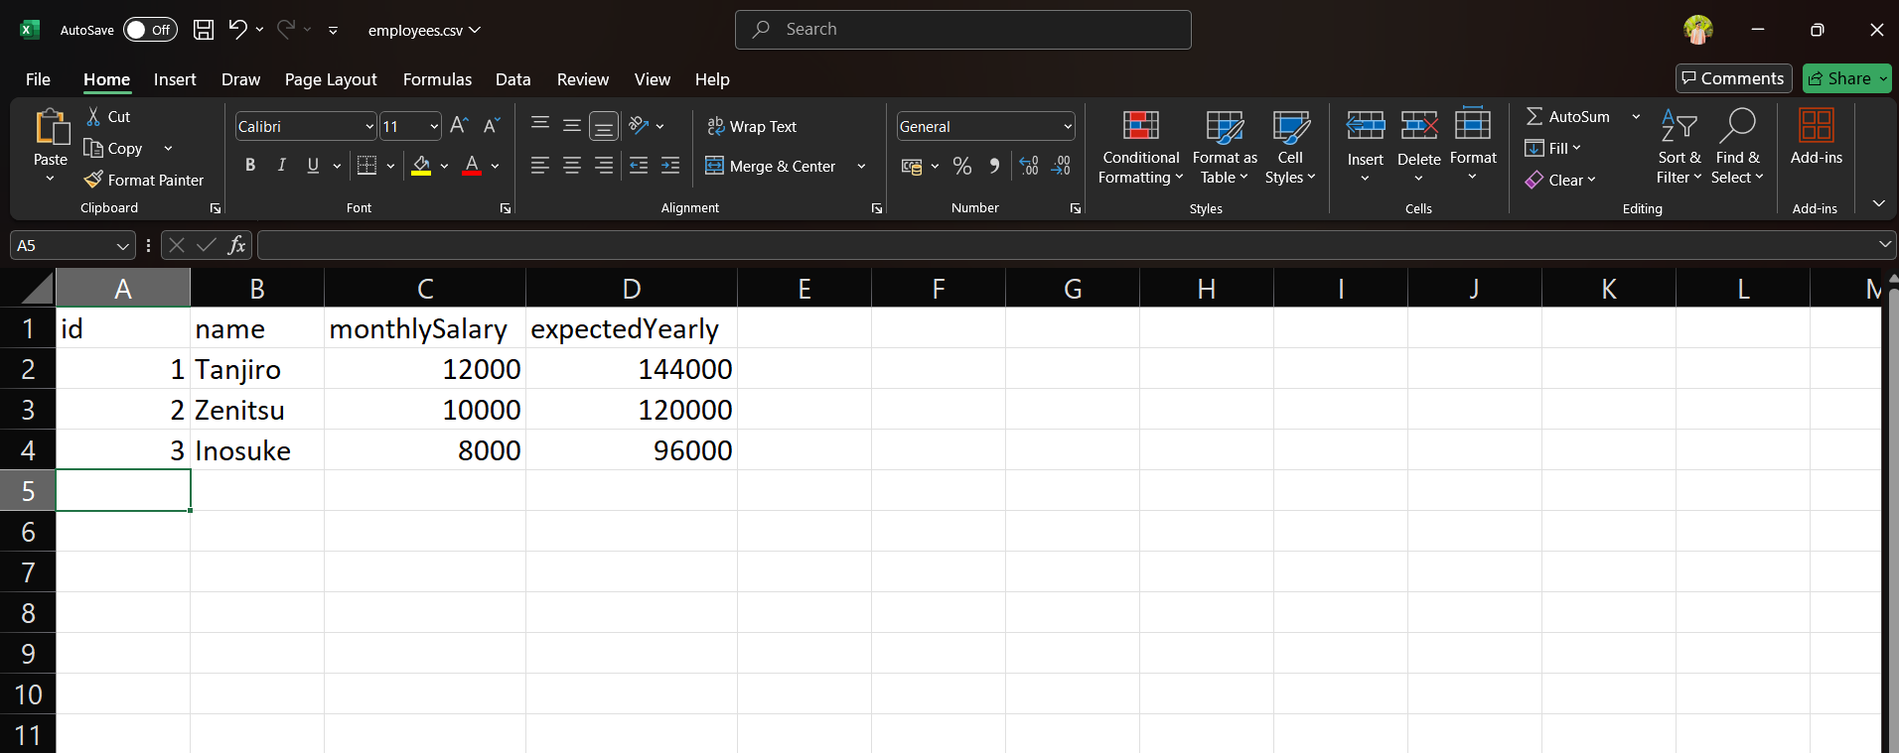

**Output:**

