# 1. Title

Improving Average Call Handling Time (AHT) in a Customer Service Call Center Using Lean Six Sigma DMAIC Approach

# 2. Problem Statement

The call center has experienced a **20% increase** in *Average Call Handling Time (AHT)* over the last quarter. This has resulted in:

* Longer **customer wait times**
* **Increased call abandonment rates**
* **Lower customer satisfaction**

Preliminary investigation shows that:

* The **call assessment process** is complex
* **Insufficient staff training** is leading to inefficiency

# 3. Objective

Reduce **AHT** by **at least 15%** in the next **3 months** without compromising customer service quality.

# 4. DMAIC

## D - Define Phase

Background: The call center handles over 10,000 calls per month with KPIs including AHT, abandonment rate, and CSAT. The current AHT is 8.4 minutes, which is 20% higher than the previous quarter.

Voice of the Customer: Customers have complained about long wait times, repeated information requests, and unprepared agents.

Project Charter:

* Problem: High AHT causing delays and dissatisfaction.
* Goal: Reduce AHT by at least 15% in 3 months.
* Scope: All inbound support calls.
* Team: Process Analyst, Supervisors, Trainers.

## M - Measure Phase

Data collected for AHT by agent, shift, and call type, abandonment rates, queue times, and FCR. Baseline AHT is 8.4 minutes with an abandonment rate of 12% and CSAT at 78%.

Tools Used: SIPOC diagram, Histogram, Run Chart.

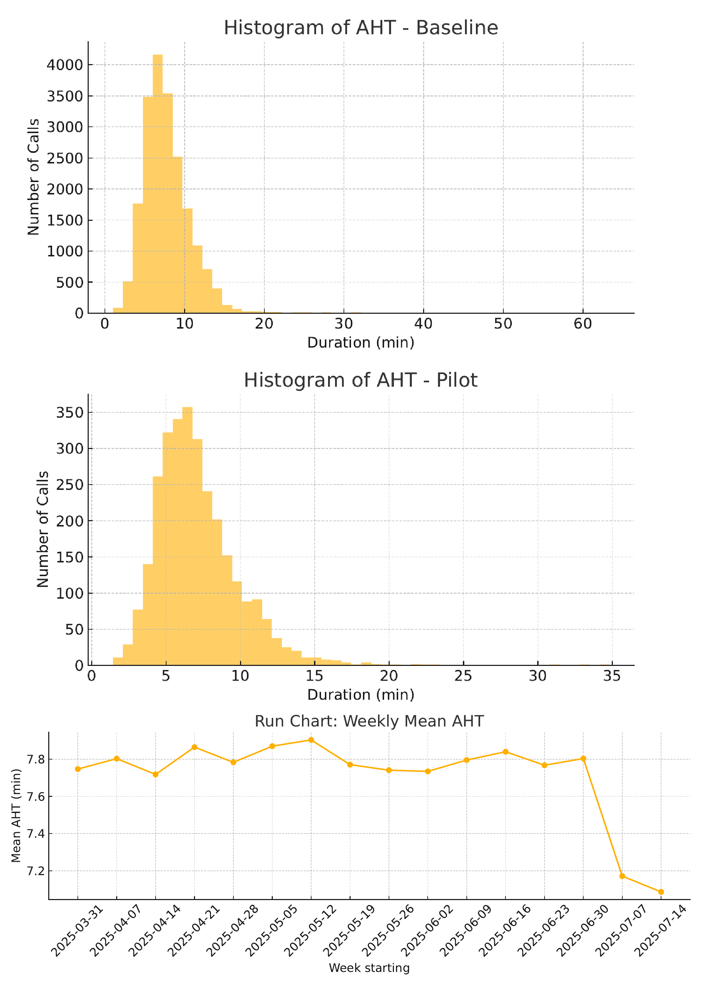

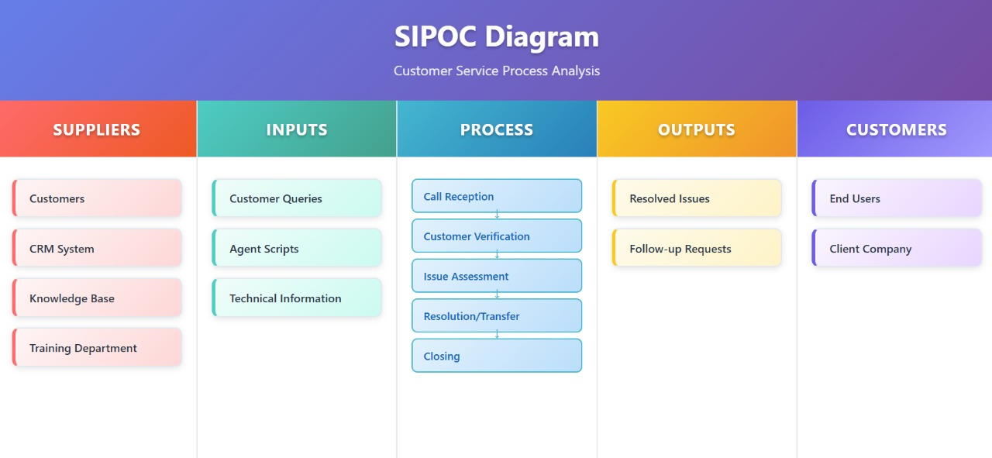

**Baseline Performance Metrics:**

|  |  |  |
| --- | --- | --- |
| **Metric** | **Current** | **Target** |
| AHT | 8.4 min | ≤ 7 min |
| Abandonment Rate | 12% | ≤ 8% |
| CSAT | 78% | ≥ 85% |

## A - Analyze Phase

Root causes identified using Fishbone Diagram and Pareto analysis:

* Training gaps
* CRM slowness
* Inefficient routing
* 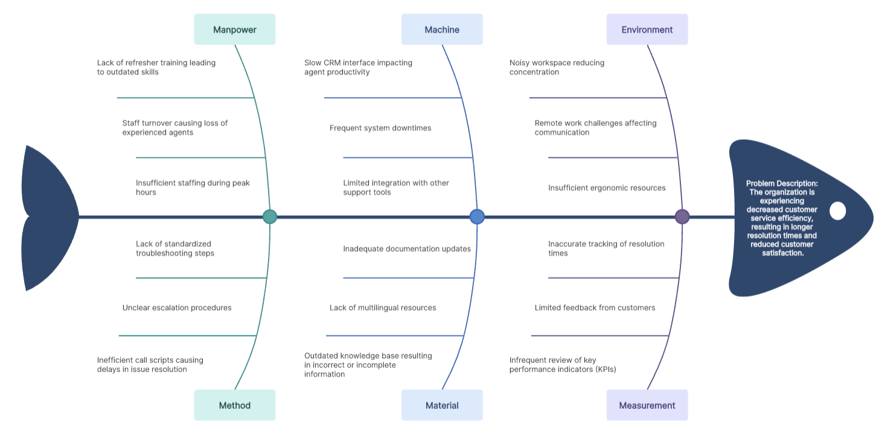

## I - Improve Phase

Solutions implemented:

1. Script optimization to remove unnecessary steps.
2. Skill-based call routing.
3. Weekly refresher training for agents.
4. Upgraded knowledge base indexing.
5. CRM performance improvements.

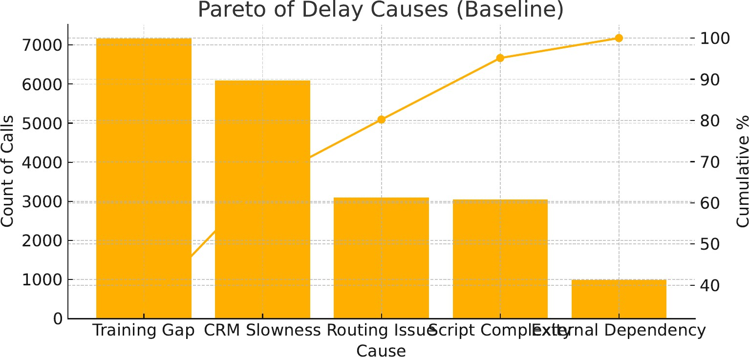Pilot testing over 2 weeks reduced AHT from 8.4 to 7.1 minutes, abandonment from 12% to 9%, and CSAT increased from 78% to 84%.

|  |  |  |
| --- | --- | --- |
| **Metric** | **Before** | **After** |
| AHT | 8.4 min | 7.1 min |
| Abandonment | 12% | 9% |
| CSAT | 78% | 84% |

## C - Control Phase

Standard Operating Procedures created for the new process flow. Monthly refresher training and a real-time AHT dashboard implemented. Control charts used for ongoing monitoring and PDCA cycle adopted for continuous improvement.

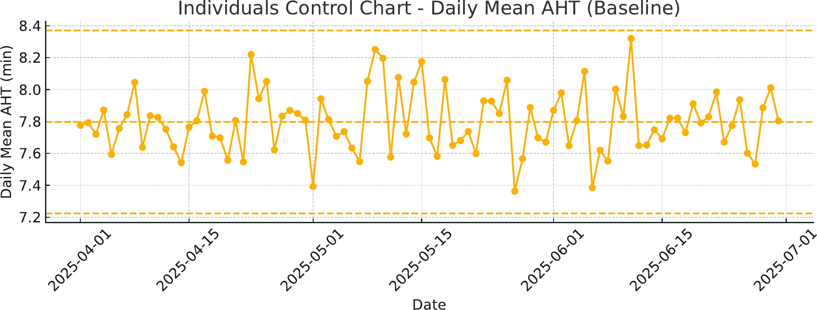

# 5. Expected Benefits

* AHT reduction: 15-20%
* Abandonment rate drop: ~4%
* CSAT increase: 7-10%
* Improved agent efficiency and morale