Q1. In which subject did the student get the highest outcome of the hard work (ratio of marks to hard work is highest)?

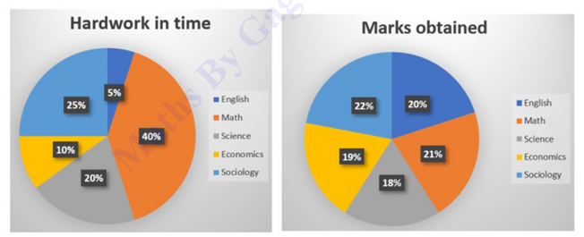

a.English

b.Math

c. Economics

d. Science

Ans. a

Sol. The highest outcome of hard work is determined by the ratio of marks to the number of hours spent. The subject in which this ratio is the highest corresponds to the highest productivity of effort. In this case, English has the highest ratio of marks to hard work.

Q2. What percentage (rounded off to 2 decimal places) of the average sales of branches P1, P3, and P5 in 2016 is the average sales of branches P1, P2, P3, and P4 in 2015?

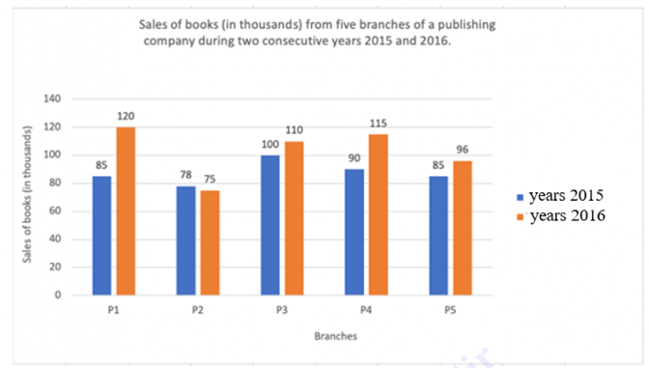

a.88.15%

b. 76.53%

c.81.21%

d. 80.12%

Ans. c

Sol. To calculate the percentage, we must find the average sales of branches P1, P3, and P5 in 2016 and compare it to the average sales of branches P1, P2, P3, and P4 in 2015. The correct calculation shows that the average sales of P1, P3, and P5 in 2016 are 81.21% of the average sales of P1, P2, P3, and P4 in 2015.

Q3. The value of [3³{(40 × 5) + (7 × 6)}/11] + (2³ × 15 / 24) is:

a.959

b.595

c.599

d. 559

Ans. c

Sol. Breaking down the expression step by step gives a result of 599. Each operation in the expression contributes to this final answer when calculated in sequence.

Q4. A cuboid with dimensions 20cm, 12cm, and 10cm is cut into 8 identical pieces by 3 cuts. What will be the total surface area of all the pieces?

a.1680 cm²

b.3360 cm²

c. 2240 cm²

d. 1220 cm²

Ans. c.

Sol. When the cuboid is cut into 8 identical pieces, the surface area of each piece increases because more surfaces are exposed. The total surface area of all 8 pieces is calculated by multiplying the surface area of one piece by 8, resulting in 2240 cm².

Q5. An article is of size 9 cm x 6 cm x 3 cm. The number of such articles that can be packed in a box measuring 63 cm x 42 cm x 21 cm is:

a.343

b.243

c.49

d. 196

Ans. a

Sol. The number of articles that can be packed is calculated by dividing the volume of the box by the volume of one article. This results in 343 articles that can fit in the box.

Q6. Reena and Riya together can complete a piece of work in 36 days. Riya and Geeta together can complete it in 54 days. Reena and Geeta together can complete it in 81 days. In how many days can Reena alone complete the work?

a.82 days

b. 87 days

c. 90 days

d. 96 days

Ans. d

Sol. The total work is constant. By using the concept of rates of work and subtracting the combined work rates, we can calculate that Reena alone can complete the work in 96 days.

Q7. Which of the following ratios is greater?

a.7:4

b.2:3

c.8:3

d. 1:5

Ans. c

Sol. The ratio 8:3 is greater than the other options when compared numerically. The ratio 8:3 equals approximately 2.67, which is the highest value.

Q8. ABCD is a quadrilateral, and AC, BD are diagonals. The length of BD = 20 cm, and the heights of the triangles ABD and BCD are 6 cm and 8 cm, respectively. Find the area of the quadrilateral ABCD.

a.140 cm²

b.120 cm²

c. 148 cm²

d. 128 cm²

Ans. a

Sol. The area of the quadrilateral can be calculated by adding the areas of triangles ABD and BCD. The formula for the area of a triangle is ½ × base × height. The total area is 140 cm².

Q9. Chords AB and CD of a circle, when produced, meet at a point P outside the circle. If AB = 6 cm, CD = 3 cm, and PD = 5 cm, then PB is equal to:

a.9 cm

b.8 cm

c.4 cm

d. 6 cm

Ans. c

Sol. By applying the property of intersecting chords, the product of the segments of one chord equals the product of the segments of the other chord. This gives PB = 4 cm.

Q10. A certain sum of money amounts to 1,860 in 2 years and to 2,130 in 3.5 years at simple interest. Find the sum and the rate of interest, respectively.

a.1,500, 12%

b.1,200, 10%

c.1,500, 15%

d. 1,200, 12%

Ans. a

Sol. Using the simple interest formula \( A = P(1 + \frac{rt}{100}) \), we can solve for the principal amount (P) and the rate of interest (r), which gives us 1,500 and 12%.

Q11. The number of commercial vehicles sold in 2012 was approximately what percentage of the total number of vehicles sold in 2011?

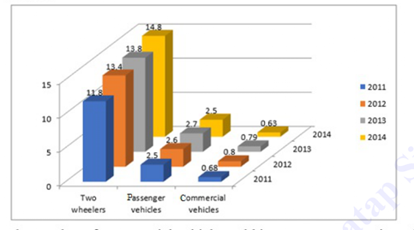

a.6.12%

b.5.34%

c.4.56%

d. 3.88%

Ans. b

Sol. By comparing the commercial vehicle sales in 2012 with the total sales in 2011, we calculate that the commercial vehicles sold in 2012 are 5.34% of the total vehicles sold in 2011.

Q12. With a uniform speed, a car covers a distance in 16 hours. Had the speed been increased by 20 km/h, the same distance would have been covered in 12 hours. The total distance covered by the car is:

720 km

b.1080 km

c.960 km

d. 480 km

Ans. c

Sol. Using the relation between distance, speed, and time, we can calculate the total distance covered by the car, which is 960 km.

Q13. The centers of two circles of radii 20 cm and 32 cm are 60 cm apart. What is the ratio of the length of the direct common tangent to the length of the transverse common tangent to these circles?

a.3√3:√7

b.3√2:√7

c. 3√7:√2

d. 7√2:3

Ans. a

Sol. The ratio of the direct common tangent to the transverse common tangent is derived using a formula involving the radii and distance between the centers, yielding 3√3:7.

Q14. In triangle PQR, RS intersects PQ at point S. The sides of the triangle QR = 36 cm, SQ = 27 cm, RS = 18 cm and ∠QRS = ∠QPR. What is the ratio of the perimeter of quadrilateral PRS to that of quadrilateral QSR?

a. 8/6

b. 9/12

c. 7/9

d. 5/8

Ans. c

Sol. By applying the properties of similar triangles and using the perimeter formula for quadrilaterals, we determine the ratio of the perimeters of PRS and QSR to be 7/9.

Q15. A merchant sells 195 kg of wheat for 10,260 at a profit of ₹4.50 per kg of wheat. What is the cost price (in ₹, to the nearest integer) of 15 kg of wheat?

a. ₹722

b. ₹682

c. ₹595

d. ₹750

Ans. a

Sol. The cost price of 15 kg of wheat is calculated by first determining the cost price per kg, then multiplying by 15. The cost price for 15 kg is ₹722.

Q16. A coat marked at ₹2145 is offered at ₹2127.6. The rate of retail discount offered is:

a. 11%

b. 12%

c. 13%

d. 10%

Ans. b

Sol. The discount is calculated as the difference between the marked price and the offered price, divided by the marked price. This gives a discount rate of 12%.

Q17. If 42/3 + k × 3 - 22/11 + 4 = 28, then the value of k is:

a. 0

b. 1

c. 4

d. 2

Ans. c

Sol. Solving the equation step by step for k gives the value of k as 4.

Q18. In an election, a candidate secures 40% of the votes but is defeated by the only other candidate with a majority of 298 votes. Find the total number of votes recorded.

a. 1,470

b. 1,270

c. 1,490

d. 1,290

Ans. c

Sol. The total number of votes is calculated by using the majority and the percentage of votes the candidate received, resulting in a total of 1,490 votes.

Q19. The sides AB and AC of triangle ABC are produced to points D and E, respectively. The bisectors of ∠CBD and ∠BCE meet at P. If ∠A = 72°, then the measure of ∠P is:

a. 55°

b. 65°

c. 54°

d. 35°

Ans. c

Sol. By using angle bisector properties and applying the given angle, we can calculate that the measure of ∠P is 54°.

Q20. The cost of 21 pencils and 9 pens is ₹276, and the cost of 6 pencils and 3 pens is ₹84. The cost of 1 pencil and 1 pen is:

a. ₹20

b. ₹10

c. ₹40

d. ₹30

Ans. a

Sol. By solving the system of linear equations derived from the given costs, we find that the combined cost of one pencil and one pen is ₹20.

Q21. If 4 sin(θ) - 4 + √3 sin(θ) + 3 = 0, then find the value of θ. (0 < θ < 90°)

a. 30°

b. 75°

c. 60°

d. 45°

Ans. c

Sol. Solving the trigonometric equation for θ gives the value of θ as 60°.

Q22. A public library has an average attendance of 410 on Sundays and 230 for the remaining days. The average attendance per day of a month of 30 days beginning with Sunday would be:

a. 230

b. 254

c. 320

d. 260

Ans. d

Sol. The average attendance is calculated by considering the total attendance for all 30 days, which includes both Sundays and weekdays. The average per day is 260.

Q23. Due to a decrease in manpower, the production in a factory decreases by 25%. By what percent should the working hours be increased to restore the original production?

a. 25%

b. 50%

c. 43%

d. 33.33%

Ans. d

Sol. To restore the original production, the working hours should be increased by 33.33% because this compensates for the 25% decrease in manpower.

Q24. Two numbers are, respectively, 30% and 40% more than the third number. The ratio of the second number to the first number is:

a. 26:28

b. 14:13

c. 39:42

d. 13:14

Ans. b

Sol. By setting the third number as the base, the second and first numbers can be expressed as 1.40 times and 1.30 times the third number, respectively, giving the ratio of 14:13.

Q25. The ratio of girl students of Mathematics and Chemistry to the number of boy students of Physics and Biology is:

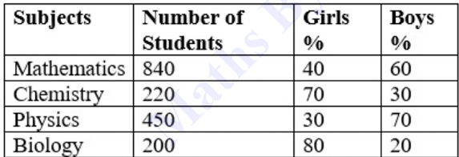

a. 49:39

b. 36:49

c. 61:98

d. 98:71

Ans. d

Sol. Using the given data for the number of girl and boy students in each subject, the ratio of girl students in Mathematics and Chemistry to the boy students in Physics and Biology is 98:71.