Java

Client

import java.net.\*;

import java.io.\*;

import java.util.\*;

class Client {

public static void main(String[] args) {

try {

int stop=1;

Socket s = new Socket("localhost", 2000);

DataOutputStream dout = new DataOutputStream(s.getOutputStream());

DataInputStream dis = new DataInputStream(s.getInputStream());

while(stop==1) {

System.out.println("Enter the URL");

Scanner sc = new Scanner(System.in);

String smsg = sc.next();

dout.writeUTF(smsg);

dout.flush();

System.out.println("DO you want to stop?");

System.out.println("Then enter 0 else enter 1");

int st=sc.nextInt();

if(st==0){

stop=0;

}

else {

stop=1;

}

}

dout.close();

s.close();

} catch (Exception e) {

System.out.println("Exception " + e);

}

}

}

Server

import java.io.\*;

import java.net.ServerSocket;

import java.net.Socket;

import java.net.URI;

import java.util.Scanner;

import java.awt.Desktop;

class Server {

public static void main(String[] args) {

Scanner sc = new Scanner(System.in);

try {

ServerSocket ss = new ServerSocket(2000);

Socket s1 = ss.accept();

DataInputStream dis = new DataInputStream(s1.getInputStream());

DataOutputStream dout = new DataOutputStream(s1.getOutputStream());

int stop = 1;

while (stop == 1) {

Desktop d=Desktop.getDesktop();

d.browse(new URI(dis.readUTF()));

System.out.println("DO you want to stop?");

System.out.println("Then enter 0 else enter 1");

int st = sc.nextInt();

if (st == 0) {

stop = 0;

} else {

stop = 1;

}

}

dout.close();

ss.close();

} catch (Exception e) {

System.out.println("Exception " + e);

}

}

}

Python

Server

*import* webbrowser  
*import* socket  
d = {'google.com':'172.217.166.78','yahoo.com':'98.138.219.232'}  
s = socket.socket()  
port = 8080  
s.bind((socket.gethostname(), port))  
s.listen(5)  
c, addr = s.accept()  
*print* ("Socket Up and running with a connection from",addr)  
  
*while True*:  
 rcvdData = c.recv(1024).decode()  
 *if* rcvdData =="bye":  
 *break  
 print* ("S:",rcvdData)  
 webbrowser.open(d[rcvdData],new=2)  
c.close()  
  
*#webbrowser.open('https://www.google.com/gmail/', new=2)*

client

*import* socket  
s = socket.socket()  
host = socket.gethostname()  
port = 8080  
s.connect((host, port))  
*while True*:  
 st = *input*("S: ")  
 s.send(st.encode())  
 *if* st == "Bye" *or* st == "bye":  
 *break  
 print*( "N:",s.recv(1024).decode())  
s.close()

PATIL

run:

enter the host name of your desired website

www.yahoo.com

http://98.137.246.7

BUILD SUCCESSFUL (total time: 1 minute 7 seconds)

I\*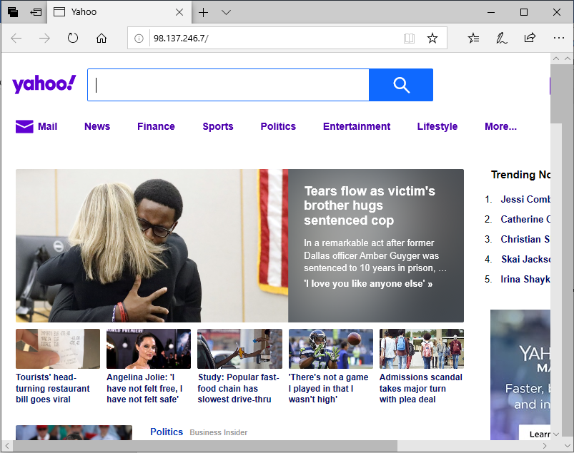

CODE:

package cnprrac10;

import java.io.BufferedReader;

import java.io.FileInputStream;

import java.io.FileNotFoundException;

import java.io.IOException;

import java.io.InputStreamReader;

import java.net.URI;

import java.net.URISyntaxException;

import java.util.Scanner;

import java.util.logging.Level;

import java.util.logging.Logger;

public class Cnprrac10 {

public static void main(String[] args) throws FileNotFoundException, IOException {

String input,dns="";

Scanner sc=new Scanner(System.in);

System.out.println("enter the host name of your desired website");

input=sc.next();

FileInputStream fis=new FileInputStream("C:\\Users\\Preha Rohtagi\\Downloads\\dns.txt");

InputStreamReader isr=new InputStreamReader(fis);

BufferedReader br=new BufferedReader(isr);

String text;

while((text=br.readLine())!=null){

if(text.contains(input)){

int i=text.indexOf("-");

dns=text.substring(i+1);

break;

}

}

System.out.println(dns);

try {

java.awt.Desktop.getDesktop().browse(new URI(dns));

} catch (URISyntaxException ex) {

Logger.getLogger(Cnprrac10.class.getName()).log(Level.SEVERE, null, ex);

}}}