# EC2

EC2 Instance Creation in AWS

Access EC2 Instance from Windows Machine

Access EC2 Instance from Linux Machine

Install Nginx in EC2 Instance

Bootstrap Script in EC2 Instance | User Data In EC2

AWS Security Group

AWS EC2 Instance Type

AWS Pricing | Reserve Instance | Spot Instance | Saving Plan | Dedicated Host

Create Windows Instance In AWS

Access Windows Instance from Linux Machine

Instance Metadata with UserData

Attach Elastic/Static IP to an EC2 Instance

Detach Elastic/Static IP

Elastic Block Storage (EBS)

Create First Elastic Block Storage Volume | Mount EBS in Linux

Detach an EBS volume from one EC2 Instance and Attach it Another One

Resize EBS Volume and Resize the File System

How to Resize ROOT EBS Volume

Attach One EBS Volume to Multiple EC2 Instance

Type of EBS Volumes - Which EBS Volume should I use ?

Snapshot Overview - AWS Snapshot - EBS Snapshot

Create First Snapshot - EBS Backup

Automate EBS Volume Backup - EBS Lifecycle Manager

Snapshot and AMI Recycle Bin - Recycle Bin for Snapshot and AMI AWS

Copy Snapshot From One Region to Another- Copy Snapshot Cross Region/Account

Encrypt the EBS Volume - What will happen when we encrypt the EBS volume

Create your Own AMI

Share Your AMI with other AWS account - Delete Your AWS AMI

Elastic Load Balancer in AWS (ELB) - Classic Load Balancer (CLB)

EC2 Instance Accessible by LoadBalancer Only

Delete Classic Load Balancer

Application Load Balancer

Path Base Routing in Application Load Balancer

How Get Client IP address on Application Server | Application Load Balancer

Stickiness And Custom Page Routing in Application Load Balancer

Network Load Balancer

AWS Launch Template - Auto Scaling Group ( ASG )

How to Enable Automatic Scaling

Auto Scaling With Load Balancer - Load Balancer with Auto Scaling

Enable Termination Protection - Hibernet vs PowerOff

How to create Reserve Instace - How to attach multiple NIC

# IAM

What is Identity and Access Management

AWS IAM Service - Groups

AWS IAM Service - Password Policy

AWS Multi Factor Authentication

How to use AWS CLI - AWS Configure - How to Create AWS Instance Using CLI

AWS CLI Handle Multiple AWS Accounts - How to use AWS CLI In Linux

What is AWS Roles & How to use AWS CLI without Access Id and Secret key

What/Why is CloudShell || IAM - Access Advisor || IAM - Credential Report

# S3

Introduction to Amazon Simple Storage Service

How to Create Bucket in AWS

Public your Bucket Object | Policy Generator | Allow Object to Public

S3 Object - S3 Object Properties - S3 Object Metadata - S3 Object

S3 Versioning - What is Versioning - Prevent object from Deletion

Host Static Website in S3

How to Redirect in S3 Static Website From one to another

How to Change Prefix in Static Website S3

S3 Accelerated Transfer, How to Enable? How to Use Accelerated Transfer?

Same/Cross Region Replication - What is SRR/CRR - Use of SRR/CRR?

Configure Logging in S3 Bucket - How to Enable S3 Logging

S3 - Storage Classes

Configure Storage Class (In Hindi)

Simplify Data Lifecycle Management with AWS S3

Cost Efficiency and Performance with AWS Intelligent Tiering for S3

What is CORS and How to Enable IT in S3

What is Presigned URL in S3

# Cloud Front

What is CloudFront? Create First Distribution with EC2 Instance

AWS CloudFront Invalidation - How to Remove Data From CloudFront Edge

How to make EC2/ALB Instance Accessible from CloudFront Only

CloudFront with S3 - S3 Private Bucket with CloudFront -S3 Origin

CloudFront Path Based routing with Multiple Origin

CloudFront Custom Error Page

How to Control Access to Your Content Based on Country

How to Disable CloudFront Distribution / How to Delete CloudFront Distribution

# VPC

Create First VPC

Create First Subnet

Internet Gateway (IGW) and Route Table

Public and Private Subnet

How to Access Private Instance in AWS using bastion host

How to access internet in Private Instance - NAT Instance

Create Network Access Control List

VPC Peering

Transit Gateway and Transit Gateway Attachments

VPC Flow Log

VPC Gateway Endpoint

VPC Interface Endpoint

# Notes: -

**"Setting Up and Configuring Nginx on EC2: A Step-by-Step Guide"**

1. Create an EC2 instance, ensuring that you download a key pair. Also, configure network settings to allow HTTP requests from anywhere.

2. Connect to the server using Git Bash with SSH: ssh -i "tingu-server.pem" ubuntu@ec2-65-2-140-82.ap-south-1.compute.amazonaws.com

3. Update the Ubuntu package list with: sudo apt-get update

4. Install Nginx with the command: sudo apt install nginx

5. Check the status of the Nginx web server: sudo systemctl status nginx

6. Use the public IP address of the EC2 instance to perform a Google search.

7. In a new Git Bash session, copy the HTML file to the server using scp -i "tingu-server.pem" tingu.html ubuntu@ec2-65-2-140-82.ap-south-1.compute.amazonaws.com:/tmp/

8. Move the HTML file from /tmp to /var/www/html with: sudo mv /tmp/tingu.html /var/www/htm

9. To access the site, use the public IP address of the instance, like 65.2.140.82/tingu.html

10. To make tingu.html load by default when the IP address is entered, edit the Nginx default configuration: sudo vim /etc/nginx/sites-available/default and change the index from index.html to tingu.html

11. Verify the Nginx configuration with: sudo nginx -t

12. Restart the Nginx server: sudo systemctl restart nginx

13. You're all set! Your changes are now in effect.

**Load Balancers**

Both Application Load Balancers (ALBs) and Network Load Balancers (NLBs) are used to distribute traffic to different servers, with ALB focusing on application-specific routing and NLB focusing on lower-level transport protocol routing.

**VPC**

If you don't already know amazon has a massive global footprint with regions and availability zones all around the world.

There are hundreds of thousands even millions of customers using AWS every day. They're using ec2 instances and s3 buckets, databases and so on.

You don't want to just throw your resources out there with all the other millions of resources. Instead, you want your own little private slice of the overall AWS pie and that's basically what a virtual private cloud or VPC is.

It's your own private cloud or network within the cloud within AWS and it's how your resources are isolated from everybody else's resources.

When you create your AWS account you get a default VPC and then of course you can create others.

(The default VPC in AWS is a pre-configured VPC that comes with a public subnet in each Availability Zone, an internet gateway, and settings to enable DNS resolution. This makes it easy to get started with AWS and to launch resources quickly. However, the default VPC is not as secure or customizable as a custom VPC. For example, the default VPC has a security group that allows all traffic from the internet to all resources in the VPC. This is not a good security practice)

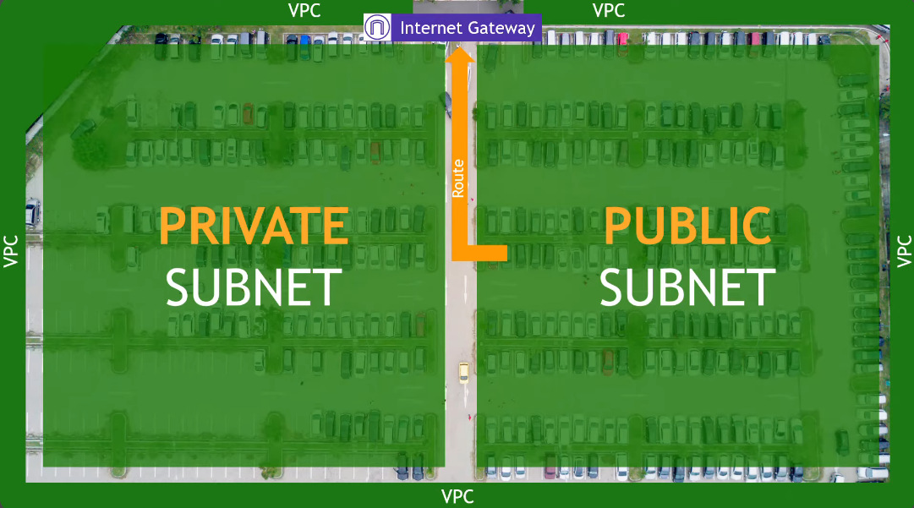

Imagine there is a parking lot and outside of the parking lot is the whole world.

The fence or border around the parking lot can be thought of as your VPC. It separates your resources from the rest of the resources in AWS.

Up at the top, we have traffic coming in from the outside world and traffic going out to the outside world. In AWS networking terms this would be an internet gateway. That's how your VPC talks to the internet.

Inside the VPC we have logically separated areas. For our example we're going to say they're the left and the right of the parking lot. These are called your subnets in AWS networking terms.

Now let's say that one subnet has a route to get out to the internet. If that's the case this is a public subnet. The other side, the subnet that doesn't have the route to the internet that's a private subnet

So maybe on the public subnet you put servers that would host public-facing web pages and in the private subnet you would put your databases so there's that extra layer of security protecting from the outside world.

Within the subnets is where your actual resources live like your ec2 instances and so on.

Remember, internet gateway is at the VPC level and the fact that a public subnet has a route to it is what makes it public. It's accessible to and from the internet. The private subnet however doesn't have that route. You can't get to it from the internet and you can't get out to the internet.

But what if you do need to get to the internet for something? Maybe to do updates or patching or to download files? But at the same time, you don't want the outside world getting in.

In this case you want to use what's called a NAT gateway. NAT stands for network address translation.

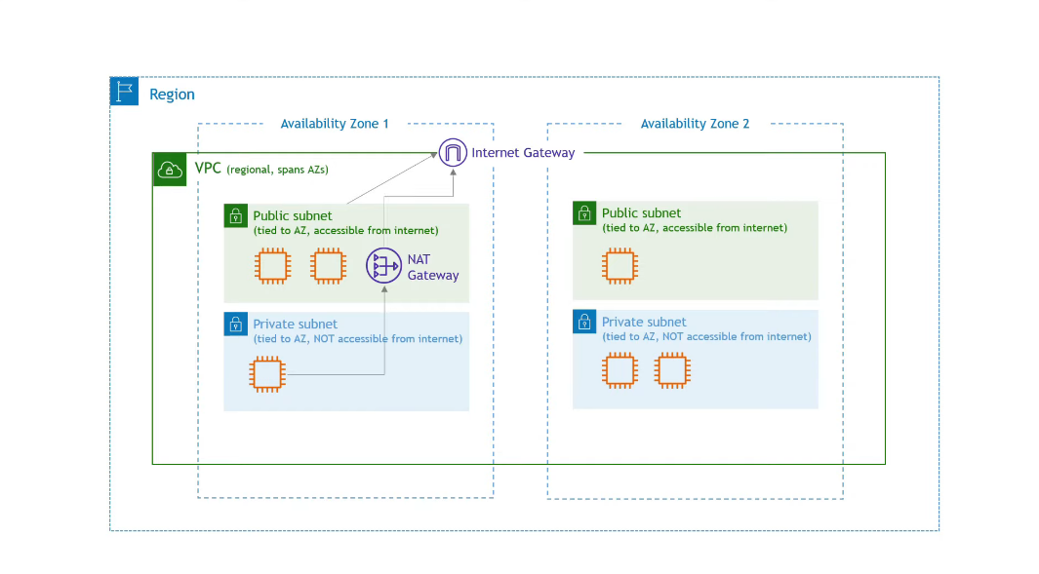

Now the question is how to secure everything we have created? The answer is using network ACLs or access control lists and security groups.

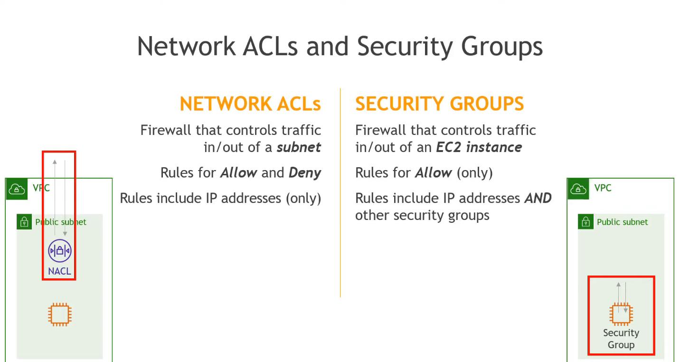

To summarize, Amazon VPC is like a big box inside which you can create your own private network environment. A VPC is a region-level resource, and subnets must be created within an Availability Zone.