IBM SkillsBuild Cybersecurity Bootcamp 2026
Organised by BharatCares
ML Network Intrusion Detector
Detecting malicious network traffic with Machine Learning on the NSL-KDD dataset

Project Report
Submitted by: Vedant Mathur
October 2026

1. Abstract
Every network produces thousands of connections every minute, and no human can inspect all of them. Some of these connections are normal (browsing, email, file transfers) while others are attacks such as denial-of-service floods, port scans or password-guessing attempts. This project builds a Machine Learning based Network Intrusion Detector that looks at the details of a single network connection and predicts whether it is normal or an attack.
The project uses NSL-KDD, a public benchmark dataset for intrusion detection. Three models were trained and compared: Logistic Regression (a simple baseline), Random Forest (a team of decision trees) and Isolation Forest (an anomaly detector trained only on normal traffic). On completely unseen test traffic the models reached an accuracy of about 75% to 79%. The Isolation Forest scored best overall (accuracy 0.788, recall 0.674) while the Random Forest had the highest precision (0.967). An additional experiment showed that the Random Forest reaches 99.9% accuracy on attacks it has already seen but drops to about 76% when new attack types appear, which highlights the real-world zero-day problem.

2. Introduction
Cyber attacks are growing every year, and organisations rely on Intrusion Detection Systems (IDS) to spot them. A traditional IDS uses fixed rules (for example, 'block anything with more than five failed logins'). Rules are easy to understand but they cannot keep up with new or changing attacks. Machine Learning offers another approach: instead of writing rules by hand, we show the computer many examples of normal and malicious traffic and let it learn the patterns by itself.
A simple way to picture this project: imagine a security guard at the gate of a network. Thousands of visitors arrive. The guard looks at how each visitor behaves, for example how long they stay, how much data they send and whether they keep failing to log in. Normal visitors behave in one way and attackers in another. In this project we teach a machine learning model to be that guard.

3. Problem Statement
Given the technical details of one network connection (duration, protocol, service, number of bytes, login failures and similar measurements), build a model that automatically classifies the connection as normal or malicious, compare different approaches, and explain which signals the model depends on.

4. Objectives
- Understand the structure of a public network intrusion dataset and the main attack families.
- Prepare the data so that machine learning models can use it.
- Train and compare a baseline model, a supervised model and an anomaly detection model.
- Evaluate the models with metrics that matter in security (precision, recall, F1-score and confusion matrices).
- Analyse which attack types are detected well and which are missed.
- Make the model explainable by finding the features that influence its decisions.

5. Dataset
The project uses NSL-KDD, an improved version of the well-known KDD'99 dataset created by the Canadian Institute for Cybersecurity at the University of New Brunswick. It removes duplicate records that made the original dataset unfair for evaluation. The dataset comes as two files:
- KDDTrain+ with 125,973 connections, used to teach the models.
- KDDTest+ with 22,544 connections, used to test the models on traffic they have never seen. It also contains attack types that do not appear in the training file, which makes it a tougher and more realistic test.
Each row describes one network connection using 41 features plus a label (either 'normal' or the name of an attack). The features include basic details (duration, protocol, service, bytes sent and received), content details (failed logins, root shell attempts) and traffic statistics (how many connections went to the same host or service in a short time window).

5.1 Attack families
The many individual attack names are grouped into four standard families:
Family | Meaning in simple words
DoS | Denial of Service: flooding a server so that real users cannot use it (for example Neptune, Smurf).
Probe | Scanning the network to find weak spots before an attack (for example port scans).
R2L | Remote to Local: an outsider trying to gain local access, for example by guessing passwords.
U2R | User to Root: a normal user trying to become the administrator.

5.2 Data exploration
The training file has no missing values and no duplicate rows. The number of connections in each family is shown below. Normal traffic and attack traffic are reasonably balanced (about 53% normal and 47% attack), so a model cannot score well by always guessing one answer. DoS is the largest attack family, while U2R is extremely rare with only 52 examples.
Connection type | Number of records | Share of training data
Normal | 67,343 | 53.5%
DoS | 45,927 | 36.5%
Probe | 11,656 | 9.3%
R2L | 995 | 0.8%
U2R | 52 | 0.04%
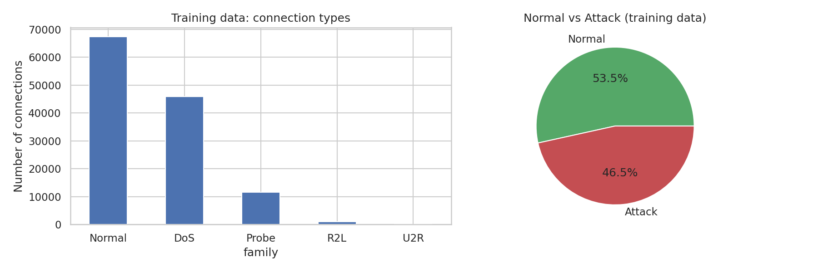
Figure 1: Distribution of connection types in the training data

6. Tools and Technologies
Tool | Purpose
Python 3 | Main programming language.
pandas and NumPy | Loading, cleaning and handling the data.
scikit-learn | Data preparation, machine learning models and evaluation metrics.
matplotlib and seaborn | Creating graphs and charts.
Jupyter Notebook / Google Colab | Writing and running the code with explanations and outputs.

7. Methodology

7.1 Data preparation
Machine learning models only understand numbers, so the data was prepared in two steps:
- One-hot encoding for text columns. The columns protocol_type, service and flag contain words. Each word becomes its own 0/1 column. For example, the protocol 'tcp' becomes the column protocol_type_tcp, which is 1 for TCP connections and 0 otherwise.
- Standardisation for number columns. Values such as src_bytes can be huge while others such as duration are small. Scaling them to a similar range stops large numbers from dominating the model.
After this step the original 41 features became 122 features. The preparation steps were learned from the training data only and then applied to the test data, so the test data stays completely unseen and the evaluation is fair. The target label was simplified to two classes: 0 for normal and 1 for attack.

7.2 Models
Model | How it works (simple explanation)
Logistic Regression | A simple baseline that learns one dividing line between normal and attack traffic. Settings: maximum 1000 iterations.
Random Forest | A team of 100 decision trees that vote. Each tree asks yes/no questions such as 'were there many failed logins?'. The majority vote is the final answer.
Isolation Forest | An anomaly detector with 200 trees. It is trained only on normal traffic and flags anything that looks very different from normal. It is useful when examples of attacks are not available.

7.3 Evaluation metrics
Accuracy alone can be misleading, so four measures were used:
- Accuracy: out of all connections, how many were classified correctly.
- Precision: when the model says 'attack', how often it is really an attack. Low precision means many false alarms.
- Recall: out of all real attacks, how many were caught. This is the most important measure in security because a missed attack is the costly mistake.
- F1-score: a single score that balances precision and recall.

8. Results

8.1 Model comparison on the unseen test set
Model | Accuracy | Precision | Recall | F1-score
Logistic Regression | 0.7537 | 0.9174 | 0.6234 | 0.7424
Random Forest | 0.7648 | 0.9670 | 0.6075 | 0.7462
Isolation Forest | 0.7884 | 0.9365 | 0.6740 | 0.7839

All three models are very precise (above 0.91), which means that when they raise an alarm it is almost always a real attack. The Random Forest is the most precise at 0.967. The Isolation Forest has the best accuracy, recall and F1-score. The Random Forest missed about 39% of the attacks in the test file.
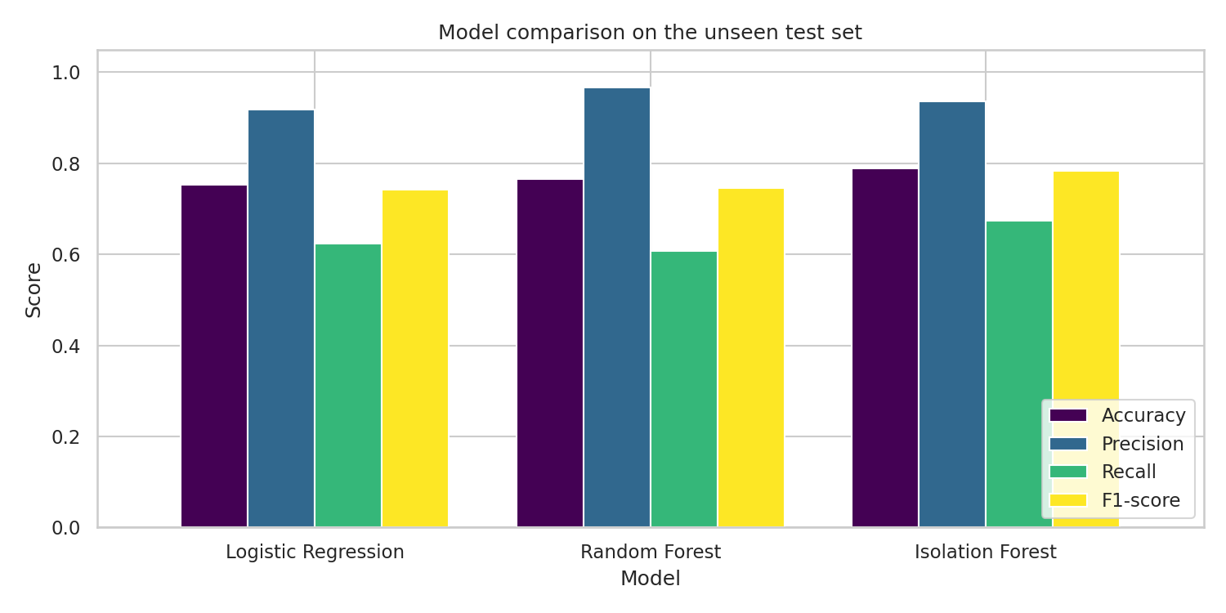
Figure 2: Comparison of the three models on the test set

8.2 Confusion matrices
A confusion matrix shows exactly where a model makes mistakes. The top-left cell is normal traffic correctly allowed, the bottom-right cell is attacks correctly caught, the top-right cell is false alarms and the bottom-left cell is missed attacks.
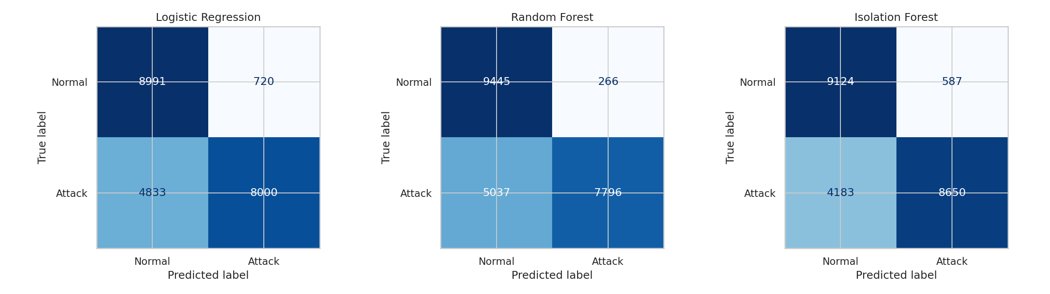
Figure 3: Confusion matrices of the three models

8.3 Detection rate by attack family
The overall numbers hide how each attack type performs. The table and chart below show the share of attacks in each family that the Random Forest detected.
Attack family | Attacks in test set | Detected by Random Forest
DoS | 7,460 | 78.8%
Probe | 2,421 | 72.7%
U2R | 67 | 11.9%
R2L | 2,885 | 5.3%
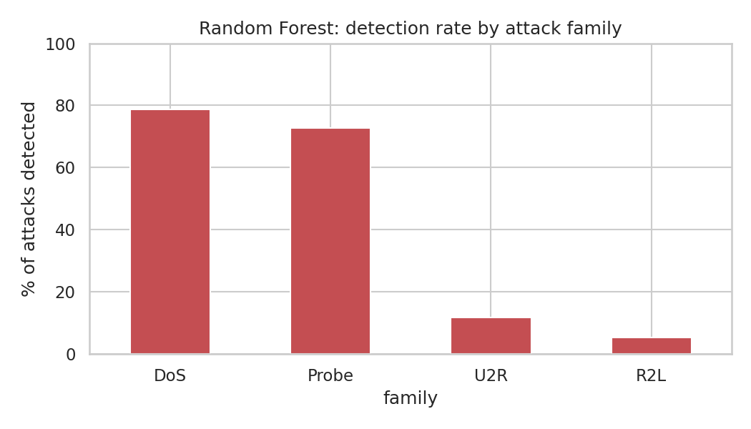
Figure 4: Random Forest detection rate by attack family
DoS and Probe attacks create very obvious traffic patterns (floods of connections, many different ports touched), so they are detected well. R2L and U2R attacks look very similar to normal behaviour and have very few training examples, so they are almost invisible to the model.

9. Discussion

9.1 Why are the test scores lower than expected?
A Random Forest is normally a very strong model, so an accuracy of about 76% looks low. To find the reason, the same Random Forest was also tested on a random 20% slice of the training file, where attack types overlap with what the model has learned.
Test data | Accuracy | Recall
Random slice of training file (familiar attacks) | 0.9990 | 0.9984
Official test file (includes new attacks) | 0.7648 | 0.6075

The model is almost perfect on attacks it has seen before but struggles with new ones. This is exactly the real-world 'zero-day' problem: attackers keep inventing new methods that no training data contains. It also explains why the anomaly-based Isolation Forest performs comparatively well here. It does not need to have seen an attack before, it only needs to notice that the traffic does not look normal.

9.2 Which features matter most?
A good security tool must be explainable. The Random Forest can report how much each feature influenced its decisions. The most important features were src_bytes (data sent by the source), dst_bytes (data returned), flag_SF (whether the connection finished normally), dst_host_same_srv_rate and dst_host_srv_count (how many recent connections went to the same service). These are sensible signals: attacks such as floods and scans produce unusual traffic volumes and unusual connection statuses.
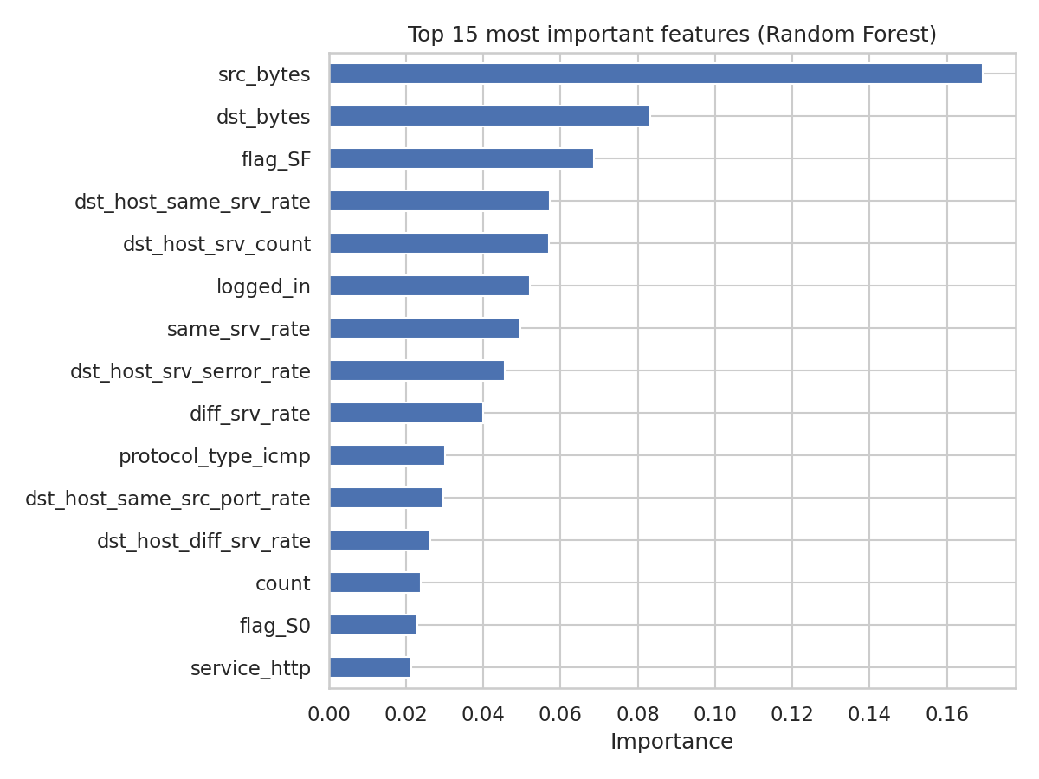
Figure 5: Top 15 most important features (Random Forest)

10. Limitations
- NSL-KDD is an older benchmark. Modern traffic (encrypted, cloud-based) and modern attacks look different, so the results cannot be directly applied to a live network.
- Rare attack families (R2L and U2R) are detected very poorly because the training data has too few examples of them.
- The test file contains attack types unseen during training. This is realistic but lowers the reported scores.
- The models were used with default settings and no hyperparameter tuning, to keep the project simple and easy to follow.

11. Future Scope
- Use a newer dataset such as CIC-IDS2017 that reflects modern traffic.
- Tune the models and handle the class imbalance for rare attacks, for example with class weights or SMOTE oversampling.
- Combine the supervised Random Forest with the Isolation Forest so that known attacks and unusual new behaviour are both covered.
- Wrap the best model in a small dashboard that scores live traffic and raises alerts.

12. Conclusion
This project built a Machine Learning based Network Intrusion Detector and compared three different approaches on the public NSL-KDD dataset. The models are highly precise and detect common attacks such as DoS and Probe well. The experiments also showed an important lesson for real-world security: a model that looks perfect on familiar attacks can lose a lot of accuracy when new attacks appear, and rare attacks such as R2L and U2R remain a hard problem. Combining supervised learning with anomaly detection, using richer data and keeping the model explainable are the most promising directions to improve the detector further.

13. References
- Tavallaee, M., Bagheri, E., Lu, W. and Ghorbani, A. (2009). A Detailed Analysis of the KDD CUP 99 Data Set. IEEE Symposium on Computational Intelligence for Security and Defense Applications.
- NSL-KDD dataset, Canadian Institute for Cybersecurity, University of New Brunswick: https://www.unb.ca/cic/datasets/nsl.html
- NSL-KDD files used in the notebook (GitHub mirror): https://github.com/defcom17/NSL_KDD
- scikit-learn documentation: https://scikit-learn.org

