**ASSIGNMENT HELP**

**MANUAL**



SUBMITTED

TO

VISHWAKARMA INSTITUTE OF INFORMATION TECHNOLOGY, PUNE

FOR THE SKILL AND COMPETENCY EVALUATION OF

ARTIFICIAL INTELLIGENCE [CAUA31201]

IN

**CSE AI DEPARTMENT**

BY

**Vedant Rakesh Mukhekar**

**Class: T.Y. BTech Division: A Batch: A2**

**Batch Teacher**

**Dr. ANURADHA YENKIKAR.**

**INDEX**

|  |  |  |
| --- | --- | --- |
| **SR. NO.** | **CONTENTS** | **PAGE NO.** |
| **1** | **PROBLEM STATEMENT** | **4-5** |
| **2** | **LIBRARY USED** | **5-6** |
| **3** | **THEORY** | **6-7** |
| **4** | **METHODOLOGY** | **7-14** |
| **5** | **ADVANTAGES & DISADVANTAGES** | **14-15** |
| **6** | **WORKING** | **16-17** |
| **7** | **DIAGRAM** | **17-18** |
| **8** | **CONCLUSION** | **18-19** |

### Problem Statement

The goal of this project is to create a **Chatbot Application** that can assist users in a specific real-world scenario. This chatbot will serve as a virtual assistant in the **healthcare domain**, providing users with information about common medical queries, appointment scheduling, medication reminders, and general health advice. The application aims to improve patient engagement, streamline communication, and reduce the burden on healthcare professionals by automating routine inquiries and tasks.

### Libraries Used

* **Python Libraries**:
  + Flask: A web framework for creating web applications.
  + NLTK: Natural Language Toolkit for processing and understanding human language.
  + ChatterBot: A machine learning library to generate automated responses based on training data.

### Theory

A chatbot is a software application designed to conduct a conversation with human users, either via text or voice. It uses natural language processing (NLP) to understand user inputs and respond in a way that mimics human interaction.

#### Key Concepts

* **Natural Language Processing (NLP)**:
  + NLP enables chatbots to understand, interpret, and generate human language. This involves several linguistic tasks, such as tokenization (breaking down text into words or phrases), part-of-speech tagging (identifying the grammatical role of each word), named entity recognition (identifying specific entities like names and places), and sentiment analysis (determining the emotional tone of the text).
* **Machine Learning**:
  + Machine learning techniques, particularly supervised learning, can be employed to train chatbots on various datasets. This training allows them to generate appropriate responses based on user queries and improve over time as they interact with users.
* **Dialog Management**:
  + Effective chatbots require dialog management, which helps in maintaining context during interactions. This involves tracking user intent, managing state across different turns in the conversation, and ensuring coherent responses.
* **Rule-Based vs. AI-Based Chatbots**:
  + **Rule-Based Chatbots**: Operate on predefined rules and scripted responses. They are limited to specific questions and answers and can struggle with user inputs that fall outside their programmed rules.
  + **AI-Based Chatbots**: Utilize machine learning and NLP to understand context and generate responses dynamically. They allow for more natural and flexible interactions, adapting to a wide range of user inputs.
* **Evaluation Metrics**:
  + Evaluating chatbot performance can involve metrics such as precision (accuracy of responses), recall (ability to provide relevant answers), and user satisfaction (user engagement and feedback). Continuous evaluation is crucial for improving chatbot performance.

#### Applications of Chatbots

* **Customer Support**: Providing assistance with inquiries and troubleshooting issues.
* **E-commerce**: Helping users navigate product selection and purchase processes.
* **Healthcare**: Answering medical questions, scheduling appointments, and providing medication reminders.
* **Education**: Assisting students with queries related to courses, schedules, and learning resources.

### Methodology

1. **Define the Scope**: Identify the specific functionalities of the chatbot in the healthcare domain, such as appointment scheduling, answering medical queries, and medication reminders.
2. **Set Up the Environment**: Install the necessary libraries and create a web application framework using Flask.
3. **Design the Chatbot Logic**:
   * Use ChatterBot to implement the chatbot's response generation.
   * Train the chatbot on a dataset related to healthcare queries.
4. **Develop the User Interface**: Create a simple web interface for users to interact with the chatbot.
5. **Testing and Iteration**: Test the chatbot with various queries and refine its responses based on user feedback.

### Advantages & Disadvantages

* **Advantages**:
  + **24/7 Availability**: Chatbots can provide instant responses and assistance at any time, improving user accessibility to information.
  + **Scalability**: They can handle multiple users simultaneously, reducing the burden on human staff and allowing healthcare professionals to focus on more critical tasks.
  + **Cost-Effective**: Automating routine inquiries can significantly reduce operational costs in healthcare facilities.
* **Disadvantages**:
  + **Limited Understanding**: Chatbots may struggle with complex queries, slang, or nuances in language, leading to user frustration.
  + **Dependency on Data**: Their effectiveness depends on the quality and extent of the training data; poorly curated data can lead to incorrect responses.
  + **User Acceptance**: Some users may prefer human interaction over chatting with a bot, impacting the chatbot’s effectiveness.

### Working Example (Python Code)

Here's a simple implementation of a healthcare chatbot using Flask and ChatterBot:

python

Copy code

from flask import Flask, request, jsonify

from chatterbot import ChatBot

from chatterbot.trainers import ChatterBotCorpusTrainer

# Create a new chatbot instance

chatbot = ChatBot('HealthBot')

# Set up the training

trainer = ChatterBotCorpusTrainer(chatbot)

trainer.train('chatterbot.corpus.english')

# Create a Flask web application

app = Flask(__name__)

@app.route('/chat', methods=['POST'])

def chat():

user_input = request.json.get('message')

bot_response = chatbot.get_response(user_input)

return jsonify({'response': str(bot_response)})

if __name__ == '__main__':

app.run(debug=True)

### Diagram

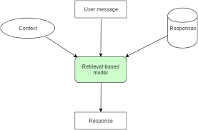

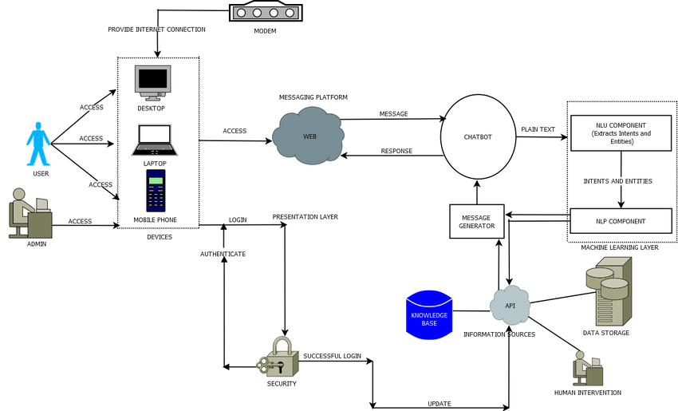

### Conclusion

The **Chatbot Application** developed in this project serves as an intelligent assistant in the healthcare domain. It utilizes natural language processing and machine learning techniques to engage users, answer common medical inquiries, and streamline appointment scheduling. By automating these tasks, the chatbot enhances patient experience and reduces the workload on healthcare providers. As technology continues to evolve, the potential for chatbots in various sectors, including healthcare, will expand, offering more sophisticated and context-aware interactions. The continued refinement of chatbots through user feedback and data will further enhance their reliability and effectiveness, making them invaluable tools in modern healthcare delivery.