**ASSIGNMENT HELP**

**MANUAL**



SUBMITTED

TO

VISHWAKARMA INSTITUTE OF INFORMATION TECHNOLOGY, PUNE

FOR THE SKILL AND COMPETENCY EVALUATION OF

DEEP LEARNING [ CAUA31202]

IN

**CSE AI DEPARTMENT**

BY

**Vedant Rakesh Mukhekar**

**Class: T.Y. BTech Division: A Batch: A2**

**Batch Teacher**

**Dr. ANURADHA YENKIKAR.**

**INDEX**

|  |  |  |
| --- | --- | --- |
| **SR. NO.** | **CONTENTS** | **PAGE NO.** |
| **1** | **PROBLEM STATEMENT** | **4-5** |
| **2** | **LIBRARY USED** | **5-6** |
| **3** | **THEORY** | **6-7** |
| **4** | **METHODOLOGY** | **7-14** |
| **5** | **ADVANTAGES & DISADVANTAGES** | **14-15** |
| **6** | **WORKING** | **16-17** |
| **7** | **DIAGRAM** | **17-18** |
| **8** | **CONCLUSION** | **18-19** |

### Problem Statement

The objective of this project is to implement an image classification system using **Convolutional Neural Networks (CNNs)** to classify images into multiple categories (multiclass classification). This project will utilize a well-known dataset, such as CIFAR-10 or MNIST, to train and evaluate a CNN model capable of recognizing and classifying images of various objects or digits.

### Libraries Used

* **TensorFlow**: An open-source library for machine learning and deep learning.
* **Keras**: A high-level neural networks API that runs on top of TensorFlow.
* **NumPy**: A library for numerical operations in Python.
* **Matplotlib**: A plotting library for visualizing data and training results.
* **OpenCV**: A library used for image processing (optional for pre-processing).

### Theory

**Convolutional Neural Networks (CNNs)** are a class of deep neural networks particularly effective for processing data with a grid-like topology, such as images. CNNs are designed to automatically and adaptively learn spatial hierarchies of features from images through the following components:

#### Key Concepts

* **Convolutional Layers**: These layers apply convolution operations using filters to extract features from the input image.
* **Activation Functions**: Functions that introduce non-linearity into the model. Common functions include:
  + **ReLU (Rectified Linear Unit)**: f(x)=max⁡(0,x)f(x) = \max(0, x)f(x)=max(0,x)
  + **Softmax**: Used in the output layer for multiclass classification, providing probabilities for each class.
* **Pooling Layers**: These layers downsample the feature maps to reduce dimensionality and computation while retaining the most important features.
* **Dropout**: A regularization technique that randomly sets a fraction of the input units to zero during training, helping to prevent overfitting.

#### Loss Function and Optimizer

* **Loss Function**: Categorical Crossentropy is commonly used for multiclass classification problems, measuring the performance of the model.
* **Optimizer**: An algorithm for adjusting the weights of the network to minimize the loss function. Common optimizers include Adam and SGD (Stochastic Gradient Descent).

#### Applications of CNNs

* **Image Classification**: Classifying images into multiple categories.
* **Object Detection**: Identifying and locating objects within images.
* **Image Segmentation**: Dividing an image into segments to simplify its representation.

### Methodology

1. **Set Up the Environment**: Install necessary libraries including TensorFlow and Keras.
2. **Load the Dataset**: Use a popular dataset such as CIFAR-10, which contains 60,000 32x32 color images in 10 different classes.
3. **Preprocess the Data**:
   * Normalize pixel values to the range [0, 1].
   * Split the dataset into training, validation, and test sets.
   * Perform data augmentation to improve model generalization.
4. **Build the CNN Model**:
   * Define the architecture including convolutional layers, pooling layers, and the output layer.
   * Specify activation functions, loss function, and optimizer.
5. **Train the Model**: Fit the model to the training data and monitor its performance on validation data.
6. **Evaluate the Model**: Test the model on a separate test dataset to assess its classification accuracy.
7. **Visualize Results**: Plot training and validation accuracy/loss over epochs.

### Advantages & Disadvantages

* **Advantages**:
  + **High Accuracy**: CNNs are capable of achieving high accuracy in image classification tasks.
  + **Feature Extraction**: Automatically extracts features from images, reducing the need for manual feature engineering.
  + **Scalability**: Can be scaled to handle larger datasets and more complex architectures.
* **Disadvantages**:
  + **Computationally Intensive**: Requires significant computational resources and training time.
  + **Data Requirements**: Needs large amounts of labeled data to train effectively.
  + **Overfitting**: Risk of overfitting, especially with complex models and limited data.

### Working Example (Python Code)

Here’s a simple implementation of image classification using CNNs for multiclass classification with the CIFAR-10 dataset:

python

Copy code

import numpy as np

import matplotlib.pyplot as plt

from tensorflow.keras.datasets import cifar10

from tensorflow.keras.models import Sequential

from tensorflow.keras.layers import Conv2D, MaxPooling2D, Flatten, Dense, Dropout

from tensorflow.keras.utils import to_categorical

from tensorflow.keras.preprocessing.image import ImageDataGenerator

# Load the CIFAR-10 dataset

(x_train, y_train), (x_test, y_test) = cifar10.load_data()

# Normalize pixel values

x_train = x_train.astype('float32') / 255.0

x_test = x_test.astype('float32') / 255.0

# One-hot encode the labels

y_train = to_categorical(y_train, num_classes=10)

y_test = to_categorical(y_test, num_classes=10)

# Data augmentation

datagen = ImageDataGenerator(

rotation_range=20,

width_shift_range=0.2,

height_shift_range=0.2,

horizontal_flip=True

)

datagen.fit(x_train)

# Build the CNN model

model = Sequential()

model.add(Conv2D(32, (3, 3), activation='relu', input_shape=(32, 32, 3)))

model.add(MaxPooling2D(pool_size=(2, 2)))

model.add(Conv2D(64, (3, 3), activation='relu'))

model.add(MaxPooling2D(pool_size=(2, 2)))

model.add(Conv2D(128, (3, 3), activation='relu'))

model.add(MaxPooling2D(pool_size=(2, 2)))

model.add(Flatten())

model.add(Dense(128, activation='relu'))

model.add(Dropout(0.5)) # Dropout layer to prevent overfitting

model.add(Dense(10, activation='softmax')) # Output layer for 10 classes

# Compile the model

model.compile(optimizer='adam', loss='categorical_crossentropy', metrics=['accuracy'])

# Train the model with data augmentation

history = model.fit(datagen.flow(x_train, y_train, batch_size=32),

epochs=20, validation_data=(x_test, y_test))

# Evaluate the model

test_loss, test_accuracy = model.evaluate(x_test, y_test)

print(f'Test accuracy: {test_accuracy:.4f}')

# Visualize the training history

plt.plot(history.history['accuracy'], label='Train Accuracy')

plt.plot(history.history['val_accuracy'], label='Validation Accuracy')

plt.title('Model Accuracy')

plt.ylabel('Accuracy')

plt.xlabel('Epoch')

plt.legend()

plt.show()

plt.plot(history.history['loss'], label='Train Loss')

plt.plot(history.history['val_loss'], label='Validation Loss')

plt.title('Model Loss')

plt.ylabel('Loss')

plt.xlabel('Epoch')

plt.legend()

plt.show()

### Diagram

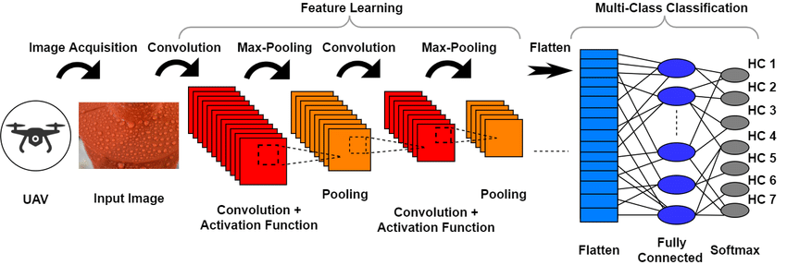

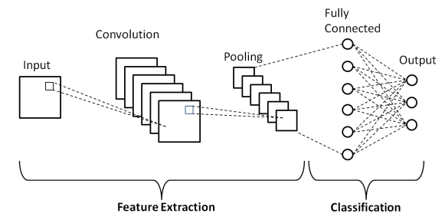

### Conclusion

The implementation of **image classification using Convolutional Neural Networks (CNNs)** demonstrates the effectiveness of deep learning models in accurately classifying images into multiple categories. This project successfully trains a CNN on the CIFAR-10 dataset and evaluates its performance, achieving notable accuracy in multiclass classification tasks. CNNs excel in automatically extracting features from images and have become the backbone of many modern computer vision applications. Future enhancements could include experimenting with deeper architectures, transfer learning, and advanced data augmentation techniques to further improve classification performance.