**ASSIGNMENT HELP**

**MANUAL**



SUBMITTED

TO

VISHWAKARMA INSTITUTE OF INFORMATION TECHNOLOGY, PUNE

FOR THE SKILL AND COMPETENCY EVALUATION OF

DEEP LEARNING [ CAUA31202]

IN

**CSE AI DEPARTMENT**

BY

**Vedant Rakesh Mukhekar**

**Class: T.Y. BTech Division: A Batch: A2**

**Batch Teacher**

**Dr. ANURADHA YENKIKAR.**

**INDEX**

|  |  |  |
| --- | --- | --- |
| **SR. NO.** | **CONTENTS** | **PAGE NO.** |
| **1** | **PROBLEM STATEMENT** | **4-5** |
| **2** | **LIBRARY USED** | **5-6** |
| **3** | **THEORY** | **6-7** |
| **4** | **METHODOLOGY** | **7-14** |
| **5** | **ADVANTAGES & DISADVANTAGES** | **14-15** |
| **6** | **WORKING** | **16-17** |
| **7** | **DIAGRAM** | **17-18** |
| **8** | **CONCLUSION** | **18-19** |

### Problem Statement

The objective of this project is to implement an object detection system using the **You Only Look Once (YOLO)** algorithm with a pretrained model. The goal is to accurately detect and classify multiple objects within an image or video stream in real-time. By utilizing a pretrained YOLO model, the project aims to leverage existing knowledge from vast datasets, allowing for rapid deployment and high accuracy in identifying common objects such as people, vehicles, and animals.

### Libraries Used

* **OpenCV**: An open-source computer vision and image processing library.
* **TensorFlow/Keras**: Libraries for building and running deep learning models (if using TensorFlow-based YOLO).
* **PyTorch**: An alternative deep learning library, depending on the YOLO version implemented.
* **NumPy**: A library for numerical operations in Python.
* **Matplotlib**: A plotting library for visualizing images and detection results.
* **Pillow**: A Python Imaging Library for image processing tasks.

### Theory

**Object Detection** involves identifying and locating objects within images and classifying them into predefined categories. The YOLO algorithm stands out due to its speed and accuracy, making it suitable for real-time applications. YOLO treats object detection as a single regression problem, directly predicting bounding boxes and class probabilities from the full image in one evaluation.

#### Key Concepts

* **YOLO Architecture**: The YOLO model divides the input image into a grid and predicts bounding boxes and class probabilities for each grid cell. The model uses convolutional layers to extract features from the image.
* **Pretrained Models**: These models are trained on large datasets (e.g., COCO, Pascal VOC) and can be fine-tuned for specific applications, allowing for faster convergence and better accuracy with limited data.
* **Non-Maximum Suppression (NMS)**: A technique used to eliminate redundant overlapping bounding boxes by keeping the one with the highest confidence score.

#### Applications of Object Detection

* **Surveillance**: Monitoring and identifying individuals or vehicles in security systems.
* **Autonomous Vehicles**: Detecting pedestrians, other vehicles, and obstacles for safe navigation.
* **Retail Analytics**: Analyzing customer behavior by detecting products and shoppers in stores.
* **Robotics**: Enabling robots to interact with and navigate their environments.

### Methodology

1. **Set Up the Environment**: Install necessary libraries, including OpenCV, NumPy, and any required deep learning framework (TensorFlow or PyTorch).
2. **Download Pretrained YOLO Model**: Obtain a pretrained YOLO model (e.g., YOLOv3, YOLOv4, or YOLOv5) along with its configuration and weights files.
3. **Load the YOLO Model**: Use OpenCV or the chosen deep learning framework to load the YOLO model.
4. **Prepare Input Data**:
   * Load images or video streams for object detection.
   * Preprocess the input data as required by the model (e.g., resizing, normalization).
5. **Run Object Detection**:
   * Perform forward propagation through the YOLO model to obtain predictions.
   * Process the output to extract bounding boxes, class IDs, and confidence scores.
   * Apply NMS to filter out overlapping boxes.
6. **Visualize Results**: Draw bounding boxes and labels on the detected objects and display the results.
7. **Evaluate Model Performance**: Assess detection performance using metrics like mAP (mean Average Precision) on a validation dataset if available.

### Advantages & Disadvantages

* **Advantages**:
  + **Real-Time Performance**: YOLO is capable of processing images at high speeds, making it suitable for real-time applications.
  + **Global Context Understanding**: The model considers the entire image during prediction, improving context awareness and detection accuracy.
  + **Ease of Use with Pretrained Models**: Utilizing pretrained weights simplifies the training process and improves performance.
* **Disadvantages**:
  + **Limited Small Object Detection**: YOLO may struggle with detecting small objects due to its grid-based approach.
  + **Trade-off Between Speed and Accuracy**: While YOLO is fast, there may be compromises in accuracy compared to other methods like Faster R-CNN.
  + **Dependency on Dataset Quality**: Performance heavily relies on the quality and diversity of the dataset used for training the pretrained model.

### Working Example (Python Code)

Here’s a simple implementation of object detection using YOLO with OpenCV:

python

Copy code

import cv2

import numpy as np

# Load YOLO

weights_path = 'yolov3.weights'

config_path = 'yolov3.cfg'

net = cv2.dnn.readNet(weights_path, config_path)

# Load COCO classes

with open('coco.names', 'r') as f:

classes = f.read().strip().split('\n')

# Set the input image

image_path = 'path_to_your_image.jpg'

image = cv2.imread(image_path)

height, width, _ = image.shape

# Prepare the image for the model

blob = cv2.dnn.blobFromImage(image, 0.00392, (416, 416), (0, 0, 0), True, crop=False)

net.setInput(blob)

# Get the output layer names

layer_names = net.getLayerNames()

output_layers = [layer_names[i[0] - 1] for i in net.getUnconnectedOutLayers()]

# Perform forward propagation

outputs = net.forward(output_layers)

# Initialize lists for detected boxes, confidences, and class IDs

boxes = []

confidences = []

class_ids = []

# Process the outputs

for output in outputs:

for detection in output:

scores = detection[5:]

class_id = np.argmax(scores)

confidence = scores[class_id]

if confidence > 0.5: # Filter out weak detections

center_x = int(detection[0] * width)

center_y = int(detection[1] * height)

w = int(detection[2] * width)

h = int(detection[3] * height)

# Calculate the coordinates for the bounding box

x = int(center_x - w / 2)

y = int(center_y - h / 2)

boxes.append([x, y, w, h])

confidences.append(float(confidence))

class_ids.append(class_id)

# Apply Non-Maximum Suppression

indexes = cv2.dnn.NMSBoxes(boxes, confidences, 0.5, 0.4)

# Draw bounding boxes and labels on the image

for i in range(len(boxes)):

if i in indexes:

x, y, w, h = boxes[i]

label = str(classes[class_ids[i]])

cv2.rectangle(image, (x, y), (x + w, y + h), (0, 255, 0), 2)

cv2.putText(image, label, (x, y + 30), cv2.FONT_HERSHEY_SIMPLEX, 1, (255, 255, 255), 2)

# Show the output image

cv2.imshow("Image", image)

cv2.waitKey(0)

cv2.destroyAllWindows()

### Diagram

### YOLO Algorithm for Object Detection Explained [+Examples]

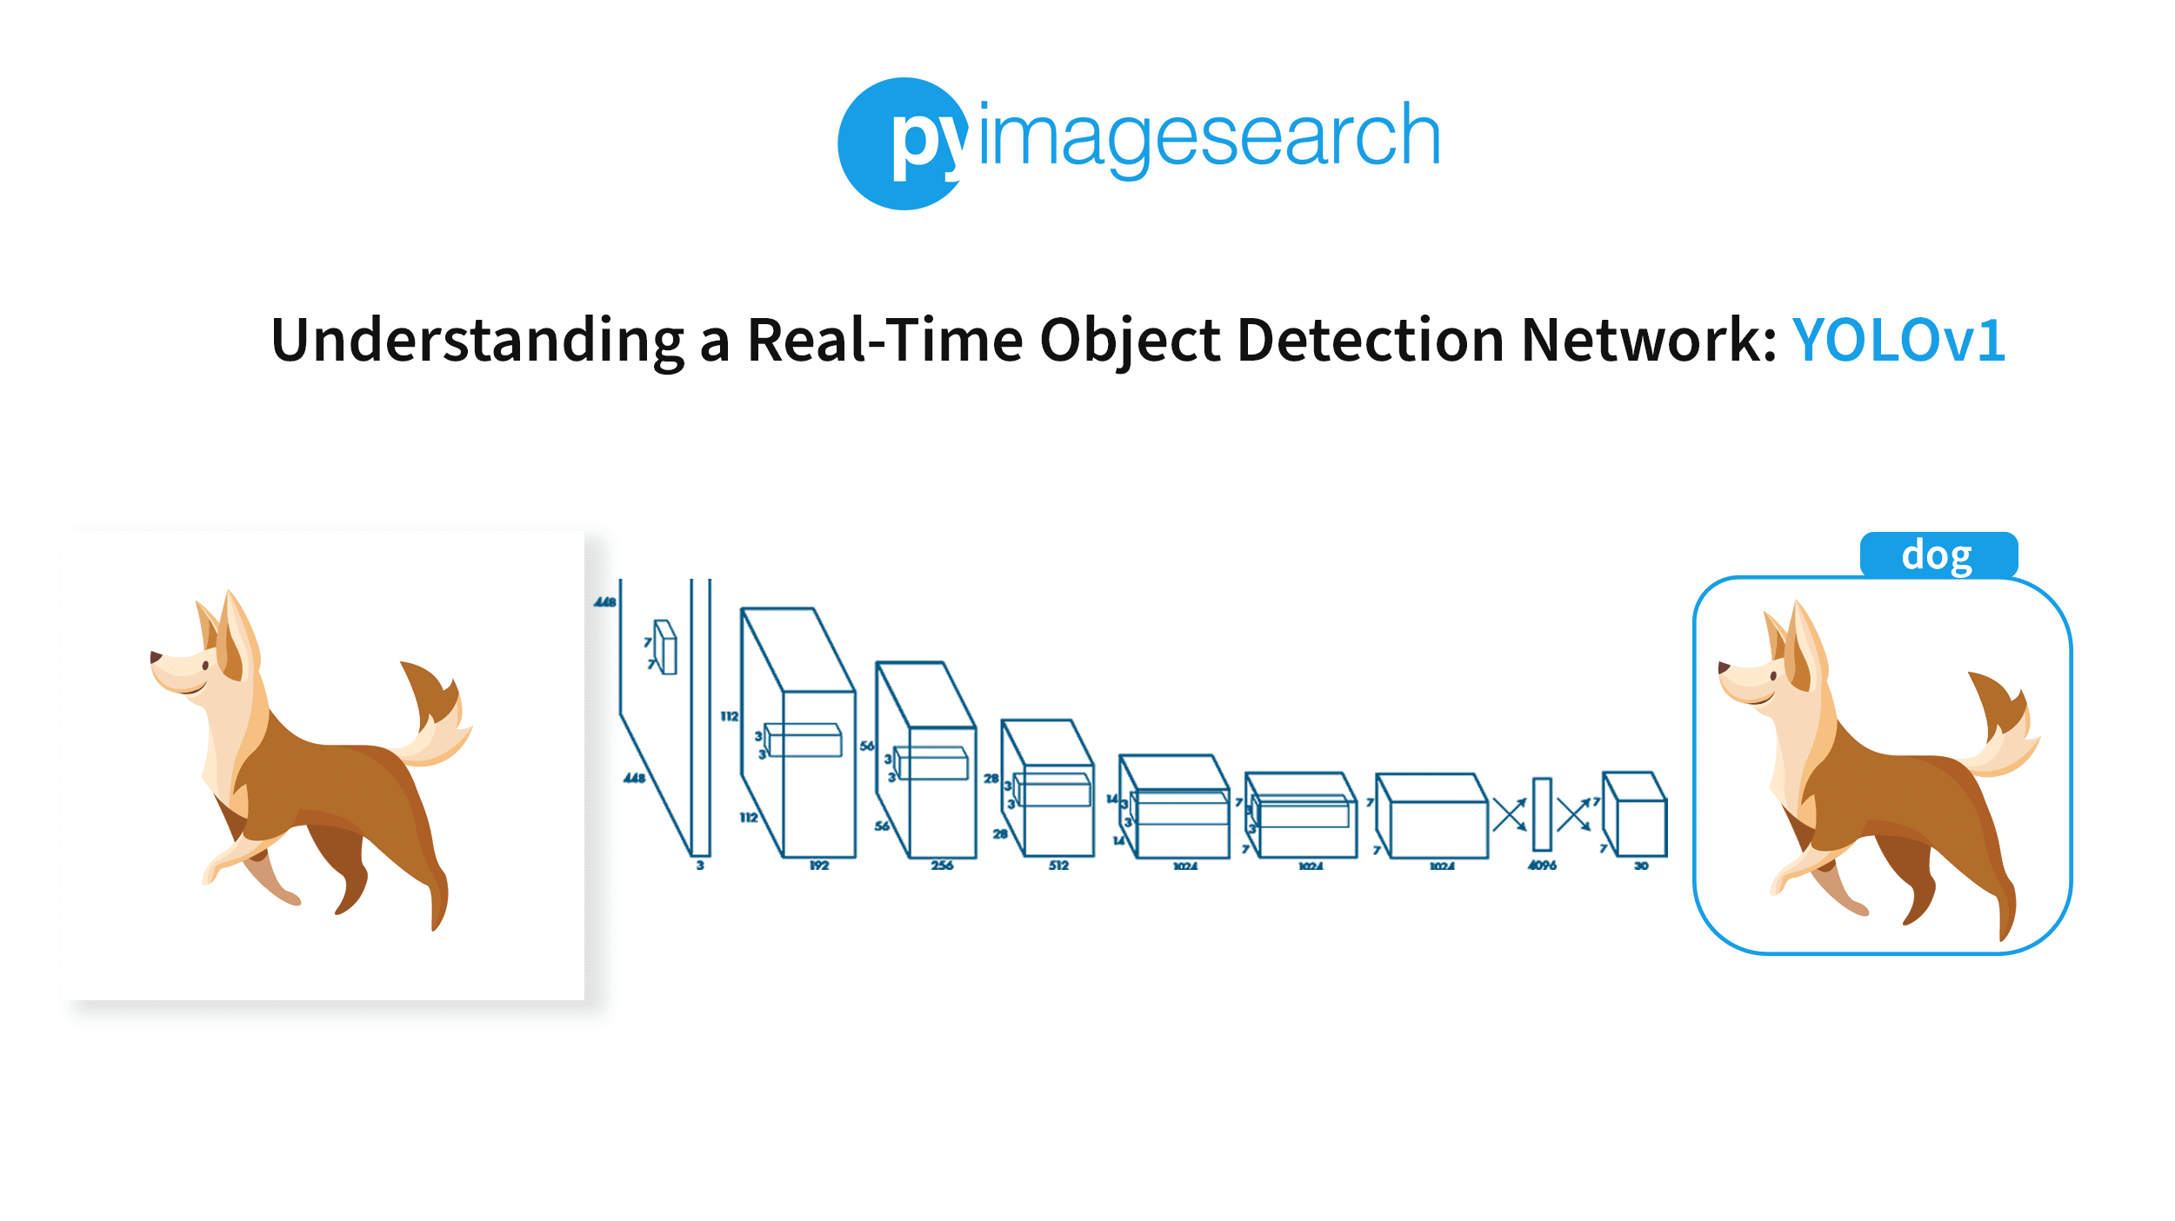

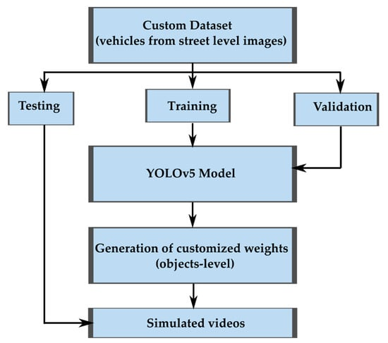

### Conclusion

The implementation of **object detection using YOLO with a pretrained model** demonstrates the effectiveness of the YOLO algorithm in identifying and localizing objects within images in real-time. This project successfully showcases the capabilities of YOLO in various applications, from surveillance to autonomous systems. The use of pretrained models significantly enhances the efficiency and accuracy of the detection process, enabling rapid deployment in real-world scenarios. Future improvements could involve fine-tuning the model on specific datasets, experimenting with newer versions of YOLO (such as YOLOv5 or YOLOv7), or optimizing the model for edge devices to facilitate on-device inference.

Top of Form

Bottom of Form