ASSIGNMENT 4

**Title: Cursors: (All types: Implicit, Explicit, Cursor FOR Loop, Parameterized Cursor)**

student(roll_no, name, marks)

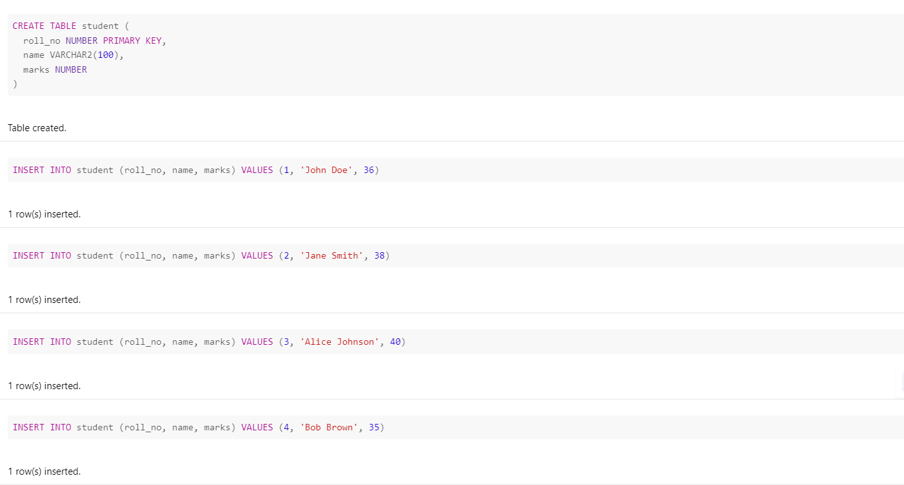

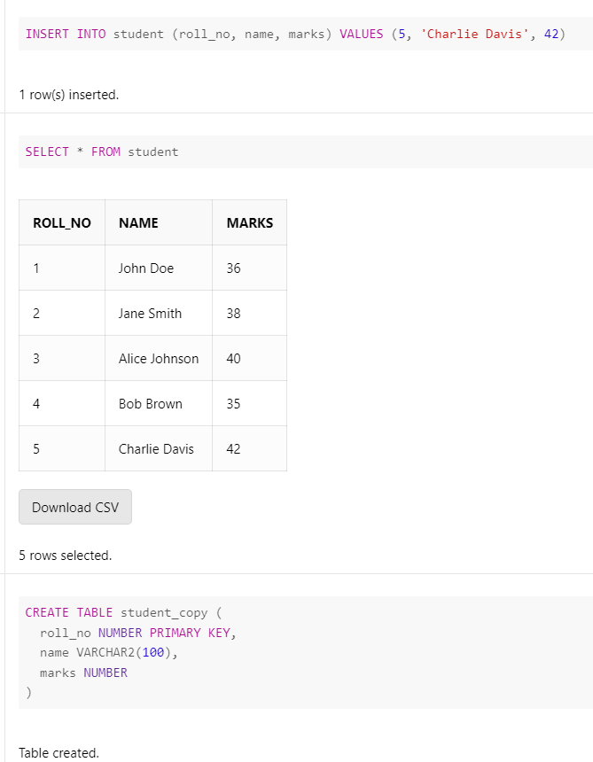

1.Write an anonymous code block which will update marks of students to 40 if he has scored between 35 to 39. Using implicit cursor parameters show whether any records have been updated or not. If updated, display how many records have been updated.

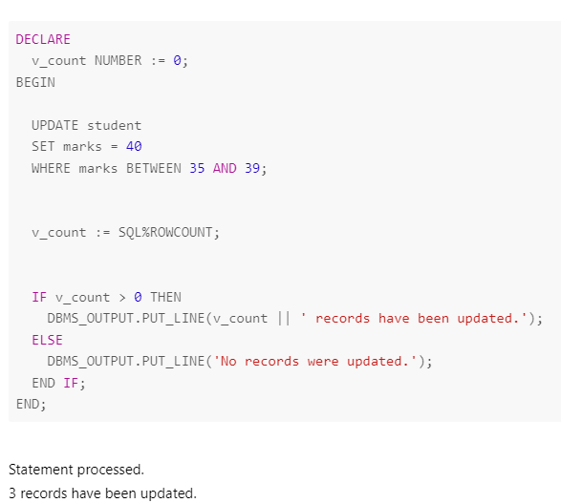

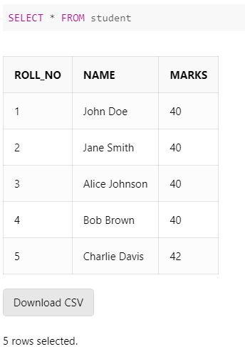

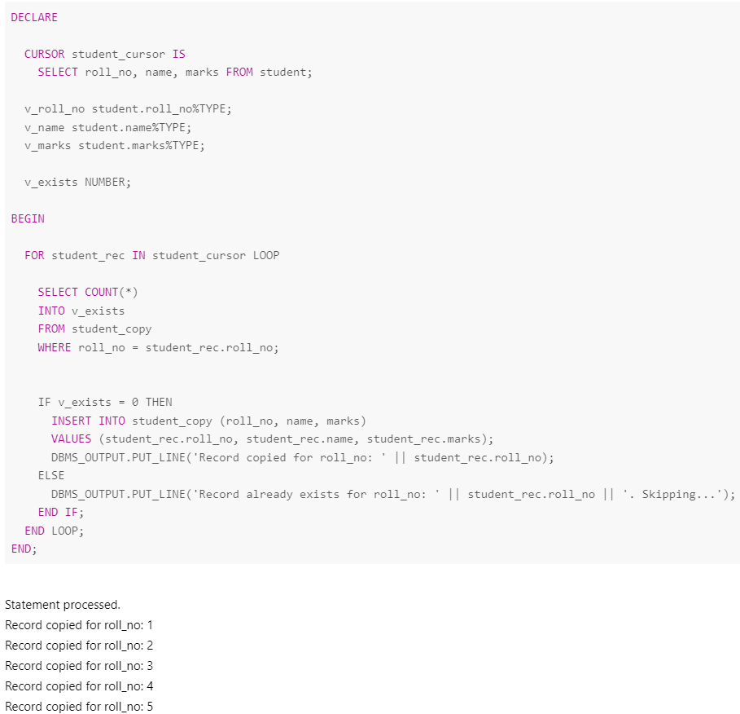2.Write an anonymous code block to demonstrate use of explicit cursor, for loop & parametrized explicit cursor. Copy the content of student table to another table. Before copying, check whether second table consists of same roll number record. If so, discard it otherwise copy it.

