1. Borrower (Rollin, Name, DateofIssue, NameofBook, Status)

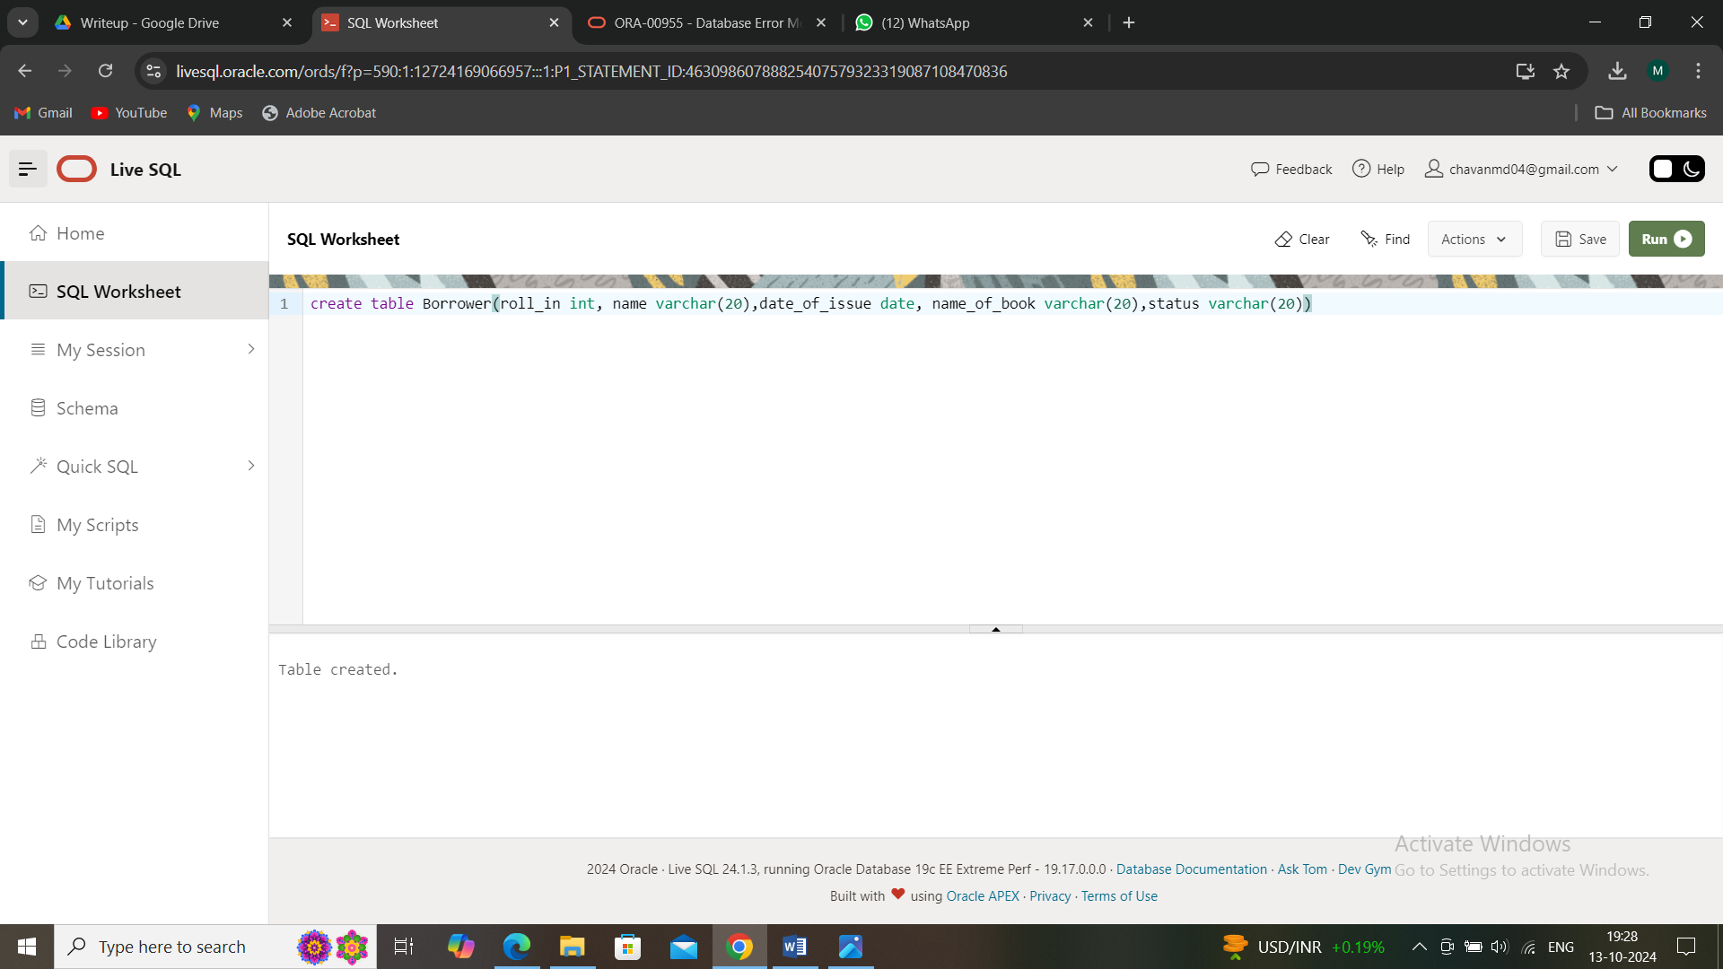

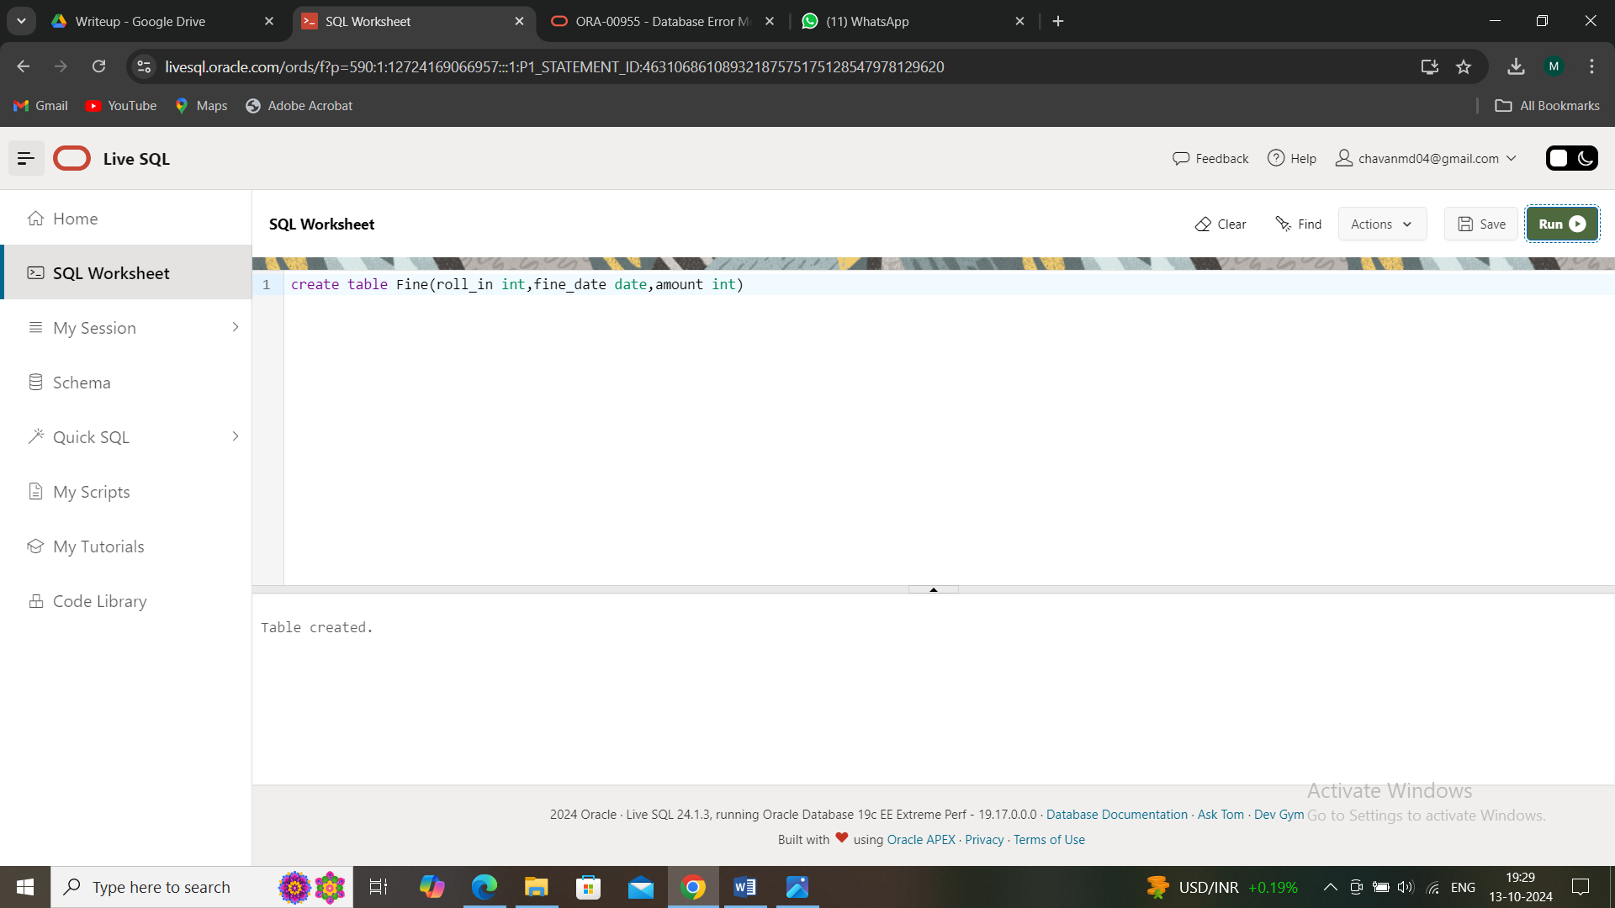

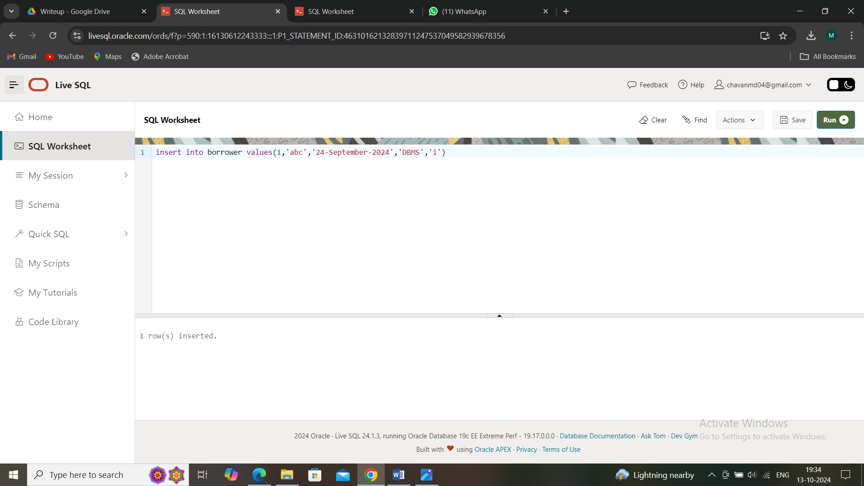

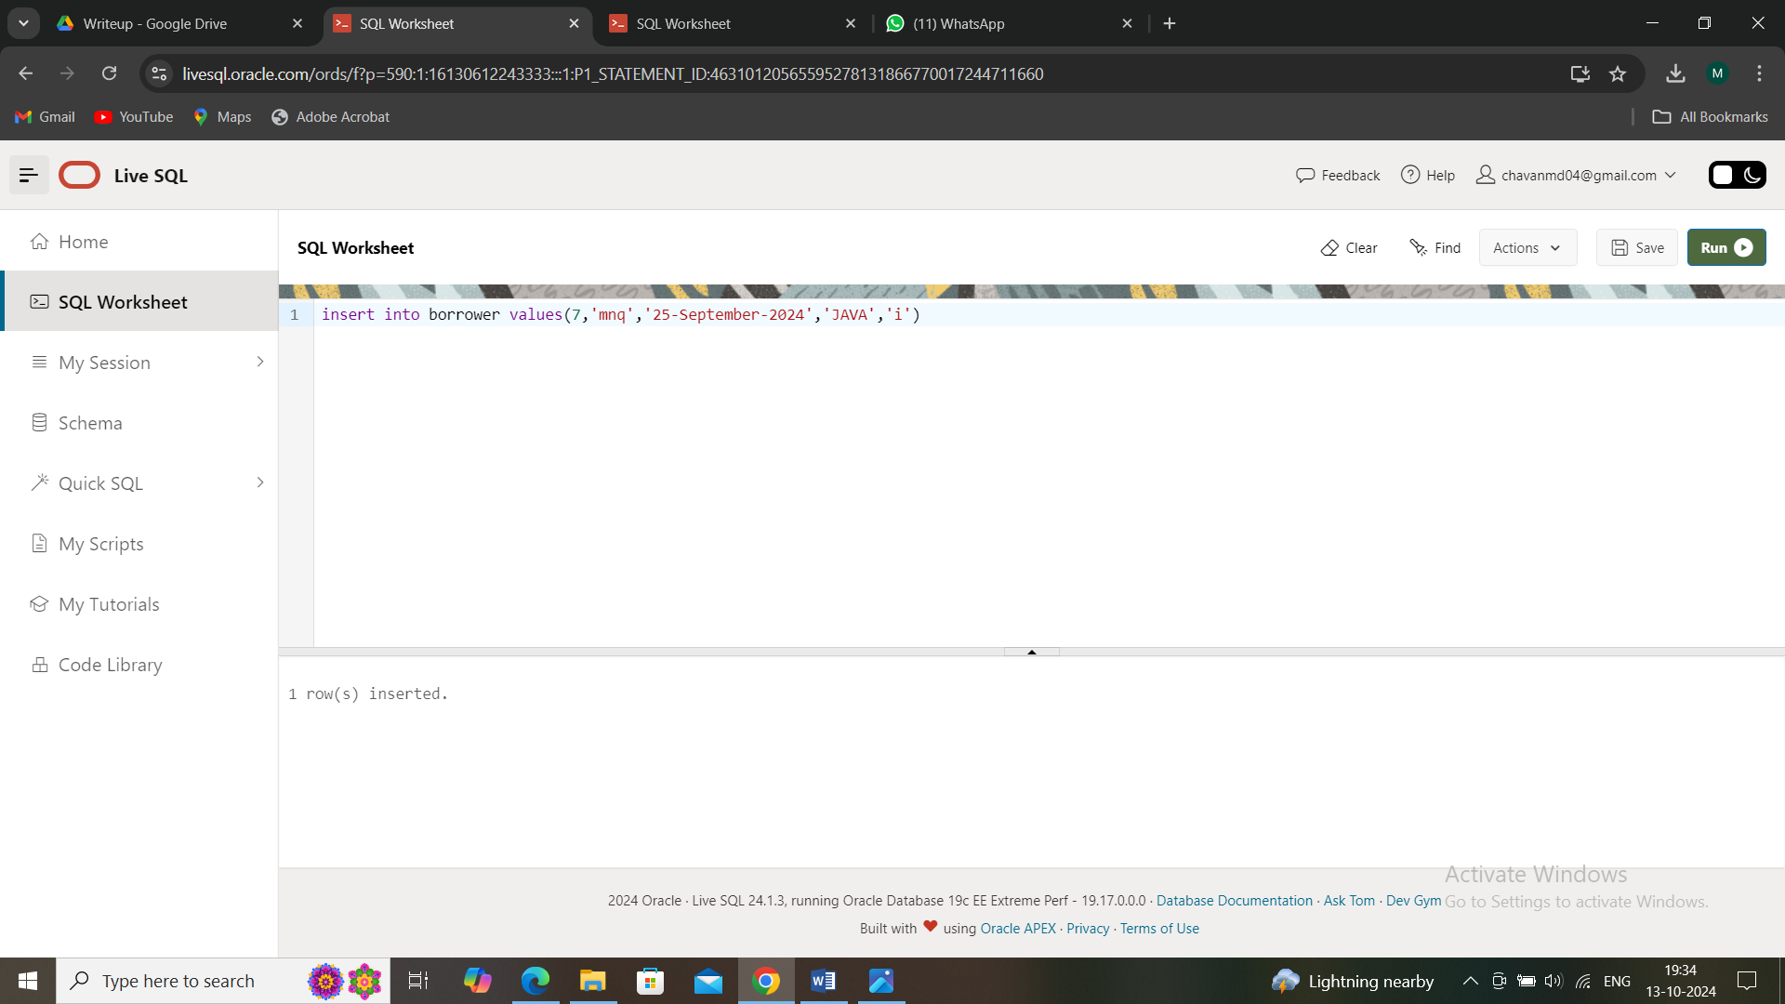

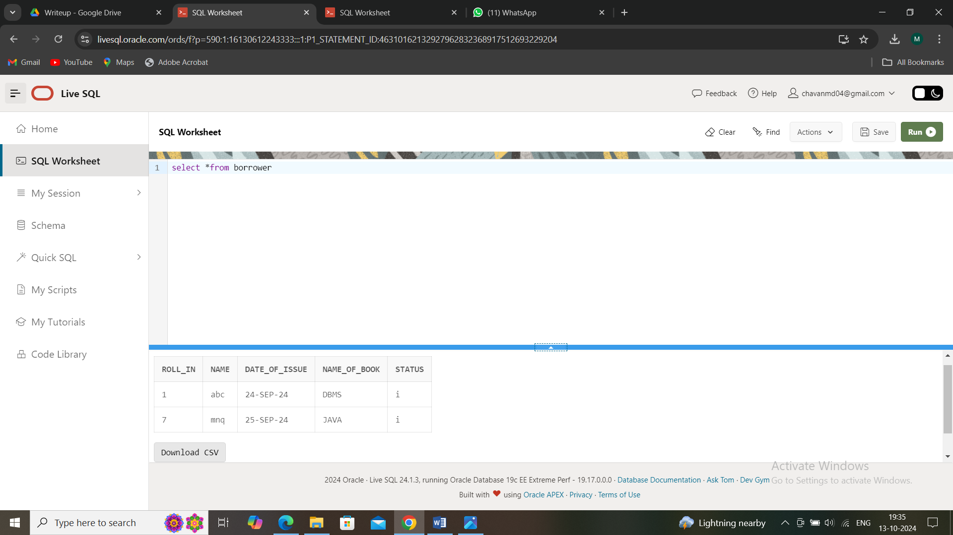

2. Fine(Roll_no,Date,Amt)

• Accept roll_no & name of book from user.

• Check the number of days (from date of issue), if days are between 15 to 30

then fine amount will be Rs 5per day.

• If no. of days>30, per day fine will be Rs 50 per day & for days less than 30,

Rs. 5 per day.

• After submitting the book, status will change from I to R.

• If condition of fine is true, then details will be stored into fine table.

declare

roll int:=1;

b_name varchar(20):='DBMS';

date_issue date;

no_days int;

amt int:=0;

no_days_to_be_fined int:=0;

ex_valid_roll exception;

begin

if roll<0 then raise ex_valid_roll;

end if;

select date_of_issue into date_issue from Borrower where roll_in=roll and

name_of_book=b_name;

dbms_output.put_line('Roll no'||date_issue);

no_days:=sysdate-date_issue;

if(no_days>15 and no_days<30) then no_days_to_be_fined:=no_days-15;

amt:=no_days_to_be_fined*5;

insert into fine values(roll, sysdate,amt);

elsif(no_days>30) then

no_days_to_be_fined:=no_days-15;

amt:=no_days_to_be_fined*50;

insert into fine values(roll,sysdate,amt);

else

amt:=0;

end if;

update Borrower set status='r' where roll_in=roll and name_of_book=b_name;

exception

when ex_valid_roll then

dbms_output.put_line('Invalid Roll no');

when no_data_found then

dbms_output.put_line('Data not Found');

when others then

dbms_output.put_line('');

end;

