# Practical 3

Aim : Build a Counter application using React JS with Increment, Decrement, and Reset functionality.

Code:

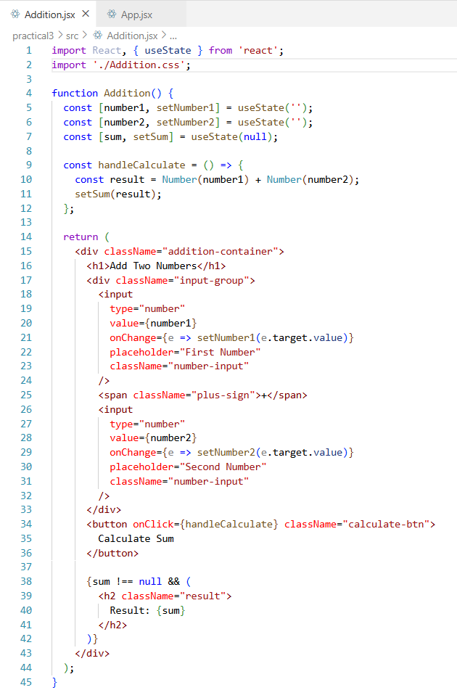

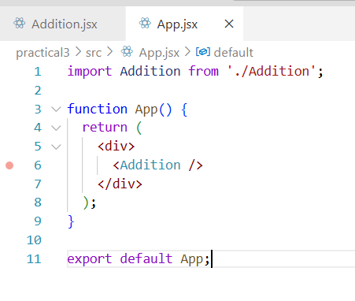

Output:

