**Case Study: How Does a Bike-Share Navigate Speedy Success?**

Welcome to the Cyclistic bike-share analysis case study! In this case study, I had been worked for a fictional company, Cyclistic, and meet different characters and team members. In order to answer the key business questions, l had been followed the steps of the data analysis process: ask, prepare, process, analyze, share, and act.

Scenario

You are a junior data analyst working in the marketing analyst team at Cyclistic, a bike-share company in Chicago. The director of marketing believes the company’s future success depends on maximizing the number of annual memberships. Therefore, your team wants to understand how casual riders and annual members use Cyclistic bikes differently. From these insights, your team will design a new marketing strategy to convert casual riders into annual members. But first, Cyclistic executives must approve your recommendations, so they must be backed up with compelling data insights and professional data visualizations.

**Ask:**

Business Task

Analyse a marketing strategy to convert casual riders into annual members and understand user usage trend to solve the problem.

**Prepare:**

Load the dataset

You can download the dataset from [Download the previous 12 months of Cyclistic trip data](https://divvy-tripdata.s3.amazonaws.com/index.html) .

Download the file and unzip it in appropriate folder.

**Process:**

Tools used for data analysis

* Spreadsheets (Excel)
* R

Follow the steps

* Open your spreadsheet and create a column called “ride_length.”
* Calculate the length of each ride by subtracting the column “started_at” from the column “ended_at” (for example, =D2-C2) and format as HH:MM:SS using Format > Cells > Time > 37:30:55.
* Create a column called “week_day,” and calculate the day of the week that each ride started using the “WEEKDAY” command (for example, =WEEKDAY(C2,1)) in each file. Format as General or as a number with no decimals, noting that 1 = Sunday and 7 = Saturday.
* Proceed to the analyze step.

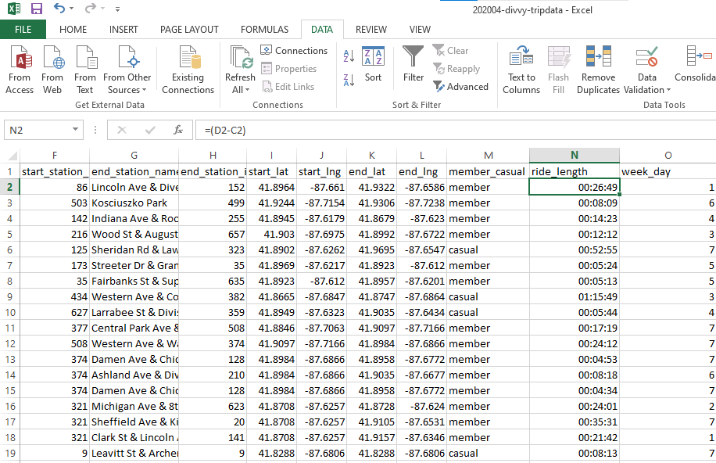

**Analyze:**

Follow the steps

Run a few calculations in one file to get a better sense of the data layout. Options:

* Calculate the mean of ride_length
* Calculate the max ride_length
* Calculate the mode of day_of_week

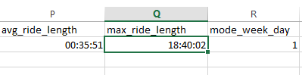

Create a pivot table to quickly calculate and visualize the data. Options:

* Calculate the average ride_length for members and casual riders. Try rows = member_casual; Values = Average of ride_length.
* Calculate the average ride_length for users by day_of_week. Try columns = day_of_week; Rows = member_casual; Values = Average of ride_length.

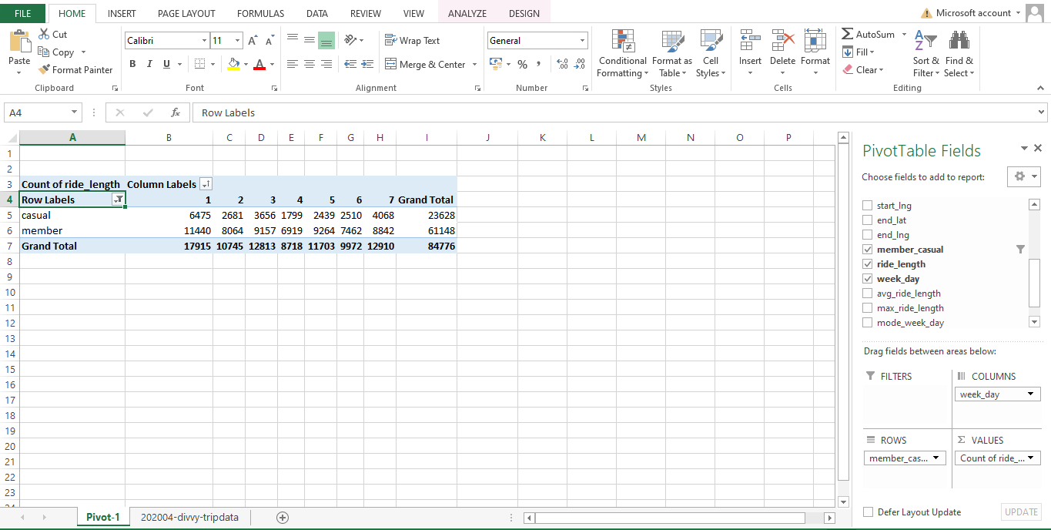

**Share:**

Now create data visualization using charts

**Act:**

**From the above chart we can conclude that**

Casual riders have less usage to Cyclistic than members which can be improved by paying attention on weekdays and introducing new schemes to grab attention of casual riders.