NAME: Kaumod Bagale

UID: 2022700022

EXPERIMENT 7

**Aim**

To implement a low-pass filter for smoothing a grayscale image, reducing noise and enhancing visibility for improved analysis of subtle details.

**Objective**

1. Apply a low-pass filter on a grayscale image to reduce high-frequency noise.
2. Evaluate the effectiveness of the low-pass filter by comparing the original and filtered images.
3. Demonstrate the practical use of spatial filtering in medical imaging.

**Introduction**

Image filtering techniques are essential in various fields, particularly in medical imaging, to enhance the interpretability of visual data. Low-pass filters, also known as smoothing filters, are designed to reduce high-frequency noise by averaging pixel values in a neighborhood. This technique allows for the attenuation of sharp transitions, such as noise, without heavily distorting the essential image structure. Inspired by remote sensing applications, spatial filtering can be adapted to enhance images captured under less-than-ideal conditions, aiding medical professionals in interpreting images more accurately.

**Algorithm**

The implemented algorithm for low-pass filtering involves the following steps:

1. **Image Loading and Conversion**: Load the image in grayscale to focus on intensity values.
2. **Kernel Definition**: Define a 3x3 low-pass filter kernel with equal weights to achieve a mean filter effect.
3. **Filter Application**: Convolve the kernel with the image using OpenCV's filter2D function to produce a smoothed image by averaging pixel values in each neighborhood.
4. **Display Results**: Display both the original and low-pass filtered images for visual comparison.

**Experimentation**

1. **Image Selection**: A grayscale chest X-ray image (Chest-X-ray-of-patient-4-while-having-COVID-19-pneumonia.jpg) was selected to evaluate the low-pass filter's effectiveness on medical images.
2. **Filter Configuration**: A 3x3 mean filter kernel was chosen to apply moderate smoothing without overly blurring critical details.
3. **Filtering Operation**: The filter was applied to the image using OpenCV functions, resulting in a new image with reduced noise and smoother transitions.
4. **Visualization**: The original and filtered images were displayed side-by-side to observe the impact of the low-pass filter.

**Code**

import cv2

import numpy as np

import matplotlib.pyplot as plt

# Function to apply a low-pass filter (smoothing)

def apply_low_pass_filter(img):

    # Define a 3x3 low-pass filter kernel (mean filter)

    low_pass_kernel = np.ones((3, 3), np.float32) / 9

    # Apply the filter to the image

    low_pass_filtered_img = cv2.filter2D(img, -1, low_pass_kernel)

    return low_pass_filtered_img

img_path = '/content/Chest-X-ray-of-patient-4-while-having-COVID-19-pneumonia.jpg'

img = cv2.imread(img_path, cv2.IMREAD_GRAYSCALE)

if img is None:

    raise ValueError(f"Error: Image at path '{img_path}' could not be loaded. Please check the path.")

# Apply the low-pass filter

low_pass_img = apply_low_pass_filter(img)

# Display the original and filtered images

plt.figure(figsize=(18, 6))

plt.subplot(1, 2, 1)

plt.title('Original Image')

plt.imshow(img, cmap='gray')

plt.subplot(1, 2, 2)

plt.title('Low-Pass Filtered Image')

plt.imshow(low_pass_img, cmap='gray')

plt.show()

**Results and Analysis**

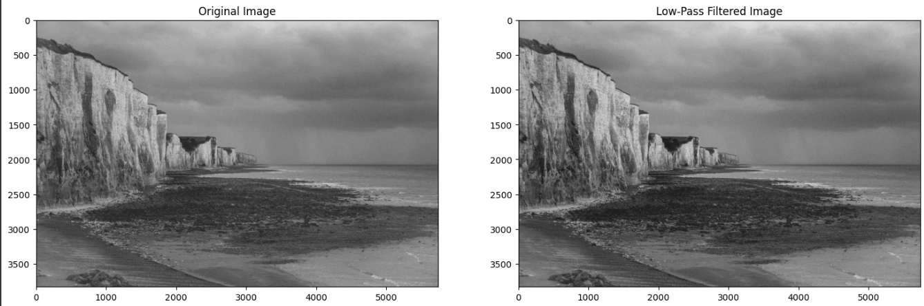

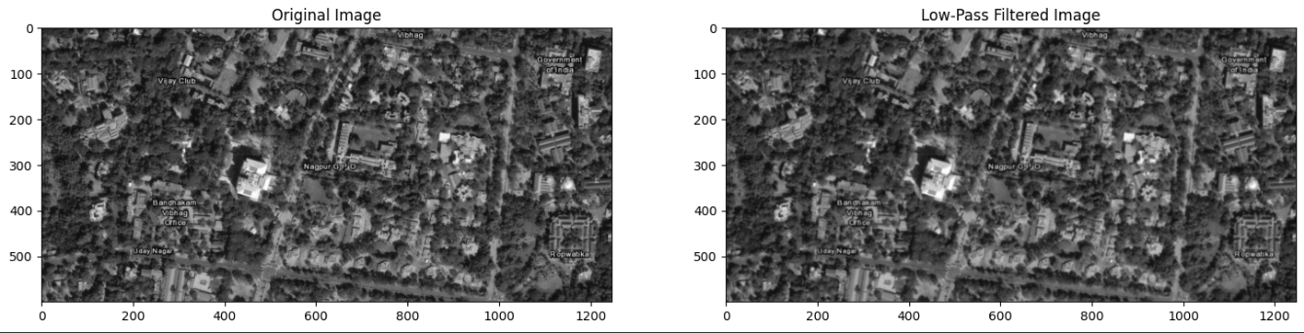

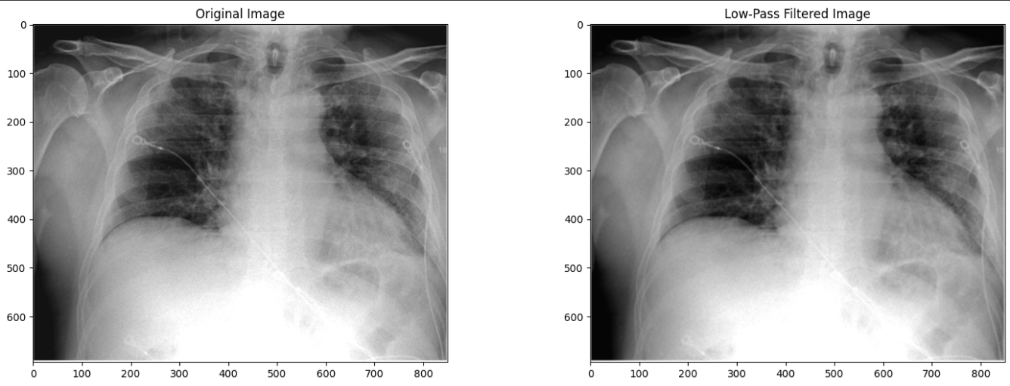

This demonstrates the filter’s utility in enhancing image quality for applications where noise may obscure important details.

**Conclusion**

The low-pass filter provided effective noise reduction on a grayscale image, enhancing the visibility of key structures. This simple approach highlights the potential of spatial filtering techniques in improving image quality in medical and other critical imaging applications.

**References**

Realization of Enhancement performance in Remote Sensing Data by Spatial Filtering Technique by Sheena A D, Dr. C. Udhayakumar