Executive Summary
  - Product Line Profitability & Margin Performance
Nassau Candy Distributor | Academic demonstration | 30 October 2026

Decision brief
Purpose: provide an audit-friendly view of product and division gross profitability to inform pricing, sourcing, assortment and portfolio concentration discussions. This summary uses a supplied illustrative dataset rather than verified corporate accounts. Values are presented in assumed USD.
Measure | Result
Source transaction lines | 10,194 (2024–2025)
Products / divisions | 15 / 3
Total sales | $141,783.63
Total gross profit | $93,442.80
Weighted gross margin | 65.91%
Profit from five Chocolate leaders | 95.06%

Three findings that matter
- Profit depends heavily on Chocolate: five Chocolate products generate 95.06% of gross profit. Concentration risk is more significant than the simple count of available products suggests.
- The Other division has a weaker 44.84% weighted gross margin compared with Chocolate at 67.45%; this is descriptive, not proof of operational underperformance.
- Kazookles has a 7.69% gross margin on $1,205.75 in sales, making it the clearest product-level direct-cost or pricing review candidate.

Immediate actions
Timeframe | Recommendation
0–30 days | Validate source/contract prices and direct costs for Kazookles; consider repricing, renegotiating sourcing or targeted promotion changes.
0–60 days | Monitor supply and discounts for the five highest-profit Chocolate products; protect contribution without creating excess portfolio dependency.
30–90 days | Review Other division mix and identify opportunities to improve gross margin while safeguarding demand.
Ongoing | Use the dashboard to monitor product-level gross margin and profit concentration on each data refresh.

Delivery for oversight and decision-making
The accompanying Streamlit dashboard includes a product leaderboard, division performance, sales-versus-cost diagnostics, low-margin flags, an 80% concentration/Pareto view and filters for date, division, product name and margin threshold. CSV exports make all product- and division-level calculations reproducible.
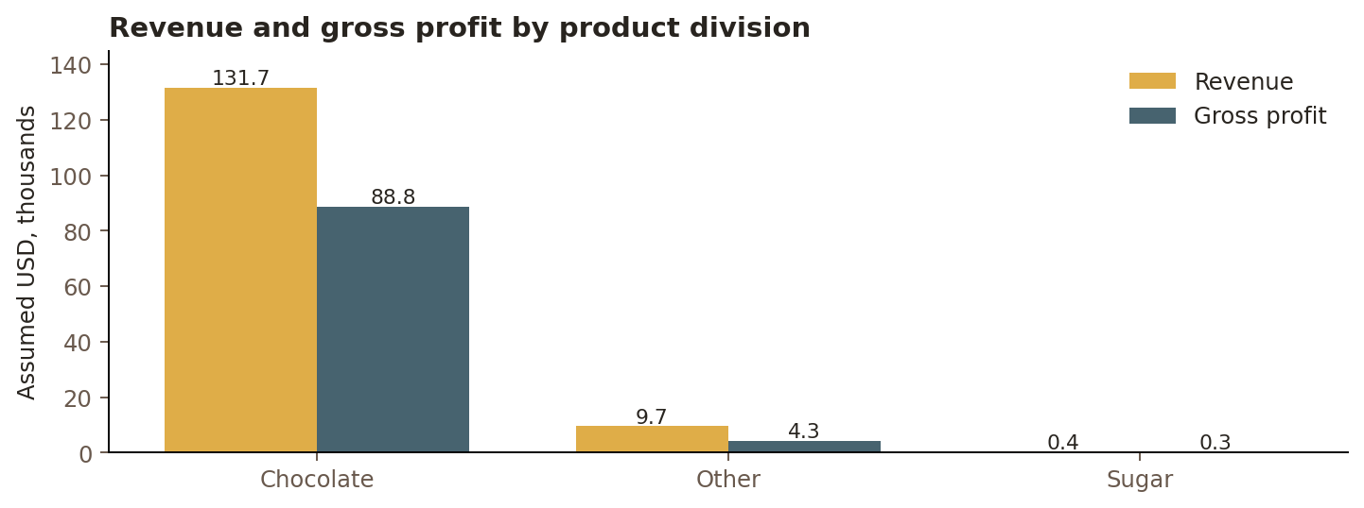
Division-level financial profile from the supplied dataset.

Governance and key caveats
- The source product labels are Wonka-themed. They must not be described as the current commercial products sold by Nassau Candy without independent verification.
- The dataset’s gross profit excludes unprovided logistics, marketing, overhead and tax; the figures are not net profitability estimates.
- Sugar is represented by only 40 transaction rows, and month-to-month margin volatility is near zero due to fixed dataset unit economics.
- Official Nassau Candy website information supplies corporate context only, not evidence supporting the dataset numbers.
- This is a course-project executive summary for public-sector/governance-style stakeholders; it is not an official statement by Nassau Candy or a government agency.

Recommended decision
Approve this dashboard as a reproducible *exploratory case study*, and commission verification of company-specific sales, cost, allocation and product-master data before acting on pricing, procurement or discontinuation recommendations.
Sources: user-provided assignment CSV and brief; Nassau Candy (https://www.nassaucandy.com/, accessed 30 October 2026) for general company context only.

