Product Line Profitability &
Margin Performance Analysis
  - Nassau Candy Distributor | Exploratory data analysis and decision recommendations
Prepared 30 October 2026 • Dataset period: 02 January 2024 – 31 December 2025
Research report · Version 1.0 · Academic case study

Abstract
This study evaluates the profitability of 15 product lines across 3 divisions using 10,194 supplied transaction-line records. The dataset totals $141,783.63 in sales and $93,442.80 in gross profit, yielding a weighted gross margin of 65.91%. Chocolate contributes 95.06% of observed gross profit. The analysis identifies extreme product concentration, division-level revenue–profit imbalances, and a low-margin product warranting commercial review. An interactive Streamlit dashboard accompanies this report.

Research questions
- Which products lead gross-profit contribution, margin, and unit economics?
- How do division revenue, gross profit, and weighted margin compare?
- What share of products drives 80% of revenue and 80% of profit?
- Which products merit pricing or sourcing review, and how reliable are the trends?

Scope and provenance
This is an analysis of a user-supplied assignment CSV, not independently verified financial records of Nassau Candy Distributors, Inc. The file contains Wonka-themed product names and should be regarded as illustrative. The official Nassau Candy website is used solely to contextualize the broad wholesale-confectionery business; the website does not authenticate these transactions. The source file contains no currency code; USD is used as a reporting assumption.

1. Data and methodology
The unit of observation is a transaction/product line. There are 10,194 lines across 8,549 distinct order identifiers. Order Date is parsed as day-first (DD-MM-YYYY); observations span 24 calendar months in 2024–2025. The 15 product IDs are grouped under Chocolate, Other, and Sugar.

1.1 Data cleaning & validation
- Checked the original 10,194 rows for invalid dates, missing financial fields, sales ≤ 0, costs < 0, and Gross Profit ≠ Sales − Cost (tolerance $0.011).
- Excluded 0 invalid rows; retained 10,194. No invalid or inconsistent records were detected.
- Normalized whitespace in product names and standardized division case; retained 15 distinct products.
- Rows with zero/missing units would remain in financial aggregates but not in per-unit denominators; none were detected in this file.
- Retained valid negative gross profits when present, because loss-making products are substantive risk signals; none appear in this file.

1.2 KPI definitions
Indicator | Definition / interpretation
Gross margin (%) | Σ gross profit ÷ Σ sales × 100, revenue-weighted
Profit per unit | Σ gross profit ÷ Σ valid units
Revenue contribution | Product revenue ÷ portfolio revenue × 100
Profit contribution | Product gross profit ÷ portfolio gross profit × 100
Margin volatility | Sample SD (percentage points) of monthly weighted product margins
80% concentration | Smallest count of ranked products whose cumulative contribution reaches ≥80%

Gross Profit is supplied by the CSV and reconciled to Sales − Cost. The cost column is described as manufacturing cost, so all profitability conclusions concern gross profit only. They exclude transport, selling, administrative, marketing, financing and tax expenses.

1.3 Filtering and risk rules
The dashboard supports date range, division selection, product-name search, gross-margin threshold, and minimum-revenue risk exposure. The default 50% low-margin threshold and $1,000 material-revenue cutoff are demonstration settings, not benchmark policies validated for Nassau Candy. “High sales / low margin” requires both margin below threshold and revenue in the top quartile of the current product selection.

2. Portfolio financial baseline
Portfolio KPI | Dataset result
Transaction lines | 10,194
Unique orders | 8,549
Products / divisions | 15 / 3
Sales (assumed USD) | $141,783.63
Manufacturing/direct cost | $48,340.83
Gross profit | $93,442.80
Weighted gross margin | 65.91%
Gross profit per unit | $2.42

2.1 Financial performance by division
Division | Sales | Gross profit | Margin | Profit share
Chocolate | $131,692.90 | $88,824.62 | 67.45% | 95.06%
Other | $9,663.25 | $4,333.45 | 44.84% | 4.64%
Sugar | $427.48 | $284.73 | 66.61% | 0.30%

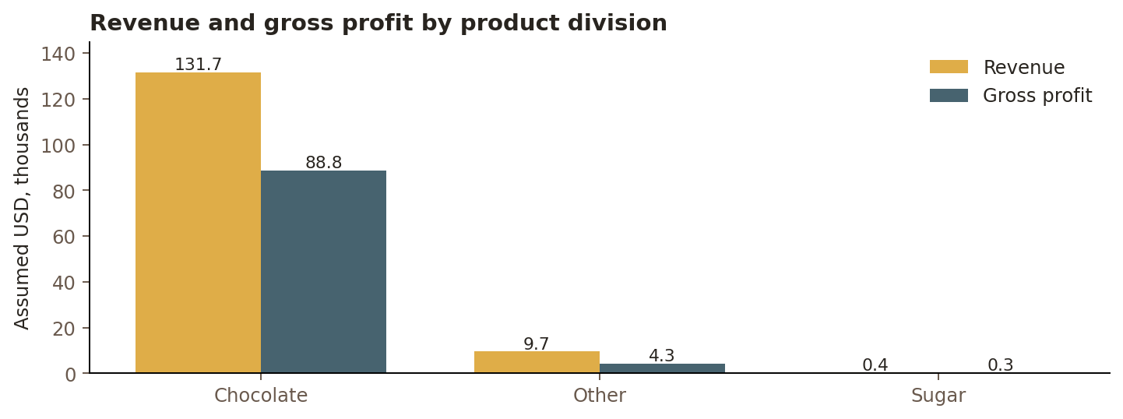
Figure 1. Revenue versus gross profit by division. Values derive exclusively from the supplied CSV.
Chocolate accounts for 9,844 of 10,194 lines (96.57%) and 95.06% of gross profit. Other earns a 44.84% weighted gross margin versus 67.45% for Chocolate; Sugar has only 40 rows, making its apparent 66.61% gross margin an especially weak basis for broad inference.

3. Product-level profitability
The five chocolate-bar products dominate absolute profits. Their profit ranking is not identical to a gross-margin ranking; absolute contribution depends jointly on volume, selling price and unit economics.
Product | Gross profit | Gross margin | Profit/unit
Wonka Bar - Scrumdiddlyumptious | $19,357.50 | 69.44% | $2.50
Wonka Bar - Triple Dazzle Caramel | $18,610.20 | 65.33% | $2.45
Wonka Bar - Milk Chocolate | $17,443.37 | 64.92% | $2.11
Wonka Bar - Nutty Crunch Surprise | $16,819.95 | 71.35% | $2.49
Wonka Bar - Fudge Mallows | $16,593.60 | 66.67% | $2.40

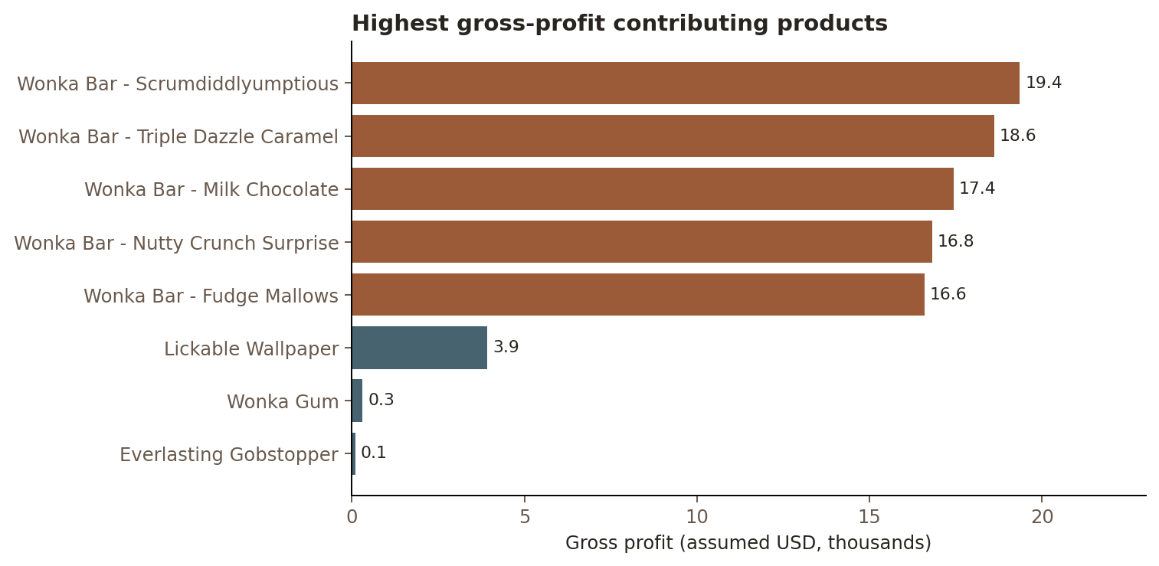
Figure 2. Eight highest contributors to portfolio gross profit.
Highest individual contribution: Wonka Bar - Scrumdiddlyumptious with $19,357.50 profit (20.72% of the portfolio). Highest margin overall: Everlasting Gobstopper at 80%, but this figure is based on only three transaction rows and $130 in revenue. This is not equivalent to being the best-performing commercial product.

4. Profit concentration and dependency risk
The five largest gross-profit products contribute 95.06% of all gross profit. They also account for 92.88% of sales. For both revenue and gross profit, 5 of the 15 products are sufficient to pass the 80% concentration threshold. That is 33.3% of products—not an exact 80/20 pattern, but marked concentration nonetheless.
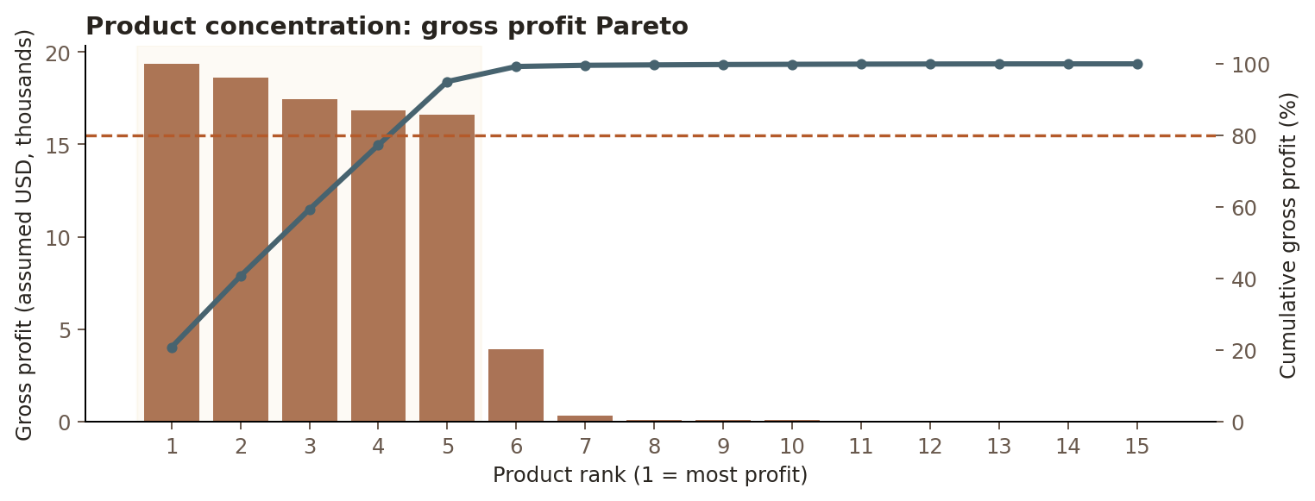
Figure 3. Product-level profit ranking and cumulative concentration.

Interpretation
- Dependence on a narrow Chocolate portfolio makes total profit sensitive to changes in those products’ demand, pricing or cost.
- Evaluate inventory availability, supply continuity and promotional discount effects on the five leaders.
- Do not discontinue lower-revenue products purely because they fall outside the top 80%; they may serve assortment, market-access or cross-selling roles.

5. Cost structure and margin risk
Product-level sales and manufacturing/direct costs are compared to identify cases where costs absorb an unusually large fraction of revenue. The default 50% margin threshold is illustrative and can be changed in the Streamlit app.
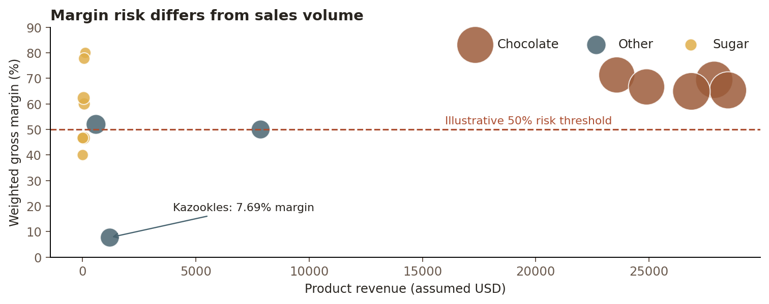
Figure 4. Weighted gross margin versus revenue by product (bubble size reflects row count).
Product | Sales | Gross margin | Rows
Kazookles | $1,205.75 | 7.69% | 96
Fun Dip | $12.00 | 40.00% | 3
Nerds | $15.00 | 46.67% | 4
SweeTARTS | $61.50 | 46.67% | 10
Lickable Wallpaper | $7,860.00 | 50.00% | 94

Kazookles has $1,205.75 of revenue, $1,113.00 of cost and only $92.75 of gross profit: a 7.69% margin over 96 rows. This is the clearest material-margin review candidate. Fun Dip (40.00% margin), Nerds (46.67%) and SweeTARTS (46.67%) are also below the 50% illustrative threshold but have very low observed revenue and sample sizes.
Recommendation: review Kazookles input costs, selling price and discounting first; validate competitive constraints, demand elasticity and fuller cost allocation before considering repricing or delisting.

6. Time trend and volatility
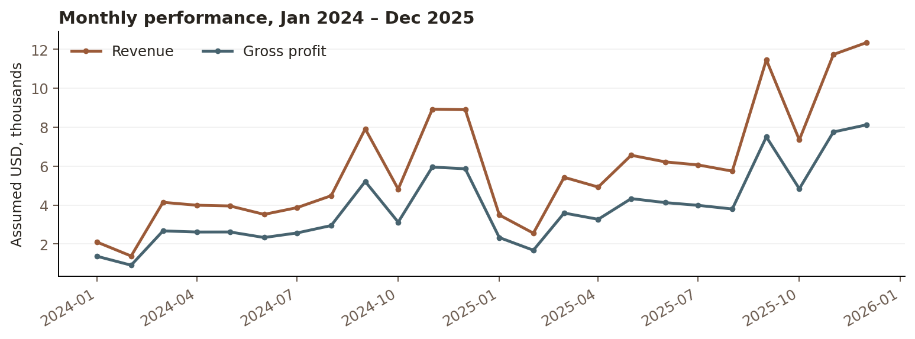
Figure 5. Monthly revenue and gross profit based on order dates; no seasonality attribution is inferred.
Year | Sales | Gross profit | Weighted margin
2024 | $57,956.20 | $38,151.43 | 65.83%
2025 | $83,827.43 | $55,291.37 | 65.96%

Revenue is higher in 2025 than in 2024, but the dataset alone does not explain the increase. Monthly totals reflect order volume and any sampling process; external macroeconomic or commercial causes must not be inferred.

6.1 Why margin volatility rounds to zero
All 15 products exhibit approximately zero standard deviation in monthly weighted gross margins (floating-point deviations below 0.0000000001 percentage points). This follows from near-fixed unit pricing and costs embedded in the case dataset. It does not demonstrate stable real-world procurement or selling economics. Monthly metrics are computed only in months with observed sales for each product.

6.2 Data limitations
- The product names and case-study structure are not authenticated as Nassau Candy’s actual commercial product portfolio.
- The source does not report discounts, tax, freight, overhead, customer acquisition cost, or realized net profit; observed gross margin must not be interpreted as net margin.
- Severely uneven division counts (Chocolate 9,844; Other 310; Sugar 40) weaken cross-division generalization.
- No source currency metadata or independent audit trail is provided; USD is an explicit presentation assumption.
- Product-specific margin constancy constrains volatility and pricing-sensitivity inference.

7. Recommendations and staged implementation
Priority | Suggested action | Success indicator
Immediate | Review Kazookles pricing, direct material cost and transactional terms; confirm data integrity. | Unit contribution and gross-margin uplift
Near-term | Protect supply and monitor prices for the five Chocolate gross-profit leaders. | Leader availability, share and margin
Near-term | Investigate Other division cost mix and contribution by SKU. | Weighted division margin, not simple mean
Ongoing | Use dashboard filters to watch monthly sales/profit, and test scenarios after adding real costs. | Monthly margin and profit by SKU
Governance | Confirm whether data is representative before presenting any finding as a company fact. | Documented source provenance

8. Conclusion
The supplied case dataset indicates substantial gross-profit concentration in five Chocolate products, alongside an overall weighted gross margin of 65.91%. Kazookles is the most material low-margin review opportunity. A repeatable Streamlit dashboard and validated KPI definitions support exploratory product and division decisions, but further verified accounting, fulfillment and pricing data are essential before implementing changes or claiming this represents actual Nassau Candy performance.

References / source notes
- Nassau Candy Distributors, Inc. Official website, https://www.nassaucandy.com/ (accessed 30 October 2026): business context only.
- Nassau Candy. Confections catalog, https://www.nassaucandy.com/confections.html (accessed 30 October 2026): product-category context only.
- User-supplied academic data file: Nassau Candy Distributor (2).csv; 10,194 records; not a verified corporate financial statement.
- Project brief supplied by the user: “Product Line Profitability & Margin Performance Analysis for Nassau Candy Distributor.”
Research-status disclosure: this document is an original analytical project report, not a peer-reviewed or approved/published research article.

