SOFTWARE ENGINEERING-JIRA LAB
NAME | SRN | SECTION
Vedanta | PES1UG24CS920 | 5F

Screenshot 1: All the epics and the stories inside them
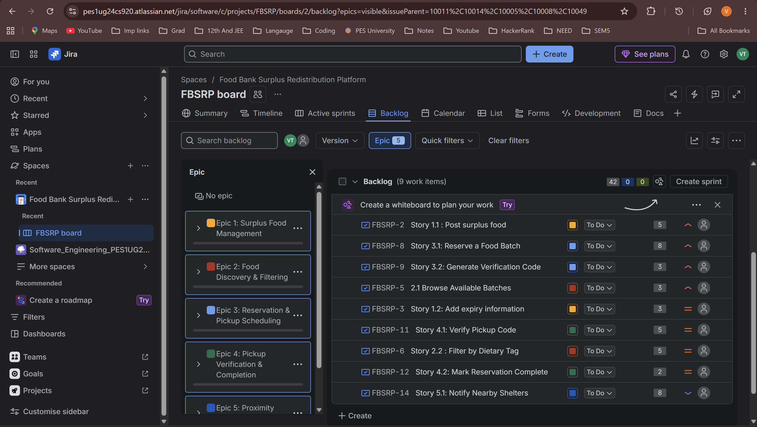
Screenshot 2: All the stories inside the epics distributed into their respective sprint according to priority
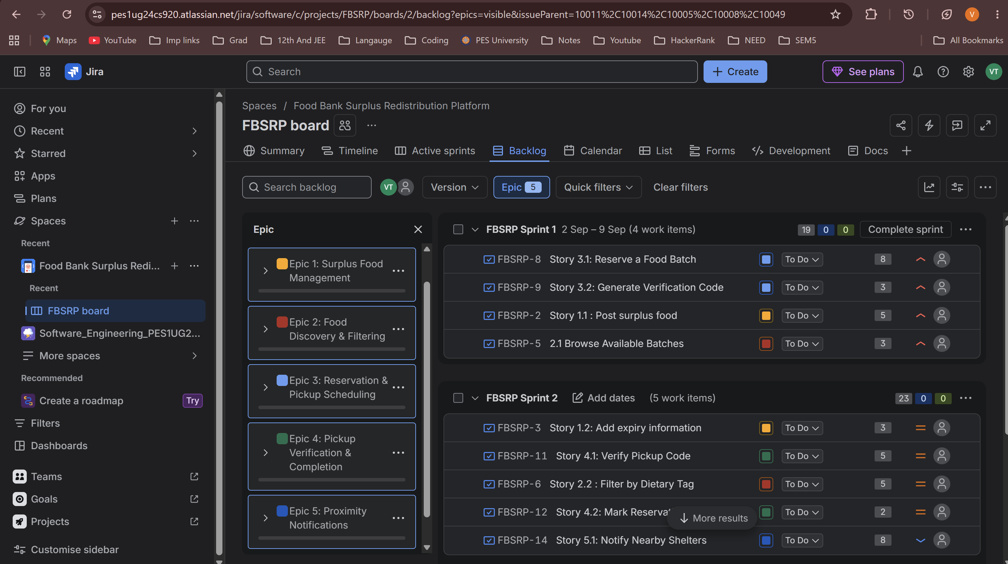
Screenshot 3: Format inside a story with Story points, Priority and Sprint Number mentioned
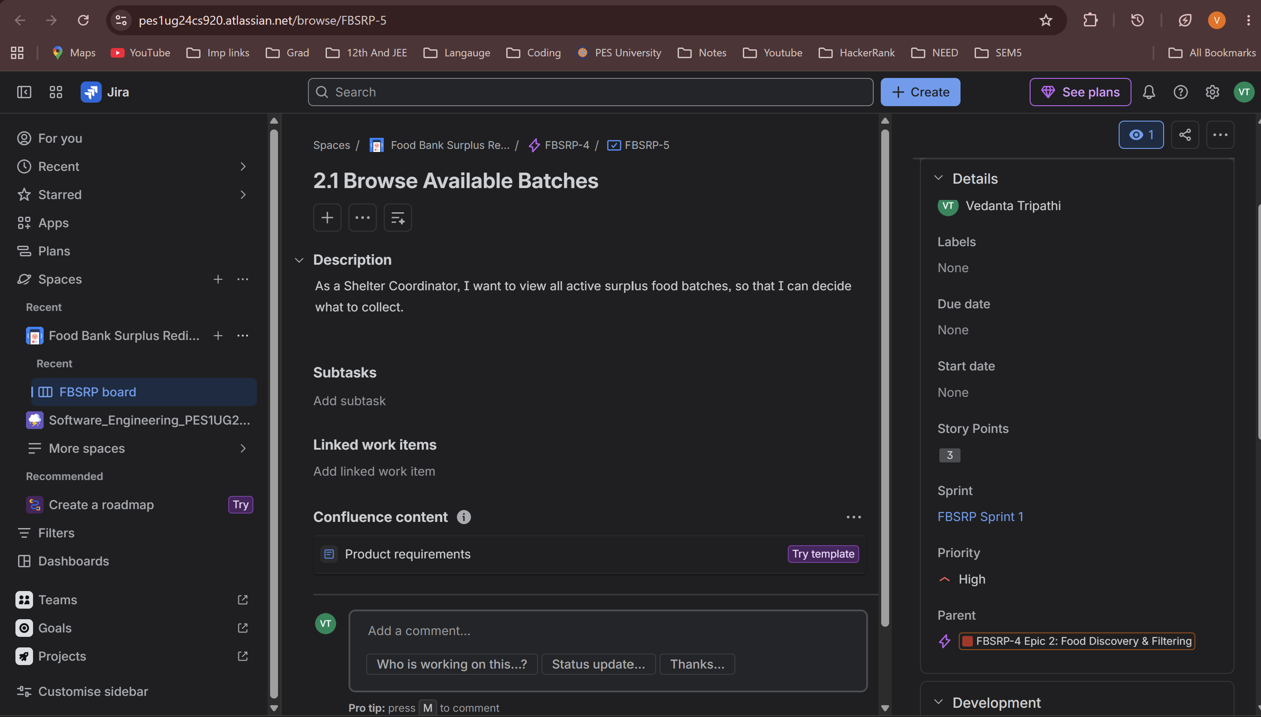

Screenshot 4: Stories in sprint 1 inside the To-do lock
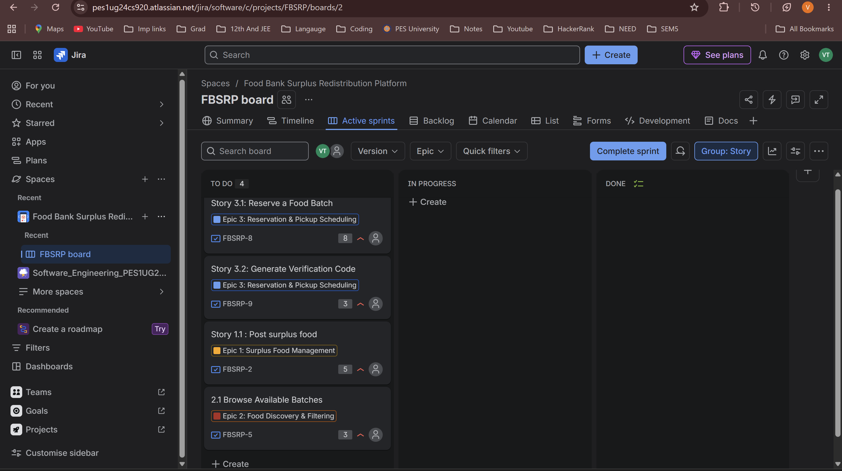

Screenshot 5: Stories in sprint 1 inside the In-progress Block
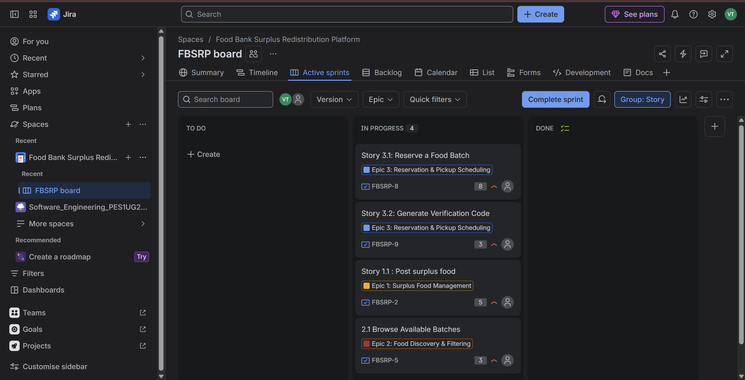

Screenshot 6: Stories in sprint 1 inside the Done Block
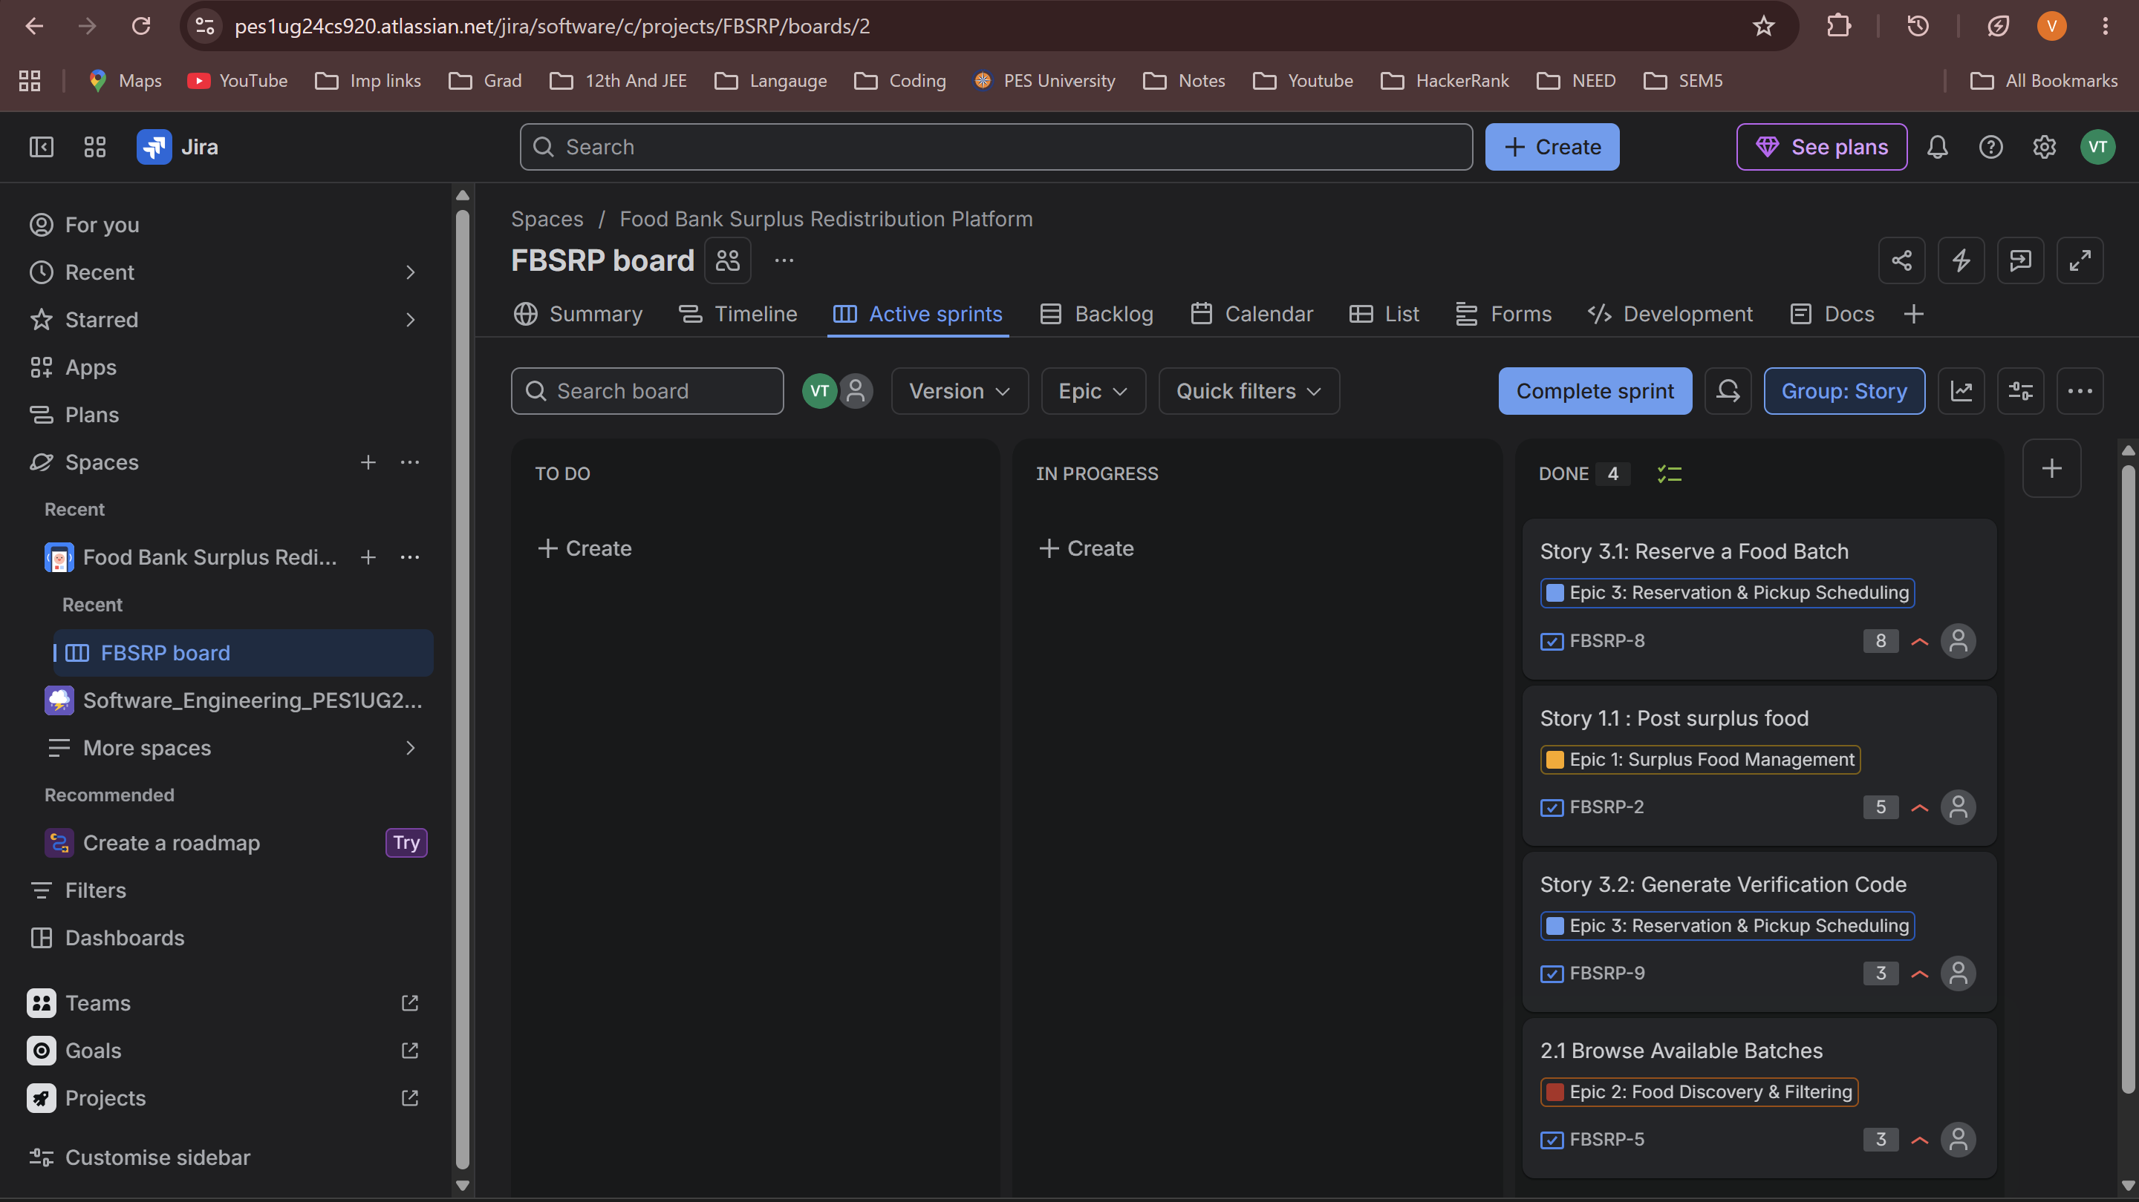

Screenshot 7: Stories in sprint 2 inside the To-do Block
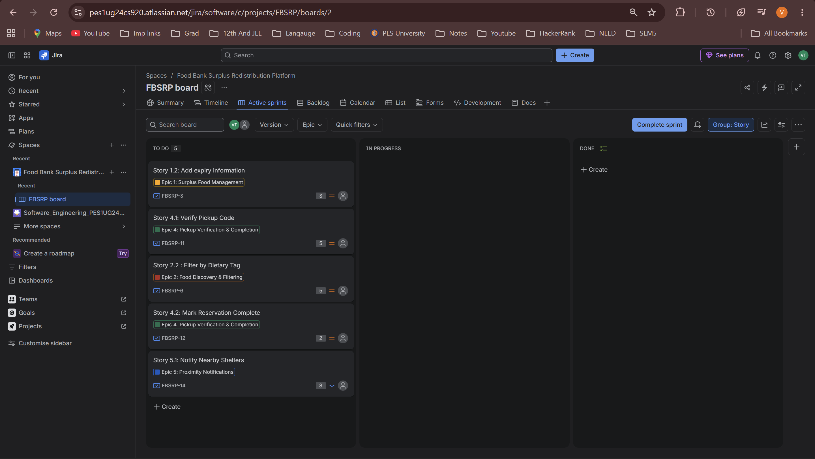

Screenshot 8: Stories in sprint 2 inside the In-progress Block
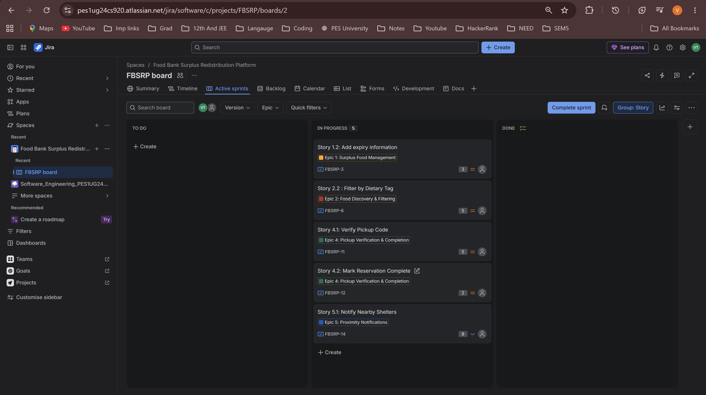

Screenshot 9: Stories in sprint 2 inside the Done Block
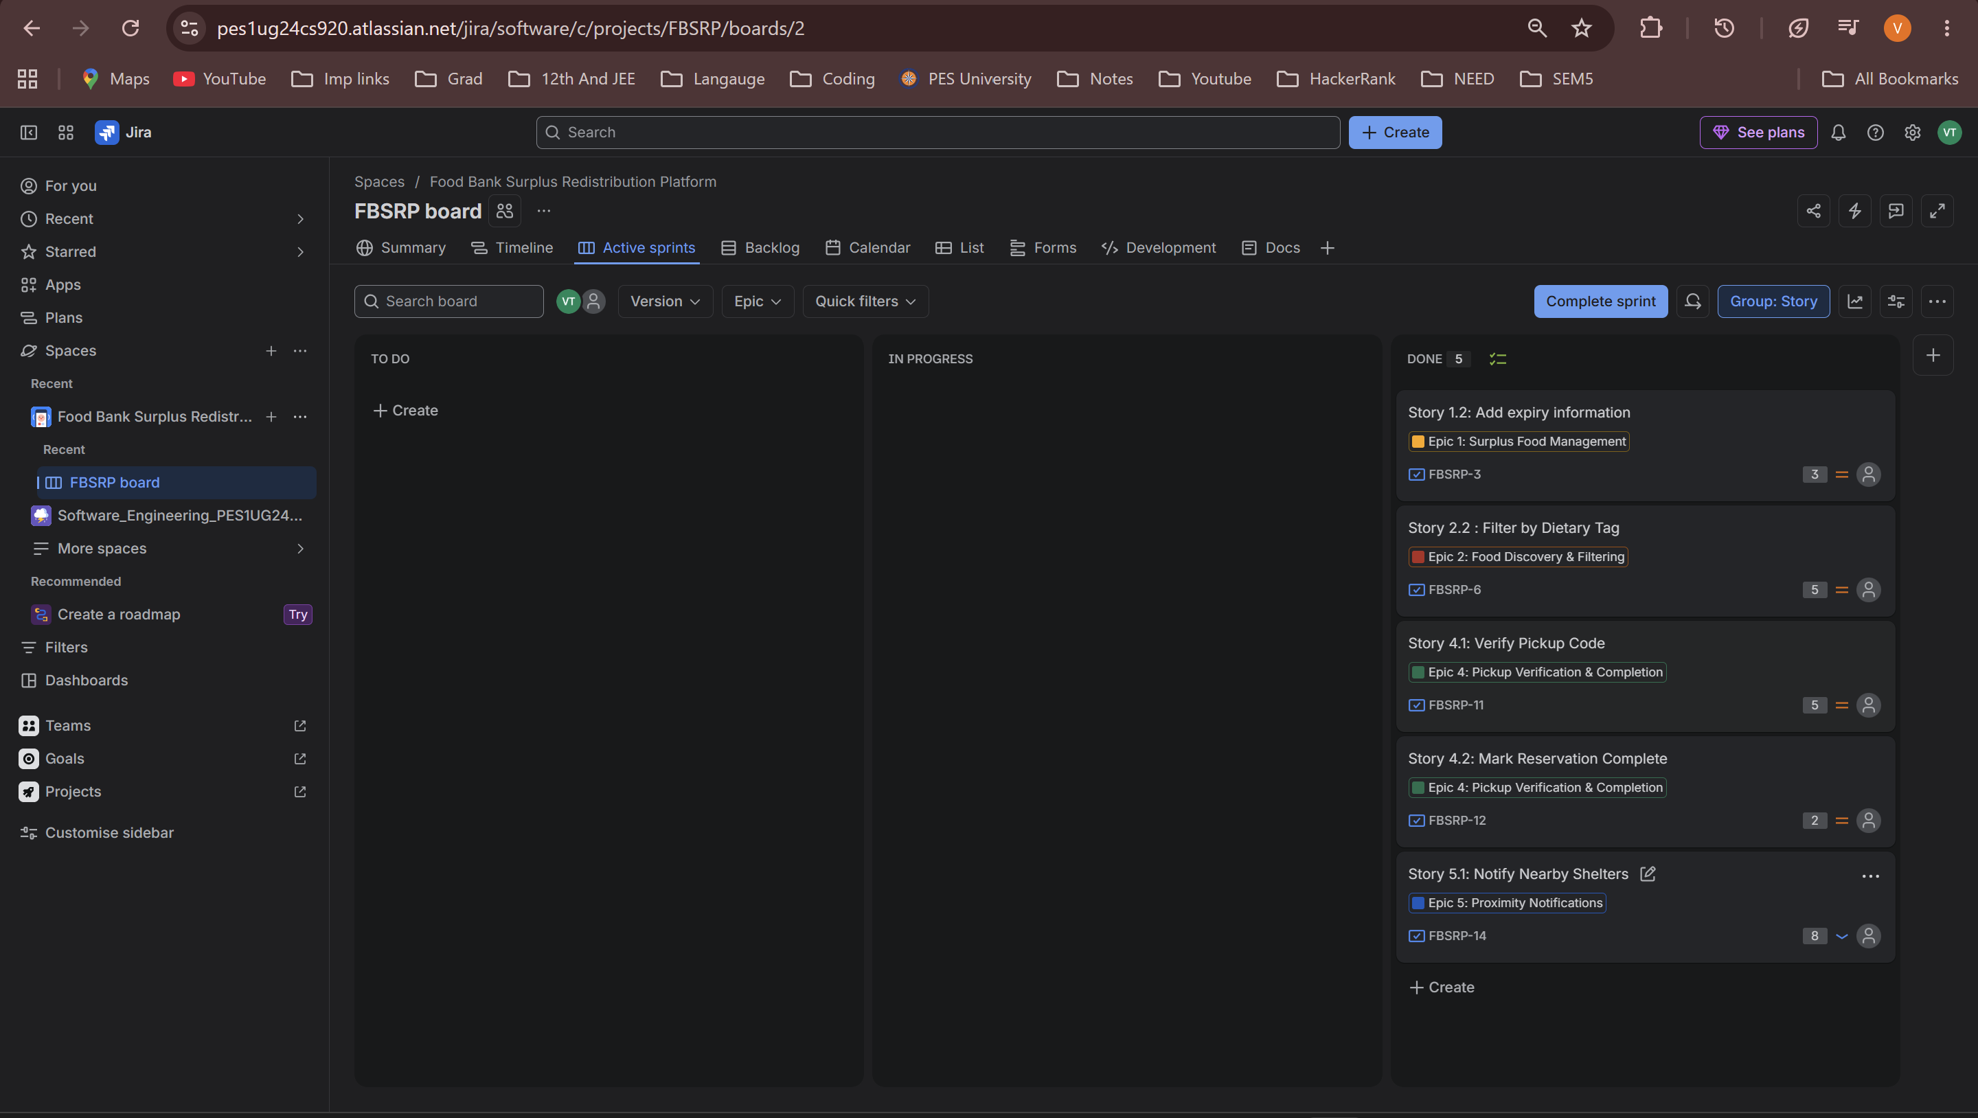
Screenshot 11: Burndown Chart of the Sprint 1
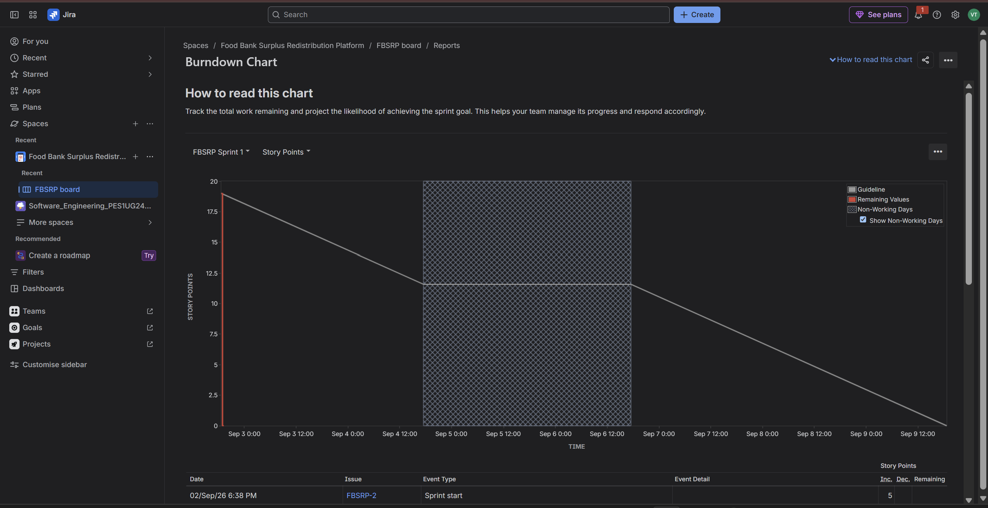

Screenshot 11: Burndown Chart of the Sprint 2
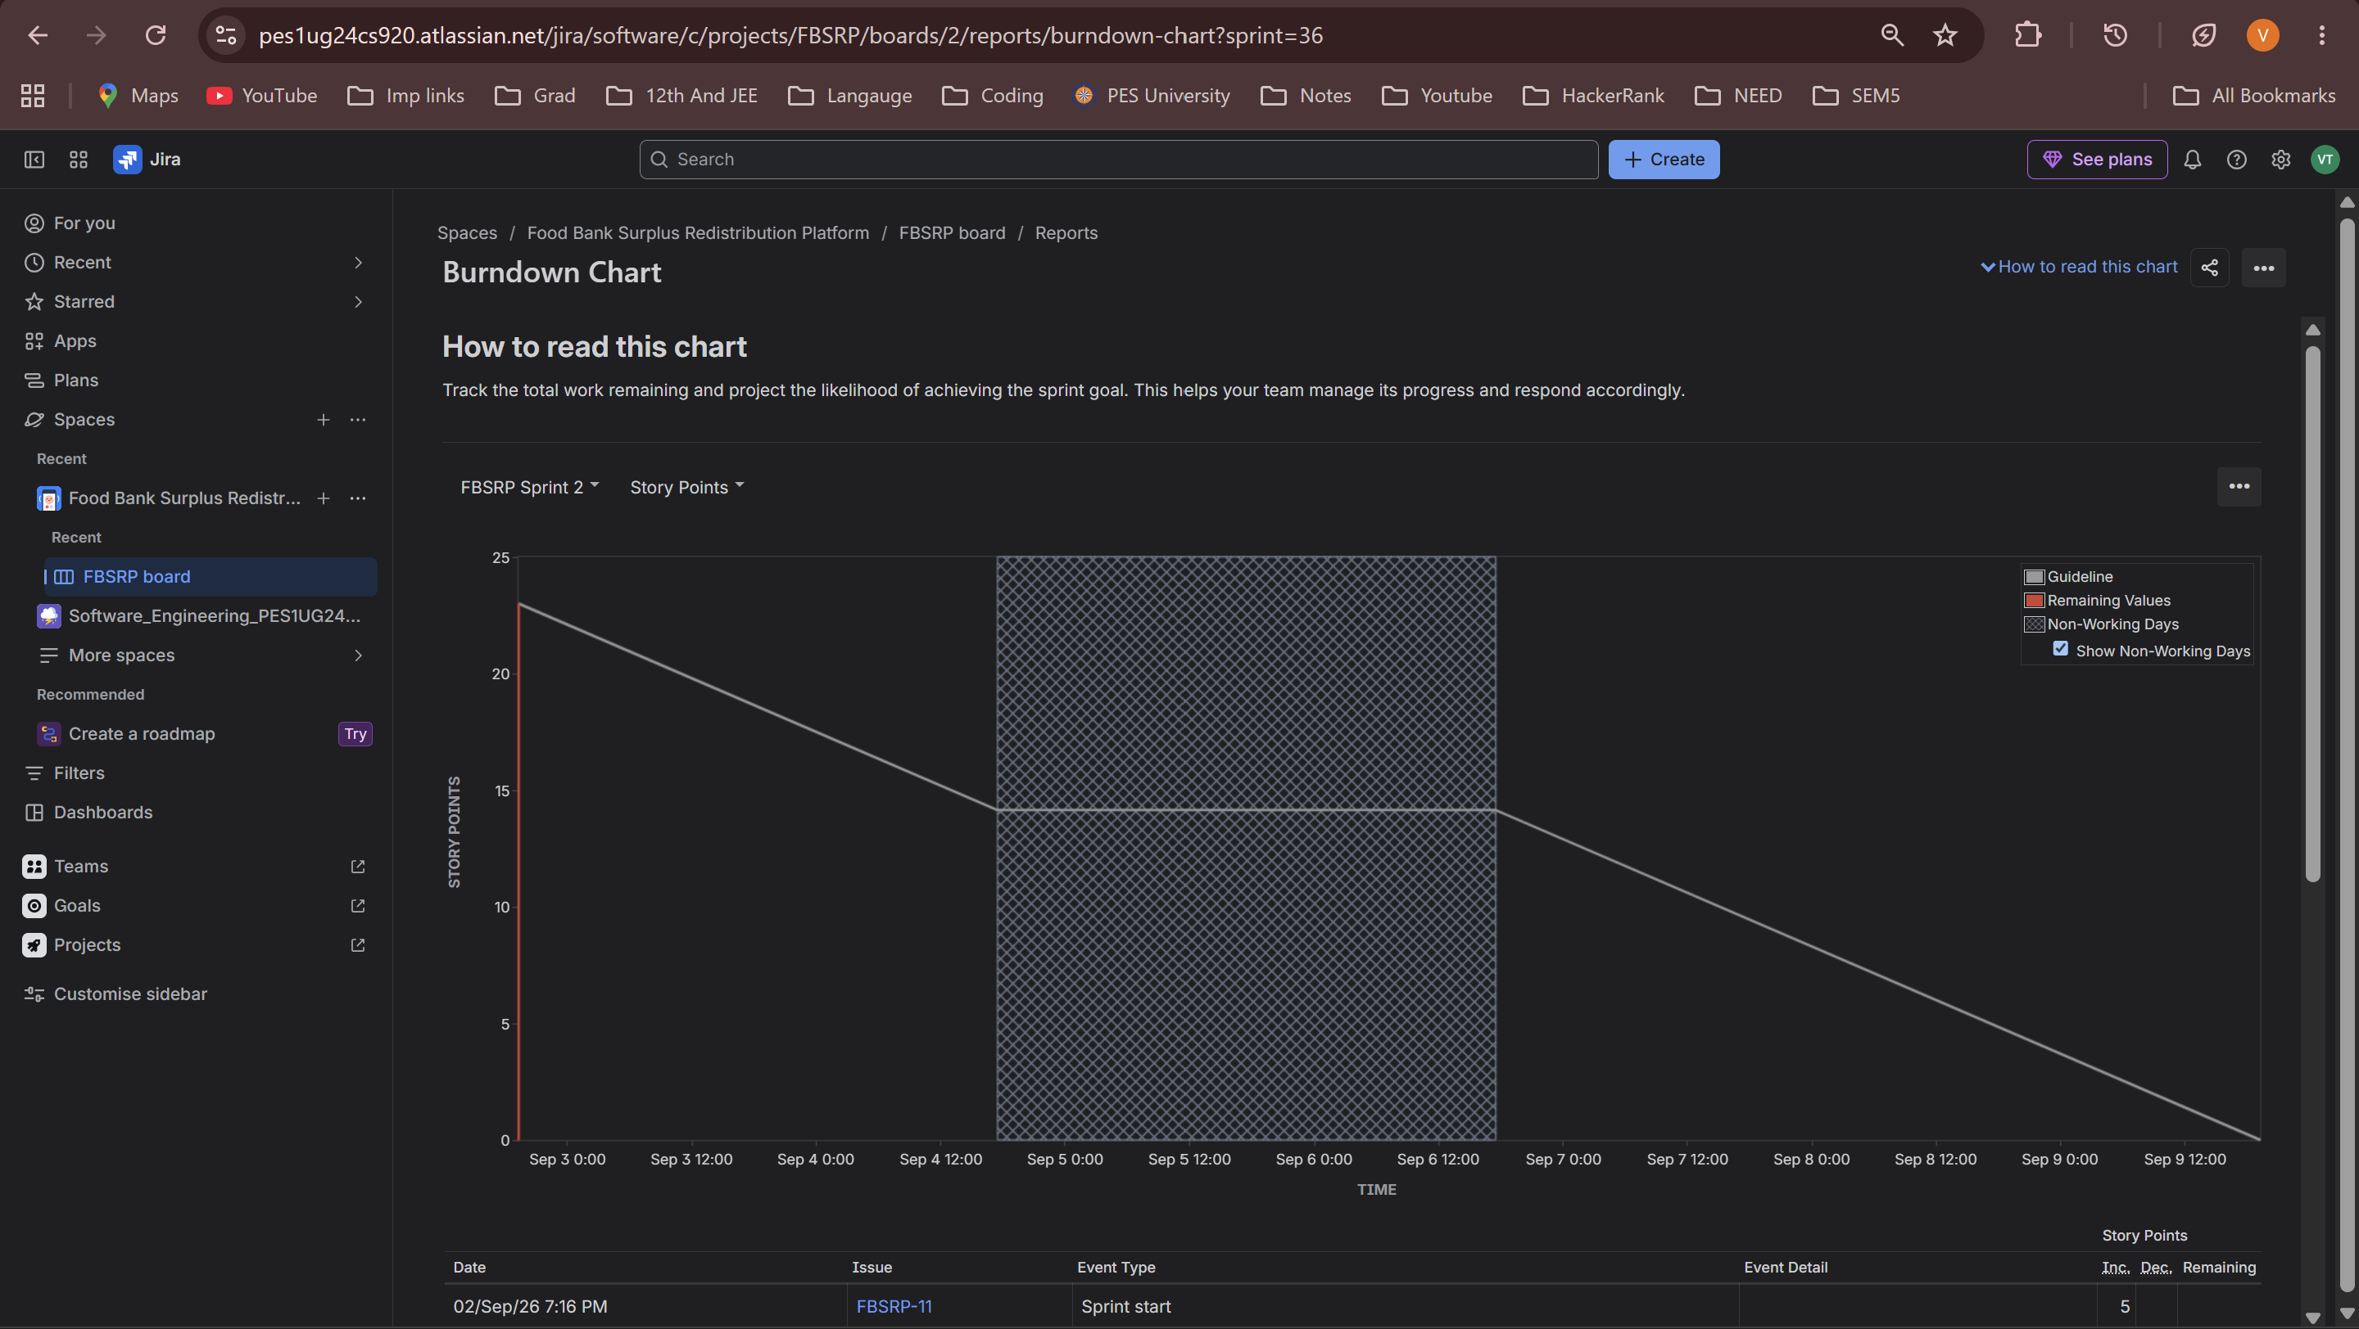

Reflection Questions:
Q1. Did your estimations reflect the actual effort?
Ans: Mostly, yes. Stories like Browse Available Batches (3 points) felt genuinely quick and simple, while Reserve a Food Batch (8 points) was clearly the most complex — it had to check availability, handle the pickup window, and hand off into generating a code, so the higher estimate made sense.

Q2. Was your backlog well-prioritized?
Ans: For the most part. The four High-priority stories (Post Surplus Food, Browse Available Batches, reserve a Food Batch, Generate Verification Code) are exactly the ones that make the core donate-to-pickup flow work, so it made sense to put them in Sprint 1 first. The Medium and Low items — filtering, verification, notifications — are genuinely useful but the platform can technically function without them on day one, so pushing them to Sprint 2 felt like the right call.
Q3. How did your simulated sprint align with your plan?
Ans: Pretty closely. All four Sprint 1 stories moved from To-Do through In-Progress to Done without needing to pull anything back from Sprint 2, which suggests the 19-point estimate was a reasonable amount of work for one sprint. If anything had stalled in In Progress, that would've been a sign I'd overcommitted, but that didn't happen here.

Q4. What insights did the burndown chart give about your team's capacity?
Ans: The burndown line tracked the guideline fairly well rather than flatlining early or dropping off a cliff near the deadline, which tells me the work was reasonably well distributed across the sprint instead of being crammed in at the end.

