LAB 7
Fuzzing for Input Validation Bugs
Phone Repair Quote Parser

Student Name | VEDANTA TRIPATHI
SRN | PES1UG24CS920

1. Objective
To explore fuzz testing as a security and quality-assurance technique by using the Hypothesis library to identify input-validation bugs in the supplied Python application and improve its handling of unexpected inputs.

2. Application and functions tested
The application processes phone repair quote information through three functions:
- mask_imei(imei): Removes spaces and hyphens and masks all but the last four characters.
- parse_parts_order(text): Parses semicolon-separated part names and quantities into a dictionary.
- parse_model(text): Separates a phone brand and model into a tuple.

3. Fuzz testing approach
The completed test file uses Hypothesis with the strategy st.text() | st.none() for each function. This generates arbitrary strings, including unusual and empty text, as well as None. Each function call is wrapped in try/except so that an uncaught exception causes the corresponding test to fail.

4. Bugs identified and fixes
Function | Issue in original code | Correction
mask_imei() | Calling replace() on None raises an AttributeError; malformed or too-short values are not validated. | Check input type and validate that the cleaned value contains digits and is long enough; return a safe fallback for invalid input.
parse_parts_order() | None, missing separators, malformed entries or non-integer quantities can raise exceptions. | Check input type and validate each entry; skip malformed entries and quantities that are not positive integers.
parse_model() | None, empty input or a one-word value can cause errors while splitting/unpacking. | Check input type and ensure both brand and model are present; return an empty pair for incomplete input.

5. Screenshot evidence
The following screenshots document execution before and after the fixes, and the Hypothesis test results.

SS1 — Original application execution
The original application is run with valid sample inputs. It produces the expected output for well-formed input.
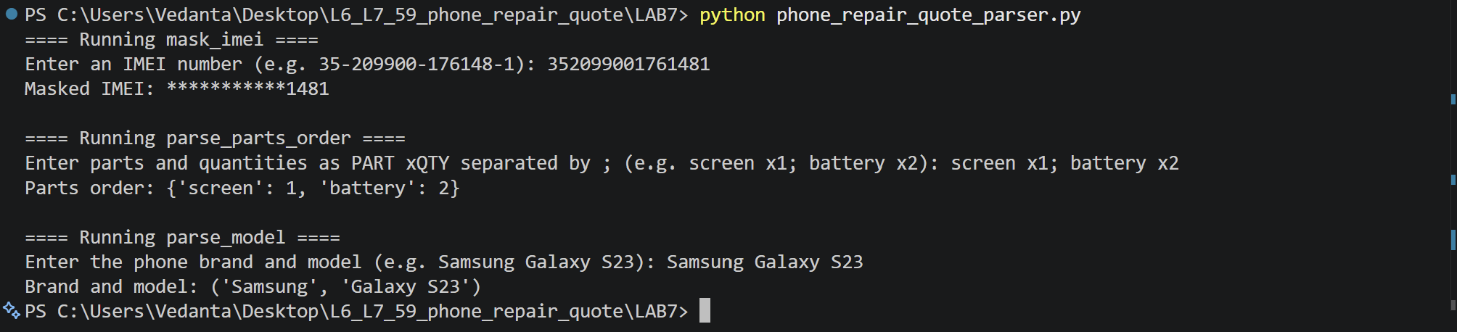
Figure 1: SS1 — Original application execution.
SS2 — Failing Hypothesis tests on the original application
The completed fuzz tests report failures. Hypothesis finds inputs that cause the original functions to raise exceptions.
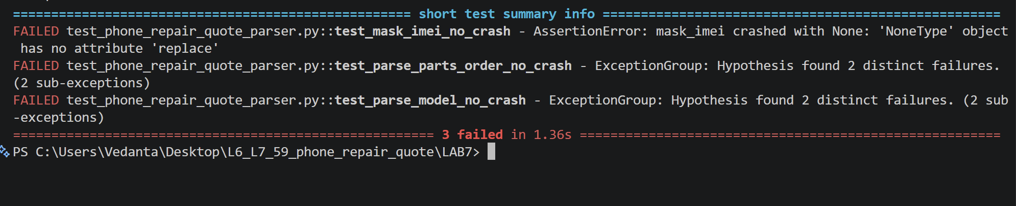
Figure 2: SS2 — Failing Hypothesis tests on the original application.
SS3 — Fixed application execution
The fixed application is run with the same valid sample inputs. Its normal outputs remain consistent with the original application.
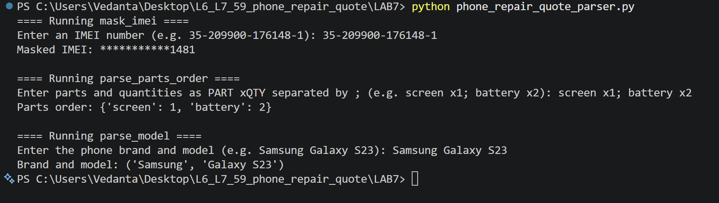
Figure 3: SS3 — Fixed application execution.

SS4 — Passing Hypothesis tests on the fixed application
After replacing the original module with the fixed implementation, all three Hypothesis tests pass (3 passed).
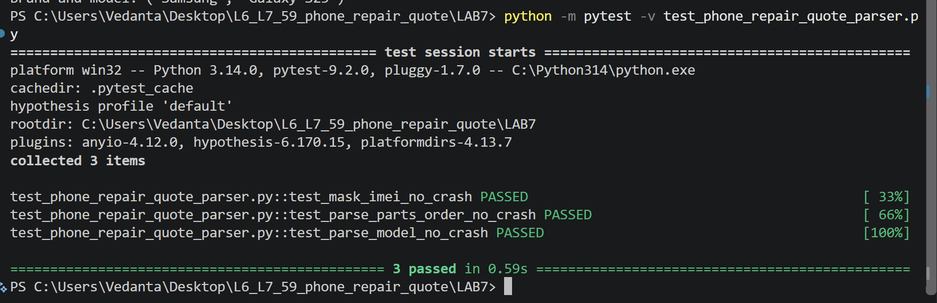
Figure 4: SS4 — Passing Hypothesis tests on the fixed application.

6. Conclusion
Hypothesis fuzz testing exposed input-validation weaknesses that were not visible when the application was run only with valid sample values. The three functions were updated to handle unexpected or malformed inputs without propagating exceptions. The final test run completed successfully with all three tests passing.

