# TicTacToe_game_python

This is another tictactoe game but this time it's in python. The project extension is of jupyter note book.

So to use it you have to install jupyter note book.

This game will work as

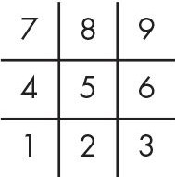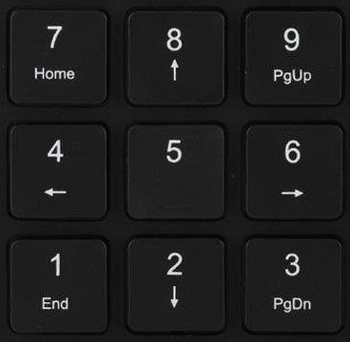

If you will press 1 the position marked 1 in the tictactoe board will be assign by cross or circle according to the active player.