Q1)
a)
CREATE TABLE Course (
CourseID INT PRIMARY KEY,
CourseName VARCHAR(50),
Fees DECIMAL(10,2)
);

CREATE TABLE Student (
StudentID INT PRIMARY KEY,
StudentName VARCHAR(50) NOT NULL,
Course_ID INT,
Marks INT,
FOREIGN KEY (Course_ID) REFERENCES Course(CourseID)
);

INSERT INTO Course (CourseID, CourseName, Fees) VALUES
(101, 'SQL', 4500.00),
(102, 'statistics', 6000.50),
(103, 'C++ and C', 8500.00),
(104, 'Web Dev and back-end', 12000.75),
(105, 'Data Science', 15000.00);

INSERT INTO student (StudentID, StudentName, Course_ID, Marks)
VALUES
(1, 'Aarav Shah', 101, 96),
(2, 'Meera Joshi', 102,80),
(3, 'Rohan Patil', 103,79),
(4, 'Sneha Desai', 105, 50),
(5, 'Amit Kumar', 104, 60),
(6, 'Pooja Singh', 102,55);
output:
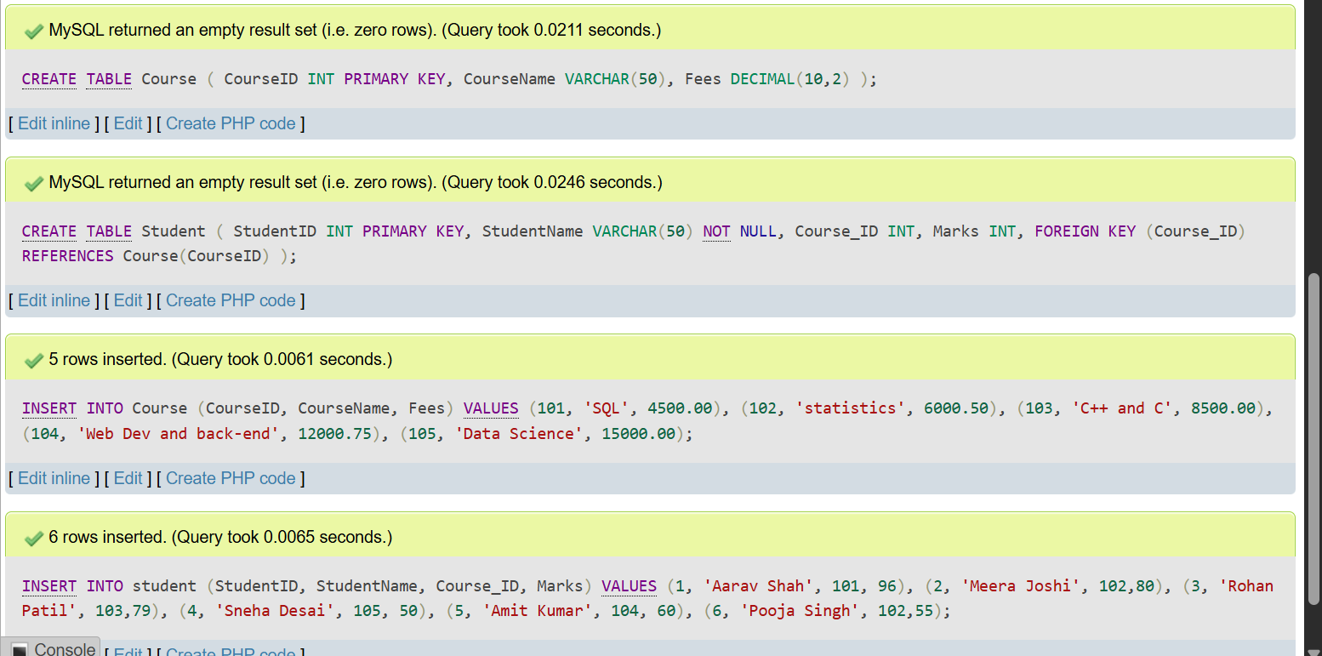
b) Query: SELECT * FROM student WHERE Marks > 70;
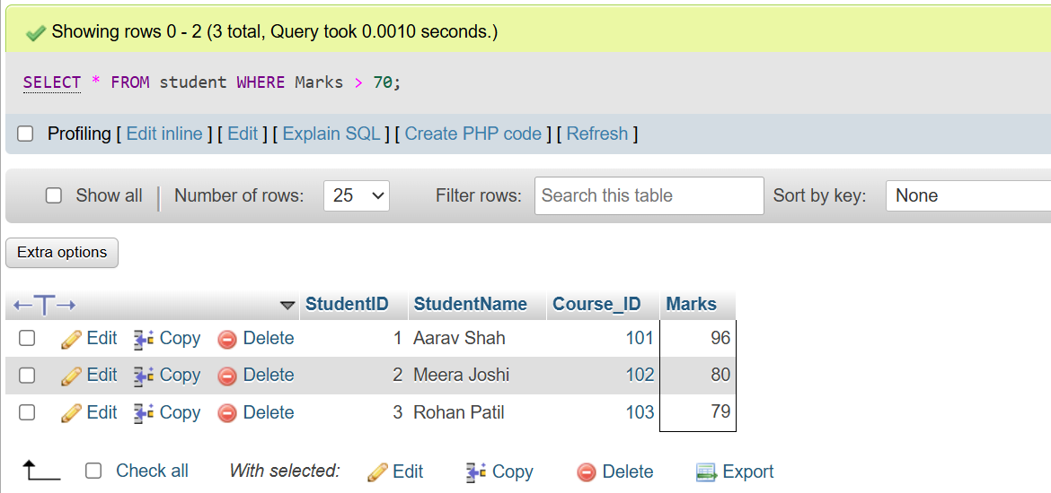
c) Query: SELECT
Student.StudentName,
Course.CourseName
FROM Student
JOIN Course
ON Student.Course_ID = Course.CourseID;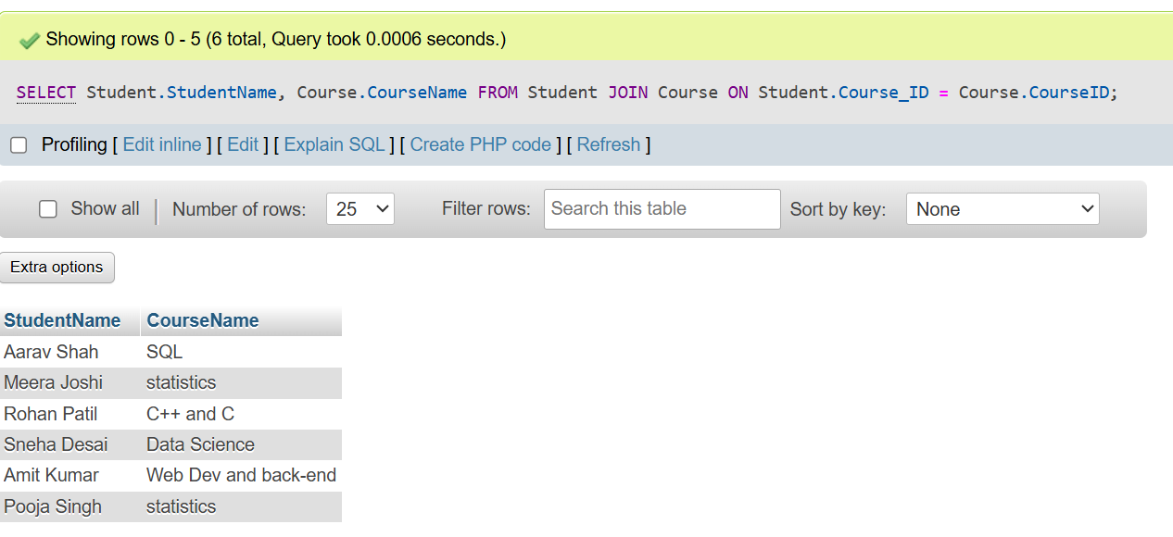
d) Query:SELECT
Course_ID,
AVG(Marks) AS Average_Marks
FROM Student
GROUP BY Course_ID;
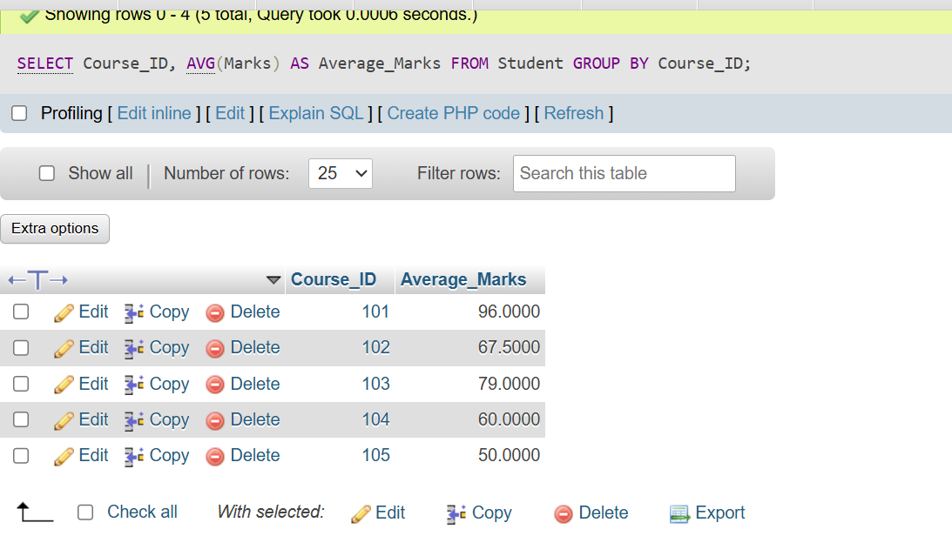
e)Query: SELECT
Course_ID,
AVG(Marks) AS Average_Marks
FROM Student
GROUP BY Course_ID
HAVING AVG(Marks) > 65;
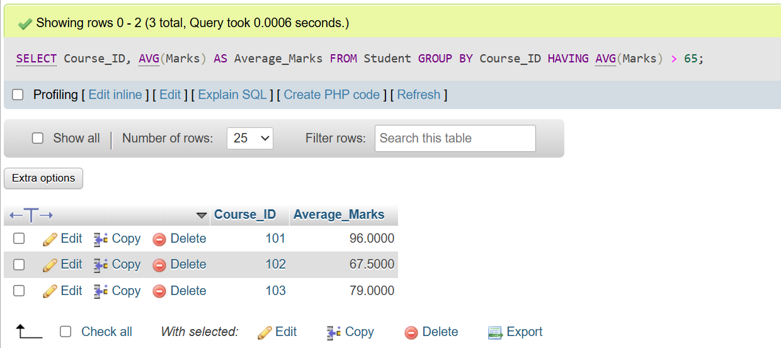
Q2)
CREATE TABLE Employee (
Emp_ID INT PRIMARY KEY,
Emp_Name VARCHAR(50),
Department VARCHAR(30),
Salary DECIMAL(10,2),
Joining_Date DATE
);

INSERT INTO Employee VALUES
(101, 'Jonny', 'IT', 75000.00, '2022-01-15'),
(102, 'vedanti', 'HR', 65000.00, '2021-06-20'),
(103, 'Sai', 'Finance', 82000.00, '2023-03-10'),
(104, 'Lisa', 'IT', 78000.00, '2020-08-12'),
(105, 'Mark', 'Sales', 60000.00, '2024-02-05');
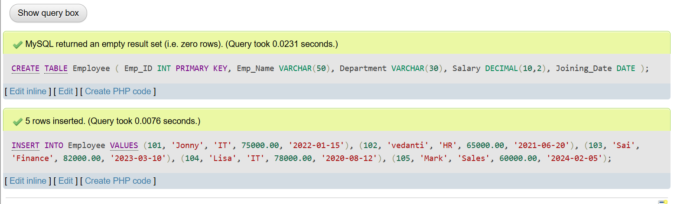
a)Query: SELECT *
FROM Employee
WHERE Department = 'IT'
ORDER BY Salary DESC;
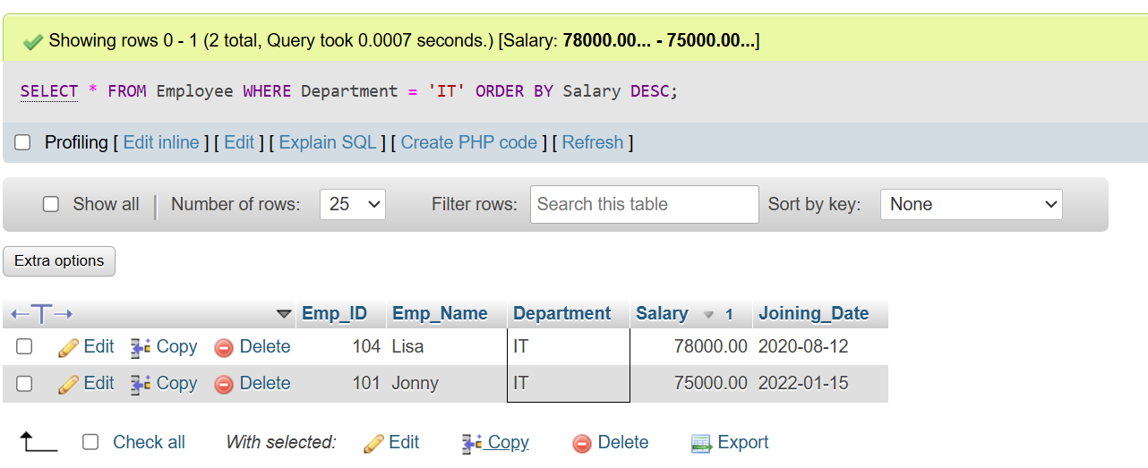
b)
SELECT MAX(Salary) AS Highest_Salary
FROM Employee;
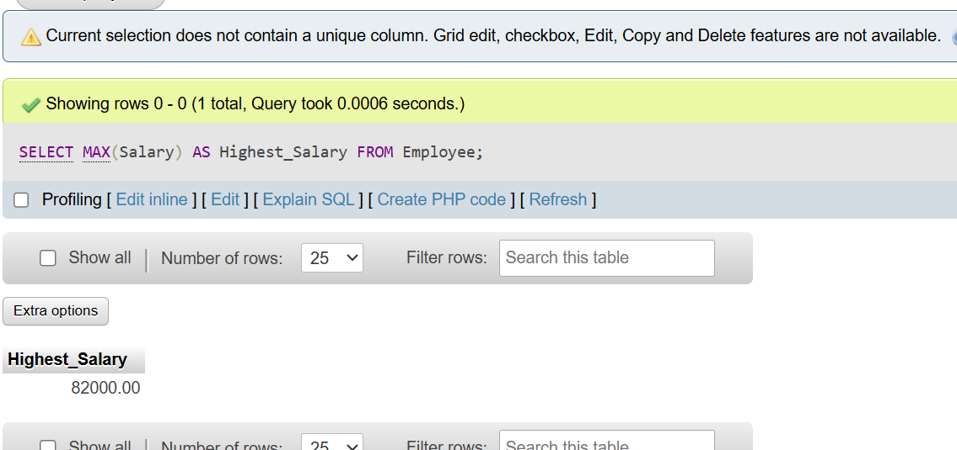
c)
SELECT Department, COUNT(*) AS Employee_Count
FROM Employee
GROUP BY Department
HAVING COUNT(*) > 3;
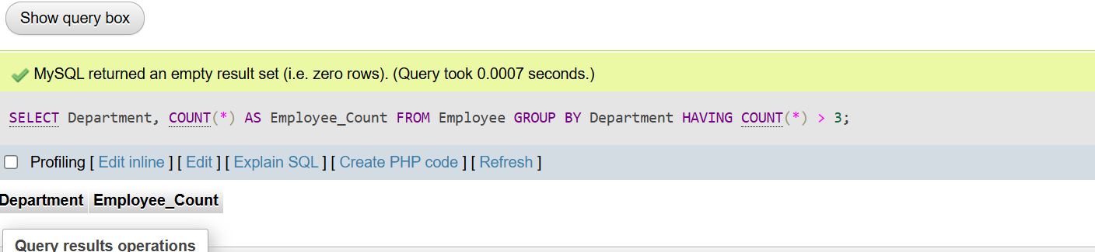
d)SELECT *
FROM Employee
WHERE Salary > (SELECT AVG(Salary) FROM Employee);
e)CREATE VIEW IT_Employee AS
SELECT *
FROM Employee
WHERE Department = 'IT';

