School of Computer Science & Applications
Department of Computer Science and Applications
Academic Year 2025-2026
A
MINI-PROJECT SYNOPSIS
ON
StudyMind AI - An Intelligent Learning Assistant
BY
[Student Name] ([PRN / Roll Number])
[Student Name] ([PRN / Roll Number])
Guide Name
[Guide Name]
DR. VISHWANATH KARAD MIT WORLD PEACE
UNIVERSITY, PUNE-411038

Problem Statement
Students increasingly receive learning material in many formats, including lecture notes, slides, PDFs, handouts and copied text. Converting this material into an effective study plan is often slow and repetitive. Learners must identify key concepts, create summaries, prepare flashcards, organise topics visually and design practice questions, usually across several disconnected tools.
This fragmented workflow can lead to passive reading, inconsistent revision and difficulty in tracking progress. A single, easy-to-use study workspace is needed to transform source material into active-learning resources and help students move from content collection to meaningful recall and practice.
Objectives of the Project
The main aim of StudyMind AI is to design and develop an intelligent, student-centred web application that converts study material into structured learning resources. The project objectives are:
- Provide a simple interface for students to upload supported study files or paste text into a learning workspace.
- Generate concise notes, important concepts and exam-focused review material from the uploaded content.
- Support active recall through flashcards and automatically generated practice quizzes.
- Present topic relationships through interactive mind maps that learners can explore.
- Offer a dashboard that organises learning resources and communicates study progress at a glance.
- Create a responsive, approachable user experience that reduces the effort required to prepare for revision.
Proposed Solution / Abstract
StudyMind AI is proposed as a web-based learning companion that brings study material, AI-assisted resource creation and revision activities into one focused interface. A student begins by creating an account and opening a personal learning workspace. They can add source material through file upload or by pasting text. The application then prepares reusable learning resources such as concise notes, important concepts, exam-focused review points, flashcards, quizzes and a visual mind map.
The interface is designed around short, focused study actions. Students can return to their dashboard, continue an existing collection, review flashcards, attempt a quiz and observe indicators such as resources created, cards mastered, study streak and focus time. The architecture keeps the user interface modular so that a content-generation service and a secure backend can be integrated without changing the learning workflow.

Scope of the Project
Technical Scope
- Development of a responsive single-page web application using React and Vite.
- Use of Tailwind CSS for a consistent, accessible learning interface.
- Route-based navigation for home, authentication, dashboard, upload, notes, flashcards, mind maps, quizzes and profile pages.
- Integration-ready API layer using Axios for authentication, content generation, data retrieval and progress updates.
- Interactive node-and-edge visualisation using React Flow for the mind-map module.
Functional Scope
- Allow learners to add PDFs, DOCX files, presentations, text files or pasted study content.
- Create AI-assisted notes, key concepts and exam-focused review resources.
- Enable flashcard practice and multiple-choice quiz sessions for active recall.
- Display topic connections in an explorable mind-map interface.
- Organise recent learning collections and show progress metrics in a personal dashboard.
Future Scope
- Personalised study recommendations based on quiz performance and revision history.
- Spaced-repetition scheduling and reminders for due flashcards.
- OCR and richer document parsing for scanned PDFs and image-based notes.
- Collaborative study spaces, shared collections and teacher feedback.
- Mobile application support and analytics for long-term learning habits.
Tools and Technologies to be Used
Layer | Tools / Technologies
Frontend | React 19, Vite, Tailwind CSS, React Router
Interactive visualization | React Flow (@xyflow/react) for mind-map exploration
HTTP integration | Axios for communicating with the application API
AI integration | Planned AI content-generation service for summaries, cards and questions
Backend / data | Planned REST API, user data store and secure file storage
Development tools | VS Code, Node.js, npm, Git and GitHub

System Architecture
StudyMind AI follows a modular client-service architecture. The existing React front end provides the learning workflow and is designed to communicate with an API layer. The API can coordinate user identity, uploaded material, generated resources and progress data, while an AI content-generation service transforms study content into useful learning artefacts.
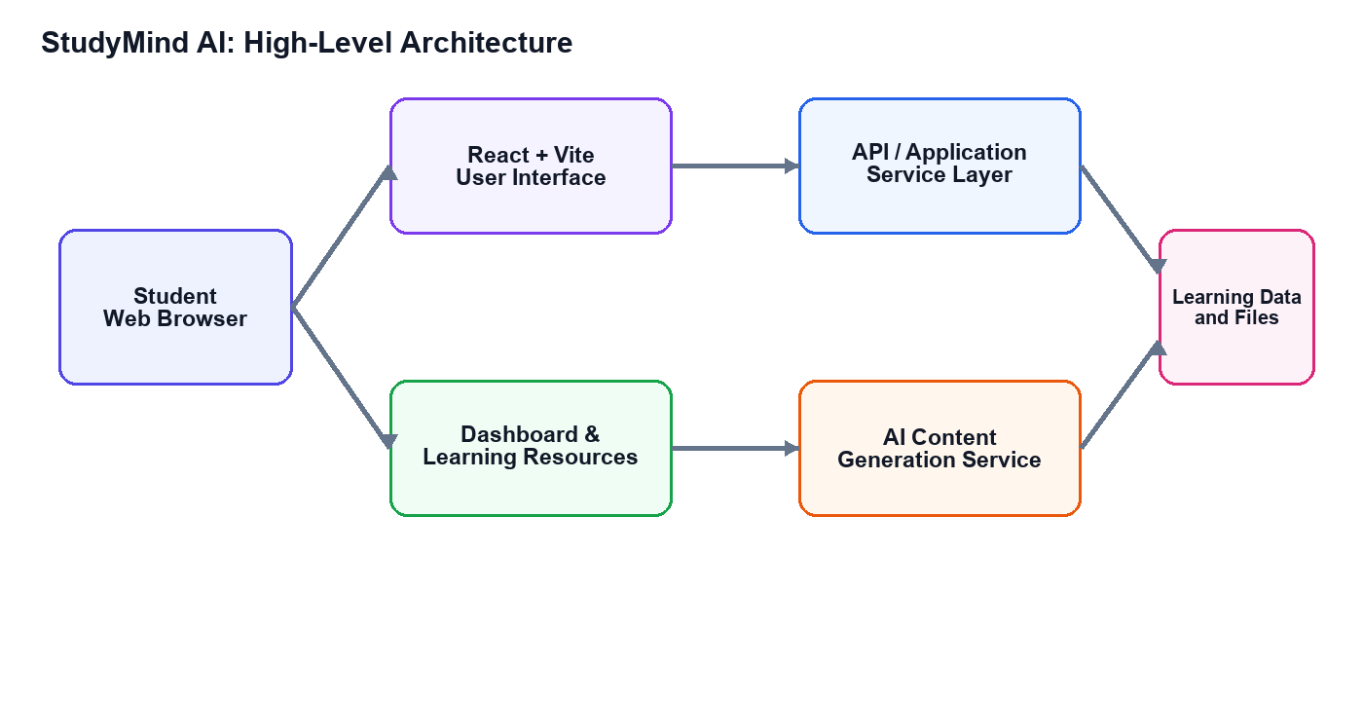
Figure 1. High-level architecture of StudyMind AI
Architecture Components
- Client interface: React pages and reusable components provide navigation, dashboard views, upload controls, cards, quizzes and mind-map interaction.
- Application API: exposes endpoints for authentication, content upload, resource creation, saved collections and progress information.
- AI content service: processes source material and returns structured notes, flashcards, quiz questions and concept relationships.
- Storage layer: retains user profiles, learning resources, progress metadata and source-file references with appropriate access control.

Use Case Diagram
The primary user of the system is the student. The student accesses StudyMind AI to manage a learning workspace, add material and use the resources produced from that material. The content-generation service supports the resource-generation actions within the system.
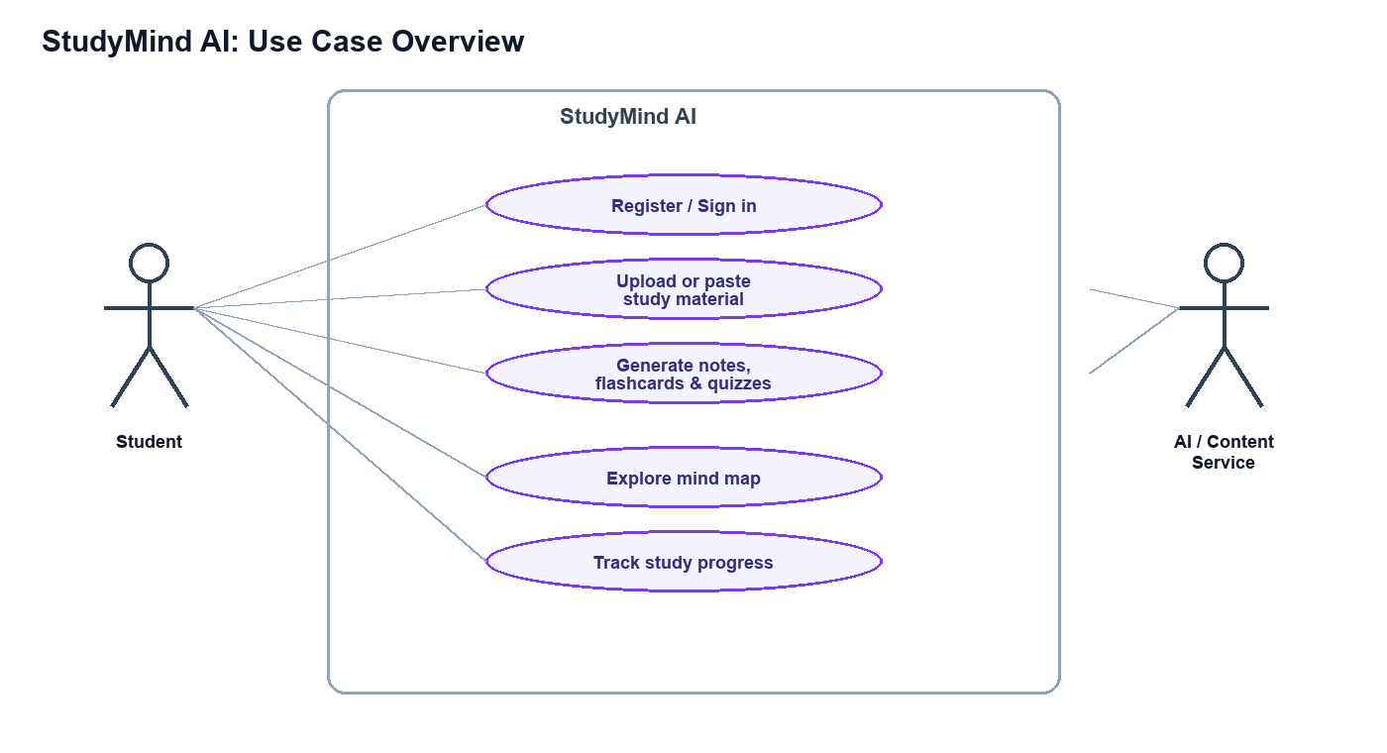
Figure 2. Primary use cases of StudyMind AI
User Flow
- 1. The student registers or signs in and opens the dashboard.
- 2. The student uploads material or pastes source text into the workspace.
- 3. The application creates selected study resources: notes, flashcards, a mind map and/or quiz questions.
- 4. The student studies the generated resources, answers quiz questions and returns for continued revision.
- 5. The dashboard records recent learning activity and displays high-level progress indicators.

Modules
1. Authentication and Profile Module
Provides registration, sign-in and profile-related entry points. It establishes a personal workspace where future backend integration can securely associate collections and progress with an individual learner.
2. Learning Material Input Module
Provides file-drop, file-selection and pasted-text paths for students to add PDFs, DOCX files, PPTX files, TXT files or typed study material. It is the starting point for resource generation.
3. AI Notes Module
Presents concise summaries, important concepts and exam-focused review points derived from the learner's material. The module is structured for quick scanning and revision.
4. Flashcard Module
Supports active recall using prompt-and-answer cards, with simple navigation through a study set. It is intended to evolve into a scheduled, mastery-aware revision tool.
5. Mind-Map Module
Uses an interactive graph interface to present a central topic and related concepts. Learners can explore or collapse branches to understand relationships between topics.
6. Quiz Module
Delivers multiple-choice questions and captures a student's current selection. The module provides a basis for automated scoring, explanations and adaptive practice.
7. Dashboard and Progress Module
Brings together current collections, recent learning, resources created, flashcards mastered, study streak and focus time, helping the learner decide what to study next.

Expected Outcomes
The project is expected to deliver a polished and extendable prototype of an AI-assisted learning workspace. The key outcomes are:
- A responsive StudyMind AI web interface covering material upload, notes, flashcards, mind maps, quizzes, dashboard and profile views.
- A clear workflow that turns learning material into activities that support summarisation, recall, visual organisation and self-assessment.
- A modular implementation that allows an AI content-generation service and backend persistence layer to be integrated incrementally.
- An engaging dashboard that helps students resume learning and interpret high-level progress signals.
- A foundation for future personalised learning features such as spaced repetition, recommendations and performance analytics.
Limitations and Assumptions
The current project repository contains the client-side prototype and an API integration point. Therefore, the synopsis treats persistent storage, full authentication, document extraction and AI generation as planned service integrations rather than completed repository features. The quality of generated study resources will depend on the clarity and completeness of the source material and the selected AI service.
Conclusion
StudyMind AI addresses a practical study challenge: students need more than a place to store materials; they need a guided path from source content to active revision. By combining a focused user interface with AI-ready generation modules, interactive mind maps, flashcards, quizzes and progress views, the project creates a strong base for a modern learning companion.

References
- 1. React. React Documentation. https://react.dev/
- 2. Vite. Vite Documentation. https://vite.dev/guide/
- 3. Tailwind CSS. Tailwind CSS Documentation. https://tailwindcss.com/docs
- 4. React Router. React Router Documentation. https://reactrouter.com/
- 5. xyflow. React Flow Documentation. https://reactflow.dev/
- 6. Axios. Axios Documentation. https://axios-http.com/docs/intro
- 7. Dunlosky, J., Rawson, K. A., Marsh, E. J., Nathan, M. J., & Willingham, D. T. (2013). Improving Students' Learning With Effective Learning Techniques. Psychological Science in the Public Interest, 14(1), 4-58.
- 8. Karpicke, J. D., & Roediger, H. L. (2008). Repeated Retrieval During Learning Is the Key to Long-Term Retention. Journal of Memory and Language, 57(2), 151-162.
- 9. Novak, J. D., & Canas, A. J. (2008). The Theory Underlying Concept Maps and How to Construct and Use Them. Technical Report IHMC CmapTools.

