Services

Kubernetes Services enable communication between various components within and outside of the application. Kubernetes Services helps us connect applications together with other applications or users. For example, our application has groups of PODs running various sections, such as a group for serving front-end load to users, another group running back-end processes, and a third group connecting to an external data source. It is Services that enable connectivity between these groups of PODs. Services enable the front-end application to be made available to users, it helps communication between back-end and front-end PODs, and helps in establishing connectivity to an external data source. Thus services enable loose coupling between microservices in our application.

The kubernetes service is an object just like PODs, Replicaset . One of its use case is to listen to a port on the Node and forward requests on that port to a port on the POD running the web application. This type of service is known as a NodePort service because the service listens to a port on the Node and forwards requests to PODs.

NodePort were the service makes an internal POD accessible on a Port on the Node. The second is ClusterIP – and in this case the service creates a virtual IP inside the cluster to enable communication between different services such as a set of front-end servers to a set of backend- servers. The third type is a LoadBalancer, were it provisions a load balancer for our service in supported cloud providers.

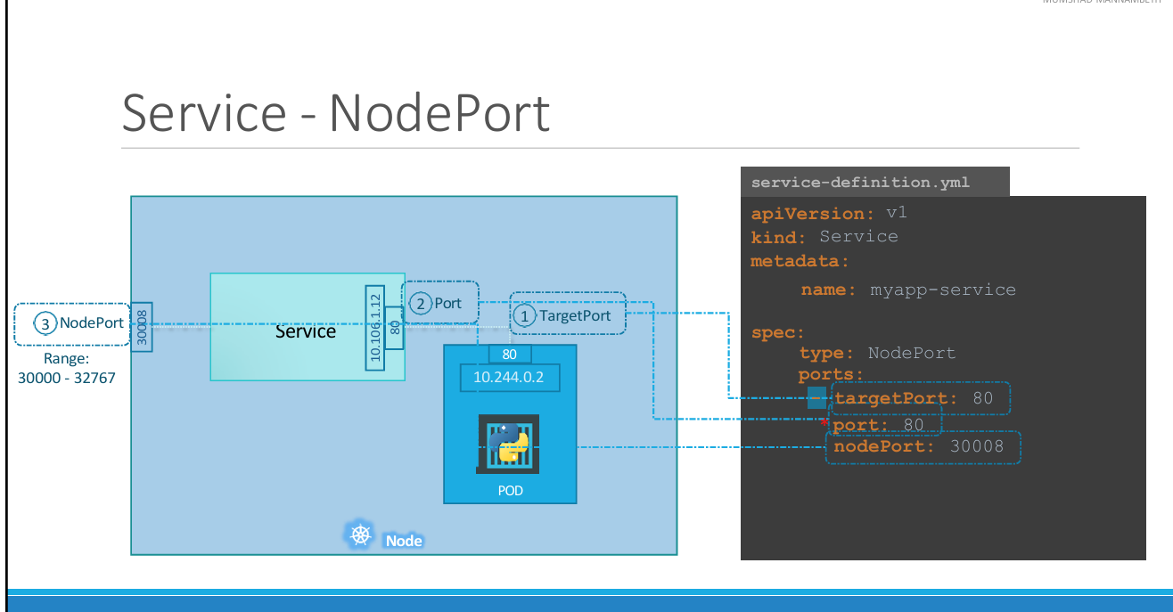

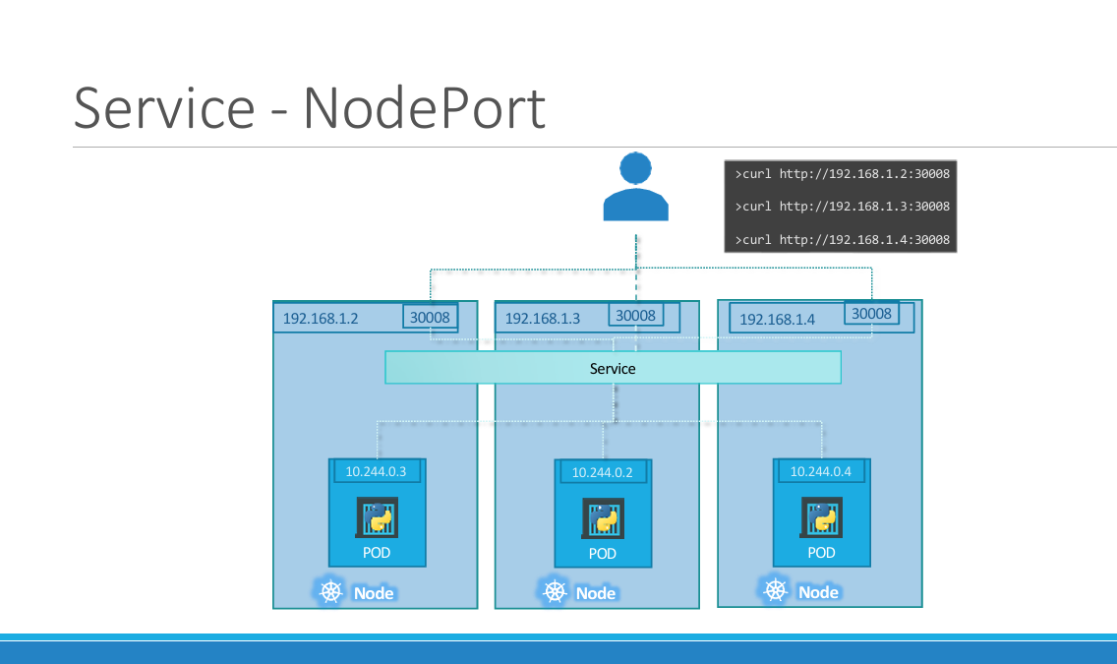

lets look at what happens when the PODs are distributed across multiple nodes. In this case we have the web application on PODs on separate nodes in the cluster. When we create a service , without us having to do ANY kind of additional configuration, kubernetes creates a service that spans across all the nodes in the cluster and maps the target port to the SAME NodePort on all the nodes in the cluster. This way you can access your application using the IP of any node in the cluster and using the same port number which in this case is 30008.

To summarize – in ANY case weather it be a single pod in a single node, multiple pods on a single node, multiple pods on multiple nodes, the service is created exactly the same without you having to do any additional steps during the service creation. When PODs are removed or added the service is automatically updated making it highly flexible and adaptive.