CPU SCHEDULER
Data Structures Laboratory
(MINI PROJECT)
Submitted by
1. Kavin Sharma
2. Vedant Kaiwade

Guided By: Dr. K. C. Waghmare

COMPUTER ENGINEERING (S. Y. B. TECH.)

Society for Computer Technology and Research’s
PUNE INSTITUTE OF COMPUTER TECHNOLOGY
DHANKAWADI, PUNE – 43 A.Y. 2026–27
Faculty Mentor | Dr. K. C. Waghmare
Project | CPU Scheduler
Department | Computer Engineering
Academic Year | 2026–27
Semester | Semester - III

Acknowledgement
I would like to express my sincere gratitude to Dr. K. C. Waghmare and the Department of Computer Engineering for providing the opportunity to develop this Data Structures mini project. Their guidance helped me understand how tree-based data structures can be applied to mathematical expression processing.
I also acknowledge the learning resources and development tools used during implementation. This project strengthened my understanding of stacks, binary trees, tree traversal, operator precedence and recursive evaluation.

Abstract
The Expression Tree Visualizer is a browser-based educational application that represents a mathematical expression as a binary expression tree. Operators are stored in internal nodes and operands are stored in leaf nodes. The application accepts an infix expression, converts it into postfix notation, constructs the tree, displays its structure and calculates the final result.
The interface also presents prefix, infix and postfix traversals, tree node count and tree height. A visual representation helps students connect theoretical data-structure concepts with the processing steps used by an expression evaluator. The project is implemented using HTML, CSS and JavaScript and runs locally in a modern web browser.

Table of Contents
Chapter No. | Title | Page No.
1. | INTRODUCTION AND PROBLEM STATEMENT
2. | OBJECTIVES AND SCOPE
3. | DATA STRUCTURES AND CONCEPTS
4. | SYSTEM DESIGN AND WORKING
5. | ALGORITHMS AND PSEUDOCODE
6. | COMPLEXITY ANALYSIS
7. | IMPLEMENTATION AND USER INTERFACE
8. | TESTING AND RESULTS
9. | LIMITATIONS AND FUTURE SCOPE
10. | CONCLUSION
— | REFERENCES

Chapter 1: INTRODUCTION AND PROBLEM STATEMENT

  - INTRODUCTION
The CPU Scheduling Simulator is a C++ project that demonstrates how an operating system manages multiple processes and decides which process gets CPU time. It includes four scheduling algorithms: First Come First Serve (FCFS), Shortest Job First (SJF), Priority Scheduling, and Round Robin. The project uses different data structures and sorting techniques to manage processes and make scheduling easier to understand. Users can add and search for processes, sort them by burst time, priority, or PID, and view their execution order through a Gantt chart. The simulator also calculates waiting and turnaround times, maintains execution history, and supports undo operations. Overall, the project provides a practical understanding of CPU scheduling and the role of data structures in process management.

  - PROBLEM STATEMENT
To develop a CPU Scheduling Simulator that demonstrates different scheduling algorithms and uses suitable data structures and sorting techniques to manage processes, calculate performance metrics, and display their execution order.
Project Objective
The main objective is to understand and compare CPU scheduling algorithms by implementing them in C++ and using appropriate data structures and sorting techniques for efficient process management.

Chapter 2: OBJECTIVES AND SCOPE
2.1 Objectives
The main objective of the CPU Scheduling Simulator is to understand how an operating system schedules processes for CPU execution. The project uses C++ and different data structures to demonstrate scheduling algorithms and process management.
The specific objectives are:
- To implement FCFS, SJF, Priority Scheduling, and Round Robin algorithms.
- To use appropriate data structures for storing, searching, and managing processes.
- To implement sorting techniques for arranging processes by burst time, priority, and PID.
- To calculate waiting time and turnaround time for evaluating scheduling performance.
- To maintain process information and execution history.
- To understand the practical applications of data structures and algorithms in operating systems.
2.2 Scope
The project focuses on simulating CPU scheduling in a simplified environment. Users can enter process details such as Process ID (PID), arrival time, burst time, and priority, and observe how different scheduling algorithms manage them.
The simulator uses arrays, hash tables, linked lists, stacks, deques, and binary search trees for different operations. It also applies sorting and searching techniques to organize and retrieve process information.
The project is intended for educational purposes and helps students understand scheduling concepts, compare algorithms, and analyze process execution. It does not interact with the actual operating system or control real CPU processes.

Chapter 3: DATA STRUCTURES AND CONCEPTS
3.1 Introduction
Data structures help organize and manage process information efficiently in the CPU Scheduling Simulator. Different data structures are used depending on the operation, such as storing processes, searching by PID, managing scheduling queues, and maintaining execution history.
3.2 Data Structures Used
1. Array
An array stores process information such as PID, arrival time, burst time, and priority. It allows processes to be accessed using their index.
2. Hash Table
A hash table stores process references using a hash function based on PID. It helps locate a process quickly without searching the entire list in most cases.
3. Circular Linked List
A circular linked list connects the last node back to the first node. It is suitable for managing the Round Robin queue, where processes receive CPU time in repeated cycles.
4. Deque (Double-Ended Queue)
A deque allows insertion and deletion at both the front and rear. It is useful for managing process admission and handling urgent processes that need to be moved to the front.
5. Stack
A stack follows the Last In, First Out (LIFO) principle. It can store previous operations or states to support undo functionality.
6. Binary Search Tree (BST)
A BST organizes process records according to a key. It supports searching and ordered traversal of process information.
7. Doubly Linked List
A doubly linked list contains links to both the previous and next nodes. It is useful for maintaining execution history and moving through records in either direction.
3.3 Sorting Algorithms Used
1. Selection Sort: Selects the smallest element from the unsorted portion and places it in the correct position. In this project, it is used to arrange processes by burst time.
2. Quick Sort: Uses a pivot to partition elements into smaller and larger groups. It is used to sort processes according to priority.
3. Bubble Sort: Compares adjacent elements and swaps them when necessary. It is used to arrange processes by PID.
3.4 Searching Techniques
Linear Search: Checks processes one by one until the required PID is found. It can be used when the process list is unsorted.
Binary Search: Repeatedly divides a sorted list into halves to find a required PID. It is more efficient than linear search for large, sorted lists.
3.5 Importance of Data Structures
Using different data structures makes the simulator easier to organize and maintain. Each structure serves a particular purpose, from storing process information to managing queues and recording execution history. This demonstrates how data structures and algorithms can be applied to a practical operating-system problem.

Chapter 4: System Design and Working
4.1 System Design
The CPU Scheduling Simulator is designed as a menu-driven C++ application. It accepts process details from the user, stores them using suitable data structures, and applies the selected scheduling algorithm to determine the order of execution.
The system consists of three main parts:
- Input Module: Accepts process details such as PID, arrival time, burst time, and priority.
- Processing Module: Executes the selected scheduling algorithm and uses sorting, searching, and data structure operations as required.
- Output Module: Displays the scheduling results, including process execution order, waiting time, turnaround time, and other available information.
4.2 Working of the System
The simulator follows these steps:
- The user starts the program and selects an operation from the menu.
- Process details are entered and stored in the process table.
- The user selects a scheduling algorithm: FCFS, SJF, Priority Scheduling, or Round Robin.
- The simulator determines the execution order according to the selected algorithm and process arrival times.
- Suitable data structures manage the processes, scheduling queues, and execution history.
- The program calculates waiting time and turnaround time for the completed processes.
- The results are displayed to the user for analysis.

4.3 System Workflow:
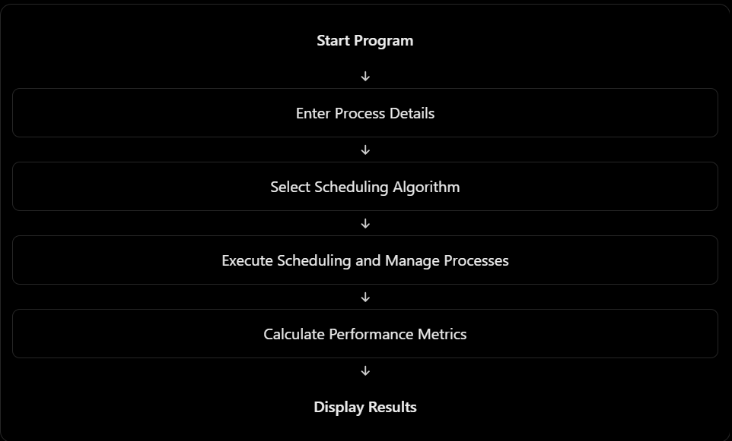
4.4 Scheduling Algorithms
The simulator includes four scheduling algorithms:
- FCFS: Executes processes in order of arrival.
- SJF: Selects the available process with the shortest burst time.
- Priority Scheduling: Selects an available process based on its priority.
- Round Robin: Gives each process a fixed time quantum and cycles through the ready queue.
4.5 Performance Metrics
The simulator uses the following metrics to evaluate scheduling:
- Completion Time (CT): The time at which a process finishes execution.
- Turnaround Time (TAT): Total time taken from arrival to completion. \(TAT = CT - AT\)
- Waiting Time (WT): Total time a process spends waiting. \(WT = TAT - BT\)
Here, AT represents arrival time and BT represents burst time.

Chapter 5: ALGORITHMS AND PSEUDOCODE
This chapter describes the basic logic of the scheduling and sorting algorithms used in the CPU Scheduling Simulator. The pseudocode is written in a simple form to explain the main steps. It should be checked against the final source code before submission.

5.1 First Come First Serve (FCFS)
FCFS executes processes in the order of their arrival. Once a process starts, it continues until it finishes.
START
Read process details
Arrange processes by arrival time
Set current_time = 0
For each process:
If current_time < arrival_time:
current_time = arrival_time
Execute the process for its burst time
Record completion time
Calculate turnaround time and waiting time
Display results
STOP

5.2 Shortest Job First (SJF)
In non-preemptive SJF, the process with the shortest burst time among the processes that have already arrived is selected next.
START
Read process details
Set current_time = 0
While unfinished processes remain:
Find arrived process with the shortest burst time
If no process is available:
Move current_time to the next arrival time
Else:
Execute the selected process until completion
Record completion time
Calculate turnaround time and waiting time
Display results
STOP

5.3 Priority Scheduling
Priority Scheduling selects an available process according to its priority. The program must follow a consistent rule for whether a smaller or larger priority number means higher priority.
START
Read process details
Set current_time = 0
While unfinished processes remain:
Select the arrived process with the highest priority
If no process is available:
Move current_time to the next arrival time
Else:
Execute the selected process
Record completion time
Calculate turnaround time and waiting time
Display results
STOP

5.4 Round Robin
Round Robin gives each ready process a fixed time quantum. A process that is not finished after its time slice is placed back in the ready queue.
START
Read process details and time quantum
Add arrived processes to the ready queue
While unfinished processes remain:
Take the front process from the queue
Run it for the time quantum or its remaining burst time
Add newly arrived processes to the queue
If unfinished, place the process at the rear
Otherwise, record completion time
Calculate and display scheduling metrics
STOP

5.5 Sorting Algorithms
- Selection Sort: Find the smallest item in the unsorted section and swap it into the next correct position.
- Quick Sort: Choose a pivot, partition the items around it, and recursively sort each partition.
- Bubble Sort: Compare adjacent items and swap them when they are in the wrong order.

5.6 Searching Algorithms
- Linear Search: Check each process in turn until the required PID is found or the list ends.
- Binary Search: Search a PID in a sorted list by repeatedly reducing the search interval by half.

Chapter 6: COMPLEXITY ANALYSIS
Time complexity describes how the work performed by an algorithm grows as the number of processes increases. The following are typical complexities for standard implementations; actual complexity depends on the code.
Algorithm / Operation | Typical Complexity | Worst Case
Linear Search | O(n) | O(n)
Binary Search | O(log n) | O(log n)
Selection Sort | O(n²) | O(n²)
Bubble Sort | O(n²) | O(n²)
Quick Sort | O(n log n) average | O(n²)
BST Search | O(log n) if balanced | O(n)
Hash Table Lookup | O(1) average | O(n)
Stack push/pop | O(1) | O(1)
Linked-list traversal | O(n) | O(n)

6.1 Scheduling Algorithms
The complexity of scheduling algorithms depends on how processes are selected and stored. Simple implementations of SJF and Priority Scheduling that repeatedly scan all remaining processes may take O(n²). FCFS may take O(n log n) if sorting by arrival time is required, or O(n) if processes are already in arrival order. Round Robin depends on the number of time slices and queue operations.

Chapter 7: IMPLEMENTATION AND USER INTERFACE

7.1 Implementation
The project is implemented in C++. Process details include PID, arrival time, burst time, and priority. The program uses functions and data structures to store process records, search for a PID, sort processes, manage scheduling queues, and calculate scheduling metrics.
Header files are used to declare structures, classes, and function interfaces, while source files contain the corresponding implementations. The project is divided into modules to keep related operations organized and easier to maintain.

7.2 User Interface
The simulator uses a command-line interface through which users can enter process details and choose the required operation or scheduling algorithm. The program displays the results in text form. Add screenshots of the actual running application here to show the inputs, selected algorithm, and output.

7.3 Main Features to Demonstrate
- Adding process details such as PID, arrival time, burst time, and priority.
- Searching for processes by PID.
- Sorting processes by burst time, priority, or PID.
- Running the available scheduling algorithms.
- Viewing scheduling metrics and execution order.
- Demonstrating history, undo, or urgent-process handling if these features are implemented in the final code.
Note: Include a Gantt chart only if it is implemented in the final program. An execution-order list alone is not a Gantt chart.

Chapter 8: TESTING AND RESULTS

8.1 Testing Approach
Testing is used to check whether the simulator stores process details correctly, applies the scheduling rules, and calculates results consistently. Test each scheduling algorithm with small examples that can also be checked manually.
Test Case | Action / Input | Expected Check
Process insertion | Add a process with a unique PID | The process is stored and can be found.
Duplicate PID | Try adding an existing PID | The program handles the duplicate according to its rules.
PID search | Search for an existing and a missing PID | Correct process or not-found message is returned.
FCFS | Use processes with different arrival times | Execution follows arrival order.
SJF | Make multiple processes available | The shortest available job is selected.
Priority | Use processes with different priorities | Selection follows the priority convention used in code.
Round Robin | Use multiple processes and a time quantum | Processes receive turns until they finish.
Metrics | Compare computed values with manual calculations | Waiting and turnaround times are consistent.

8.2 Results
Enter the actual test results after running the final program. Add screenshots showing sample inputs and outputs, and mention any errors that were corrected. A test should be marked as passed only after the result has been verified.

Chapter 9: LIMITATIONS AND FUTURE SCOPE

9.1 Limitations
- The simulator models scheduling in a simplified environment and does not control real operating-system processes.
- The correctness of the results depends on the implementation and the input provided.
- A command-line interface offers less visual interaction than a graphical application.
- Advanced features such as multi-core scheduling and context-switch overhead may not be included.

9.2 Future Scope
- Add a graphical interface to make scheduling easier to visualize.
- Add a Gantt chart if it is not already part of the implementation.
- Compare average waiting time and turnaround time across scheduling algorithms.
- Add preemptive scheduling algorithms such as Shortest Remaining Time First.
- Allow users to save and load process sets for repeated testing.
- Extend the simulator to demonstrate multi-core scheduling and context-switch overhead.

Chapter 10: CONCLUSION
The CPU Scheduling Simulator demonstrates how different CPU scheduling algorithms can be implemented using C++ and data structures. FCFS, SJF, Priority Scheduling, and Round Robin show different ways of selecting processes for execution. The use of arrays, hash tables, linked lists, stacks, deques, and trees demonstrates how data structures support process storage, searching, queue management, and history tracking. Overall, the project provides practical experience with data structures, sorting, searching, and operating-system scheduling concepts.

REFERENCES
1. GeeksforGeeks — CPU Scheduling in Operating Systems.
https://www.geeksforgeeks.org/operating-systems/cpu-scheduling-in-operating-systems/

2. Gate Smashers — Operating System: CPU Scheduling Algorithms.
https://www.gatesmashers.com/roadmaps/operating-systems

3. C++ STL / cppreference.com — C++ Standard Library Reference.
https://en.cppreference.com/w/

