**Salesforce Project**

**👉 Project Title: *“E-Commerce Customer Support & Case Management System”*  
👉 Industry: E-Commerce / Retail  
👉 Type: B2C Salesforce Service Cloud Implementation  
👉 Target Users: Support Agents, Managers, and Customers**

* **Problem Statement**

An e-commerce company receives thousands of customer queries daily regarding order tracking, returns, and complaints. Currently, these requests are handled manually through emails, calls, and spreadsheets, causing delays, missed follow-ups, and poor customer satisfaction. Managers also lack visibility into agent performance and service quality.

To address these challenges, the company requires a Salesforce Service Cloud implementation that:

* Centralizes all customer service requests into one CRM system.
* Automates case creation and assignment to agents.
* Sends real-time notifications and updates to customers.
* Tracks resolution progress and maintains complete service history.
* Provides dashboards and reports for monitoring productivity and customer satisfaction.

**Phase 1: Problem Understanding & Industry Analysis**

**👉 Goal:** The goal of this phase is to clearly understand the business problem faced by the e-commerce company and to document the functional and non-functional requirements for the Salesforce solution. This ensures that the project has a clear direction before the actual system setup and development begin.

**1. Requirement Gathering**

We conducted structured discussions with **support agents, managers, and customers** to capture key pain points and opportunities:

* Customer complaints and return requests managed via manual channels (emails, calls, spreadsheets).
* Lack of intelligent prioritization, leading to delays in urgent cases.
* Response time is inconsistent, reducing customer trust and satisfaction.
* Managers lack real-time visibility into service performance

**Key Business Requirements:**

* **Automate Case Creation** from multiple channels (Email, Web Form, Chatbot, Social Media).
* **Automatic Case Assignment** using defined rules (region, workload, skill).
* **Customer Notifications** via Email/SMS at each case stage.
* **Lifecycle Tracking** with defined statuses (Open → In Progress → Resolved → Closed).
* **Interactive Dashboards** to monitor SLA compliance, agent workload, and CSAT (Customer Satisfaction).

**2. Stakeholder Analysis**

* Support Agents → Need a system to view, manage, and resolve cases efficiently.
* Support Managers → Need dashboards/reports for team productivity and case SLAs.
* Customers → Expect quick responses, real-time updates, and transparency.
* Business Owners → Want higher customer satisfaction and reduced service costs.

**3. Business Process Mapping**

Current Manual Workflow:

1. Customer complaint logged in Excel/Email.
2. Assigned manually to agents.
3. Updates communicated through calls/emails.
4. No real-time tracking; escalations are delayed.

Proposed Salesforce Workflow:

1. **Multi-Channel Intake:** Complaints via Email/Web/Social auto-logged as Cases.
2. **Automation Rules:** Assignment based on region, agent skills, and workload.
3. **Customer Acknowledgement:** Automated Email/SMS confirmation.
4. **Case Resolution Tracking:** Agents update case status in Salesforce.
5. **Escalation Management:** SLA timers trigger notifications for overdue cases.
6. **Dashboards & Reports:** Managers track performance, SLA compliance, and CSAT.

**4. Industry-Specific Use Case Analysis (E-Commerce)**

The e-commerce sector has **unique service challenges**:

* High Case Volumes: Order tracking, return/refund requests, and delivery complaints.
* Return & Refund Management: Frequent disputes requiring quick resolution.
* Automated Notifications: Customers expect real-time updates (refund initiated, order shipped, etc.).
* Agent Performance Monitoring: Peak shopping seasons require real-time workload balancing.
* Customer Feedback Integration: Post-resolution surveys to improve processes.

**5. AppExchange Exploration**

To enhance Service Cloud, the company may explore:

* Email-to-Case Apps: Automatically convert support emails into structured Salesforce Cases.
* SMS Integration (e.g., Twilio): Send proactive customer updates.
* Survey & Feedback Apps: Capture post-resolution customer satisfaction metrics.
* Knowledge Base & FAQ Apps: Reduce agent workload with customer self-service.

**Phase 2: Org Setup & Configuration**

**👉 Goal:** Prepare Salesforce environment for the e-commerce support system.

1. **Company Information Setup**

* Updated Organization Name to *E-Shop Customer Care*.
* Set Default Time Zone to *Asia/Kolkata*.
* Configured Default Currency as *INR – Indian Rupee*.
* This ensures that the Salesforce org reflects the business identity and operates in the correct regional context.

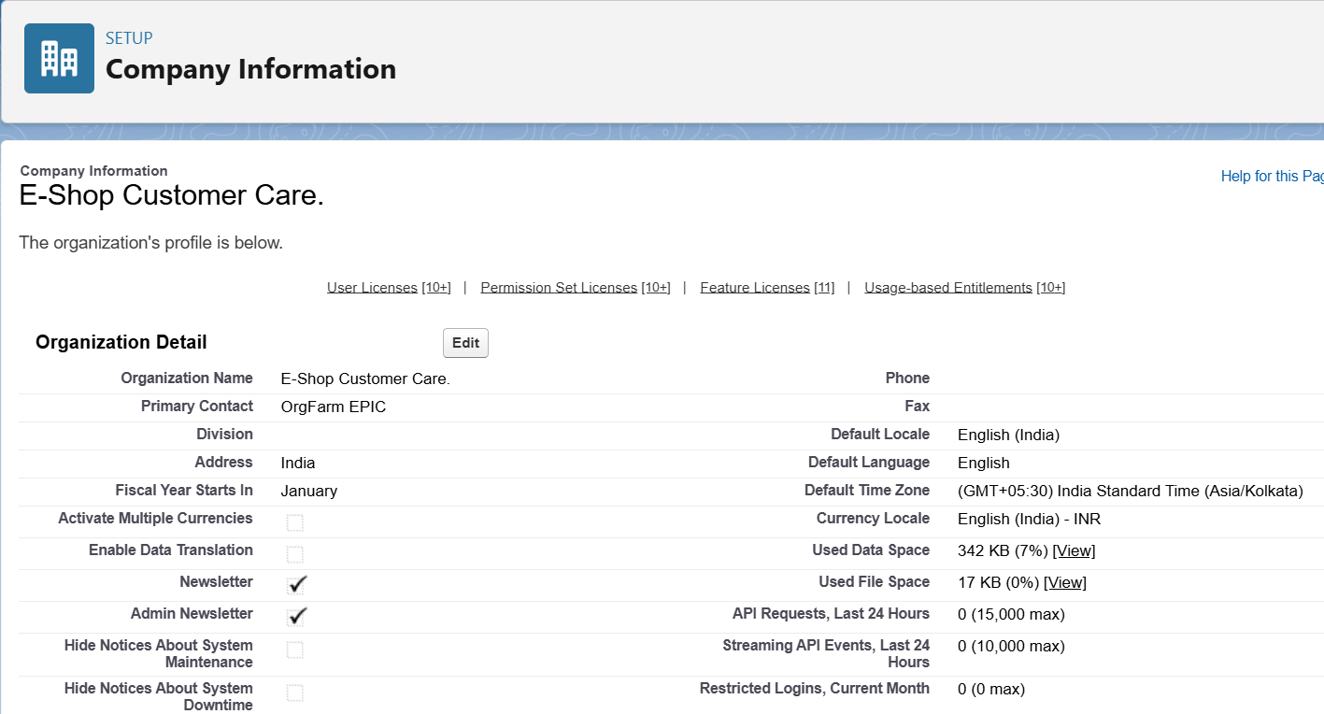

1. **Business Hours & Holidays**

* Defined *E-Shop Support Hours* (Monday–Saturday, 9:00 AM – 6:00 PM).
* Added *Diwali Holiday* as a public holiday.
* These configurations ensure that support processes and SLAs align with actual business working hours.

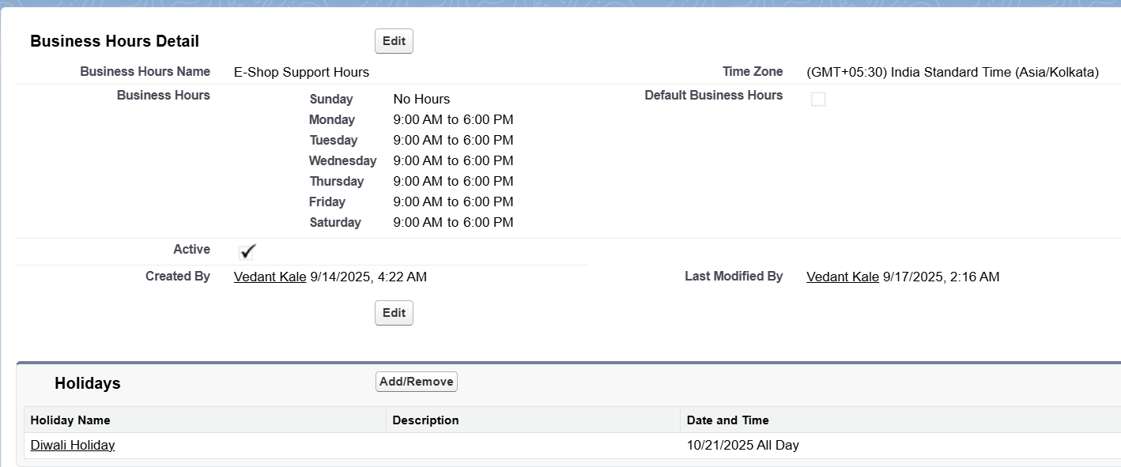

1. **Role Hierarchy**

* Created a Manager role at the top of the hierarchy.
* Created an Agent role that reports to the Manager.
* This hierarchy ensures that Managers can view and monitor the work of Agents, while Agents only see their own cases.

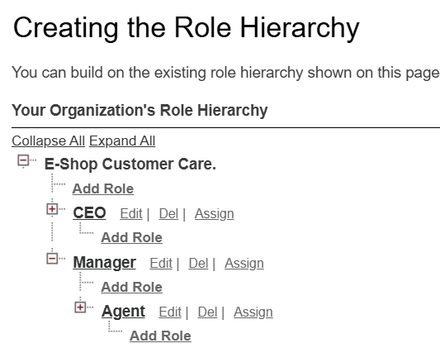

1. **User Creation**

* Created a Manager User with the Salesforce license and System Administrator profile.
* Created an Agent User with the Salesforce license and assigned to the Agent role.
* Unique usernames were used in email format, while activation emails were sent to real email accounts.
* This enables role-based access and simulates a real business environment with multiple users.

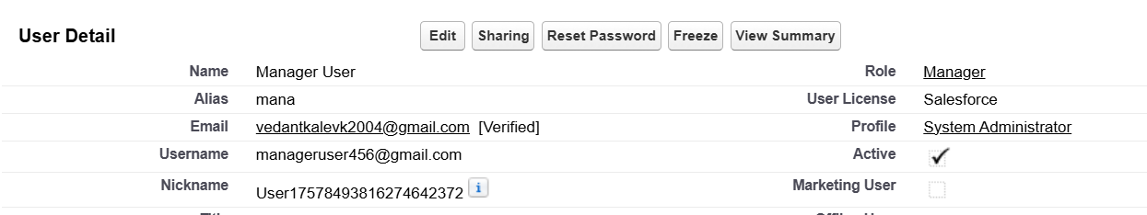

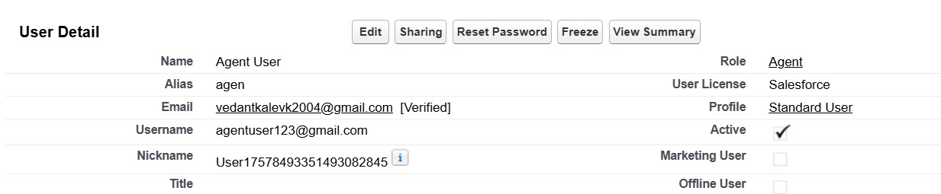

1. **Organization-Wide Defaults (OWD)**

* Set the Case object’s Default Internal Access = Private.
* This restricts case visibility so that only record owners and their managers can access them.

1. **Queue Setup**

* Created General Support Queue for normal cases.
* Created Priority Support Queue for high-priority cases.
* Queues will later be used for automatic case assignment and workload management.

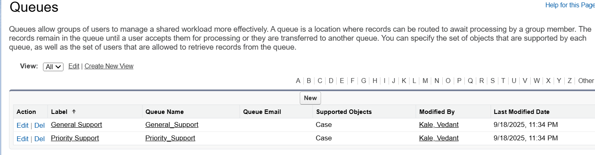

1. **Profiles & Permission Sets**

* Verified the Agent user’s profile permissions.
* Created a Permission Set (*Case_Access_Agent*) to allow the Agent user Read, Create, Edit access on Cases while restricting delete access.
* This ensures Agents have the right level of access without administrative privileges.

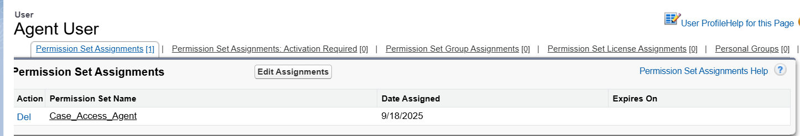

**Phase 3: Data Modeling & Relationships**

**👉 Goal:** The goal of this phase is to design and implement the Salesforce data model required to manage customer support operations for the e-commerce company. This includes creating custom objects, fields, and relationships to capture essential information such as customer details, orders, products, and support cases.

1. **Using Standard Objects**  
   Salesforce provides standard CRM objects that are reused in this project:
   * Account → represents the customer’s company (for B2B) or household (for B2C).
   * Contact → represents an individual customer.
   * Case → used to log complaints, returns, or order-related issues.
   * User → represents system users (Agent and Manager).
2. **Custom Fields on Case**  
   To capture additional e-commerce–specific details, new fields were added to the Case object:
   * Order Number (Text) → stores the customer’s order ID.
   * Case Type (Picklist) → values: *Order Issue, Return Request, Product Complaint*.
   * Region (Picklist) → values: *North, South, East, West*.
   * SLA Due Date (Date) → tracks case deadline for resolution.

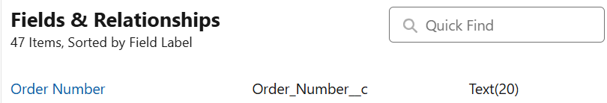



1. **Custom Objects**  
   Two custom objects were created to extend functionality:
   * Product__c
     + Fields: *Product Name, SKU, Price*.
     + Relationship: Lookup to Case (to identify which product was involved in the issue).
   * Return_Request__c
     + Fields: *Reason (Picklist), Status (Picklist: Initiated, In Progress, Completed)*.
     + Relationship: Lookup to Case (each return request is tied to a support case).

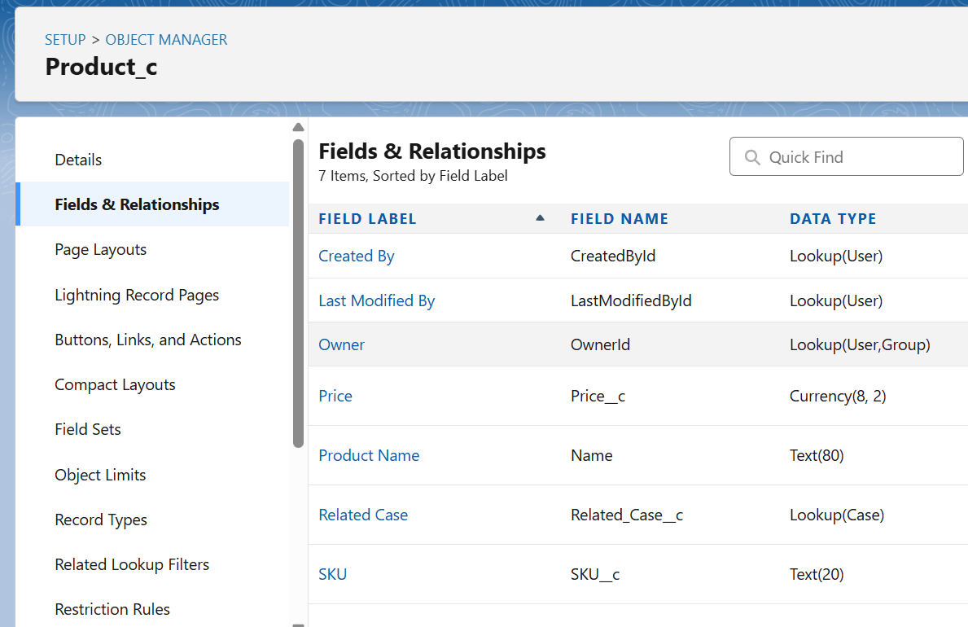

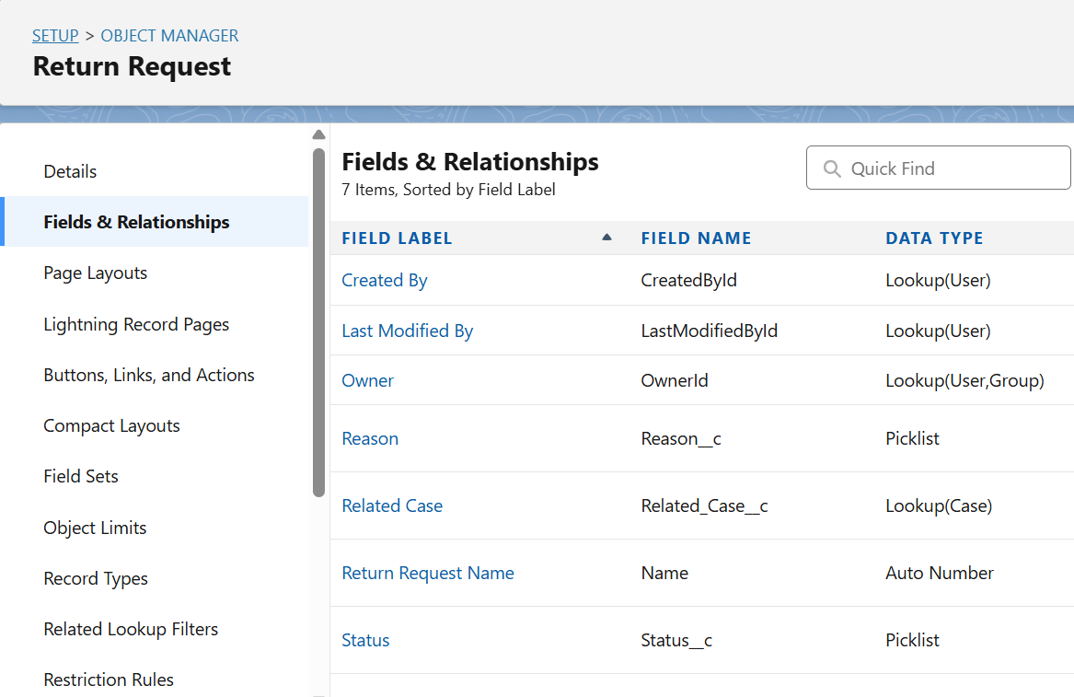

1. **Relationships**
2. **Case → Product__c (Lookup Relationship)**
   * Each Case can be linked to a Product.
   * Example: Case #C-002 → Product = “Laptop Model X.”
   * **Business Use:** Helps identify which product the issue/return request is about.
3. **Case → Return_Request__c (Lookup Relationship)**
   * Each Case can have one Return Request record linked.
   * Example: Case #C-003 → Return Request = “RR-005, Reason: Damaged Product.”
   * **Business Use:** Tracks the lifecycle of return cases separately from general cases.
4. **Case → User (Owner Standard Relationship)**
   * Every Case has an Owner (Agent or Manager).
   * Example: Case #C-004 → Owned by Agent = “Priya Mehta.”
   * **Business Use:** Ensures accountability for case resolution.
5. **User → User (Hierarchical Relationship)**
   * Defines reporting between users (Agent reports to Manager).
   * Example: Agent “Priya” → Manager “Kunal.”
   * **Business Use:** Manager automatically sees all cases handled by Agents.

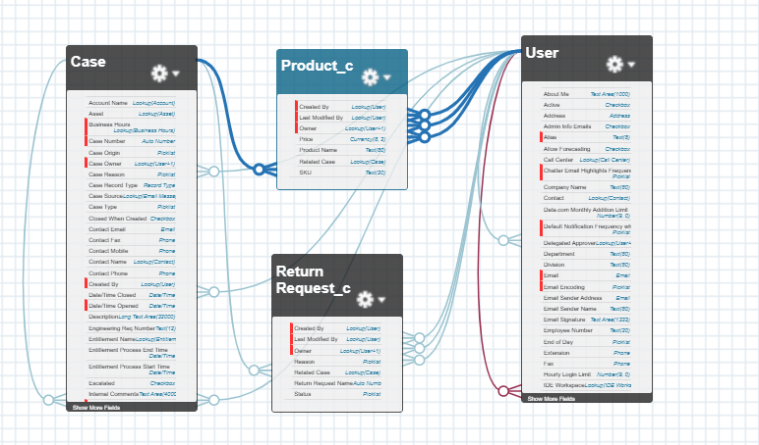

1. **Page Layouts & Record Types**
   * Modified the Case Page Layout to include new custom fields (Order Number, Case Type, SLA Due Date).
   * Added a Record Type on Case:
     + *General Case*
     + *Return Request Case*
     + This allows different page layouts for general support vs return cases.

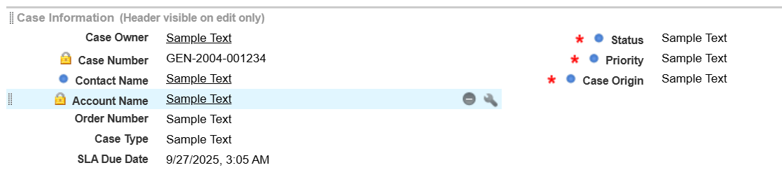 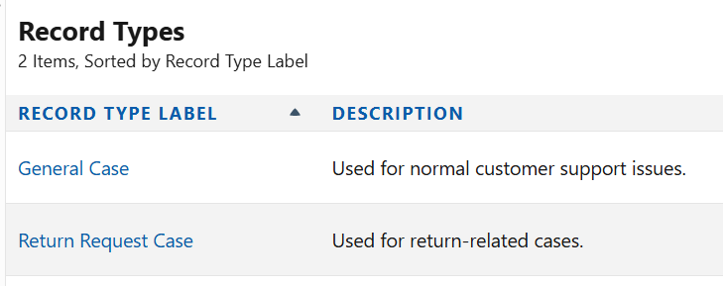

1. **Compact Layouts**  
   Configured a compact layout for Case to display *Case Number, Subject, Priority, Case Type, SLA Due Date* in the record header.

