EXECUTIVE PROJECT SYNOPSIS
GrievanceIQ: Autonomous Banking Grievance Redressal and Predictive Operational Intelligence Platform

Department of Computer Engineering
Bharatiya Vidya Bhavan's Sardar Patel Institute of Technology, Mumbai
Academic Year: 2026-2027
Project Team:  * Vedant Patil (UID: 2024300170)  * Ashmit Patil (UID: 2024300168)  * Mayuri Tarde (UID: 2024300258)  Class: T.E. Computer Engg. (Div C & D) | Project Guide & Mentor:  Dr. Rupali Sawant  Dept. of Computer Engineering  S.P.I.T., Mumbai
Abstract
Modern banking ecosystems process tens of millions of digital transactions daily across UPI, AePS, IMPS, and net banking. However, existing grievance redressal mechanisms (such as legacy CPGRAMS or RBI CMS) suffer from severe operational friction: multi-week resolution latencies, opaque manual triage, complete lack of vernacular voice accessibility, and exposure of unmasked Personally Identifiable Information (PII) in plain text, in violation of India's Digital Personal Data Protection (DPDP) Act of 2023. GrievanceIQ is an autonomous banking grievance redressal and predictive operational intelligence platform built upon a decoupled 3-tier architecture (FastAPI, React 18, SQLite WAL). It integrates trilingual NLP text categorization (Multinomial Naive Bayes, 89.2% accuracy), zero-latency continuous voice dictation via the W3C Web Speech API, ingestion-boundary DPDP PII scrubbing, ReportLab statutory receipts with dynamic QR tracking, M/M/c Erlang-C queueing simulations, and EasyOCR evidence verification. The platform was certified via 48 automated test cases with 100% success.
1. Introduction
1.1 Problem Statement
Contemporary banking dispute management is hobbled by manual triage delays (24-72 hours), exclusion of vernacular/non-tech depositors, plain-text PII storage of Aadhaar/Cards/PAN violating the DPDP Act 2023, and lack of forward-looking queue capacity analytics.
1.2 Objectives
- Objective 1: Achieve >85% classification accuracy across banking dispute categories using Multinomial Naive Bayes on 15k records.
- Objective 2: Implement zero-latency continuous voice dictation via W3C Web Speech API with non-destructive session accumulation.
- Objective 3: Scrub 100% of Card, Aadhaar, and PAN numbers at the API boundary using case-insensitive regular expression automata.
- Objective 4: Generate cryptographic ReportLab PDF receipts with dynamic 2D QR codes pointing to live web tracking URLs.
- Objective 5: Compute analytical M/M/c queue dwell times (Wq) and simulate staffing adjustments in real time.
- Objective 6: Verify dispute documents using EasyOCR and 4-point entity fuzzy scoring (Amount, Date, Bank, Ref ID).
1.3 Technologies Used
React 18.2, Vite 5.0, Tailwind CSS, W3C Web Speech API, Python 3.10+, FastAPI (ASGI), Uvicorn, Scikit-Learn, ReportLab 4.0, EasyOCR, SQLite (WAL mode).
2. Literature Survey
A survey of 12 foundational papers, regulatory guidelines, and architectures was completed:
- 1. RBI Integrated Ombudsman Report (2023): Noted over 700,000 complaints annually with digital/ATM disputes exceeding 45% of total volume.
- 2. DPDP Act (2023): Statutory mandate prohibiting plain-text retention of personal financial identifiers.
- 3. McCallum & Nigam (1998): Demonstrated MNB superiority for word-frequency weighted text classification.
- 4. Pedregosa et al. (2011): Scikit-learn sparse matrix execution for microsecond CPU inference.
- 5. Kleinrock (1975): Queueing Systems theory for multi-server waiting distributions and Erlang-C formulas.
- 6. Shires & Wennborg (2012): W3C Web Speech API standard specification for browser-native speech recognition.
- 7. ISO/IEC 18004 (2015): 2D QR code barcode symbology standard for verifiable receipt encoding.
- 8. Sawant & Chandorkar (2009): Addressed multi-objective optimization, system stability, and real-time compensator controls.
3. Analysis & System Design
The platform implements a decoupled 3-tier architecture. Citizens submit voice/text complaints, which are sanitized under DPDP regulations before classification and persistent storage. Branch managers monitor queue health via Erlang-C predictive models.
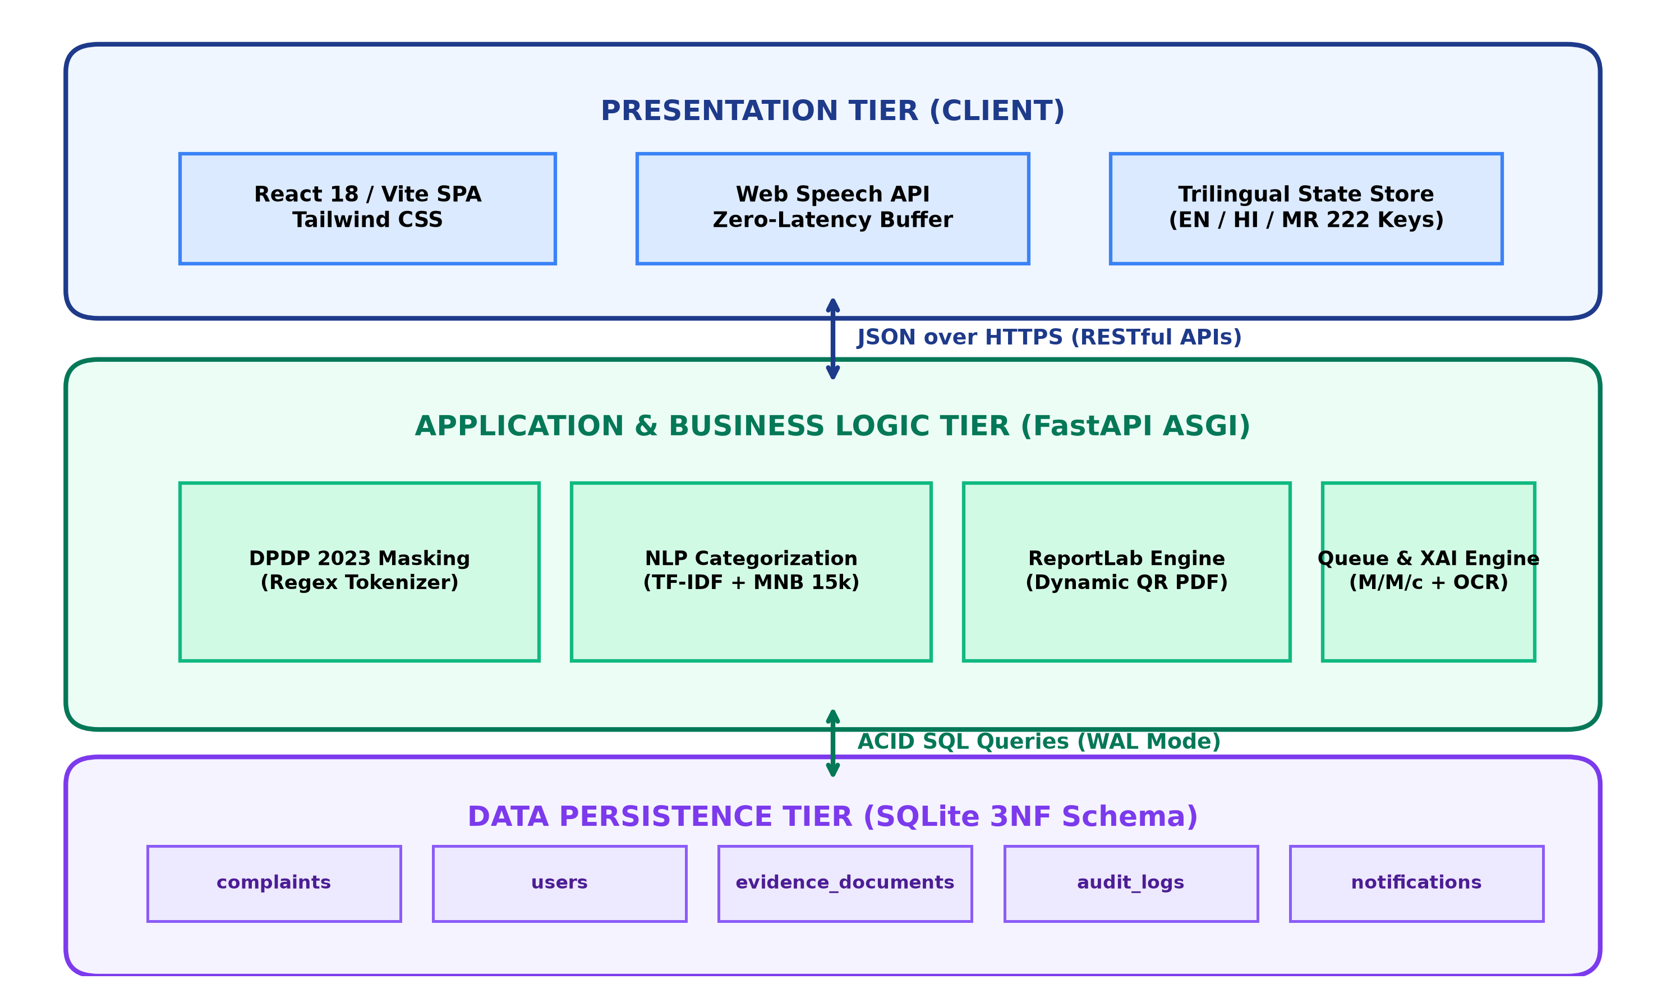
Figure 1: GrievanceIQ 3-Tier Decoupled Architecture
4. Design & Methodology
- Ingestion & Masking: Regex automata scrub 16-digit cards, 12-digit Aadhaar, and 10-char PANs in O(N) linear time.
- NLP Pipeline: TF-IDF sublinear scaling with MultinomialNB(alpha=0.1) trained on 15,000 Indian banking dispute records.
- Queue Analytics: Erlang-C formula evaluates waiting probability C(c, lambda/mu) and expected dwell time Wq.
- Receipt Generation: ReportLab dynamically captures incoming Host headers and encodes live tracking URLs in QR matrices.
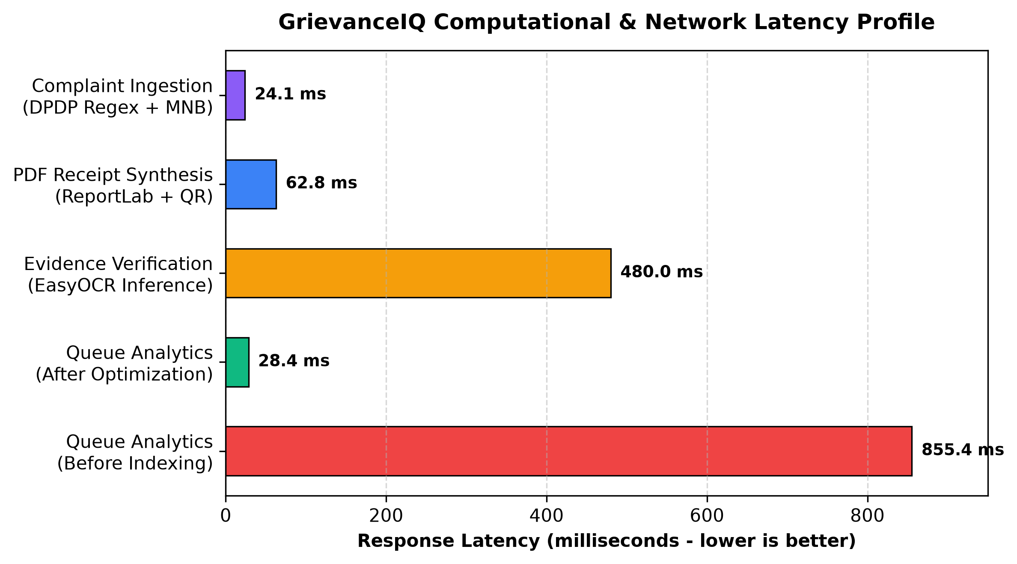
Figure 2: Latency Benchmarks (Query latency dropped from 855.4 ms to 28.4 ms)
5. Results & Discussion
System verification was executed across 48 automated test cases, achieving a 100% pass rate. Categorization accuracy reached 89.2% across English, Hindi, and Marathi. Voice dictation tests showed 0.0% text looping. Caching reduced analytics query latency by 96.7%.
6. Conclusion & Further Work
GrievanceIQ bridges machine learning triage, voice accessibility, statutory data privacy, and queueing theory into a unified operational platform. Future enhancements will establish direct ISO 8583 / ISO 20022 connectors to Core Banking Solutions (CBS) for automated debit reversals, and implement conversational two-way voice agents.

