**Classification using Data Warehouse**

**Data Warehousing and Mining Mini Project**

**By:**

Vedant Sahai (8364)

Anup Joseph (8351)

Abhishek Nagvekar (8352)

Anuj Purandare (8360)

Sherwin Pillai (8358)

**Problem Statement:**

The project aims in performing classification algorithms on the dataset provided by the user. The user will be uploading the unclassified data in csv format through the upload portal and selects the required algorithm that he or she wants to execute on the given dataset. Then the following details provided by the user will be processed by the flask server and the required model is chosen. The server is run the model on the provided dataset and get the results of the following classification. This result is returned to the user as the output. This output image will be displayed on the result page of our project.

Clustering Algorithm Implemented are as follows:

* Spectral Clustering
* DBSCAN
* Optics
* Birch
* Affinity Propagation

**Flow Diagram:**

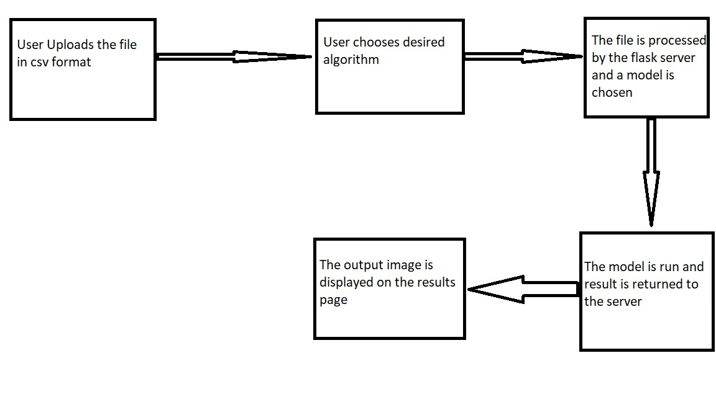

Fig1: Flow Diagram

**Requirements:**

Software-

1. Flask
2. Scikit-Learn
3. NumPy
4. Pandas
5. Matplotlib

Hardware-

1. 4GB+ RAM
2. Intel i3 core + processor

**Screenshots of the output:**

1. The data upload page:

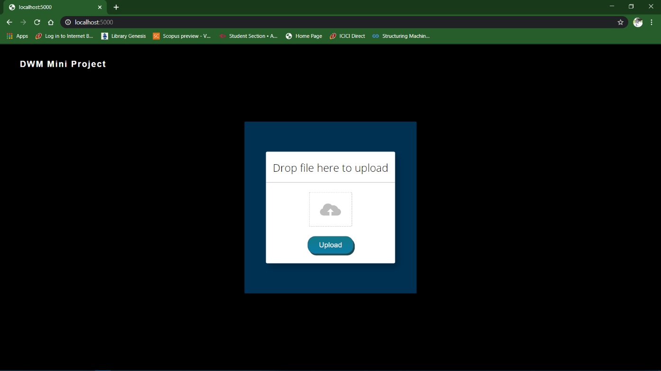

Fig2: Data Upload

1. Any classification algorithm can be chosen from the list

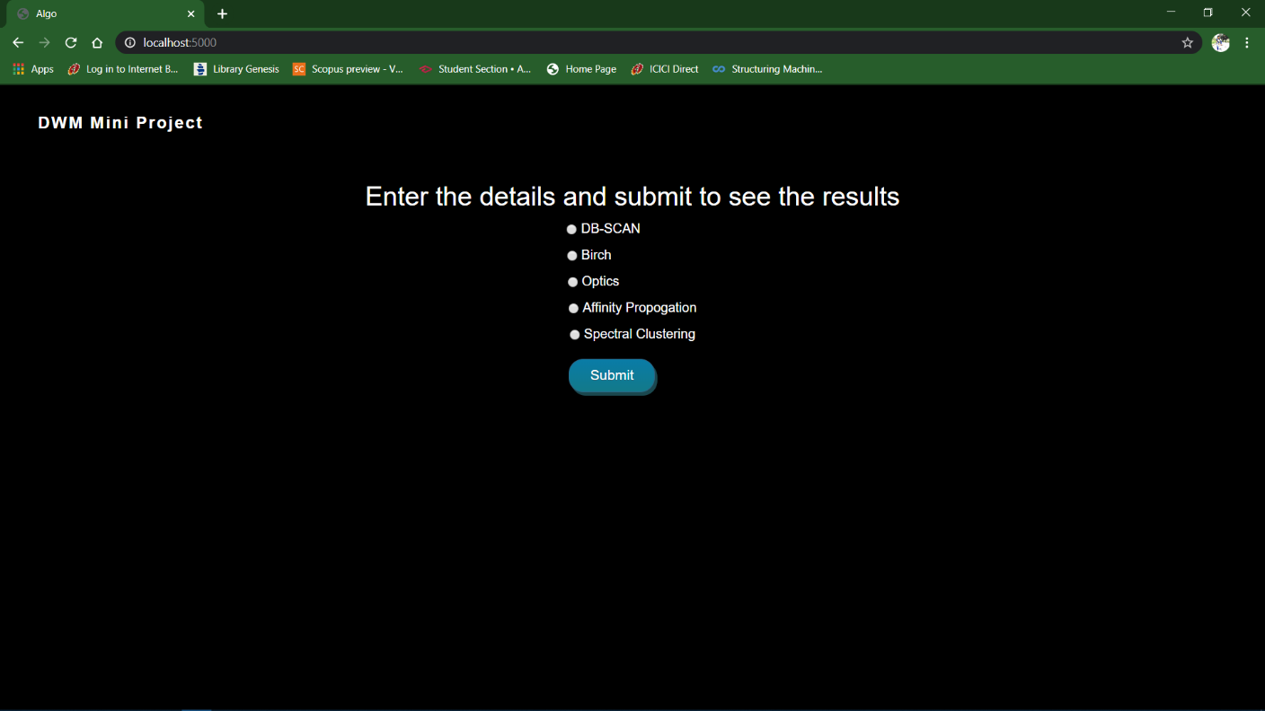

Fig3: Algorithm Select

1. The output of the classification performed will be shown in the result page:

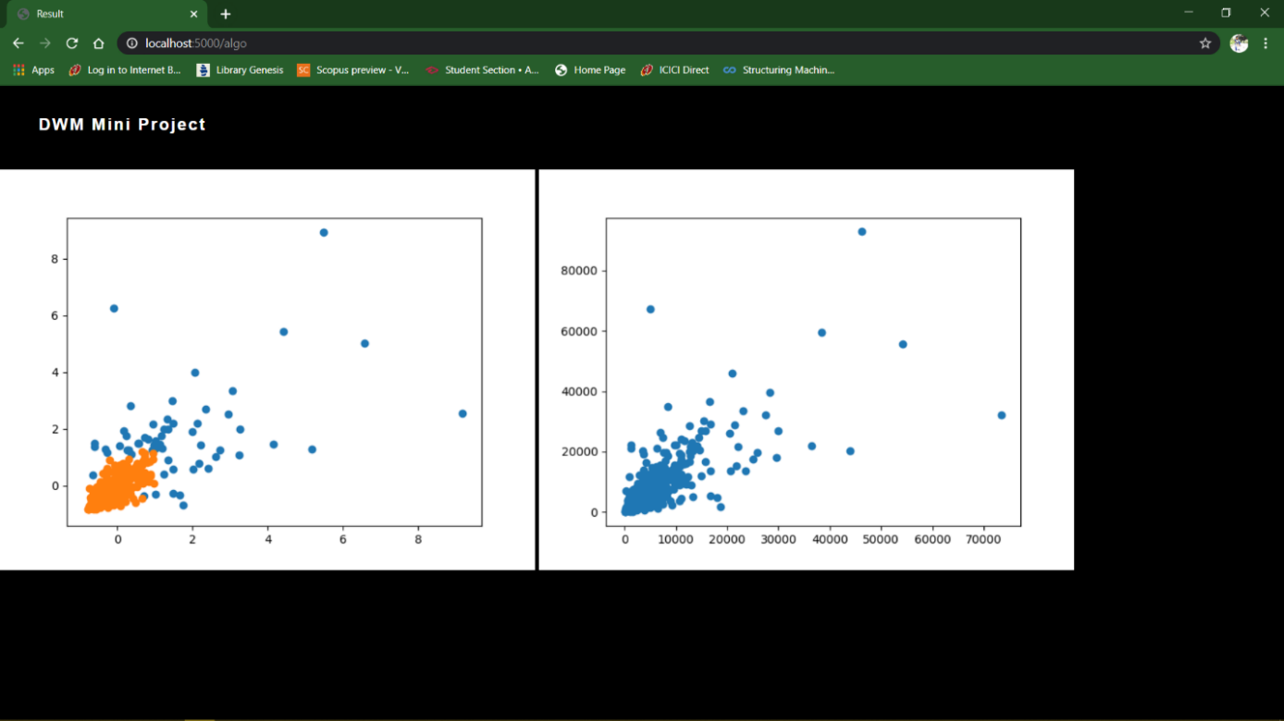

Fig4: Graph Visualization