Docker basic commands:

docker run imagename -> it will run the image createing its container

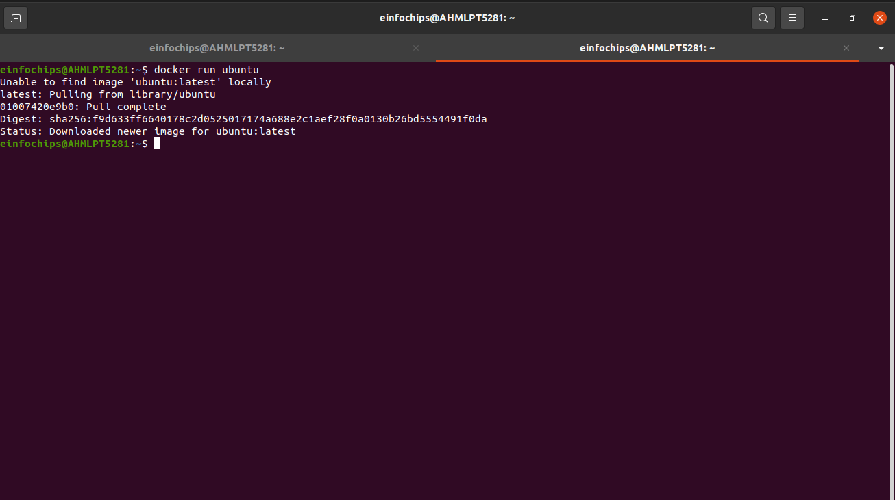
-----

docker ps = lists all the crunning ontainers ran by docker

docker ps -a = lists all the containers ran by docker

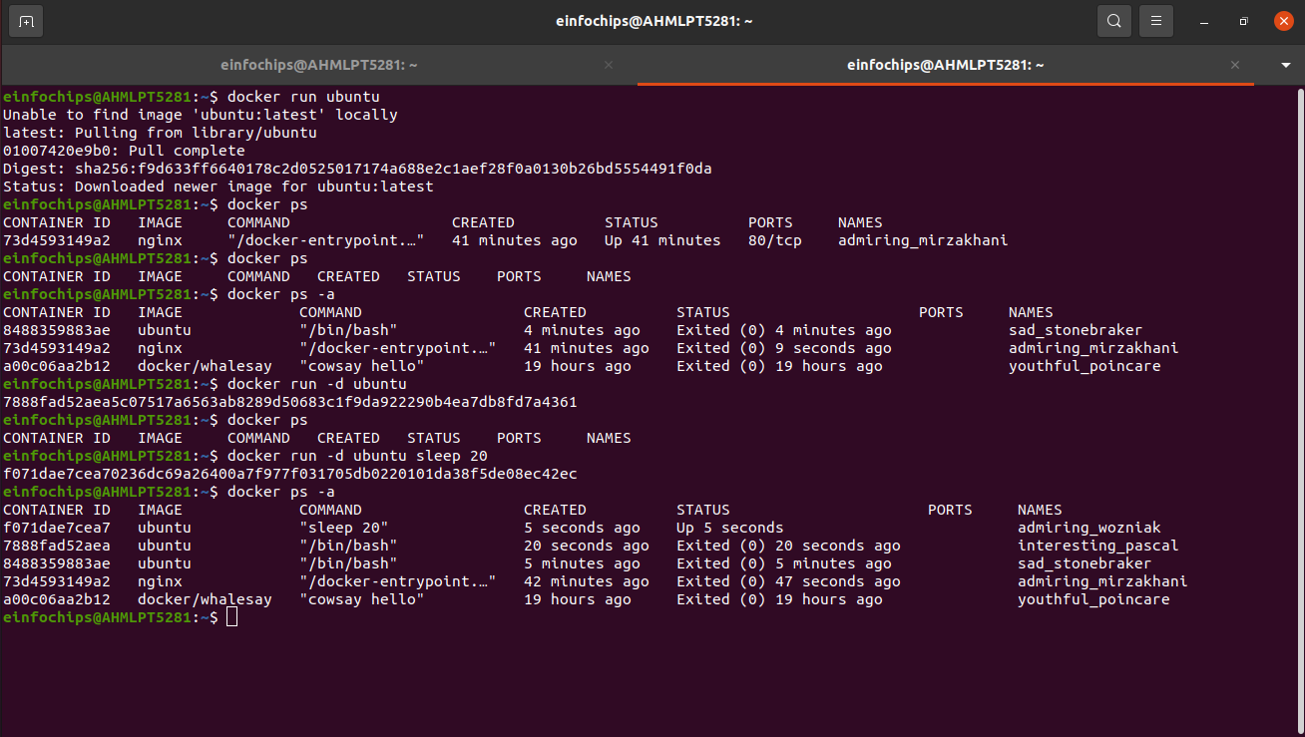
dasda

To go inside any service of docker

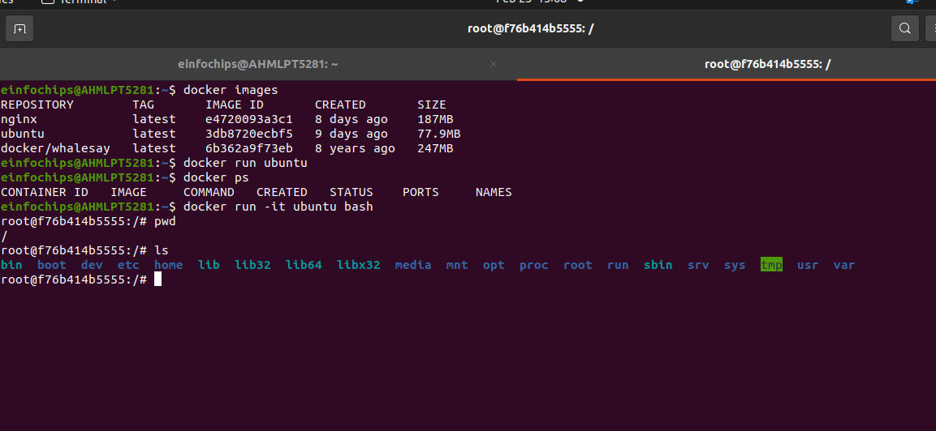
docker run -lt ubuntu bash

//to run the service inside docker

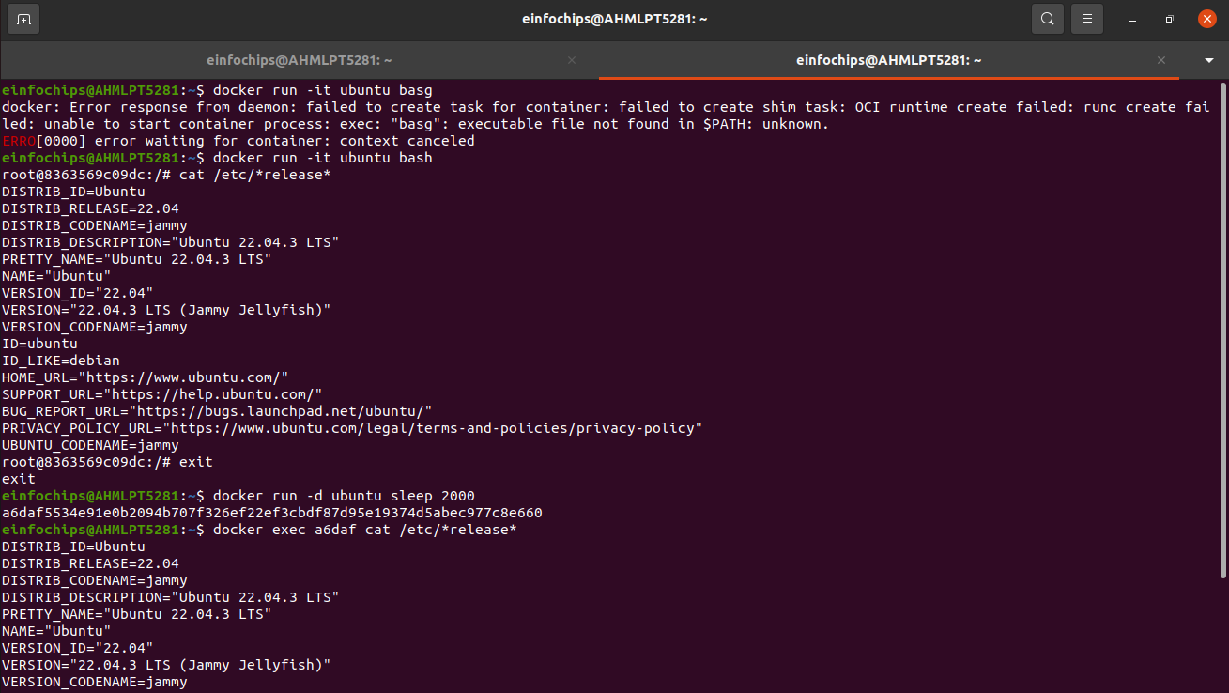
use of exec command

