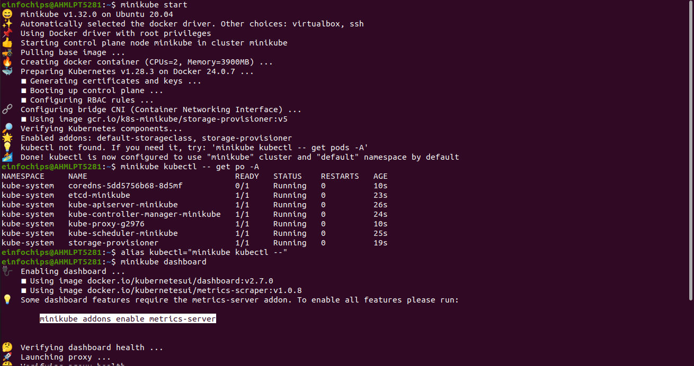
d

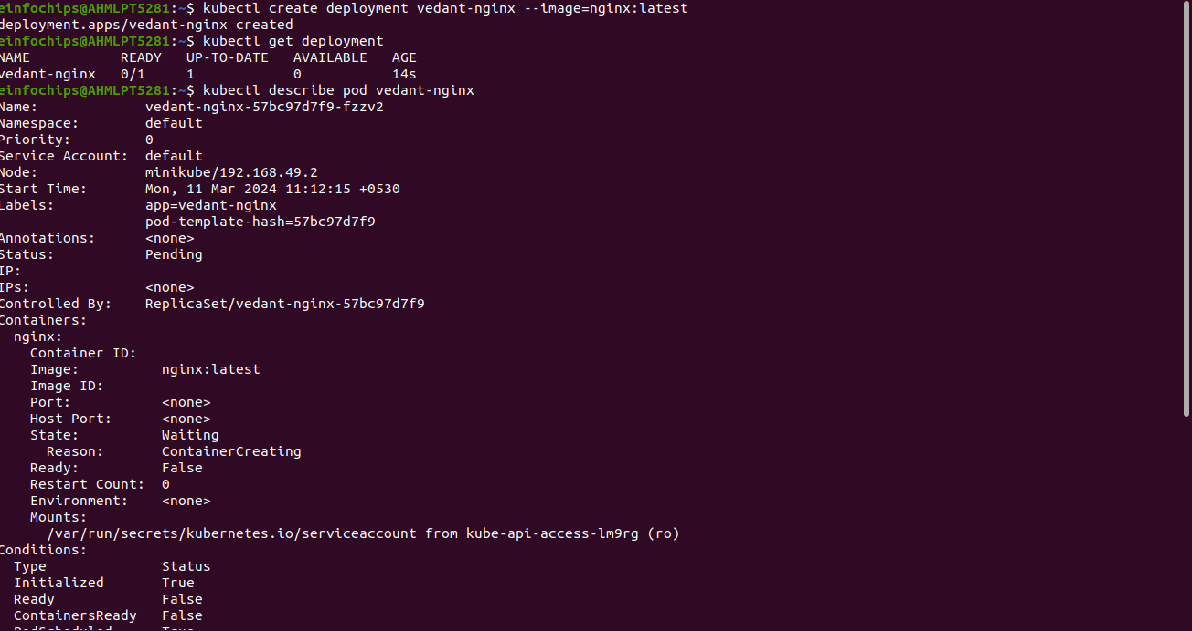
s

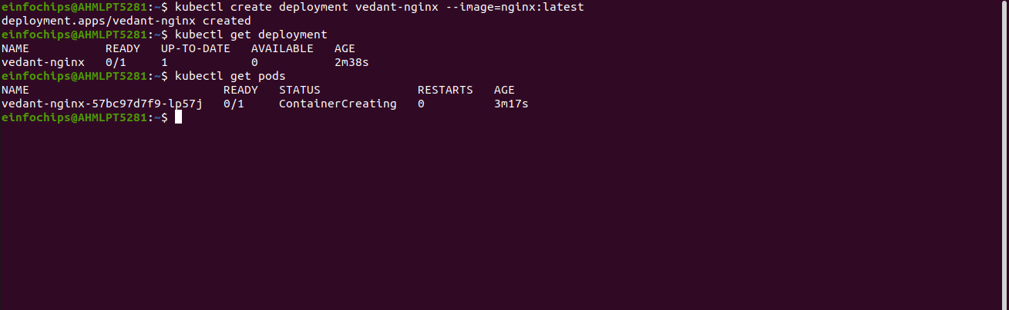
pods are not in running state

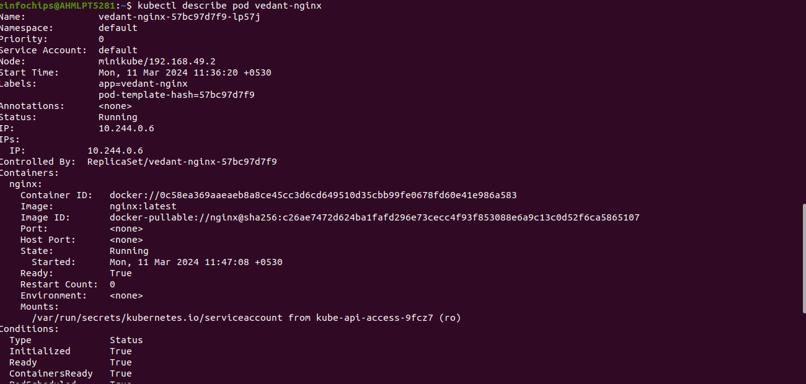
d

kubectl scale deployment vedant-nginx –replicas=2

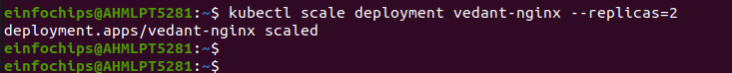
s

kubectl expose deployment my-nginx --type=NodePort –port=80

d

kubectl get service
minikube service vedant-nginx --url

