SMART INDIA HACKATHON 2026

PROJECT REPORT

AGRINEXUS
AI-Powered Post-Harvest Decision Intelligence Platform

Problem Statement ID 26193
Problem Statement Title AI Powered Post-Harvest Decision Intelligence Platform
Theme Agriculture, FoodTech & Rural Development
PS Category Software
Team Name AGRINEXUS
Team ID

Submitted for Smart India Hackathon 2026
Academic Year: 2025–2026

Team Members: Vedant Vijay , Kartik Soni , Omitya Dhanotiya , Ashish Chachodiya , Harshvardhan Singh , Somya Sinha
Mentor / Guide: Prof.Vishal Sharma Sir

Smarter Decisions. Stronger Farmers

ACKNOWLEDGEMENT

We express our sincere gratitude to Smart India Hackathon 2026 and the organizing bodies for providing a platform to address real-world challenges in the Agriculture, FoodTech and Rural Development domain. Problem Statement 26193 has given us the opportunity to design a decision-intelligence solution focused on post-harvest loss reduction and improved farmer outcomes.
We thank our institution, department and faculty mentor for their guidance, constructive feedback and continuous encouragement throughout the ideation and documentation of this project. Their support has been instrumental in shaping the technical approach and feasibility considerations presented in this report.
We also acknowledge the publicly available agricultural data platforms and knowledge resources—including Soil Health Card, AGMARKNET, e-NAM, India Meteorological Department (IMD) and the Indian Council of Agricultural Research (ICAR)—which form the foundational data references for the proposed AgriNexus platform.
Finally, we thank our teammates for their collaborative effort, technical discussions and shared commitment to designing a practical, farmer-centric decision-support system. Any shortcomings in this work remain our own responsibility.

— Team AGRINEXUS

ABSTRACT

Post-harvest decision-making is a critical yet under-supported stage in the agricultural value chain. Immediately after harvest, farmers and farmer producer organisations (FPOs) must decide whether to sell, store, process or redirect a batch of produce. These decisions are made under time pressure, with fragmented information, limited visibility into shelf-life and spoilage risk, and uncertainty about market prices and demand. Existing agricultural platforms typically provide individual services—market prices, weather, soil health or advisory content—in isolation. As a result, farmers often rely on experience-based or ad-hoc decisions that can lead to avoidable spoilage, suboptimal timing of sale, under-utilised storage or missed processing and alternate-channel opportunities.
This project report presents AgriNexus, an AI-powered post-harvest decision intelligence platform designed to address this decision gap. AgriNexus is structured around a Digital Batch Twin—an up-to-date digital representation of each harvested batch that consolidates crop details, condition observations and related agricultural context. On top of this representation, the platform applies proposed AI prediction capabilities for quality assessment, shelf-life estimation and spoilage-risk evaluation. Market intelligence draws on price and demand information, including references to sources such as AGMARKNET and e-NAM. What-if simulation allows comparison of alternative actions (sell now, store, process or redirect), and a smart optimisation layer—proposed to use OR-Tools—selects a recommended action intended to balance value, loss and cost. Recommendations are designed to be explainable through AgriNexus Assist, a RAG-based language model component.
A key differentiator of AgriNexus is cluster-level joint decision optimisation. Rather than treating each farmer’s batch in isolation, the platform is designed to support coordinated decisions across a farmer cluster or FPO, enabling shared storage, pooled transport and improved market coordination. This joint view aims to reduce logistical duplication and strengthen bargaining and operational efficiency at the cluster level.
The proposed system architecture comprises four zones: a client layer (Flutter farmer application and React FPO/buyer dashboard with offline-first design), an API layer (Python/FastAPI services for authentication, batches, clusters and alerts), an intelligence layer (AI prediction, OR-Tools optimisation and decision engine), and a data and AI layer (PostgreSQL, agricultural data sources and AgriNexus Assist). Implementation technologies include Flutter, React, FastAPI, PyTorch, OR-Tools, PostgreSQL, AWS/GCP and GitHub.
Feasibility is grounded in the use of existing agricultural datasets and proven AI/ML methods, with an MVP path that begins with one or two high-value crops in a single FPO. No major specialised hardware investment is required. The intended benefits include lower post-harvest loss through spoilage-risk detection and alternate-channel routing, higher realised value for farmers through better timing and reduced uncertainty, stronger farmer clusters through coordinated storage and transport, and a more efficient supply chain. Pilot validation KPIs focus on loss reduction, value improvement and sales improvement; these remain targets to be validated in field trials.
This report documents the problem context, proposed system design, technical architecture, data sources, workflow, feasibility, challenges and mitigation, impact framework and future scope of AgriNexus, strictly aligned with the concepts presented for Smart India Hackathon 2026 Problem Statement 26193.

Keywords: Post-harvest decision support, Digital Batch Twin, shelf-life prediction, spoilage risk, market intelligence, what-if simulation, OR-Tools optimisation, cluster-level optimisation, FPO, Agriculture AI, Smart India Hackathon 2026

TABLE OF CONTENTS

Front Matter Title Page Certificate Declaration
Acknowledgement Abstract
Chapter 1 — Introduction
  - Background
  - Problem Statement
  - Existing Problems
  - Motivation
  - Proposed Solution
  - Objectives
  - Scope
Chapter 2 — Existing System and Literature Review
  - Existing System
  - Research Gap
  - Proposed Improvement Chapter 3 — Proposed System
  - System Overview
  - Digital Batch Twin
  - AI Prediction Layer
  - Market Intelligence
  - What-If Simulation
  - Smart Optimization
  - Decision Engine
  - AgriNexus Assist
Chapter 4 — System Architecture Chapter 5 — Technical Approach Chapter 6 — Technology Stack Chapter 7 — Data Sources Chapter 8 — System Workflow
Chapter 9 — Functional Requirements Chapter 10 — Non-Functional Requirements Chapter 11 — AI/ML Methodology
Chapter 12 — Optimization Methodology Chapter 13 — What-If Simulation
Chapter 14 — Cluster-Level / FPO Optimization Chapter 15 — User Interface and User Experience Chapter 16 — Feasibility and Viability
Chapter 17 — Practical Implementation and Rollout Chapter 18 — Challenges and Mitigation
Chapter 19 — Testing Strategy Chapter 20 — Impact and Benefits Chapter 21 — Pilot KPIs
Chapter 22 — Limitations Chapter 23 — Future Scope

Chapter 24 — Conclusion References
Appendices

LIST OF FIGURES

Figure 4.1 AgriNexus System Architecture (Four Zones) Figure 5.1 End-to-End Technical Pipeline
Figure 5.2 Decision Intelligence Flow
Figure 14.1 Cluster-Level Joint Decision Optimization
Figure 17.1 Practical Rollout Roadmap (Pilot  Validate  Expand)

LIST OF TABLES

Table 2.1 Capability Comparison (AgriNexus vs Existing Platforms) Table 6.1 Technology Stack
Table 18.1 Challenges and Proposed Mitigations Table 19.1 Sample Test Case Template
Table 21.1 Pilot Validation KPI Framework

CHAPTER 1 — INTRODUCTION

Background
The post-harvest stage begins immediately after a crop is harvested and continues until the produce reaches the consumer or is processed into a value-added form. Decisions taken in this window—whether to sell at the nearest mandi, hold the batch in storage, send it for processing, or redirect it to an alternate market or channel—directly influence spoilage, storage cost, transport cost, realised price and overall supply-chain efficiency.
In India, a significant share of horticultural and perishable produce is lost or value-degraded after harvest due to inadequate cold-chain coverage, delayed market access, poor quality visibility and fragmented decision support. Farmers and FPOs operate under time pressure: once a batch is harvested, its remaining shelf-life starts declining, and market conditions may change within hours or days. Without integrated visibility into batch condition, expected shelf-life, spoilage risk, live market prices and demand, the choice among sell, store, process and redirect remains largely experience-based and isolated to individual farms.

Problem Statement
Problem Statement 26193 under Smart India Hackathon 2026 (Theme: Agriculture, FoodTech & Rural Development; Category: Software) calls for an AI-Powered Post-Harvest Decision Intelligence Platform. The core problem is the post-harvest decision gap: farmers and farmer clusters lack a unified, data-driven system that combines batch-level condition assessment, predictive intelligence (quality, shelf-life, spoilage risk), market and demand information, scenario analysis and optimisation to recommend a timely action among SELL, STORE, PROCESS and REDIRECT.
The decision gap is amplified at the cluster or FPO level, where multiple batches could be coordinated for shared storage, pooled transport and collective market engagement, yet existing tools rarely support joint optimisation across batches.

Existing Problems
The following problems characterise the current post-harvest decision environment:
- Fragmented information: Crop data, soil health, weather, mandi prices and advisory content are available on separate platforms and are not combined into a single decision workflow for a harvested batch.
- Manual and experience-based decisions: Farmers often rely on personal experience or local advice rather than structured assessment of shelf-life, spoilage risk and market opportunity.
- Time pressure: Harvested batches deteriorate over time; delayed or suboptimal decisions increase avoidable loss.
- Limited shelf-life and spoilage visibility: There is little systematic estimation of remaining usable life or risk of quality degradation for a specific batch.
- Market uncertainty: Price and demand information may be incomplete or not linked to the condition and urgency of a particular batch.
- Lack of future scenario visibility: Farmers have limited ability to compare the expected outcomes of selling now versus storing, processing or redirecting.
- Difficulty comparing multiple actions: The four major options—SELL, STORE, PROCESS, REDIRECT—are rarely evaluated side by side with shared data.
- Lack of coordinated cluster-level decisions: Individual batch decisions are not systematically optimised together for shared logistics, storage and market access within an FPO or farmer cluster.

Motivation
An AI-powered post-harvest decision intelligence system is needed because the combination of batch condition, predictive risk, market signals and logistical options is too complex to manage reliably by manual means alone, especially under time constraints. Integrating available agricultural data sources with prediction, simulation and optimisation can help farmers and FPOs make more informed, timely choices and can support cluster-level coordination that individual decision-making cannot achieve. The motivation is therefore both technical—to unify fragmented data into a decision pipeline—and developmental—to contribute to lower avoidable post-harvest loss and better realised value for farmers.

Proposed Solution
AgriNexus is proposed as an AI-powered post-harvest decision intelligence platform. For each harvested batch, the system creates a Digital Batch Twin—an updated digital profile of the batch. AI prediction components estimate quality, shelf-life and spoilage risk. Market intelligence incorporates price and demand insights. What-if simulation allows evaluation of alternative scenarios (sell, store, process, redirect). Smart optimisation selects a recommended action intended to maximise value while reducing loss and cost. Recommendations are designed to be explainable via AgriNexus Assist (RAG-based). At the cluster level, joint optimisation across multiple batches supports shared storage, transport and market coordination—identified in the design as a key differentiator relative to platforms that treat batches in isolation.

Objectives
The objectives of the AgriNexus project, aligned with the problem statement and proposed design, are:
- To design a Digital Batch Twin that consolidates post-harvest batch information for decision support.
- To propose AI-based prediction of quality, shelf-life and spoilage risk at the batch level.
- To integrate market intelligence (price and demand information) into the decision workflow.
- To enable what-if simulation of alternative actions: SELL, STORE, PROCESS and REDIRECT.
- To apply optimisation (proposed using OR-Tools) to select a recommended action considering value, loss and cost.
- To support cluster-level / FPO joint decision optimisation for coordinated storage, transport and market access.
- To provide explainable recommendations through AgriNexus Assist.
- To deliver a farmer-facing mobile application (Flutter, offline-first) and an FPO/buyer dashboard (React).
- To ground the system in existing agricultural data sources (Soil Health Card, AGMARKNET, e-NAM, IMD, ICAR).
- To define a practical rollout path (pilot with 1–2 high-value crops in one FPO, validation, expansion) and pilot KPIs focused on loss reduction, value improvement and sales improvement.

Scope

In Scope
      - Farmer and crop information; post-harvest batch registration and condition information.
      - Digital Batch Twin creation and maintenance.
      - Proposed quality, shelf-life and spoilage-risk prediction; price and demand-related intelligence.
      - What-if simulation and optimisation for SELL / STORE / PROCESS / REDIRECT recommendations.

      - FPO / cluster-level coordination and joint optimisation.
      - Flutter farmer application with offline-first design; React FPO/buyer dashboard.
      - API layer (authentication, batches, clusters, alerts); AgriNexus Assist for explanation of recommendations.
      - Continuous re-optimisation under changing conditions; alerts.

Limitations / Out of Scope (as supported by the design)
      - Initial pilot limited to 1–2 high-value crops in one FPO; broader crop and regional coverage is future scope.
      - Dependence on availability and quality of agricultural datasets and farmer/batch inputs.
      - Rural connectivity constraints addressed via offline-first design but not eliminated.
      - Variable market, storage and transport conditions require continuous re-optimisation; outcomes depend on real-world validation.
      - No claim of already-achieved loss reduction, income increase or model accuracy; such outcomes are targets for pilot validation.

CHAPTER 2 — EXISTING SYSTEM AND LITERATURE REVIEW

Existing System
Several government and institutional platforms provide valuable agricultural data and services, but they typically operate as separate services rather than as a unified post-harvest decision engine.

Soil Health Card (Ministry of Agriculture & Farmers Welfare / NIC)
The Soil Health Card portal (https://soilhealth.dac.gov.in/) provides soil nutrient status and recommendations at the farm/plot level. Relevance to AgriNexus: soil and crop context can support better characterisation of produce quality and expected behaviour post-harvest when combined with batch observations. AgriNexus is designed to reference such context as part of the broader data foundation for the Digital Batch Twin and prediction layers.

AGMARKNET (Government of India)
AGMARKNET (https://agmarknet.gov.in/) disseminates agricultural marketing information, including mandi prices and arrivals. Relevance: live and historical price information is central to market intelligence for sell-versus-store and redirect decisions. AgriNexus proposes to use such price information within the market intelligence and optimisation stages.

e-NAM — National Agriculture Market
e-NAM (https://www.enam.gov.in/) is a pan-India electronic trading portal that networks existing APMC mandis. Relevance: price discovery and market access information support decisions on where and when to sell, and on redirect options. AgriNexus treats e-NAM-related market information as an input to market intelligence and scenario comparison.

India Meteorological Department (IMD)
IMD (https://mausam.imd.gov.in/) provides weather observations and forecasts. Relevance: temperature, humidity and extreme events affect shelf-life and spoilage risk during storage and transport. Weather context is intended to inform AI prediction and what-if scenarios involving storage and movement of batches.

ICAR and ICAR Crop Agro-Advisories
The Indian Council of Agricultural Research (https://icar.gov.in/) and its agro-advisory resources provide crop-specific knowledge and advisories. Relevance: domain knowledge supports interpretation of batch condition, processing possibilities and risk factors. AgriNexus is designed to draw on such knowledge, including via the RAG-based AgriNexus Assist component for explainable recommendations.

Research Gap
As stated in the project design: existing platforms provide separate agricultural services; AgriNexus proposes integrating them into one AI-powered farmer platform focused on post-harvest decision intelligence. The gap is not the absence of data, but the absence of an integrated workflow that combines batch-level condition, predictive quality/shelf-life/spoilage assessment, market intelligence, what-if simulation and optimisation—especially with cluster-level joint decision support—into actionable SELL / STORE / PROCESS / REDIRECT recommendations.

Proposed Improvement

AgriNexus proposes to combine multiple information sources into a single decision pipeline: data collection and validation  Digital Batch Twin  AI prediction  market intelligence  what-if simulation  optimisation  actionable recommendation (with explanation). Capability differentiation relative to selected existing platforms (as framed in the design) is summarised below.
Table 2.1 — Capability Comparison (Conceptual)

Capability | AgriNexus | Arya.ag | StarAgri | AgriBazaar
Batch-level quality / spoilage AI | Proposed | — | — | —
Sell / Store / Process / Redirect engine | Proposed | — | — | —
Cluster-level joint optimization | Proposed (key differentiator) | — | — | —
What-if scenario simulation | Proposed | — | — | —
Live mandi-price integration | Proposed | Varies | Varies | Varies
Note: The comparison reflects the design emphasis of AgriNexus. Specific capabilities of other platforms may evolve; the table is not a definitive audit of third-party products.

CHAPTER 3 — PROPOSED SYSTEM

System Overview
AgriNexus follows an integrated decision-intelligence journey:
Harvested Batch  Digital Batch Twin  AI Prediction  Market Intelligence  What-If Simulation  Optimization  Recommendation (SELL / STORE / PROCESS / REDIRECT)
Each stage builds on the previous: batch data is structured into a twin; predictions estimate condition and risk; market data situates the batch in price/demand context; simulation explores alternatives; optimisation selects a recommended action; and the recommendation is explained to the user.

Digital Batch Twin
A batch represents a discrete quantity of harvested produce with shared origin, crop type, harvest time and handling conditions. Batch-level information matters because quality, remaining life and market suitability can vary significantly between batches even of the same crop. The Digital Batch Twin is proposed as an up-to-date digital profile that consolidates farmer/crop details, post-harvest observations and related context. It acts as the canonical representation used by subsequent AI prediction, market intelligence, simulation and optimisation steps. Attributes are maintained generically as proposed batch information (e.g., crop identity, quantity, harvest time, observed condition indicators) and are updated as new observations or outcomes become available.

AI Prediction Layer
The proposed AI prediction capabilities include:
    - Quality prediction: estimation of quality status or grade relevant to marketability and processing.
    - Shelf-life prediction: estimation of remaining usable life under stated or assumed storage/handling conditions.
    - Spoilage-risk prediction: estimation of the risk of quality degradation or loss within a decision-relevant time horizon.
    - Price and demand prediction: support for market intelligence by estimating or incorporating expected price and demand signals.
These are proposed capabilities. Exact model architectures are to be selected and validated during implementation (PyTorch is the indicated ML framework). No accuracy percentages or trained model results are claimed in this report.

Market Intelligence
Market intelligence incorporates mandi and market price information (with AGMARKNET and e-NAM as key references), demand-related signals and nearby market context. This information contributes to deciding whether selling now is advantageous, whether storage is justified by expected price movement, whether processing adds value, or whether redirecting to another market or channel is preferable. Market data is combined with batch condition and risk predictions so that urgency and opportunity are considered together.

What-If Simulation
What-if simulation allows the system (and the user) to compare alternative scenarios before committing to an action. Typical scenario families include: selling the batch now; storing it for a period;

sending it for processing; or redirecting it to another market or channel. Simulation uses available prediction and market information to support comparison of potential outcomes. Numerical outcomes are not fabricated in this report; the mechanism is conceptual and intended to improve decision transparency.

Smart Optimization
Smart optimisation is proposed to select a recommended action by considering multiple factors simultaneously—value, loss, cost, timing, storage, market opportunity and, at cluster level, coordination across batches. The design identifies OR-Tools as the optimisation technology. Optimisation evaluates feasible actions under constraints (e.g., shelf-life limits, storage capacity, transport availability) and aims to recommend the action that best balances the intended objectives. No specific mathematical objective function is claimed as implemented; any formulation during development should be treated as conceptual until validated.

Decision Engine
The decision engine consolidates prediction, market intelligence, simulation and optimisation outputs into a final recommendation among SELL, STORE, PROCESS and REDIRECT. Recommendations are designed to be explainable: underlying factors (e.g., elevated spoilage risk, favourable price, storage constraint) should be communicated so that farmers and FPO staff can understand and trust the suggestion.

AgriNexus Assist
AgriNexus Assist is proposed as a RAG-based (Retrieval-Augmented Generation) language model component. Its role is to help explain recommendations and support users in understanding decision outputs, drawing on agricultural knowledge and system context. It is not presented as a general-purpose conversational agent beyond the scope of decision explanation and related guidance as designed.

CHAPTER 4 — SYSTEM ARCHITECTURE

The AgriNexus architecture is organised into four zones that interact to deliver decision intelligence from client interfaces through APIs, AI/optimisation services and data stores.

Zone 1 — Client
The client zone includes a Flutter farmer application designed for batch entry, viewing recommendations, alerts and offline-first operation, and a React FPO/buyer dashboard for cluster monitoring, coordination, market overview and decision support at the organisational level. Offline-first design addresses rural connectivity gaps by allowing critical workflows to continue when network access is intermittent.

Zone 2 — API Layer
The API layer is implemented with Python and FastAPI. It exposes services for authentication, batch management, cluster management and alerts. This layer mediates between clients and the intelligence and data zones, enforcing access control and structuring requests/responses for prediction, optimisation and recommendation workflows.

Zone 3 — Intelligence
The intelligence zone contains AI components for quality and shelf-life prediction (and related risk estimation), OR-Tools-based optimisation, and the decision engine that produces SELL / STORE / PROCESS / REDIRECT recommendations. This zone performs the core analytical work that turns batch and market data into actionable advice.

Zone 4 — Data & AI
The data and AI zone includes PostgreSQL for structured storage of users, batches, clusters and related records; integration points for agricultural data sources; and AgriNexus Assist, the RAG-based language model used for explainable recommendations. Cloud infrastructure (AWS/GCP) is proposed for hosting and scalability.
Interaction flow (simplified): Client applications call the API layer; the API layer invokes intelligence services and reads/writes data; intelligence services consume batch and market data, run prediction and optimisation, and return recommendations; AgriNexus Assist generates explanations from retrieved context and decision outputs.

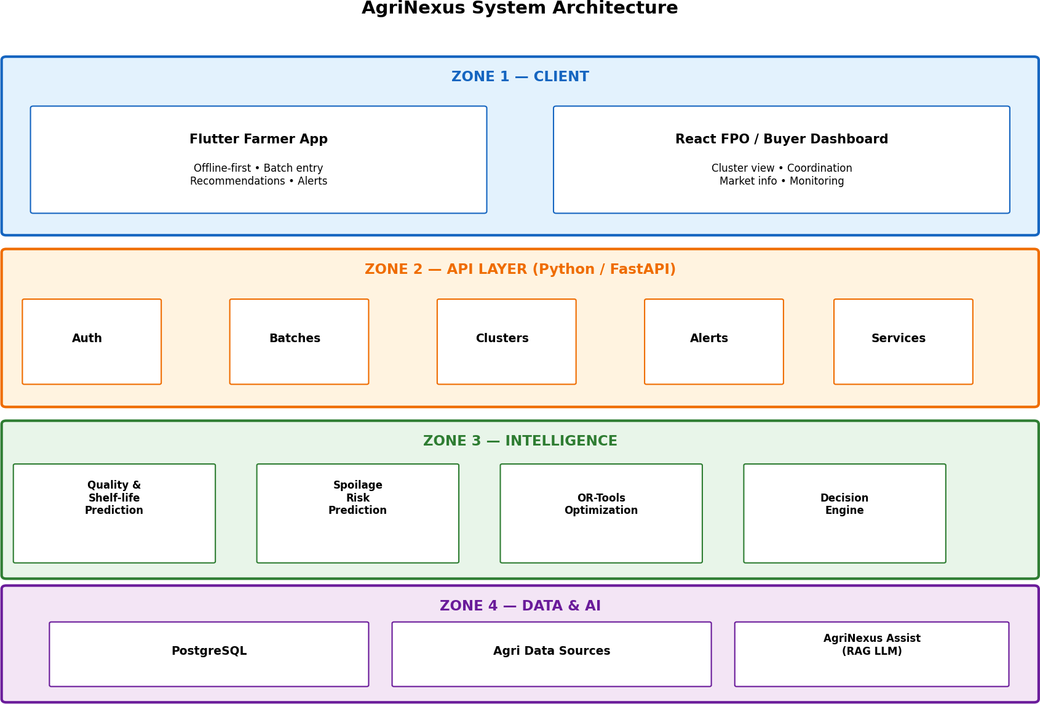
Figure 4.1 — AgriNexus System Architecture (Four Zones)

CHAPTER 5 — TECHNICAL APPROACH

The end-to-end technical approach follows a staged pipeline. Each stage has defined inputs, processing and outputs.

Data Collection & Validation
Inputs: farmer/crop information, batch observations, Soil Health Card context, AGMARKNET/e-NAM prices, IMD weather, ICAR knowledge. Processing: validation of completeness and consistency. Output: validated data package for the batch.

Digital Batch Twin
Input: validated batch and context data. Processing: creation/update of the batch digital profile. Output: current Digital Batch Twin used by downstream stages.

AI Prediction
Input: Digital Batch Twin and relevant features. Processing: proposed models for quality, shelf-life, spoilage risk (and supporting price/demand signals). Output: prediction results attached to the batch.

Market Intelligence
Input: price and demand information, nearby market context, batch urgency from predictions. Processing: structuring of market opportunity relative to the batch. Output: market context for simulation and optimisation.

What-If Simulation
Input: predictions, market context, feasible actions. Processing: evaluation of alternative scenarios (sell, store, process, redirect). Output: comparative scenario insights.

Optimization
Input: scenario results, constraints, cluster-level information if applicable. Processing: OR-Tools-based selection of preferred action. Output: recommended action and supporting metrics.

Action Recommendation
Input: optimisation result and explanation context. Processing: packaging of recommendation and generation of explanation via AgriNexus Assist. Output: SELL / STORE / PROCESS / REDIRECT recommendation with explanation to the user.

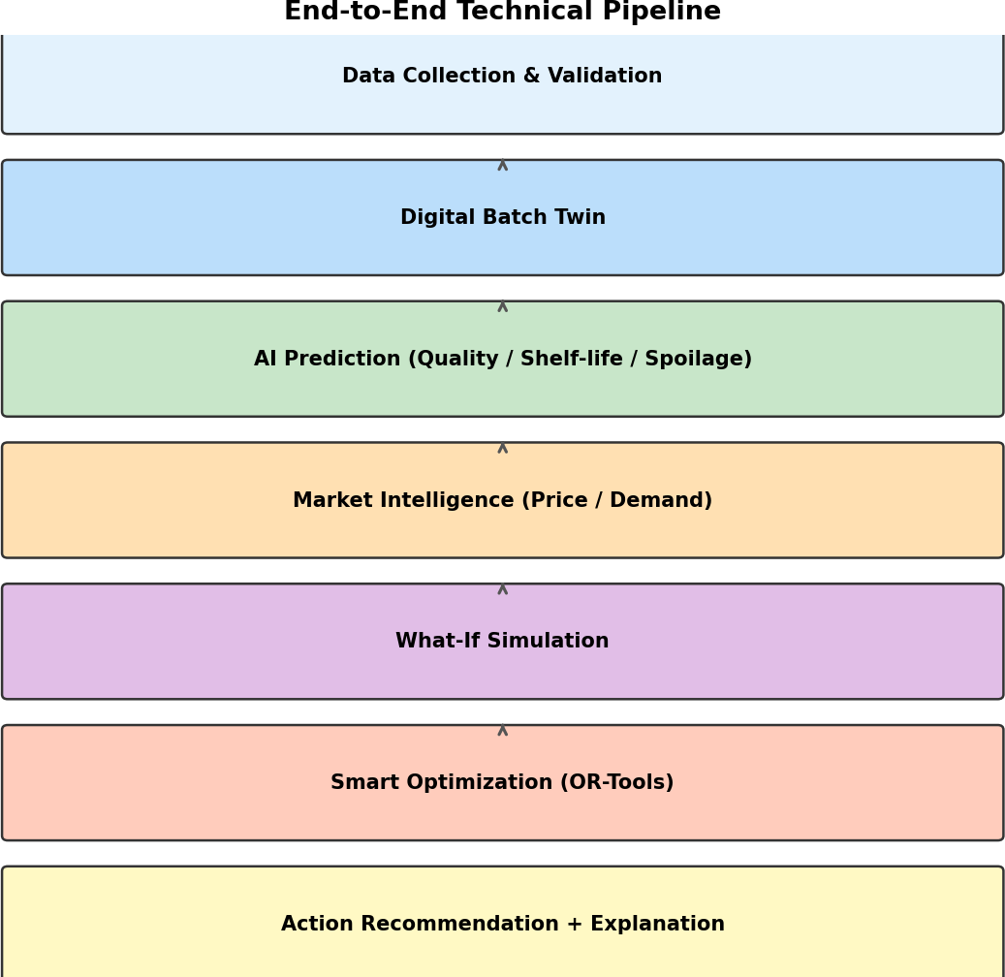
Figure 5.1 — End-to-End Technical Pipeline
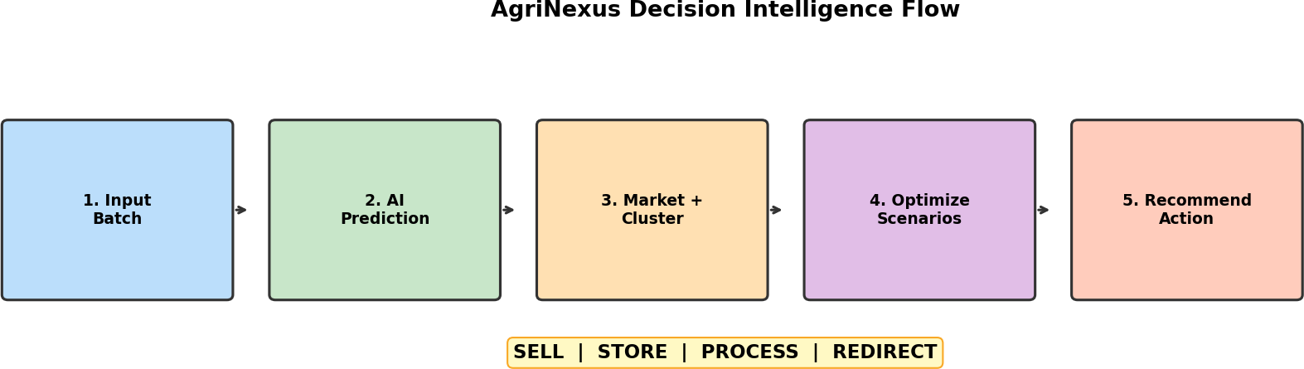

Figure 5.2 — Decision Intelligence Flow

Key design properties of the pipeline include real-time (or near-real-time) computation where feasible, what-if simulation, explainable recommendations and cluster-level optimisation when multiple batches are coordinated.

CHAPTER 6 — TECHNOLOGY STACK

The technology stack is taken directly from the project design. Each technology is assigned a clear proposed role.
Table 6.1 — Technology Stack

Technology | Proposed Role
Flutter | Farmer mobile application (offline-first)
React | FPO / buyer dashboard
Python | Backend and AI processing
FastAPI | API services (auth, batches, clusters, alerts)
PyTorch | AI / ML model development and inference
OR-Tools | Optimization of action selection and cluster coordination
PostgreSQL | Primary structured data storage
AWS / GCP | Cloud infrastructure and deployment
GitHub | Version control and collaborative development
RAG-based LLM | AgriNexus Assist (explainable recommendations)

Flutter enables cross-platform mobile delivery with strong offline capabilities. React supports a responsive dashboard for FPO and buyer users. FastAPI provides a modern, high-performance API layer in Python, aligning with PyTorch-based ML workflows. OR-Tools is a proven library for combinatorial and constraint-based optimisation. PostgreSQL offers reliable relational storage. AWS/GCP provide scalable hosting. The RAG-based component supports grounded natural-language explanations without requiring the core decision logic to be opaque.

CHAPTER 7 — DATA SOURCES

AgriNexus is designed to draw on the following data sources. Live API integration is not claimed unless and until implemented; the sources are treated as reference foundations for the decision system.

Soil Health Card
Provides soil nutrient and related farm-level information. Contributes crop and plot context to the Digital Batch Twin and quality-related interpretation.

AGMARKNET
Provides mandi price and market information. Central to market intelligence for sell, store and redirect decisions.

e-NAM
Provides electronic market and price discovery information. Supports market access and redirect scenario evaluation.

IMD
Provides weather observations and forecasts. Informs shelf-life and spoilage-risk estimation under storage and transport conditions.

ICAR
Provides agricultural research and crop knowledge. Supports domain-consistent interpretation of batch condition and processing options.

ICAR Crop Agro-Advisories
Provides advisory content that can enrich explanations and risk interpretation via AgriNexus Assist and the knowledge layer.

Farmer and Batch Data
Direct inputs from farmers and FPO staff: crop type, quantity, harvest time, observed condition and related batch attributes. Essential for creating and updating the Digital Batch Twin.

CHAPTER 8 — SYSTEM WORKFLOW

The operational workflow from harvest to action is as follows:
- Farmer harvests crop. Produce is harvested and prepared as a batch for decision-making.
- Batch information is captured. Crop details, quantity, harvest time and condition observations are entered via the farmer app (online or offline).
- Digital Batch Twin is created. The system creates or updates the batch digital profile.
- Batch condition is evaluated. Available observations and context are structured for prediction.
- AI predicts quality / shelf-life / spoilage risk. Proposed prediction models produce risk and life estimates.
- Market and demand information is collected. Price and demand context is associated with the batch.
- Available options are generated. Feasible actions among SELL, STORE, PROCESS and REDIRECT are identified.
- What-if scenarios are evaluated. Alternative scenarios are compared using predictions and market data.
- Optimization is performed. OR-Tools-based optimisation selects a preferred action; cluster constraints are applied when relevant.
- Recommendation is generated. The decision engine outputs the recommended action.
- Recommendation is explained. AgriNexus Assist provides an explanation of the main factors.
- Farmer / FPO takes action. The user acts on the recommendation (or overrides with awareness of the trade-offs).
- Outcomes feed validation / re-optimization. Where available, outcomes can support continuous improvement and re-optimisation under changing conditions.

CHAPTER 9 — FUNCTIONAL REQUIREMENTS

Functional requirements are stated as proposed capabilities of the system design.

Farmer Application (Flutter)
    - User login and authentication.
    - Batch registration with crop and quantity details.
    - Capture of batch condition information.
    - Viewing of AI-based assessment (quality, shelf-life, spoilage risk) as available.
    - Viewing of decision recommendation (SELL / STORE / PROCESS / REDIRECT).
    - Viewing of recommendation explanation.
    - Access to what-if scenario comparison where provided.
    - Alerts related to batch urgency or market changes.
    - Offline operation for core data entry and later synchronisation.

FPO / Buyer Dashboard (React)
    - Batch monitoring across member farmers.
    - Cluster-level view of batches and recommendations.
    - Market information overview.
    - Support for storage and transport coordination views.
    - Decision overview and alerts.
    - Coordination support for joint actions.

Intelligence Layer
    - Quality prediction (proposed).
    - Shelf-life prediction (proposed).
    - Spoilage-risk prediction (proposed).
    - Price / demand analysis support.
    - Scenario simulation.
    - Optimization (OR-Tools).
    - Recommendation generation and explanation support.

CHAPTER 10 — NON-FUNCTIONAL REQUIREMENTS

Performance. Decision pipeline should complete within a time acceptable for post-harvest use cases; exact targets to be set during implementation.
Scalability. Architecture should support growth from one FPO pilot to multiple FPOs and regions via cloud deployment.
Availability. Core services should be designed for high availability on cloud infrastructure; offline-first client reduces dependence on continuous connectivity.
Reliability. Recommendations should be consistent for the same inputs; data validation should reduce garbage-in/garbage-out failures.
Security. Authentication, authorised access to batch and cluster data, and secure API communication are required.
Usability. Farmer app and dashboard should be simple, task-oriented and suitable for users with varying digital literacy.
Explainability. Recommendations must be accompanied by understandable explanations of key factors.
Maintainability. Modular zones (client, API, intelligence, data) should allow independent updates of models and services.
Offline support. Farmer app must support offline data capture and later sync.
Multilingual accessibility. Where applicable, multilingual support is intended to improve farmer adoption and trust.
Data consistency. Batch twin and related records should remain consistent across client and server after synchronisation.
Interoperability. Design should accommodate integration with agricultural data sources (AGMARKNET, e-NAM, IMD, etc.) as interfaces allow.
None of the above are claimed as already achieved; they are design requirements for implementation and validation.

CHAPTER 11 — AI/ML METHODOLOGY

The AI/ML methodology is described at a design level. PyTorch is the indicated framework. Exact model architectures, hyperparameters, training datasets and accuracy metrics are to be selected and validated during implementation and are not fabricated here.
Input data: Features derived from the Digital Batch Twin (crop type, quantity, harvest time, condition indicators), environmental context (e.g., weather), and market-related signals as available.
Feature preparation: Cleaning, encoding of categorical crop/batch attributes, normalisation of continuous variables, and alignment of time-based features (harvest age, forecast horizon).
Quality, shelf-life and spoilage-risk prediction: Supervised or hybrid models appropriate to the available labels and domain constraints. The exact architecture is to be selected and validated during implementation.
Price and demand prediction: Support for market intelligence using historical and live price series and demand indicators where data permits.
Model inference: Predictions are attached to the batch twin and passed to simulation and optimisation.
Uncertainty and decision considerations: Where possible, risk estimates should be expressed in a form usable by the optimisation layer (e.g., probability or risk score of spoilage within a time window).
Integration with optimization: Prediction outputs become parameters or constraints in the OR-Tools optimisation problem (e.g., maximum hold time implied by shelf-life, penalty for high spoilage risk).

CHAPTER 12 — OPTIMIZATION METHODOLOGY

Optimisation is proposed using OR-Tools. The system evaluates candidate actions (SELL, STORE, PROCESS, REDIRECT) under constraints derived from shelf-life, spoilage risk, storage capacity, transport availability, market opportunity and, at cluster level, shared resources across batches.
Decision dimensions informed by the design include: market price, demand, shelf-life, spoilage risk, storage, transport, processing feasibility, batch availability and cluster-level coordination. The optimiser is intended to prefer actions that improve realised value while reducing avoidable loss and unnecessary cost. No optimisation results or objective-function coefficients are reported here; formulation and tuning are implementation tasks.

CHAPTER 13 — WHAT-IF SIMULATION

What-if simulation enables comparison of alternative courses of action before a decision is locked in. Representative scenario families include:
Scenario A — SELL now: Dispose of the batch at current market conditions; prioritises immediate realisation of value and minimises storage risk.
Scenario B — STORE: Hold the batch for a period under assumed storage conditions; relevant when expected future price or logistics justify the risk and cost of holding.
Scenario C — PROCESS: Route the batch to processing; relevant when processing improves value or utilises produce that might otherwise spoil.
Scenario D — REDIRECT: Move the batch to another market or channel; relevant when price or demand is better elsewhere and transport is feasible within shelf-life limits.
The system compares scenarios using available prediction and market information. Numerical outcomes are not invented in this document; the value of simulation lies in structured comparison and transparency for the decision-maker.

CHAPTER 14 — CLUSTER-LEVEL / FPO OPTIMIZATION

Cluster-level joint decision optimisation is identified in the project design as a key differentiator. Individual batch decisions, if taken in isolation, can lead to duplicated transport, under-used storage and weaker bargaining. When multiple farmer batches are coordinated through an FPO, the system can consider shared storage, pooled transportation, batch pooling and collective market engagement.
Joint optimisation aims to reduce logistical duplication, improve utilisation of storage and transport, and support better coordination between batch condition, market opportunity and cluster resources. The intended result is stronger farmer clusters and more efficient supply-chain behaviour at the local level. Benefits are stated as design goals; they require validation in pilot settings and are not claimed as proven outcomes.
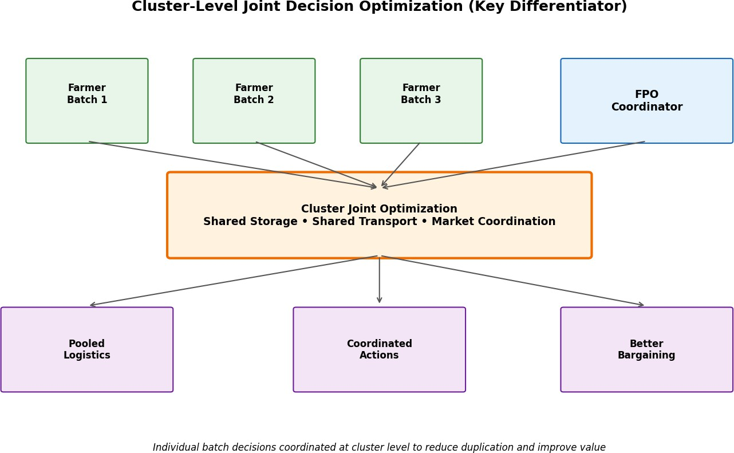

Figure 14.1 — Cluster-Level Joint Decision Optimization

CHAPTER 15 — USER INTERFACE AND USER EXPERIENCE

Farmer Mobile Application
The Flutter farmer application is designed for simplicity and offline resilience. Expected screens and features include: login; batch entry (crop, quantity, harvest details, condition); batch status and AI assessment view; recommendation display (SELL / STORE / PROCESS / REDIRECT); what-if simulation view where provided; explanation of the recommendation; alerts; and offline data capture with later synchronisation. UX priorities are clarity of the recommended action, visibility of key risk and market factors, and minimal steps to register a batch under field conditions.

FPO / Buyer Dashboard
The React dashboard supports organisational users. Expected capabilities include: overview of batches across the cluster; cluster-level recommendation and status views; market information panels; storage and transport coordination views; alerts; and tools to support joint decisions. The dashboard complements the farmer app by enabling coordination that individual mobile users cannot perform alone.

CHAPTER 16 — FEASIBILITY AND VIABILITY

Technical Feasibility
Proven AI/ML methods can support quality and shelf-life related prediction tasks. Existing agricultural datasets (AGMARKNET, e-NAM, IMD, Soil Health Card, ICAR) provide a foundation. The stack (Flutter, React, FastAPI, PyTorch, OR-Tools, PostgreSQL, cloud) is mature and widely used. An MVP can start with one or two crops in one FPO without requiring specialised physical infrastructure.

Data Feasibility
Data feasibility rests on the availability of public market and weather data, institutional knowledge bases, and farmer/batch inputs collected through the app. Gaps in crop-specific labelled data for prediction models are acknowledged and mitigated by starting with major crops and improving with usage.

Operational Viability
The platform is designed to work within the existing FPO ecosystem and trust structures. FPO-level coordination is a natural fit for cluster optimisation. Offline-first design improves operational viability in rural connectivity conditions.

Economic / Value Viability
Intended value benefits include lower spoilage, lower unnecessary costs and higher realised returns. These are intended benefits and require validation through pilot KPIs (loss , value , sales ). No financial savings or income increases are claimed as already achieved.

CHAPTER 17 — PRACTICAL IMPLEMENTATION AND ROLLOUT

The design specifies a three-stage rollout. No major specialised hardware investment is required; the solution is software-centric and uses existing data sources and cloud infrastructure.
Stage 1 — Pilot: Deploy with 1–2 high-value crops in one FPO. Focus on core batch twin, prediction (as available), recommendation and basic coordination.
Stage 2 — Validate: Test against real outcomes; refine models, optimisation parameters and UX based on observed decisions and results.
Stage 3 — Expand: Extend across additional crops, regions and FPOs, improving crop-specific models and cluster optimisation with accumulated data.
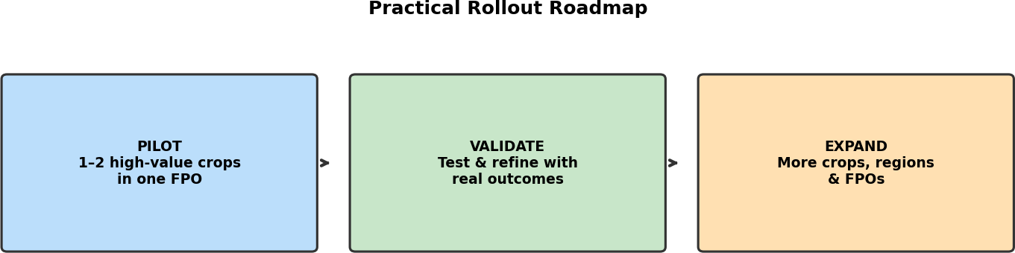

Figure 17.1 — Practical Rollout Roadmap

CHAPTER 18 — CHALLENGES AND MITIGATION

Table 18.1 — Challenges and Proposed Mitigations

Challenge | Proposed Mitigation
Rural connectivity gaps | Offline-first design of the farmer application
Farmer adoption and trust | Multilingual support and explainable recommendations
Limited crop-specific data | Start with major crops and improve models with usage
Variable market conditions | Continuous re-optimization as conditions change
Storage / transport variation | Scenario analysis and optimization under constraints

CHAPTER 19 — TESTING STRATEGY

A professional testing plan covers unit, integration, API, AI/ML pipeline, data validation, optimisation, what-if simulation, mobile, offline, dashboard, security, performance, usability and field/pilot validation. Actual test results are not claimed; status is marked as To Be Tested until execution.
  - Unit Testing — Individual functions and modules (API handlers, prediction wrappers, optimisation helpers).
  - Integration Testing — Interaction between API, database, prediction and optimisation services.
  - API Testing — Authentication, batch CRUD, cluster endpoints, alert endpoints.
  - AI/ML Pipeline Testing — Feature pipeline, inference path, output schema validation (without claiming accuracy).
  - Data Validation Testing — Rejection of incomplete or inconsistent batch inputs.
  - Optimization Testing — Feasible solutions under sample constraints; consistency of recommended actions.
  - What-If Simulation Testing — Scenario generation and comparative output structure.
  - Mobile Application Testing — Flutter app flows on target devices.
  - Offline Mode Testing — Capture offline and sync behaviour.
  - Dashboard Testing — React dashboard views and coordination workflows.
  - Security Testing — Auth, access control, basic API security checks.
  - Performance Testing — Response times under expected pilot load.
  - Usability Testing — Task completion with representative users.
  - Field / Pilot Validation — Comparison of recommendations and outcomes in pilot FPO (KPI framework).

Table 19.1 — Sample Test Case Template

Test ID | Module | Test Scenario | Expected Result | Actual Result | Status
TC-01 | Auth | Valid login | Access granted | — | To Be Tested
TC-02 | Batch | Register batch offline | Stored locally; syncs later | — | To Be Tested
TC-03 | Decision | Recommendation generated | One of SELL/STORE/PRO CESS/REDIRECT with  explanation | — | To Be Tested
TC-04 | Optimize | Cluster constraint applied | Joint recommendation respects shared capacity | — | To Be Tested

CHAPTER 20 — IMPACT AND BENEFITS

Impact and benefits are described as intended outcomes of the design. They align with the workflow: Harvested Batch  Risk + Market Assessment  Timely Action  Value Preserved.

Lower Post-Harvest Loss
Spoilage-risk detection, batch prioritisation and alternate-channel routing are intended to help reduce avoidable losses by prompting earlier or better-directed action when risk is high.

Higher Value for Farmers
Better timing, reduced uncertainty and improved realised value are intended outcomes of linking batch condition to market opportunity and feasible logistics.

Stronger Farmer Clusters
Coordinated batches, pooled storage and transport, and improved bargaining through FPO-level joint decisions are intended to strengthen cluster-level coordination.

More Efficient Supply Chain
Faster decisions, better coordination and more usable produce are intended to improve supply-chain efficiency at the local and cluster level.

CHAPTER 21 — PILOT KPIs

The design identifies pilot validation focus on Loss , Value  and Sales . These are pilot validation KPIs. No target percentages are defined in the source material; measurement frameworks should be set with the pilot FPO.
Table 21.1 — Pilot Validation KPI Framework

KPI | Intent | Measurement Approach (Proposed) | Status
Loss  | Reduce avoidable post-harvest loss for pilot batches | Compare spoilage / discard rates before vs during pilot for comparable batches | To Be Validated
Value  | Improve realised value per unit of produce | Compare average realised price / net value accounting for storage and transport costs | To Be Validated
Sales  | Improve successful and timely sale or channel utilisation | Track share of batches sold/processed/redirected as recommended vs delayed or distressed sales | To Be Validated

CHAPTER 22 — LIMITATIONS

    - Rural connectivity remains a constraint; offline-first design mitigates but does not eliminate it.
    - Crop-specific data for robust prediction models may be limited initially.
    - Market, storage and transport conditions are variable; continuous re-optimisation is required.
    - Real-world validation is necessary; design benefits are not yet proven outcomes.
    - Initial pilot scope is limited to 1–2 high-value crops in one FPO.
    - System performance depends on the quality and availability of input data from farmers and external sources.

CHAPTER 23 — FUTURE SCOPE

    - Expansion to more crops, more FPOs and more regions after successful pilot validation.
    - Improved crop-specific prediction models as labelled data accumulates.
    - Richer market intelligence and finer-grained demand signals.
    - Enhanced cluster optimisation algorithms and multi-FPO coordination.
    - Continuous model improvement and feedback loops from field outcomes.
    - Expansion of decision-intelligence capabilities (e.g., deeper processing-option models) while preserving the core SELL / STORE / PROCESS / REDIRECT framework.
Future scope is clearly distinct from current proposed functionality; items above are not claimed as present features.

CHAPTER 24 — CONCLUSION

AgriNexus is designed to transform post-harvest decision-making from fragmented, experience-based choices into an integrated, data-driven decision-intelligence workflow. The core path—
Digital Batch Twin  AI Prediction  Market Intelligence  What-If Simulation
→ Optimization  SELL / STORE / PROCESS / REDIRECT
—combines batch-level condition assessment with predictive risk, market context, scenario comparison and optimisation. Cluster-level joint decision optimisation distinguishes the design by enabling coordinated storage, transport and market actions across farmer batches within an FPO.
Intended benefits include reduced avoidable losses, better realised value for farmers, stronger farmer clusters and improved supply-chain efficiency. These remain design goals to be validated through pilot KPIs (loss , value , sales ). The technology stack, data foundations and rollout path (pilot  validate  expand) are chosen to be feasible without major specialised hardware, leveraging existing agricultural data platforms and modern software components.
This report has documented the problem, proposed system, architecture, methodology, feasibility, challenges, impact framework and future scope strictly in line with the AgriNexus design for Smart India Hackathon 2026 Problem Statement 26193. Implementation and field validation are the necessary next steps to convert the proposed decision-intelligence platform into measured outcomes for farmers and FPOs.

REFERENCES

- Soil Health Card – Ministry of Agriculture & Farmers Welfare / NIC. Available at: https://soilhealth.dac.gov.in/
- AGMARKNET – Government of India. Available at: https://agmarknet.gov.in/
- e-NAM – National Agriculture Market. Available at: https://www.enam.gov.in/
- India Meteorological Department (IMD). Available at: https://mausam.imd.gov.in/
- ICAR – Indian Council of Agricultural Research. Available at: https://icar.gov.in/
- ICAR Crop Agro-Advisories. Available at: https://icar.gov.in/

Note: Only references provided in the project source material are listed. No additional publications, DOIs or invented bibliographic details have been added.

APPENDICES

Appendix A — System Architecture
See Figure 4.1 and Chapter 4. Four zones: Client (Flutter, React, offline-first); API Layer (Python/FastAPI); Intelligence (prediction, OR-Tools, decision engine); Data & AI (PostgreSQL, agri data, AgriNexus Assist RAG).

Appendix B — End-to-End Workflow
See Chapter 8 and Figure 5.1. Pipeline: Data Collection & Validation  Digital Batch Twin  AI Prediction  Market Intelligence  What-If Simulation  Optimization  Action Recommendation.

Appendix C — Technology Stack
See Table 6.1: Flutter, React, Python, FastAPI, PyTorch, OR-Tools, PostgreSQL, AWS/GCP, GitHub, RAG-based LLM.

Appendix D — Functional Requirements Summary
See Chapter 9. Farmer app: auth, batch registration, recommendations, explanations, alerts, offline. FPO dashboard: batch/cluster monitoring, market view, coordination. Intelligence: prediction, simulation, optimisation, recommendation.

Appendix E — Testing Scenarios
See Chapter 19 and Table 19.1. All listed test cases are To Be Tested until executed in implementation.

Appendix F — KPI Framework
See Table 21.1. Pilot validation KPIs: Loss , Value , Sales  — To Be Validated.

Appendix G — Glossary
Digital Batch Twin: An up-to-date digital profile of a harvested batch used as the basis for prediction and decision support.
Shelf Life: Estimated remaining period during which the batch remains usable or marketable under stated conditions.
Spoilage Risk: Estimated likelihood or severity of quality degradation or loss within a relevant time horizon.
Market Intelligence: Structured use of price, demand and market-access information in decision-making.
What-If Simulation: Comparison of alternative action scenarios (e.g., sell now vs store) before committing to a decision.
Optimization: Selection of a preferred action under constraints and objectives, proposed via OR-Tools.
FPO: Farmer Producer Organisation — collective entity of farmers that can coordinate storage, transport and marketing.
RAG: Retrieval-Augmented Generation — approach used by AgriNexus Assist to ground explanations in retrieved knowledge.

Decision Engine: Component that consolidates analytical outputs into a SELL / STORE / PROCESS / REDIRECT recommendation.

— End of Project Report —
AGRINEXUS | Smart India Hackathon 2026 | Problem Statement 26193

