WEEK – 2 : PL/SQL PROGRAMMING
EXERCISE 1: CONTROL STRUCTURES
STEP 1: CREATE REQUIRED TABLES IN ORACLE LIVE SQL
CREATE TABLE CUSTOMERS (
CustomerID NUMBER PRIMARY KEY,
Name VARCHAR2(100),
Age NUMBER,
Balance NUMBER(10, 2),
IsVIP VARCHAR2(5) DEFAULT 'FALSE'
);
CREATE TABLE LOANS (
LoanID NUMBER PRIMARY KEY,
CustomerID NUMBER REFERENCES CUSTOMERS(CustomerID),
InterestRate NUMBER(5, 2),
DueDate DATE
);

STEP 2: INSERT SAMPLE DATA
INSERT INTO CUSTOMERS VALUES (1, 'Alice', 65, 12000, 'FALSE');
INSERT INTO CUSTOMERS VALUES (2, 'Bob', 45, 8000, 'FALSE');
INSERT INTO CUSTOMERS VALUES (3, 'Charlie', 70, 9500, 'FALSE');
INSERT INTO CUSTOMERS VALUES (4, 'David', 35, 15000, 'FALSE');

INSERT INTO LOANS VALUES (101, 1, 8.5, SYSDATE + 10); -- Alice
INSERT INTO LOANS VALUES (102, 2, 7.0, SYSDATE + 40); -- Bob
INSERT INTO LOANS VALUES (103, 3, 9.0, SYSDATE + 20); -- Charlie
INSERT INTO LOANS VALUES (104, 4, 6.5, SYSDATE + 5); -- David
COMMIT;

SCENARIO 1: DISCOUNT FOR CUSTOMERS OVER 60
BEGIN
FOR loan_rec IN (
SELECT l.LoanID, l.InterestRate, c.Age
FROM LOANS l
JOIN CUSTOMERS c ON l.CustomerID = c.CustomerID
WHERE c.Age > 60
) LOOP
UPDATE LOANS
SET InterestRate = InterestRate - 1
WHERE LoanID = loan_rec.LoanID;
END LOOP;

DBMS_OUTPUT.PUT_LINE('✅ Discount applied for customers above 60.');
END;
/

SCENARIO 2: PROMOTE CUSTOMERS TO VIP BASED ON BALANCE
BEGIN
FOR cust_rec IN (
SELECT CustomerID, Balance
FROM CUSTOMERS
WHERE Balance > 10000
) LOOP
UPDATE CUSTOMERS
SET IsVIP = 'TRUE'
WHERE CustomerID = cust_rec.CustomerID;
END LOOP;
DBMS_OUTPUT.PUT_LINE('VIP status updated based on balance.');
END;/

SCENARIO 3: LOAN DUE DATE REMINDER (NEXT 30 DAYS)
BEGIN
FOR loan_rec IN (
SELECT l.LoanID, c.Name, l.DueDate
FROM LOANS l
JOIN CUSTOMERS c ON l.CustomerID = c.CustomerID
WHERE l.DueDate BETWEEN SYSDATE AND SYSDATE + 30
) LOOP
DBMS_OUTPUT.PUT_LINE('Reminder: Loan ' || loan_rec.LoanID ||
' for customer ' || loan_rec.Name ||
' is due on ' || TO_CHAR(loan_rec.DueDate, 'DD-MON-YYYY'));
END LOOP;
END;
/
OUTPUT
QUERY RESULT
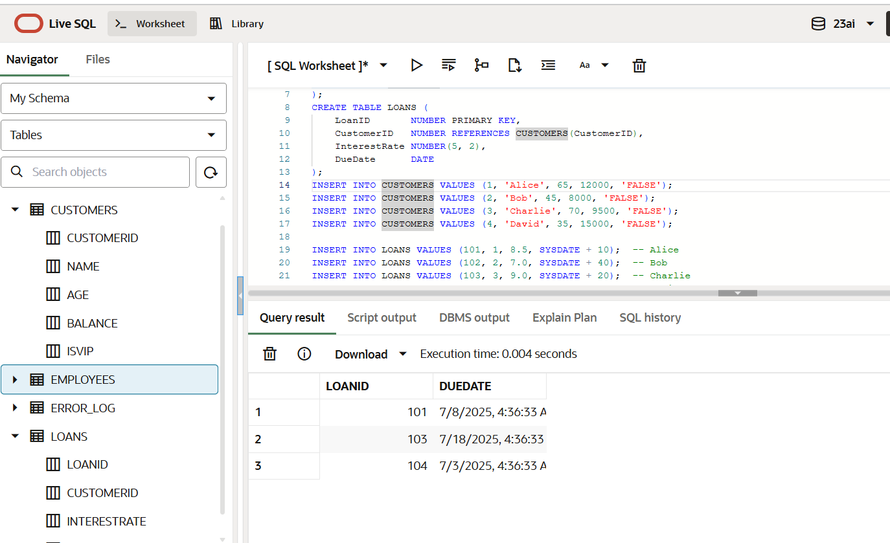

DBMS OUTPUT
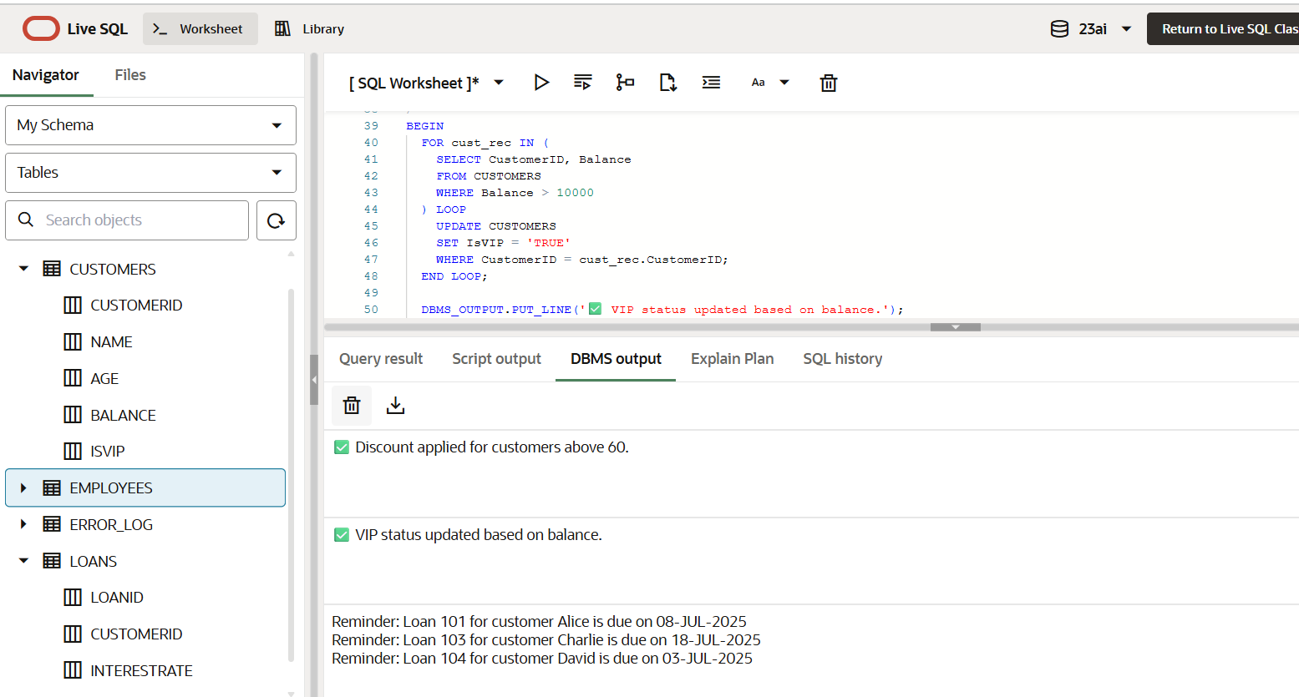
EXERCISE 3: STORED PROCEDURES
STEP 1: CREATE REQUIRED TABLES
CREATE TABLE SAVINGS_ACCOUNTS (
AccountID NUMBER PRIMARY KEY,
CustomerName VARCHAR2(100),
Balance NUMBER(10, 2)
);
CREATE TABLE EMPLOYEES (
EmployeeID NUMBER PRIMARY KEY,
Name VARCHAR2(100),
Salary NUMBER(10, 2),
DepartmentID NUMBER
);
CREATE TABLE ACCOUNTS (
AccountID NUMBER PRIMARY KEY,
CustomerName VARCHAR2(100),
Balance NUMBER(10, 2)
);
STEP 2: INSERT SAMPLE DATA
-- Savings Accounts
INSERT INTO SAVINGS_ACCOUNTS VALUES (1, 'Alice', 10000);
INSERT INTO SAVINGS_ACCOUNTS VALUES (2, 'Bob', 5000);
INSERT INTO SAVINGS_ACCOUNTS VALUES (3, 'Charlie', 15000);

-- Employees
INSERT INTO EMPLOYEES VALUES (101, 'John', 60000, 10);
INSERT INTO EMPLOYEES VALUES (102, 'Jane', 65000, 10);
INSERT INTO EMPLOYEES VALUES (103, 'Mark', 55000, 20);
-- Accounts
INSERT INTO ACCOUNTS VALUES (1, 'Alice', 10000);
INSERT INTO ACCOUNTS VALUES (2, 'Bob', 8000);
INSERT INTO ACCOUNTS VALUES (3, 'Charlie', 6000);
COMMIT;
SCENARIO 1: DISCOUNT FOR CUSTOMERS OVER 60
BEGIN
FOR loan_rec IN (
SELECT l.LoanID, l.InterestRate, c.Age
FROM LOANS l
JOIN CUSTOMERS c ON l.CustomerID = c.CustomerID
WHERE c.Age > 60
) LOOP
UPDATE LOANS
SET InterestRate = loan_rec.InterestRate - 1
WHERE LoanID = loan_rec.LoanID;
END LOOP;
DBMS_OUTPUT.PUT_LINE('✅ Discount applied for customers above 60.');
END;
/
SCENARIO 2: PROMOTE CUSTOMERS TO VIP BASED ON BALANCE
BEGIN
FOR cust_rec IN (
SELECT CustomerID, Balance
FROM CUSTOMERS
WHERE Balance > 10000
) LOOP
UPDATE CUSTOMERS
SET IsVIP = 'TRUE'
WHERE CustomerID = cust_rec.CustomerID;
END LOOP;

DBMS_OUTPUT.PUT_LINE('✅ VIP status updated based on balance.');
END;
/
SCENARIO 3: LOAN DUE DATE REMINDER (NEXT 30 DAYS)
BEGIN
FOR loan_rec IN (
SELECT l.LoanID, c.Name, l.DueDate
FROM LOANS l
JOIN CUSTOMERS c ON l.CustomerID = c.CustomerID
WHERE l.DueDate BETWEEN SYSDATE AND SYSDATE + 30
) LOOP
DBMS_OUTPUT.PUT_LINE(
'🔔 Reminder: Loan ' || loan_rec.LoanID ||
' for customer ' || loan_rec.Name ||
' is due on ' || TO_CHAR(loan_rec.DueDate, 'DD-MON-YYYY')
);
END LOOP;
END;
/
OUTPUT
QUERY RESULT
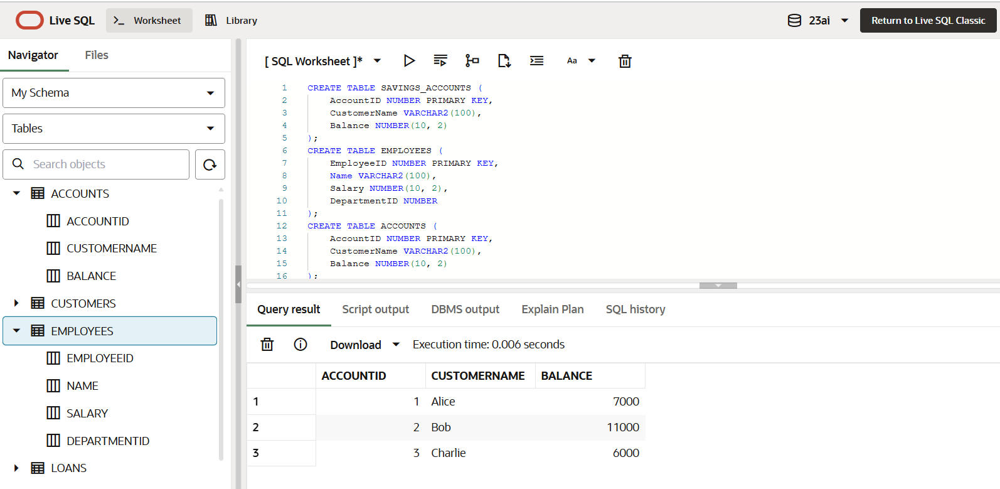

DBMS OUTPUT
