Rain Sensing Automatic Car Wiper

Today’s car wipers are manual systems that work on the principle of manual switching. So here we propose an automatic wiper system that automatically switches ON on detecting rain and stops when rain stops. Our project brings forward this system to automate the wiper system having no need for manual intervention. For this purpose we use rain sensor along with microcontroller and driver IC to drive the wiper motor. Our system uses rain sensor to detect rain, this signal is then processed by microcontroller to take the desired action.
The rain sensor works on the principle of using water for completing its circuit, so when rain falls on it it’s circuit gets completed and sends out a signal to the microcontroller. The microcontroller now processes this data and drives the motor IC to perform required action. The motor driver IC now drives a servomotor to simulate as a car wiper.

Block Diagram:

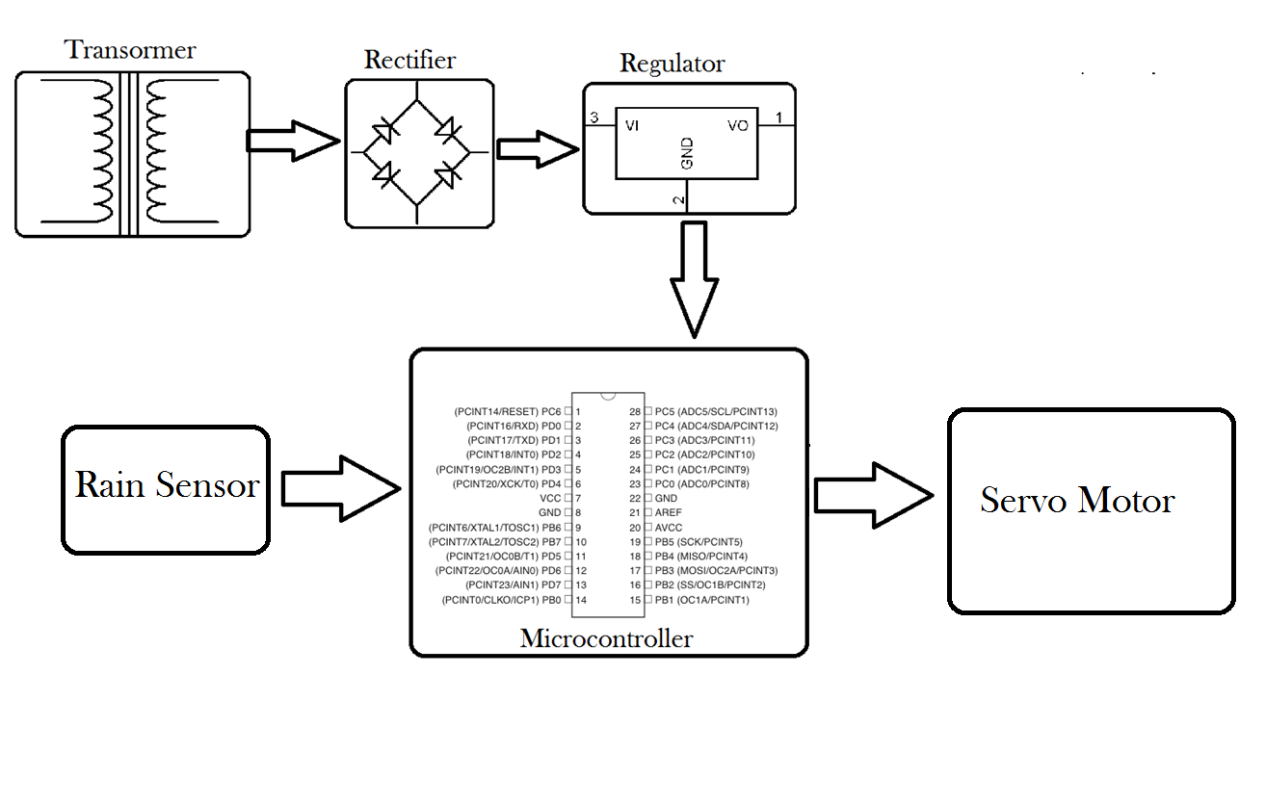

Hardware Specifications
- ATmega Family Microcontroller
- Transformer
- Regulator
- Rain Sensor
- Servo Motor

Software Specifications
- Arduino Compiler

- MC Programming Language: C

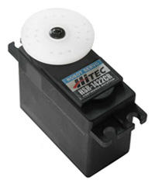
SERVO MOTOR:

A Servo is a small device that has an output shaft. This shaft can be positioned to specific angular positions by sending the servo a coded signal. As long as the coded signal exists on the input line, the servo will maintain the angular position of the shaft. As the coded signal changes, the angular position of the shaft changes. In practice, servos are used in radio controlled airplanes to position control surfaces like the elevators and rudders. They are also used in radio controlled cars, puppets, and of course, robots.
Servo Control
The servo motor can be moved to a desired angular position by sending PWM (pulse width modulated) signals on the control wire. The servo understands the language of pulse position modulation. A pulse of width varying from 1 millisecond to 2 milliseconds in a repeated time frame is sent to the servo for around 50 times in a second. The width of the pulse determines the angular position.

For example, a pulse of 1 millisecond moves the servo towards 0°, while a 2 milliseconds wide pulse would take it to 180°. The pulse width for in between angular positions can be interpolated accordingly. Thus a pulse of width 1.5 milliseconds will shift the servo to 90°.
It must be noted that these values are only the approximations. The actual behavior of the servos differs based on their manufacturer.
A sequence of such pulses (50 in one second) is required to be passed to the servo to sustain a particular angular position. When the servo receives a pulse, it can retain the corresponding angular position for next 20 milliseconds. So a pulse in every 20 millisecond time frame must be fed to the servo. 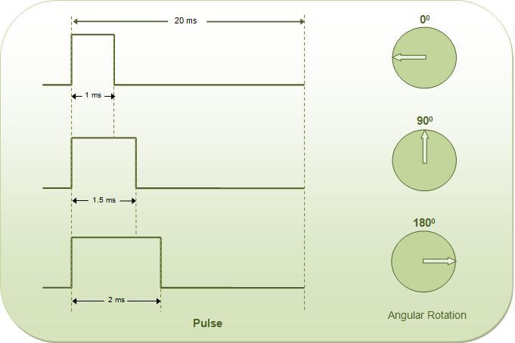

A servo motor mainly consists of a DC motor, gear system, a position sensor which is mostly a potentiometer, and control electronics.
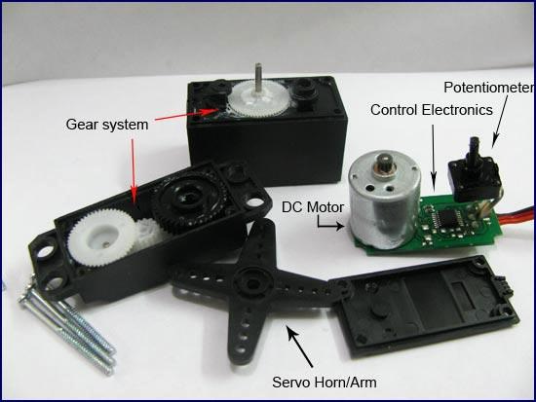
The DC motor is connected with a gear mechanism which provides feedback to a position sensor which is mostly a potentiometer. From the gear box, the output of the motor is delivered via servo spline to the servo arm. The potentiometer changes position corresponding to the current position of the motor. So the change in resistance produces an equivalent change in voltage from the potentiometer. A pulse width modulated signal is fed through the control wire. The pulse width is converted into an equivalent voltage that is compared with that of signal from the potentiometer in an error amplifier.
